


Structural Design Features Report
  - <School Name – Block X>
  - <
  - <Block X>

New Zealand School Property Agency Template
Date
Prepared By: Consultant Name

Document Control
Document Prepared by:
<Full Legal Company Name>
<Company Address Physical>
<Company Address Postal>

Telephone: <Company Phone number>
Email: <Company email>
Web: <Company Website>

Revision History
Revision No. | Prepared By | Description | Date
0 | xxxxxx | Masterplanning | xx/yy/yyyy
1 | xxxxxx | Preliminary Design | xx/yy/yyyy
2 | xxxxxx | Developed Design | xx/yy/yyyy
3 | xxxxxx | Detailed Design | xx/yy/yyyy

Document Acceptance
Action | Name | Signed | Date
Prepared by: | xxxxxx |  | xx/yy/yyyy
Reviewed by:  CPEng # | xxxxxx  xxxxxx |  | xx/yy/yyyy
Approved by:  CPEng # | xxxxxx  xxxxxx |  | xx/yy/yyyy

Contents

Document Control 1
Executive Summary 4
1. General 5
1.1 Project Overview 5
1.1.1 Scope 5
1.1.2 New buildings 5
1.1.3 Existing building and seismic assessment review 5
1.2 Project team 5
2. Ground Conditions 7
2.1 Geotechnical investigations 7
2.2 Site soil conditions 7
2.3 Seismic subsoil classification 8
2.4 Soil design values 8
2.4.1 Soil strengths 8
2.4.2 Spring stiffness 8
2.4.3 Lateral earth pressure coefficients 8
2.5 Significant geohazards 9
3. Structure 10
3.1 Structural opportunities and constraints 10
3.2 Foundations 10
3.3 Building gravity system 10
3.4 Building lateral system 10
3.5 Secondary structural systems 11
3.6 Significant design features 11
3.7 Material Properties 11
4. Means of Compliance 12
4.1 Building regulatory purposes 12
4.2 NZSPA’s Structural and Geotechnical Requirements compliance 12
4.3 Alternative solutions 12
5. Building Design Actions 13
5.1 Building design life 13
5.2 Building importance level 13
5.3 Annual probability of exceedance 13
5.4 Design loads 13
5.4.1 Design imposed loads 13
5.4.2 Design wind loads 14
5.4.3 Design earthquake loads 15
5.4.4 Snow loads 15
5.4.5 Earth retaining loads 15
5.4.6 Fire resistance loads 16
5.4.7 Construction loads 16
6. Building Performance 17
6.1 General performance 17
6.1.1 Gravity and wind deflections 17
6.1.2 Floor vibration 17
6.2 Earthquake performance 17
6.2.1 Earthquake design philosophy and expected performance 17
6.2.2 Seismic gaps 20
6.3 Secondary and non-structural elements 20
6.4 Durability and expected maintenance 20
6.4.1 Design Life 20
6.4.2 Durability provisions 20
6.4.3 Summary of steel surface treatments 21
6.5 Fire resistance rating 21
7. Software and Design Systems 23
8. Safe Design 24
9. Sustainable Design 25
10. Construction 26
10.1 Construction category 26
10.2 Proprietary systems 26
10.3 Construction monitoring 26
Appendices 28
Appendix A - Site Plan 29
Appendix B - Geotechnical Hazard Site Plan 30
Appendix C - Project and Sites Constraints Table 31
Appendix D - Secondary and Non-Structural Design Brief 32
Appendix E - General Design Local Wind Pressures 37
Appendix F - Construction Monitoring Plan (In Development) 38

Executive Summary
This structural Design Features Report (DFR) is a detailed document outlining the key structural design criteria and the resulting building performance for School Name – Block X at insert address.
A summary of the project and new building features is provided in the table below.
Project scope | <Provide a short, general description of the proposed works>.
Number of Storeys | <e.g., 2>
Gross Floor Area (m²) | <e.g., 1242m²>
Proposed use | <e.g., Hall, Library, classroom, storage etc.>
Interconnections with existing or future buildings | <None / or extent and approximate date carried out>
Basement | <None or provide short summary>
Gravity Load Resisting System | <Provide short summary>
Lateral Load Resisting System | < Provide short summary >
Wall/Cladding/Roof System | < Provide short summary >
Floor System | <provide details as appropriate – in particular for suspended floors for multi-storey buildings as well as the ground floor slab>
Foundation System | < Provide short summary >
Geotechnical Considerations | <The site is considered to be Class D.>  <Add any other known/relevant geotechnical aspects such as the site topography or potential liquefaction that may influence likely building performance>
Building Performance | The building design complies with B1 of the New Zealand Building Code and the additional requirements outlined in the NZSPA’s Structural and Geotechnical Requirements, Version 3.0.  The following alternative solutions have been adopted in the design of the structure:

- General
  - Project Overview
    - Scope
<Summarise the general project scope and outline the structural scope of work, including any exclusions>.

Insert a good overview site plan

    - New buildings
<Description of the proposed new buildings>.
    - Existing building and seismic assessment review
<Summarise the existing buildings that are to remain, any previous seismic assessment information and what seismic review has been completed or is recommended>.
  - Project team
The project team includes:
Client | New Zealand School Property Agency
Lead Designer | Company
Project Manager | Company
Architect | Company
Structural Engineer | Company
Geometric Engineer | Company
Building Services Engineer | Company
Quantity Surveyor | Company
Fire Engineer | Company
Acoustic Engineer | Company
Civil Engineer | Company
Etc.

- Ground Conditions
  - Geotechnical investigations
<Summarise the geotechnical investigations undertaken and provide reference to the geotechnical report>.
  - Site soil conditions
The site soil conditions can be summarised as…
<Outline whether the site soil conditions have influenced the siting of the building or the need to adopt a more settlement tolerant building approach>.
<Insert relevant diagrams such as geotechnical cross sections where useful to illustrate a particular feature of a site, and a site plan where there may be significant changes in geology across the site.>.
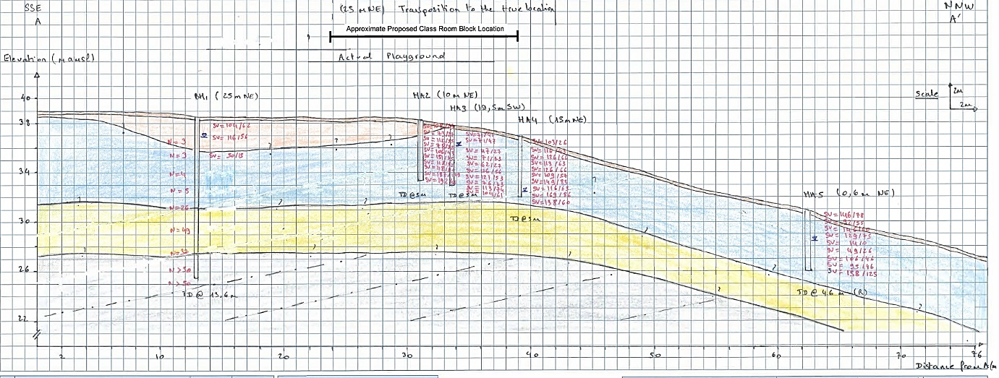
Figure 2.11 - Example geotechnical cross-section.
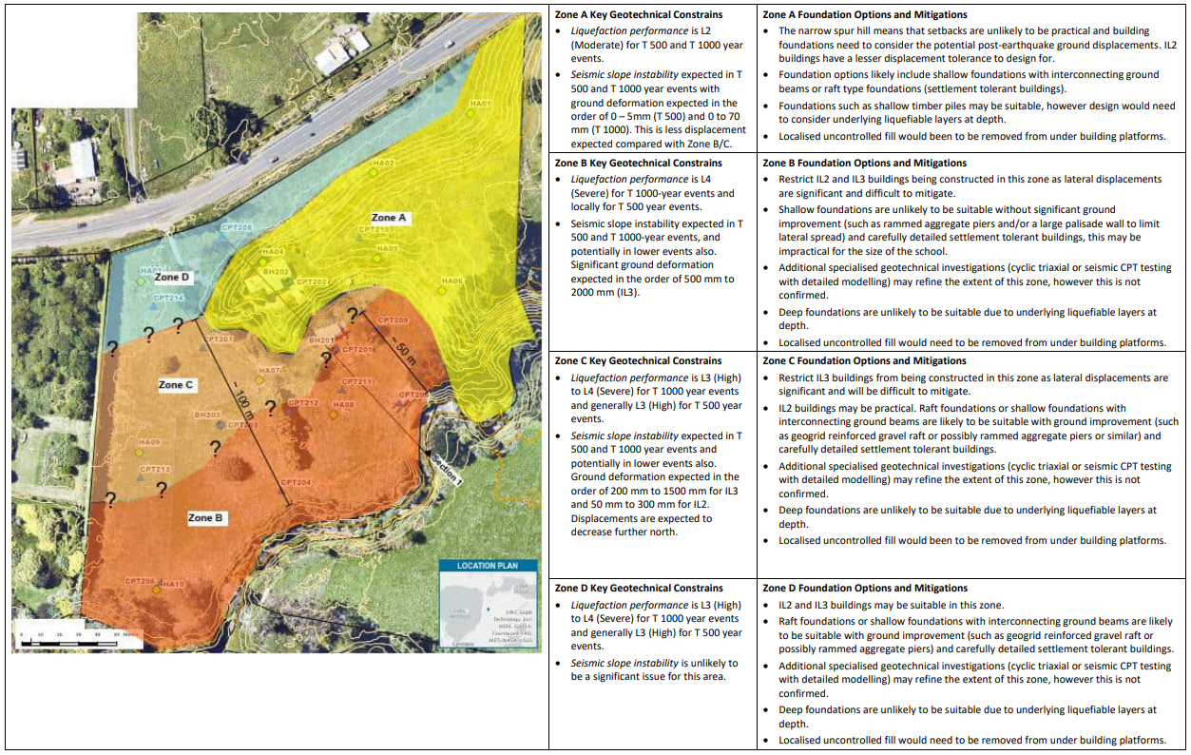
Figure 2.2 - Example site plan.
  - Seismic subsoil classification
The site subsoil category in terms of NZS 1170.5:2004 Clause 3.1.3 is Class D (Deep soil site).
  - Soil design values
    - Soil strengths
<Summarise key bearing capacities from the geotechnical report and adopted in the foundation design, including the strength reduction factors used >.
    - Spring stiffness
<Where appropriate, summarise spring stiffness properties from the geotechnical report and adopted in the building design>.
    - Lateral earth pressure coefficients
<Where appropriate summarise key lateral earth pressure coefficients and soil densities from the geotechnical report and adopted in the design of retaining structures. Include soil friction parameters when this is utilised for base shear takeout.>.
  - Significant geohazards
<Where appropriate, summarise the geohazards (e.g., liquefaction potential, slope stability, reactive soils, contamination etc) from the geotechnical report and adopted in the building design and proposed mitigation methodology where appropriate>.

- Structure
  - Structural opportunities and constraints
< Outline key project and site opportunities and constraints (siting, layout, form, consistency across buildings, performance, cost and constructability considerations) that led to a preferred structural option>
  - Foundations
<Describe the foundation system. Outline the process of considering shallow foundations and arriving at the final foundation solution. For settlement-prone ground include the relevant completed tables as per Table 7.2 of the NZSPA’s Structural and Geotechnical Requirements and outline the factual reasons for the selected foundation>.
  - Building gravity system
<Describe options considered and the reasons for the preferred gravity systems (roof, suspended floors, ground floor, internal and external walls)>
  - Building lateral system
<Describe the options considered and the reasons for the preferred lateral systems (roof, floor diaphragms and vertical lateral elements). Describe the design philosophy and methodology for complying with the design levels as described in the SGR, for SLS1, SLS2, ULS.>

insert a good overview image of the building structure

Figure 3.12 - General arrangement of the lateral systems.
  - Secondary structural systems
<Outline the secondary elements such as stairs, lifts, ceilings, services, partitions and plant, and description of the support structure>
  - Significant design features
<Outline the methodology for the design of any significant features >
  - Material Properties
<Outline the properties of the structural components, concrete, precast, reinforcement, structural steel, timber, other >

- Means of Compliance
  - Building regulatory purposes
The design of the structure is in compliance with the New Zealand Building Code (NZBC), section B1.
  - NZSPA’s Structural and Geotechnical Requirements compliance
The design of the structure complies with the NZSPA’s Structural and Geotechnical Requirements, Version 3.0 and dated October 2020.
  - Alternative solutions
The following alternative solutions have been adopted in the design of the structure:
- Xx
<A design that involves a settlement-tolerant building will be an Alternative Solution>

- Building Design Actions
  - Building design life
The design working life of the building is 50 years as per the requirements of the Building Code.
  - Building importance level
The building is <building type and use e.g., heavy construction classroom block> with <less/more than 250 occupants> and therefore has been designed as an Importance Level 3 building as required by the NZSPA’s Structural and Geotechnical Requirements.
  - Annual probability of exceedance
The following return periods have been considered in the design of the structure.
Performance level  Design load | SLS  All | SLS2  Earthquake | ULS  Snow | ULS  Wind | ULS  Earthquake
Return Period | 25 years | 250 years | 250 years | 1000 years | 1000 years
  - Design loads
    - Design imposed loads
The following superimposed dead load and live load allowances have been used as a basis for the design.
Area / Location | Type of Load | Uniformly Distributed Loads (kPa) | Concentrated Point Loads (kN)
Classrooms and offices | SDL  LL | 1.0  3.0 | 2.7
Assembly areas | SDL  LL | 1.5  4.0 | 4.5
Circulation space (e.g., stairs, corridors) | SDL  LL | 1.0  4.0 | 4.5
Storage areas | SDL  LL | 1.0  4.8 | 4.5
Plant Rooms | SDL  LL | 1.0  5.0 | 4.5
Non- trafficable roof | SDL  LL | 1.0  0.25 | 1.4

Barrier loads
Imposed actions for barriers have been derived from Table 3.3 of AS/NZS 1170.1.
Activity | Top Edge |  |  | Infill
 | Horizontal | Vertical | In/outwards, or downwards | Horizontal | Any direction
Classrooms | 0.75 kN/m | 0.75 kN/m | 0.60 kN | 1.00 kPa | 0.50 kN
Balconies | 3.0 kN/m | 0.75 kN/m | 0.60 kN | 1.50 kN | 1.50 kN
Designated Fire Exits | 3.0 kN/m | 0.75 kN/m | 0.60 kN | 1.50 kN | 1.50 kN
    - Design wind loads

Site wind speeds and design pressures
Wind actions for this building have been determined from AS/NZS1170.2:2021. A summary of the wind design assumptions is provided below.
Variable | Description | SLS | ULS
Regional gust wind speed, VR | Region A7 | 37 ms⁻¹ | 46 ms⁻¹
Wind directional multiplier | Allow all wind directions | 1.0 | 1.0
Terrain/height Multiplier, Mz,cat | Height up to 10m in Terrain Category 3 | 0.83 | 0.83
Shielding multiplier, Ms | No shielding | 1.0 | 1.0
Topographic multiplier, Mt (Hill, Lee) | On flat ground with no slope | 1.0 | 1.0
Site wind speed |  | 30.7ms⁻¹ | 38.2ms⁻¹
Design wind pressure |  | 0.57C_{fig}C_{dyn} kPa | 0.88 C_{fig}C_{dyn} kPa
<Add notes about dominant openings, canopies etc requiring special attention.>
Design wind pressures are summarised on elevations and plans in Appendix E. Indicative local pressures are also summarised on the elevations. Design wind pressures for specific elements are available on request.
    - Design earthquake loads

Key earthquake load parameters
The seismic load coefficients have been determined using the following parameters in accordance with NZS 1170.5:2004.
Parameter | Value
Design Working Life | <50 years>
Importance Level | <3>
Return Period Factor (R): SLS1, SLS2, ULS | <0.25, 0.75, 1.3>
Site Subsoil Classification | <D>
Period (seconds) | <0.4> seconds (longitudinal direction)  <0.4> seconds (transverse direction)  etc
Hazard Factor (Z) | <0.40>
Near Fault Factor (N) | <1.0>
Ductility & S_{p} Factors | µ | S_{p}
Ductility & S_{p} Factors | <µ_{ULS, EBF} = 2.0 >  <µ_{ULS, Portal Frames} = 2.0 >  <µ_{SLS2, EBF} = 1.25 >  <µ_{SLS2, Portal Frames} = 1.25 >  <µ_{SLS1, EBF} = 1.0 >  <µ_{SLS1, Portal Frames} = 1.0 >  etc | <S_{p (ULS, EBF)} = 0.7 >  <S_{p (ULS, Portals)} = 0.7 >  <S_{p (SLS2, EBF)} = 0.9 >  <S_{p (SLS2, Portals)} = 0.9 >  <S_{p (SLS1, EBF)} = 0.9 >  <S_{p (SLS1, Portals)} = 0.9 >  etc

Ductility and S_{p} Factors
<Outline the rationale for the choice and proving of ductility>

Modelling basis and assumptions
<Outline the modelling basis and assumptions e.g. static equivalent, modal, time history etc.>
    - Snow loads
Snow loads have been determined using NZ1170.3 based on the building being located in Region N1/2/3/4/5 at an elevation of Xm above sea level.
    - Earth retaining loads
<Summarise key earth retaining loads if applicable>.
    - Fire resistance loads
<Summarise fire loads if applicable>.
    - Construction loads
<Summarise construction loads>.

- Building Performance
  - General performance
    - Gravity and wind deflections
Particular elements are designed to the recommended serviceability deflection limits of AS/NZS 1170.0:2002, Table C1.
Actual deflection values for specific elements are available upon request. Refer Appendix D for secondary and non-structural briefing document.
    - Floor vibration
Floor vibrations will meet the limits in Table C1 of AS/NZS1170.0:2002.
<or describe vibration analysis and summary results>
  - Earthquake performance
    - Earthquake design philosophy and expected performance
< A comprehensive narrative summarising the earthquake design philosophy including a clear description of the hierarchy of failure >
A summary of the estimated building movements at the various levels of earthquake shaking, including the expected level of damage and occupancy impacts are summarised in the following table. For multi-storey buildings a table of storeys and drifts is to be provided.

Design case | SLS1 | SLS2 | ULS
T (years) | 25 | 250 | 1,000
Differential Foundation settlement (mm) | 15 – 25 | 80 – 120 | >200
Seismic Lateral Drift (mm)1 | 5mm (max X.X% drift) | 30mm (max X.X% drift) | 60mm (max X.X% drift)
Expected level of damage and required repairs | Cosmetic cracking of wall finishes.  Building services operational.  Weathertight (no reinstatement work required).  No disruption to building operation  Some minor ‘cosmetic’ work may be required. | Re-levelling required to 20% of the floor area. Grout injection of foundation pads/beams and mechanical re-levelling of floor area with 1 to 2 months duration.  Work able to be planned for a school holiday period. Limited temporary accommodation/decanting costs (could use Hall/Gym as temporary classroom space).  Redecoration of interior space(s) involving replastering and repainting. Sticking doors and windows.  Some repairs to non-structural elements. Some cladding repairs.  Building services readily reinstated.  Fire protection systems readily reinstated.  Weathertightness readily reinstated. | Major repairs required including re-levelling of foundations and floor area (80% of area) with duration of 4 to 6 months. Expected to require temporary accommodation/decanting.  Foundation re-levelling using mechanical lifting and grout injection. Liquefaction ejecta removal.  Replacement of some structural elements.  Extensive non-structural repairs. Most service connections to be replaced.  Seismic separations reinstated.  Significant repairs expected to reinstate weathertightness.
Recommended Inspections | <outline recommended inspections to be completed> | <outline recommended inspections to be completed> | <outline recommended inspections to be completed>
Expected impact on continued occupancy | No impact on occupancy | No impact on occupancy | Occupancy restricted until repairs have been suitably completed.
Notes: 1 - Refer Appendix D for secondary and non-structural briefing document

    - Seismic gaps
<Outline the provision of seismic gaps>
  - Secondary and non-structural elements
The building drifts have been limited to ensure the secondary and non-structural elements meet the NZSPA’s qualitative performance requirements outlined in Table A1 of the Structural and Geotechnical Requirements.
These requirements have been distributed to the relevant designers and a briefing document for the design of the secondary and non-structural elements provided in Appendix D.
  - Durability and expected maintenance
    - Design Life
Foundations: 50 years
Superstructure: 50 years
Non-Structural / Cladding: 15 years
OR
Note: non-structural elements and cladding specification are by <architects name> / others and are not covered by this design features report.
    - Durability provisions
Compliance with Clause B2 (Durability) of the Building Code will be achieved as outlined in the table below.
Material | Means of compliance | Details
Reinforced concrete | B2/AS1 | Concrete cover to reinforcing has been selected in accordance with NZS3101, Part 1, Section 3  For interior environments, the Exposure Category is A1.  For exterior environments, the Exposure Category is B1.
Structural timber | B2/AS1 | Timber treatment has been selected in accordance with Table 1A of B2/AS1.
Mild steel structure | Alternative Solution | The site is located approximately Xkm from the coast and accordingly is classified as Category C3 (medium corrosivity) to AS/NZS 2312:2014/SNZ TS 3404: 2018 for structural steelwork.  This guide works on a time to first maintenance basis and assumes on-going maintenance.
Other
    - Summary of steel surface treatments
The table below summarises the surface treatments and time to first maintenance for the structural steel elements covered by this design features report.
Element | Design Life | Exposure Category | Surface Treatment in accordance with NZS/AS 2312 | Time to first major maintenance
Accessible exterior Structural Steelwork | 50 | C3 (Medium) | Metal Spray Zinc 150 microns  NZS 2312 - TZ150 | 25+
Inaccessible exterior Structural Steelwork | 50 | C4  (Medium) | Hot Dipped Galvanised (after fabrication) 85 microns  NZS 2312 - HDG600  Alternative + decorative paint* system HDG + 80 microns  NZS2312 - HDG600P2  (*paint system by architect) | 25+
Interior Structural Steelwork | 50 | C1  Low | Painted – Zinc Primer with 2 coats Acrylic Latex. | 15-25
The proposed surface treatments are to be validated in construction.
  - Fire resistance rating
Refer to the Fire Report by XXXX, dated YYYYY.
<Summarise critical elements for structural performance and as further briefing to the lead designer>
The fire safety design requires the following fire rating:
- Level 1 floors: 60-minutes 60/60/60
- Emergency egress stairwell and lift: 60 minutes 60/60/60.
- To adjacent buildings
Compliance is to be achieved via:
Concrete: Concrete element dimensions and covers in accordance with NZS 3101:2006
Steel: Painted passive treatment (or fire rated linings)
Timber: Appraised system such as GIB, boarded or verified by specific design

- Software and Design Systems
The following computer applications have been used:
Analysis type | Software used
Seismic response spectra analyses | ETABS (2018)
2D frame analysis | SpaceGass (v12.5)
General spreadsheet design | EXCEL
Member capacity | MathCad
Steel Member Design | Memdes
Concrete Beam Design | BeamDes
Concrete Column Design | Gencol
ComFlor Flooring design | ComFlor S&T
Cellular Beam Design | Westok Cellbeam 10.3
Structural Steel Connection Design | Limcon V3.63
Floor Vibration Assessment | GSA Oasys

- Safe Design
Refer to the separate Safe Design register.

- Sustainable Design
TBC

- Construction
  - Construction category
In accordance with the requirements of AS/NZS 5131 the Construction Categories for the project are defined in the table below:
Element | Importance Level | Service Category | Fabrication Category | Construction Category | Service
1 | All structural steelwork UNO. | IL3 | SC2 | FC2 | CC3
Specific requirements for steel fabrication quality assurance and sourcing of steelwork are addressed in the structural specification.
  - Proprietary systems
All proprietary products are accompanied by certification from a recognised certification body or testing agency (in NZ) certifying that the product is suitable for use in the application for which it has been specified.
The following proprietary systems have been specified:
- Timber Trusses – Pryda etc
- Timber Floors and roofs - Posistrut / Beams/ Hyspan / Hy joist / LVL
- Timber connectors – Pryda / Lumberlok
- Bracing systems – GIB, Hardies, Ecoply
- Cold formed “DHS” purlins / rafters - Dimond, HST, Formsteel
- Cold formed Studs - Rondo
- Steel Tray Composite flooring – Hibond / Traydeck / Comflor
- Precast proprietary flooring
- Precast shell beams
  - Construction monitoring
Company Name have been engaged to provide construction monitoring services to a CM3 level in accordance with ACE New Zealand/Engineering New Zealand levels.
A full list of inspections including construction expectations are outlined in the separate Construction Monitoring Plan.
Specific high-risk elements requiring specific inspection include:
- Brick veneer ties above egress routes and adjacent to congregation areas.
- Precast panel Drossbach tubes
- Others
Following satisfactory completion of the structural works and the provision of the Contractor’s and specialist Sub-Contractors’ PS3s with supporting documentation, a PS4 certificate will be issued.

Appendices

- Site Plan

- Geotechnical Hazard Site Plan

- Project and Sites Constraints Table

- Secondary and Non-Structural Design Brief
  - General
The performance of secondary structure and non-structural components are essential to ensure schools can continue to be used, even after more regularly occurring levels of earthquake shaking.
This design brief outlines the key performance criteria and design inputs for the design of secondary and non-structural elements included in the development of <school name – Block name>.
  - Means of Compliance
The design of the secondary structure and non-structural components is to be in compliance with the New Zealand Building Code (NZBC), sections B1 (Structure), B2 (Durability) and C6 (Fire Stability).
Designers should certify that their design complies with the Building Code using Producer Statements
(PS1 Design, PS4 Construction).
  - Design criteria
    - Performance criteria
The non-structural components should be designed to the following summary performance criteria:
- SLS1: Building shall remain fully operational. Some damage allowed but damage must be repairable immediately or in conjunction with normal building maintenance activities.
- SLS2: Building shall remain operational. Some reduced amenity allowed provided no impact on building warrant of fitness.
- ULS: Protection of life (hazardous systems designed to avoid failure, life safety systems necessary for building evacuation designed to remain operational).
A detailed description of the performance requirements for non-structural elements is provided in Appendix A2 of the NZSPA’s Structural and Geotechnical Requirements.
    - Building design life
The design working life of the building is 50 years as per the requirements of the Building Code.
    - Building importance level
The building is <building type and use e.g., heavy construction classroom block> with <less/more than 250 occupants> and therefore has been designed as an Importance Level 3 building as required by the NZSPA’s Structural and Geotechnical Requirements.
    - Annual probability of exceedance
The following return periods have been considered in the design of the structure.
Performance level  Design action | SLS  All | SLS2  Earthquake | ULS  Wind | ULS  Earthquake
Return Period | 25 years | 250 years | 1000 years | years
  - Structural deflections and design actions
    - Structural deflections
Non-structural components shall accommodate vertical deflections beneath suspended floors, beams and roof purlins.
The vertical deflections to be accommodated shall be based on the span length of the beam concerned, taken as the larger of <20mm or Span/300> unless noted otherwise.

Schedule of building movements
Non-structural components shall accommodate horizontal inter-storey deflections between floors.
Non-structural components (including non-load bearing internal partitions) shall either be provided with sliding connection details or be capable of deforming to accommodate the required inter-storey deflections to meet the performance requirements outlined above.
The horizontal inter-storey deflections to be accommodated are summarised below.
Level | Interstorey drifts (Earthquake)
Level | SLS1 | SLS2 | ULS
L1 to Roof | <xmm> | <xmm> | <xmm>
GF to L1 | <xmm> | <xmm> | <xmm>
The total building movements are summarised below.
Building | Total ULS building displacements (at roof)
Building | North-South | West-East
New Classroom Block | <xmm> | <xmm>

Seismic Gaps
Non-structural components crossing seismic gaps shall accommodate the relative building movements shown below.
Building | Seismic gaps between buildings
Building | GF to L1 | L1 to Roof
New Classroom Block to Gym | <xmm> | <xmm>
The seismic gaps summarised here relate to the primary separations only, and do not include reference to the various sliding joints between solid partition walls and adjacent structure, sliding joints in façade or partition systems, etc.
    - Seismic loads for parts
A summary of the design parameters to be used in conjunction with AS/NZS1170.5 are:
Parameter | Value
Design Working Life | <50 years>
Importance Level | <3>
Return Period Factor (R): SLS1, SLS2, ULS | <0.25, 0.75, 1.3>
Site Subsoil Classification | <D>
Hazard Factor (Z) | <0.40>
Near Fault Factor (N) | <1.0>
Spectral Shape Factor, Ch(T) | <1.12> (T=0)
The site hazard coefficient, C(0) | SLS1 | SLS2 | ULS
The site hazard coefficient, C(0) | <x.xx> | < x.xx > | < x.xx >
The horizontal design actions for each part shall be calculated from AS/NZS1170.5: 2004 (including Amendment 1) and is dependent on the part height, period, ductility, risk factor and weight.
The horizontal seismic coefficient at each floor level is summarised below.
Level | Support Height (m) | Parts Coefficient |  |  | Parts coefficient (SLS)
Level | Support Height (m) | Cph = 0.55 | Cph = 0.55 | Cph = 0.55 | Parts coefficient (SLS)
Underside of L1 | <x.x> | <x.xx> | <x.xx> | <x.xx> | <x.xx>
Underside of roof | <x.x> | <x.xx> | <x.xx> | <x.xx> | <x.xx>
    - Wind loads for parts
Non-structural components affected by external and internal wind pressures shall be designed for the respective wind loads accordingly.
The design wind loads are derived from AS/NZS1170.2:2021. The static analysis procedure set out in AS/NZS1170 shall be used to calculate the wind pressures on all cladding elements and supporting frameworks.
A summary of Site Wind Speed and Design Pressures, using AS/NZS1170.2:2021 is as follows:
Variable | Description | SLS | ULS
Regional gust wind speed, VR | Region A7 | 37 ms⁻¹ | 46 ms⁻¹
Wind directional multiplier | Allow all wind directions | 1.0 | 1.0
Terrain/height Multiplier, Mz,cat | Height up to 10m in Terrain Category 3 | 0.83 | 0.83
Shielding multiplier, Ms | No shielding | 1.0 | 1.0
Topographic multiplier, Mt (Hill, Lee) | On flat ground with no slope | 1.0 | 1.0
Site wind speed |  | 30.7ms⁻¹ | 38.2ms⁻¹
Design wind pressure |  | 0.57C_{fig}C_{dyn} kPa | 0.88 C_{fig}C_{dyn} kPa
Modifications to the wind load include: height of part being considered, location of part, wind directionality, exposure area, localised pressure, and building permeability if applicable.
Design wind pressures are summarised on elevations and plans in Appendix E. Design wind pressures for specific elements are available on request.
    - Snow design loads
Non-structural components affected by snow shall be designed for snow loads accordingly.
The design snow loads are derived from AS/NZS 1170.3:2003 (including the modification to basic snow load given in Amendment 9 to the New Zealand Building Code). The basic design parameters are as follows:
Characteristic snow load on ground
ULS | S_{g}: | <X.XX> kPa
SLS1 | S_{g}: | <X.XX> kPa
Exposure reduction coefficient | C_{e}: | <1.0>
Shape coefficient (4° pitch typ) | μ: | <0.7>
Where snow drifts are applicable, the shape coefficient shall be calculated specifically. Modifications to the snow load include height of part being considered, roof slope being considered, and potential for drifting, or obstructions.
    - Barrier and balustrade actions
Imposed actions for barriers have been derived from Table 3.3 of AS/NZS 1170.1.
Activity | Top Edge |  |  | Infill
 | Horizontal | Vertical | In/outwards, or downwards | Horizontal | Any direction
Classrooms | 0.75 kN/m | 0.75 kN/m | 0.60 kN | 1.00 kPa | 0.50 kN
Balconies | 3.0 kN/m | 0.75 kN/m | 0.60 kN | 1.50 kN | 1.50 kN
Designated Fire Exits | 3.0 kN/m | 0.75 kN/m | 0.60 kN | 1.50 kN | N
    - Inspection and quality assurance requirements

Review of designs
<Outline specific requirements for review of design submissions from suppliers>

Manufacturer construction requirements
<Outline specific QA requirements>

Producer Statement PS3 and/or PS4 by manufacturer – or any testing results.
<Outline compliance or acceptance requirements>

- General Design Local Wind Pressures
<Provide elevations and roof plans showing global and local wind pressures>.

- Construction Monitoring Plan (In Development)



