


Initial Seismic Assessment (ISA)
  - <School Name>
  - <Block X – Building Name>

Template V2.0 (February 2021)
<Date>
Prepared By: <Consultant Name>
For the New Zealand School Property Agency

Document Control
Document prepared by:
<Full Legal Company Name>
<Company Address Physical>
<Company Address Postal>

Telephone: <Company Phone number>
Email: <Company email>
Web: <Company Website>

Revision History
Revision No. | Prepared By | Description | Date
0 | xxx | <Draft for review> | Xx/mm/yyyy

Document Acceptance
Action | Name | Signed | Date
Site visit by: | xxx |  | Xx/mm/yyyy
Prepared by: | xxx
Reviewed by: | xxx
Approved by: | xxx

Executive Summary
This building report provides the results of an Initial Seismic Assessment (ISA) completed for the following building on behalf of the New Zealand School Property Agency. The report provides an initial assessment of the building’s %NBS rating, outlines the potential critical structural weaknesses and presents recommendations for improvements to mitigate potential risks. The table below presents a summary of the assessment findings.
School | <School name>
Block No (PMIS) | <PMIS block number or number off site plan – request from NZSPA personnel if not known>
Block Name/Description | <e.g. main hall, admin block or classroom block>
Known Standard Design | <e.g. CANTY, CEBUS, etc. or non-standard>
Number of Storeys: | <2>
Year of Design (approximate) | <e.g. 1965 approx.>
Gross Floor Area (m²) | <1242>
Construction Type | <e.g. concrete frame with infill masonry walls>
Construction Type | <e.g. concrete frame with infill masonry walls>
Assessment Type | Initial Seismic Assessment
Date Building Inspected | <date of actual inspection of building e.g. 20 July 2021>
Importance Level | <e.g. IL2>
Basis of Structural Assessment | <e.g. The assessment was based upon a physical internal and external walk around, reviewing drawings and utilising an IEP spreadsheet, with additional specific calculations for XX elements >
Current %NBS estimate | <e.g. 45% NBS>
List Potential CSWs and life safety hazards | <None or list potential CSWs and/or any other life safety hazards>
Occupancy Considerations | <e.g. no need to change the building’s current occupancy>
Other Observations | <e.g. note any significant degradation of the building observed>
Conclusions & Recommendations | <Further seismic assessment of this building is not considered necessary.>  <OR>  <It is recommended a Detailed Seismic Assessment is obtained prior to commencing any design for remediation in the future.>  <OR>  <A Detailed Seismic Assessment or Specific Engineering Investigation is recommended in order to confirm......>
Contents

Document Control 1
Revision History 1
Document Acceptance 1
Executive Summary 2
1. Introduction 4
2. Building and Site Description 5
2.1 Building Location 7
3. Seismic Assessment of the Building 8
3.1 Analysis Methodology 8
3.2 Intrusive Investigations 8
3.3 Key Input Parameters 8
3.4 Seismic Rating 9
3.5 Structural Weaknesses & Life Safety Hazards 9
3.5.1 Potential Critical Structural Weakness 9
3.5.2 Stairs 9
3.5.3 Secondary Structural and Non-structural Elements 9
4. Conclusions & Recommendations 10
4.1 Conclusions 10
4.2 Recommendations 10
5. Explanatory Statement 12
Appendix A - Building Plans 13
(Key floor plans) 13
Appendix B - Building Photographs 14
Appendix C - IEP Spreadsheet and Any Specific Calculations 15

- Introduction
This report provides the results of an Initial Seismic Assessment (ISA) completed for this building on behalf of NZSPA. The report provides an assessment of the building’s seismic rating, highlights the key risks and presents recommendations.
Specifically, this report:
- Provides an assessment of the building’s rating in terms of percentage of New Building Standard (%NBS) based on loadings as defined in New Zealand loading standard NZS 1170.5:2004.
- Identifies any potential Critical Structural Weaknesses (pCSWs) or life safety hazards associated with the building and presents recommendations for seismic improvement (if required).
The assessment has involved the following:
- Review of calculations, drawings, specifications and geotechnical information where available.
  - <provide a summary list of documents used in assessment here>
- Inspection of the building to confirm it is consistent with available design documentation.
For further background information on the Initial Seismic Assessment (ISA) process please refer to the EQ-Assess website - this includes commentary and relevant context on Building Act compliance requirements.

- Building and Site Description
Number of Storeys | <e.g. 2>
Gross Floor Area (m²) | <e.g. 1242>
Year of Design (approximate) | <e.g. 1965 approx.>
Current use | <e.g. Hall, Library, classroom, storage etc.>
Structural Alterations | <None / or extent and approximate date carried out>
Basement | <None or give details>
Gravity Load Resisting System | <give details> Include details on load paths to foundations
Lateral Load Resisting System | <give details>
Wall/Cladding/Roof System | <give details>
Floor System | <provide details as appropriate – in particular for multi-storey buildings>
Foundation System | <give details>
Geotechnical Considerations | <e.g. Based on our understanding of the underlying geology the subsoil classification for the site is considered to be Class D in accordance with NZS1170.5:2004>  <add any other known/relevant geotechnical aspects such as the site topography that may influence likely building performance>
Number of Storeys | <e.g. 2>
Gross Floor Area (m²) | <e.g. 1242>
Year of Design (approximate) | <e.g. 1965 approx.>
Current use | <e.g. Hall, Library, classroom, storage etc.>
Structural Alterations | <None / or extent and approximate date carried out>
Basement | <None or give details>
Gravity Load Resisting System | <give details> Include details on load paths to foundations
Lateral Load Resisting System | <give details>
Wall/Cladding/Roof System | <give details>
Floor System | <provide details as appropriate – in particular for multi-storey buildings>
Foundation System | <give details>
Geotechnical Considerations | <e.g. Based on our understanding of the underlying geology the subsoil classification for the site is considered to be Class D in accordance with NZS1170.5:2004>  <add any other known/relevant geotechnical aspects such as the site topography that may influence likely building performance>
Refer to the building plan in Appendix A and photos of the building in Appendix B that will assist with understanding the building description.

  - Building Location
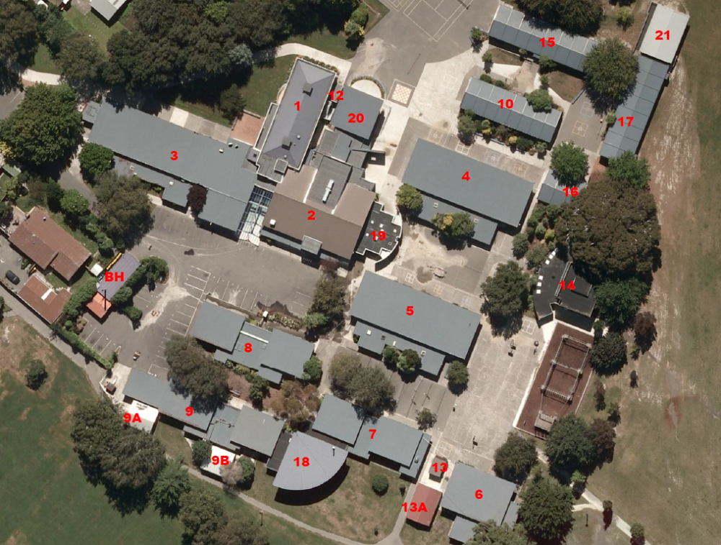
<Insert image snapshot of the site showing building identity and location clearly. Reference source of aerial imagery (e.g. LINZ, Web Map Services) and orientate photo with north aligned to the top of the page>

- Seismic Assessment of the Building
  - Analysis Methodology
The building was designed in xxxx by xxxx <(if/or known)>. <either> It was designed to the then current building code NZS xxxx <(if known) > <or> It was designed to the applicable design code for this time NZS 4203 (1992) <(if not known)>.
<State the type of Assessment Methodology used to assess the seismic capacity of the building. This may be the IEP spreadsheet or another methodology more suited to accurately assess the condition of the specific building type e.g. comparing actual horizontal design coefficient used in previous calculations with that required under current code or undertaking supplementary/specific calculations for selected building components.>
<Note: the IEP standardised calculations and any supplementary calculations shall be included in Appendix C, stating clearly what elements have been the subject of specific calculations .>
  - Intrusive Investigations
<Describe what intrusive investigations were carried out and what was found, or state “None”. If “None” describe basis for assumed materials and structural systems.>
  - Key Input Parameters
The following table summarises the principal parameters used for the derivation of earthquake loads and the analysis of the building.
<Populate the structural assessment factors in the value column in the table below. Note the values stated are examples only.>
Parameter | Value
Design Working Life | <50 years>
Importance Level | <3>
Return Period Factor (R) | <1.3>
Site Subsoil Classification | <D>
Period (seconds) | <0.4> seconds (longitudinal direction)  <0.4> seconds (transverse direction)
Hazard Factor (Z) | <0.40>
Near Fault Factor (N) | <1.0>
Ductility Factors | <2.0>
Sp Factor | <0.5>
Judgement Factor (F) | <1.5> List the basis for the selection of this value, and where it sits in the range of possible values
  - Seismic Rating
The assessment establishes that the building achieves an overall seismic rating of XX%NBS (ILY).
This corresponds to a “Grade X’ building as defined in Table A3.1 of the Engineering Assessment Guidelines.
<If the rating is less than 34%NBS, prepare and append an Assessment Summary Report (table) using the national template from www.EQ-Assess.org.nz.>
  - Structural Weaknesses & Life Safety Hazards
<Discuss and note as required: note that any items here must also be listed in the Executive Summary. Note if any Severe Structural Weaknesses are likely to be present, and hence a Detailed Seismic Assessment (DSA) is required >
    - Potential Critical Structural Weakness
< Identify and discuss the existence of any Potential Critical Structural Weaknesses, which may include:
- Horizontal Structure Irregularity
- Vertical Structure Irregularity
- Poor Diaphragm Connectivity>
    - Stairs
<Have any stairs been specifically evaluated or has there been any previous reporting on stairs? If so, add to the report.>
    - Secondary Structural and Non-structural Elements
<Describe the Secondary Structural and Non-structural (SNSS) elements that are present and have either been included within this assessment or should be further investigated.>
<e.g.
- Overhead unrestrained masonry (solid masonry or veneer where there is specific evidence of an absence of ties or ineffective ties)
- Precast concrete panels, including any non-ductile connectors between the panels and primary structure
- Heavy suspended ceiling tiles (weight greater than 25kg/m2)
- Heavy light fittings (individual light fittings of greater than 5kg in weight that are not fixed directly to framing)
- Other unsecured heavy fixtures or furniture or overhead items>
<If there is a safety hazard which has the potential to immediately cause an injury, then appropriate steps to isolate the hazard, or isolate people from the hazard need to be undertaken. NZSPA property personnel is to be contacted immediately.>
- Conclusions & Recommendations
  - Conclusions
The building achieves an overall seismic rating of XX% NBS when considered as an Importance Level 2/3 building.
<Either>
As this rating is less than the earthquake prone threshold in the Building Act of 34%NBS, this building is likely to be determined earthquake prone by <ABC> Council when they receive this report. As required by the EPB Methodology, we append an Assessment Summary Table.
This building requires strengthening in order to meet NZSPA’s policy objective of not being earthquake-prone as a short term goal.
<Or>
This does meet NZSPA’s minimum seismic strength requirements of not being earthquake-prone in the short term, but does not meet the medium term goal of 67% NBS or above.
<Or>
This meets NZSPA’s medium term goal of 67% NBS or above.
<Choose one of the 3 options above.>
<Include statement on occupancy status e.g. “No need to change the current occupancy of the building” or provide sufficient reasons why a change of building occupancy is recommended.>
  - Recommendations
<Further seismic assessment of this building is not considered necessary.>
<OR “It is recommended a Detailed Seismic Assessment is obtained prior to commencing any design for remediation in the future.” >
< “A Detailed Seismic Assessment or Specific Engineering Investigation is recommended in order to confirm......” where a DSA is required to confirm buildings status.>
<Clearly explain why it is recommended (or not) to undertake a Detailed Seismic Assessment for the building.>
<List any other recommendations>

- Explanatory Statement
This report contains the professional opinion of XXXX as to the matters set out herein, in the light of the information available to it during preparation, using its professional judgment and acting in accordance with the standard of care and skill normally exercised by professional engineers providing similar services in similar circumstances. No other express or implied warranty is made as to the professional advice contained in this report.
An Initial seismic assessment has been carried out. To more accurately define a buildings seismic capacity significantly greater amount of analysis, modelling and research may need to be done.
We have prepared this report in accordance with the brief as provided and our terms of engagement. The information contained in this report has been prepared by XXXX at the request of its client, the New Zealand School Property Agency, and is exclusively for its use and reliance. It is not possible to make a proper assessment of this report without a clear understanding of the terms of engagement under which it has been prepared, including the scope of the instructions and directions given to and the assumptions made by XXXX. The report will not address issues which would need to be considered for another party if that party’s particular circumstances, requirements and experience were known and, further, may make assumptions about matters of which a third party is not aware. No responsibility or liability to any third party is accepted for any loss or damage whatsoever arising out of the use of or reliance on this report by any third party.
The report is also based on information that has been provided to XXXX from other sources or by other parties. The report has been prepared strictly on the basis that the information that has been provided is accurate, complete and adequate. To the extent that any information is inaccurate, incomplete or inadequate, XXXX takes no responsibility and disclaims all liability whatsoever for any loss or damage that resulting from any conclusions based on information that has been provided to XXXX.

- Building Plans

(Key floor plans)
<Add plans of building here>

- Building Photographs
<Add photos of the actual building here with labels and any issues identified in the report.>

Figure 1 - <Type a brief photo caption>

- IEP Spreadsheet and Any Specific Calculations
<Add IEP spreadsheet and any supporting calculations here – provide any necessary commentary that may be useful to justify selections of parameters such as ductility and Judgement (F) Factor.>



