


XXXX School
Stage XX Classroom Block
  - Internal Environmental Quality (IEQ) Design Report

Legend
General instructions
To be completed by Architect
To be completed by Consulting Engineer (Acoustic, Electrical, or Mechanical)
To be completed by NZSPA
Template V.2.1
July 2023
Prepared By: <Architect Name>
For the New Zealand School Property Agency
Document Control Records

Document Prepared by:
<Full Legal Company Name>
<Company Address Physical>
<Company Address Postal>
Telephone: <Company Phone number>
Email: <Company email>
Web: <Company Website>
Revision History
Revision No. | Prepared By | Description | Signed | Date
0 | xxx | Draft for review |  | 2/07/2023
1 | xxx | Final |  | Click here to enter a date.
Document Acceptance
Action | Name | Date
Received by: | xxxxxx
Reviewed by: | xxxxxx

Understanding Internal Environmental Quality
Internal environmental quality refers to the entire quality of a building’s environment in relation to the health and wellbeing of the occupants within it. Internal environmental quality is determined by many factors:
Internal Environment Quality Factors
1 | Lighting and Visual Comfort – illuminance, luminance ratios, view, reflection, etc.
2 | Acoustic Quality – noise from indoors, outdoors, vibrations, etc.
3 | Indoor Air Quality (IAQ) – fresh air supply, odour, indoor air pollution, etc.
4 | Thermal Comfort – temperature, air velocity, relative humidity, moisture, etc.
There is strong evidence that good lighting, temperature, humidity, acoustics, and indoor air quality support educational outcomes (Barrett et al., 2015; Wall, 2016; Ackley et al., 2017). For example, a United Kingdom study of 3766 students in 153 classrooms in 27 schools identified seven key design parameters that together explain 16% of the variation in students’ academic progress. These design parameters were Light, Colour, Temperature, Air Quality, Ownership, Flexibility, and Complexity (Barrett et al., 2015).
Better internal environmental quality in learning spaces could support teachers/kaiako and learners/ākonga to succeed. For example, learning can be impeded if the lighting conditions cause visual discomfort, which can lead to eyestrain and headaches and can disturb the circadian rhythm. Research on biological lighting demands has revealed that the dosing of daylight is important for health purposes. The amount of light that enters the eye affects our bio-rhythm: more light supresses melatonin production, thereby making us more awake and alert.
Poor acoustics can make communication difficult and increase activity noise levels. Poorly ventilated rooms can result in unwanted thermal effects (both through temperature and humidity) and lead to high levels of carbon dioxide, which could cause drowsiness. Indoor air pollutants can be odorous and could irritate the trigeminal nerve endings in nose and eyes, causing itching and other negative reactions impeding learning.
NZSPA is committed to providing better internal environmental quality in learning spaces to achieve the objectives of the Te Rautaki Rawa Kura – The School Property Strategy 2030. Setting standards for, monitoring, and evaluating internal environmental quality are extremely important across all stages of the building process: design, construction, commissioning, operation and renovation.
Internal environmental quality factors must be considered during the design phase so that comfort is achieved. A holistic approach is essential, and no single internal environmental quality factor should be altered without assessing its effect on all the others. This is because they interact with one another e.g. achieving good daylighting must be balanced against possible uncomfortable heat gain from the sun, and the need for ventilation can increase noise levels inside.
Where applicable, design teams are to use this template to report on their IEQ modelling results.

Executive Summary
This report provides results of Internal Environmental Quality (IEQ) analysis for the following buildings. The report provides an assessment of the building’s daylight, acoustics and indoor air quality and thermal performance, highlights the key IEQ risks and presents recommendations. The table below presents a summary of the assessment findings.
IEQ Variable | Description
Daylight Compliance | Block name and summary of findings
Artificial Lighting Compliance | Block name and summary of findings
Security Design Report | Block name and summary of findings  Required for all projects with floor area >1000 m², as per DQLS – Lighting, Section 1.2.2
Acoustics Performance | Block name and summary of findings
Outdoor Air Supply & CO2 Compliance | Block name and summary of findings
VOC & Refrigerant Compliance | Block name and summary of findings
Thermal Comfort Compliance | Block name and summary of findings
Thermal Performance (Insulation) Compliance | Block name and summary of findings
HVAC System Lifecycle Cost Analysis | Block name and summary of findings
IEQ Monitoring Systems Compliance | Block name and summary of findings
Specialist Spaces Compliance | Block name and summary of findings
Conclusions & Recommendations | Include the summary and recommendations

Commentary
Add additional commentary here with a brief description of the main limiting aspects for the building from the IEQ assessment. Where a design does not meet all requirements set out in the DQLS suite of documents, a statement to this effect must be included here. The statement must detail the reasons for non-compliance, identify and quantify the adverse implications of non-compliance, and provide justifications for the non-compliant design.
Remove above paragraph if not relevant

Contents

Understanding Internal Environmental Quality 2
Executive Summary 4
Commentary 5
1. Introduction 8
2. Building and Site Description 9
2.1 Building Location 9
3. Daylight Assessment 10
3.1 Assessment Methodology 10
3.2 a) Simple Building Forms 10
3.3 b) Complex Building Forms – Daylight Modelling 10
4. Artificial Lighting Compliance 12
4.1 Artificial Lighting 12
4.2 Emergency Lighting 12
5. Security Design Report 13
5.1 Security Lighting & Design 13
6. Acoustic Assessment 14
6.1 Assessment Methodology 14
6.2 Internal Sound Insulation 14
6.3 Reverberation and Room Acoustics 14
6.4 External Noise 14
6.5 Mechanical Service Noise 14
7. Outdoor Air Supply & CO₂ Compliance 15
7.1 Outdoor Air Supply 15
7.2 CO₂ Concentrations 15
8. VOC & Refrigerant Compliance 16
8.1 VOC Concentrations 16
8.2 Refrigerants 16
9. Thermal Comfort Compliance 17
9.1 Minimum Internal Temperature 17
9.2 Maximum Internal Temperature 17
10. Thermal Performance (Insulation) Compliance 19
10.1 Building Element R-Values 19
10.2 Window to Wall Ratios 19
11. Heating & Cooling System Life Cycle Cost Analysis 20
11.1 Life Cycle Cost Analysis 20
12. Specialist & Ancillary Spaces Compliance 21
12.1 IEM Requirements 21
13. Specialist & Ancillary Spaces Compliance 22
13.1 Specialist & Ancillary Spaces Requirements 22
14. Conclusions & Recommendations 23
14.1 Conclusions 23
14.2 Recommendations 23
15. Explanatory/Limitations Statement 24
Appendix A - IEQ Assessment Calculations 25
Appendix B - Photos of Building and Model Images 26
Appendix C - Plans of Building 27

- Introduction
A draft IEQ Design Report should be submitted at preliminary design, and then updated at developed design to capture design refinements and include criteria that can only be demonstrated later in the design process
This report summarises the results of daylighting, artificial lighting, acoustic, thermal, and ventilation DQLS design compliance assessments for the proposed XXX. The report summarises the proposed design’s compliance with the relevant DQLS requirements. The report also highlights key risks and recommendations.
Specifically, this report summarises:
- Daylighting assessment (4-Step method for simple building forms, or CBDM for complex building forms)
- Artificial lighting compliance, including emergency & security lighting
- Security design report
- Acoustic compliance, including internal sound insulation, reverberation & room acoustics, external noise, & mechanical services noise
- Outdoor air supply and CO₂ compliance – design statement or modelling report
- VOC and refrigerant compliance - design statement and supporting calculations
- Thermal comfort compliance - design statement or modelling report
- Thermal performance (insulation) compliance – design statement
- HVAC system life cycle cost analysis
- Indoor air quality monitoring systems compliance – design statement
- Specialist spaces compliance – design statements
Delete as appropriate
This report serves as a compliance document for NZSPA of Education Designing Quality Learning Spaces (DQLS):
- Lighting and Visual Comfort
- Acoustic Performance
- Indoor Air Quality and Thermal Comfort
- Building and Site Description
Number of Storeys | e.g. 1
Gross Floor Area (m²) | e.g. 242
Year of Design (approximate) | e.g. 1965 approx.
Current use | e.g. hall, library, classroom, storage etc.
Wall/Cladding/Roof System | provide details
Floor System | provide details as appropriate – in particular for multi-storey buildings
Refer to photos of the models (new builds) or existing building (renovations) provided in Appendix B, and to the site plan in Appendix C, for further information regarding the building form and site layout.
It is recommended that the Gross Floor Area and Year of design/construction are validated by the Architect; do not rely on NZSPA data.
Give a good description of the building construction type including roof, frame, cladding, lining, and floor construction, without doubling up on details below if possible.
  - Building Location
Insert image snapshot of the site showing building identity and location clearly
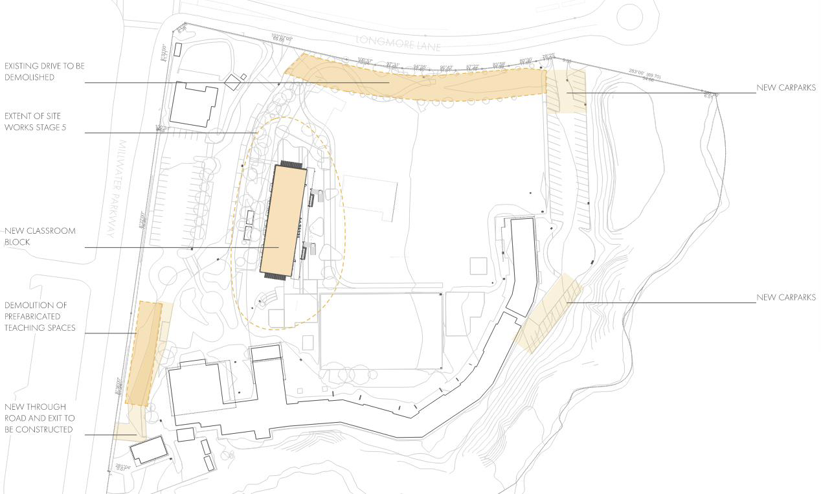
- Daylight Assessment
  - Assessment Methodology
State the type of Assessment Methodology used to assess the daylight quantity and quality - four-step daylight sequence calculation (simple building forms) or Climate Based Daylight Modelling (CBDM – complex building forms)?
Justify the Assessment Methodology you have selected above - state why this methodology is appropriate for the type of building being assessed.
  - a) Simple Building Forms
Provide a design statement and supporting calculations for simple building forms (refer to Section 1.1.1 in DQLS – Lighting for the four-step daylight sequence).
Design teams must use the Daylight Calculator Tool to demonstrate compliance with the four-step daylight sequence.
Results should identify those spaces which fail the Step 2 daylighting feasibility test. For spaces which pass Step 2, minimum required glazing areas should be identified, and the % daylit floor area should be calculated according to Equation 2 given in Step 3.
Tabulate summary results for applicable spaces in each of the assessed blocks at zone-level.
Note that the daylighting design sequence is intended to provide for adequate daylighting under generic New Zealand conditions. It does not allow for regional variations in outdoor illuminance. The target daylight factor of 2% is intended to yield approximately 300 lux at the working plane under standard clear sky conditions. Higher target daylight factors may be used, with caution, where lower-than-typical outdoor illuminance values are expected; refer to NZS 6703:1984, Section 5, for guidance.
The DQLS daylighting design sequence does not allow for control of glare. Consideration should be given to the orientation and location of windows, and provision of shading devices, in order to minimize direct sunlight and control glare; specific recommendations should be provided where appropriate. Refer to Section 3.8, of DQLS - Lighting, for more information.
…or…
  - b) Complex Building Forms – Daylight Modelling
For complex building forms that do not meet the simple building criteria above, provide results of Climate Based Daylight Modelling (CBDM) in accordance with the daylight modelling requirements and guidelines set out in Sections 1.1.2 and 1.1.3 of DQLS – Lighting.
Note that the Useful Daylight Illuminance (UDI) target for learning spaces is 300 lux to 2000 lux for 60% of school hours across more than 50% of the applicable floor area.
Summarise the key modelling inputs, including analysis parameters, weather data, external obstructions, orientation, model zones, and layout.
Tabulate summary results for all applicable spaces in each of the assessed blocks, using a format similar to the table template provided below.
- The daylighting report shall clearly show which areas have been excluded from the analysis, which spaces are exempt from compliance with the UDI criteria, which applicable spaces meet the UDI criteria, and which fail due to insufficient daylighting or due to overprovision.
- The daylighting report shall also show the percentage of the total applicable floor area which complies with the UDI target range.
- The daylighting report shall tabulate the window-to-wall ratio (WWR) for each applicable space. This shall be calculated to exclude window frames, but include mullions. Glazed doors shall also be included in the WWR calculation.
- Refer to the results table provided in the accompanying demonstration IEQ Design Report Example.
Provide specific recommendations to achieve compliance or improve daylighting performance, as appropriate. The daylighting report shall clearly describe the daylighting solutions (shading, glazing selections, window geometry and distibution, etc.) that have been considered for each space as part of the optimisation process. The report shall identify which solutions are recommended as providing the best daylighting outcomes
Daylighting Results Summary Table
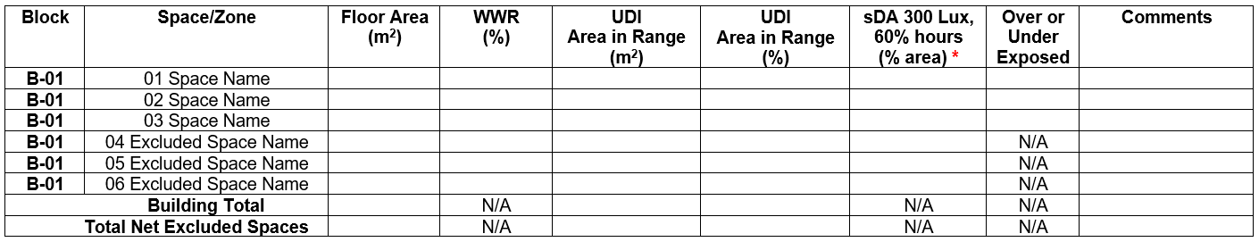
*Refer to the ‘Rationale for Daylighting Requirements Addendum’ document for example school block results for daylighting performance metrics and compliance requirements.

- Artificial Lighting Compliance
  - Artificial Lighting
Provide design statement demonstrating compliance with DQLS – Lighting, Section 1.2
This should be demonstrated at Developed Design; at Preliminary Design, reference could be made to design criteria listed in the Electrical Preliminary Design Report; at Developed Design reference can be made to the Specification and Luminaire Schedules
  - Emergency Lighting
Provide a design statement demonstrating compliance with DQLS – Lighting, Section 1.2.1
This should be demonstrated at Developed Design; at Preliminary Design, reference could be made to design criteria listed in the Electrical Preliminary Design Report; at Developed Design reference can be made to the Specification and Luminaire Schedules

- Security Design Report
  - Security Lighting & Design
Where the project floor area is >1000m2, provide a design statement demonstrating compliance with DQLS – Lighting, Sections 1.2.2 & 3.11, and addressing security risks, secutity lighting, and security systems generally
This should be demonstrated at Developed Design; at Preliminary Design, reference could be made to design criteria listed in the Electrical Preliminary Design Report; at Developed Design reference can be made to the Specification and Luminaire Schedules
- Acoustic Assessment
  - Assessment Methodology
Provide information on acoustic design criteria, building layout and building envelope construction.
  - Internal Sound Insulation
Where applicable, provide results and discussion on internal sound insulation (floors, walls, ceiling and doors), including airborne sound insulation, impact sound insulation and ambient noise environment.
  - Reverberation and Room Acoustics
< Where applicable, provide results and discussion on internal sound insulation, including airborne sound insulation, impact sound insulation and ambient noise environment.>
  - External Noise
<Where applicable, provide results and discussion on external noise, rain noise, road traffic noise, air noise contour, construction noise mitigation and external noise transmission
  - Mechanical Service Noise
Where applicable, provide results and discussion on mechanical services noise.
- Outdoor Air Supply & CO₂ Compliance
  - Outdoor Air Supply
Provide a design statement to demonstrate that the requirements of DQLS – IAQTC, Section 1.1.1 have been met. A modelling report is required for naturally ventilated spaces in buildings > 600 m2 GFA
  - CO₂ Concentrations
Provide a design statement and modelling report (where required) to demonstrate that the CO2 concentration limits of DQLS – IAQTC, Section 1.1.2, have been met.
- VOC & Refrigerant Compliance
  - VOC Concentrations
Section 1.1.3 of DQLS – IAQTC requires that for new or upgraded learning spaces, 90% of the carpet, ceiling materials and paints installed must comply with the maximum VOC-content, or the maximum allowable VOC-emission rates, as described by the New Zealand Green Building Council (NZGBC) or Green Building Council of Australia (GBCA) Recognised Eco-Labels list
Provide a design statement demonstrating compliance with this requirement. Tabulate the maximum allowable VOC emissions/content, together with values for all materials and components
  - Refrigerants
Section 1.1.3 of DQLS – IAQTC requires that installations containing refrigerants comply with relevant refrigerant safety standards, particularly AS/NZS 5149.1
Provide a design statement and supporting calculations demonstrating compliance with this requirement. If a leak detection system is specified, provide justification
- Thermal Comfort Compliance
  - Minimum Internal Temperature
Provide a design statement demonstrating that the minimum internal temperatures set out in DQLS – IAQTC, Section 1.2 will be met. Tabulate the DQLS minimum requirements and the design temperatures for each space.
At Preliminary Design, this would involve referring to the design criteria in the Preliminary Design report. At Developed Design, reference could be made to heat loss and system sizing calculations, and to the Equipment Schedules.
  - Maximum Internal Temperature
Provide a design statement, and thermal modelling where required, to demonstrate that maximum internal temperature requirements set out in Section 1.2 have been met.
    - Assessment Methodology
State the type of Assessment Methodology used to assess the max’ internal temperatures - for small building forms (buildings <600 m2 GFA,) provide a design statement and supporting calculations; for large building forms (≥600 m2 GFA,), use Thermal Modelling.
Justify the Assessment Assumptions/Methodology you have selected above. State why this Methodology is best for the type of building being assessed.
    - a) Small Building Forms
Provide a design statement and supporting calculations for small building forms (refer to Section 1.2 in DQLS – IAQTC).
Tabulate summary results for each space, and identify any spaces that fail.
…or…
    - b) Large Building Forms – Thermal Modelling
For large building forms, provide results of Thermal Modelling in accordance with the requirements and guidelines set out in Sections 1.2 & 5.1.4 of DQLS – IAQTC.>
Summarise the key modelling inputs, including weather data, occupancy schedules, lighting & plug loads, ventilation & infiltration schedules, building envelope thermal resistance values, model zones, and building layout.
Tabulate summary results for all spaces in each of the assessed blocks.
Provide specific recommendations to achieve compliance or improve thermal performance, as appropriate.
Thermal modelling should be done at 100% Preliminary Design, when the Architectural design is sufficiently detailed.

- Thermal Performance (Insulation) Compliance
  - Building Element R-Values
A design statement must be provided, together with supporting calculations, confirming that building element R-values meet the requirements set out in Table 4.
Provide a design statement demonstrating that the mechanical cooling system has been sized as per the above requirement.
Authorization of a mechanical cooling system will likely depend on the results of the Thermal Modelling Report, issued at Preliminary Design.
  - Window to Wall Ratios
A design statement must be provided, together with supporting calculations, confirming that WWRs for each space are within the range stipulated in Section 1.3.2
Where a WWR >35% is proposed, thermal modeling must be undertaken to demonstrate that the over-heating criteria in Section 1.2 can be achieved. Provide a thermal modeling report in accordance with Section 5.1.4
- Heating & Cooling System Life Cycle Cost Analysis
  - Life Cycle Cost Analysis
Provide a design statement and supporting calculations to demonstrate that the Life Cycle Cost Analysis requirements in Section 1.5 have been followed in selecting an appropriate heating system, and an appropriate mechanical cooling system where provided.
Use the NZSPA’s LCCA tool and provide screenshot of the results
- Specialist & Ancillary Spaces Compliance
  - IEM Requirements
Provide a design statement, together with supporting documentation, demonstrating compliance with IEQ monitoring system requirements in DQLS - IAQTC Section 1.6
Provide plan mark-ups showing the proposed location of the IEMs within the spaces in line with the IEM requirements in Section 1.6
- Specialist & Ancillary Spaces Compliance
  - Specialist & Ancillary Spaces Requirements
For each specialist or ancillary space covered by DQLS – IAQTC Sections 4.5, 4.6, 4.7, 4.8 & 4.9, provide a design statement, together with supporting calculations & documentation, demonstrating compliance with the requirements specific to that space.
- Conclusions & Recommendations
  - Conclusions
Provide a summary of findings and sufficient reasons to support the recommendations in Section 14.2 below.
  - Recommendations
At Preliminary Design, provide recommendations for each internal environmental quality variable (Lighting, Acoustics, Indoor Air Quality, Indoor Temperature) to ensure compliance with DQLS requirements. The adoption of these recommendations is to be reviewed and updated at Developed Design to capture design refinements
- Explanatory/Limitations Statement
- This report contains the professional opinion of XXXX as to the matters set out herein, in the light of the information available to them during preparation, using their professional judgment and acting in accordance with the standard of care and skill normally exercised by professional building scientist providing similar services in similar circumstances. No other express or implied warranty is made as to the professional advice contained in this report.
- An IEQ assessment has been carried out. We have prepared this report in accordance with the brief as provided and our terms of engagement. The information contained in this report has been prepared by XXXX at the request of its client, the NZSPA of Education, and is exclusively for its use and reliance. It is not possible to make a proper assessment of this report without a clear understanding of the terms of engagement under which it has been prepared, including the scope of the instructions and directions given to and the assumptions made by XXXX. No responsibility or liability to any third party is accepted for any loss or damage whatsoever arising out of the use of or reliance on this report by any third party.
- The report is also based on information that has been provided to XXXX from other sources or by other parties. The report has been prepared strictly on the basis that the information that has been provided is accurate, complete and adequate. To the extent that any information is inaccurate, incomplete or inadequate, XXXX takes no responsibility and disclaims all liability whatsoever for any loss or damage that resulting from any conclusions based on information that has been provided to XXXX.
- IEQ Assessment Calculations
Add IEQ modelling standardised calculations and any supporting calculations here – provide any necessary commentary that may be useful to justify selections of model parameters.
- Photos of Building and Model Images
Add photos of the actual building here with labels and any issues identified in the report.
…and/or…
Add images of the building model(s) here with labels and any issues identified in the report.
Caption xxxxxxxxx
- Plans of Building
Add plans of building here.



