


XXXX School
Stage XX Classroom Block
  - Internal Environmental Quality (IEQ) Design Report
DEMONSTRATION EXAMPLE ONLY
NOT INTENDED FOR COMPLIANCE PURPOSES

Legend
General instructions
To be completed by Architect
To be completed by Consulting Engineer (Acoustic, Electrical, or Mechanical)
To be completed by NZSPA
Template V.2.1
July 2023
Prepared By: <Architect Name>
For the New Zealand School Property Agency
Document Control Records

Document Prepared by:
<Full Legal Company Name>
<Company Address Physical>
<Company Address Postal>
Telephone: <Company Phone number>
Email: <Company email>
Web: <Company Website>
Revision History
Revision No. | Prepared By | Description | Signed | Date
1 | AA | Preliminary IEQ Design Report | AA | 2/07/2023
 |  |  |  | Click here to enter a date.
Document Acceptance
Action | Name | Date
Received by: | xxxxxx
Reviewed by: | xxxxxx

Understanding Internal Environmental Quality
Internal environmental quality refers to the entire quality of a building’s environment in relation to the health and wellbeing of the occupants within it. Internal environmental quality is determined by many factors:
Internal Environment Quality Factors
1 | Lighting and Visual Comfort – illuminance, luminance ratios, view, reflection, etc.
2 | Acoustic Quality – noise from indoors, outdoors, vibrations, etc.
3 | Indoor Air Quality (IAQ) – fresh air supply, odour, indoor air pollution, etc.
4 | Thermal Comfort – temperature, air velocity, relative humidity, moisture, etc.
There is strong evidence that good lighting, temperature, humidity, acoustics, and indoor air quality support educational outcomes (Barrett et al., 2015; Wall, 2016; Ackley et al., 2017). For example, a United Kingdom study of 3766 students in 153 classrooms in 27 schools identified seven key design parameters that together explain 16% of the variation in students’ academic progress. These design parameters were Light, Colour, Temperature, Air Quality, Ownership, Flexibility, and Complexity (Barrett et al., 2015).
Better internal environmental quality in learning spaces could support teachers/kaiako and learners/ākonga to succeed. For example, learning can be impeded if the lighting conditions cause visual discomfort, which can lead to eyestrain and headaches and can disturb the circadian rhythm. Research on biological lighting demands has revealed that the dosing of daylight is important for health purposes. The amount of light that enters the eye affects our bio-rhythm: more light supresses melatonin production, thereby making us more awake and alert.
Poor acoustics can make communication difficult and increase activity noise levels. Poorly ventilated rooms can result in unwanted thermal effects (both through temperature and humidity) and lead to high levels of carbon dioxide, which could cause drowsiness. Indoor air pollutants can be odorous and could irritate the trigeminal nerve endings in nose and eyes, causing itching and other negative reactions impeding learning.
NZSPA is committed to providing better internal environmental quality in learning spaces to achieve the objectives of the Te Rautaki Rawa Kura – The School Property Strategy 2030. Setting standards for, monitoring, and evaluating internal environmental quality are extremely important across all stages of the building process: design, construction, commissioning, operation and renovation.
Internal environmental quality factors must be considered during the design phase so that comfort is achieved. A holistic approach is essential, and no single internal environmental quality factor should be altered without assessing its effect on all the others. This is because they interact with one another e.g. achieving good daylighting must be balanced against possible uncomfortable heat gain from the sun, and the need for ventilation can increase noise levels inside.
Where applicable, design teams are to use this template to report on their IEQ modelling results.

Executive Summary
This report provides results of Internal Environmental Quality (IEQ) analysis for the following buildings. The report provides an assessment of the building’s daylight, acoustics and indoor air quality and thermal performance, highlights the key IEQ risks and presents recommendations. The table below presents a summary of the assessment findings.
IEQ Variable | Description
Daylight Compliance | Based on Preliminary Design assumptions, a number of learning spaces fail the daylighting criteria due to excessive hours with >2000 lux. Recommendations include additional external shading fins, reduced glazing areas, and internal shading devices.
Artificial Lighting Compliance | LED lighting will be used throughout. Other artificial lighting criteria will be addressed at Developed or Detailed Design.
Security Design Report | A new security system will be provided to the Stage 5 classroom block.  Security design report to be provided at Developed or Detailed Design.
Acoustics Performance | TBC by Acoustic Consultant at Developed Design.
Outdoor Air Supply & CO2 Compliance | All spaces (except toilets, ancillary spaces, and internal breakout spaces) will be naturally ventilated. Extract ventilation will be provided to toilets and IT server rooms. Mechanical supply ventilation will be provided to internal breakout spaces.  A climate-based modelling report will be provided at Developed or Detailed Design to demonstrate CO2 compliance.
VOC & Refrigerant Compliance | VOC compliance TBC by Architect at Detailed Design.  Compliance with AS/NZS 5149.1 (refrigerant safety) will be demonstrated at Developed or Detailed Design.
Thermal Comfort Compliance | Heating system sizing data will be provided at Developed or Detailed Design.  Based on the Preliminary Design thermal modelling assessment, all learning spaces comply with the DQLS overheating criteria. Compliance to be confirmed again at Detailed Design.
Thermal Performance (Insulation) Compliance | Compliance to be demonstrated at Developed or Detailed Design; insufficient information available at the Preliminary Design stage.
HVAC System Lifecycle Cost Analysis | LCCA results suggest that Individual Split A/C units should be preferred over VRF Multi-Split systems; however, we recommend that a VRF system would be more suitable for this project. An alternative air-source heat pump with fan coil units is also proposed (low refrigerant option). Final selection TBC in consultation with Ministry & School.
IEQ Monitoring Systems Compliance | Local temperature & CO2 monitors to be provided in each learning space.
Specialist Spaces Compliance | Domestic kitchen extract systems provided to Maker Spaces.  Server/IT rooms provided with extract ventilation.  Standard & accessible toilet facilities to be provided with mechanical extract at 35 l/s & 50 l/s respectively.
Conclusions & Recommendations | Additional external shading fins, reduced glazing areas, and internal shading devices should be considered to mitigate excessive daylighting.  Additional compliance documentation to be provided at Developed and Detailed Design.

Commentary

Daylighting
A number of spaces fail to achieve the minimum UDI criteria due to excessive hours with >2000lx. This may be resolved by providing additional external shading fins, by reducing the glazing areas, or by providing internal shading devices.

Artificial Lighting
The Electrical Services Preliminary Design Report provides for LED lighting throughout.
Other artificial lighting criteria (standard maintained illuminance, colour rendering index, uniformity ratio, limiting glare index, lamp colour temperature group, etc.) will be addressed at Developed or Detailed Design.

Emergency Lighting
The Electrical Services Preliminary Design Report provides for LED emergency lighting throughout.
Other emergency lighting criteria will be addressed at Developed or Detailed Design.

Security Report
The Stage 5 classroom block will be provided with a new ICT Protage security system, which will interface with the existing school security system.
A security design report will be provided at Developed Design.

Acoustic Assessment
TBC by Acoustic Consultant at Developed Design.

Outdoor Air Supply
All spaces (except toilets, ancillary spaces, and internal breakout spaces) will be naturally ventilated. Larger spaces have openable windows on two or more sides, allowing crossflow ventilation. Smaller spaces, such as breakout spaces, have openable windows on one side only. Openable windows with an area >10% of the floor area will be provided; compliance will be demonstrated at Developed or Detailed Design.
A number of breakout spaces are internally located and have no external wall. These spaces will be provided with mechanical supply ventilation at ≥10 l/s/p.
Mechanical extract ventilation will be provided to toilets at ≥35 l/s in compliance with NZSPA’s Toilet Design Guide.
It is a DQLS requirement that all low-level (sill height <1.5m) windows be provided with restrictors. Compliance will be demonstrated at Detailed Design.

CO₂ Concentrations
The building GFA is >600m², therefore climate-based modelling will be used to demonstrate compliance with DQLS CO₂ concentration limits. A modelling report will be provided at Developed Design.

VOC Concentrations
Compliance TBC by Architect at Detailed Design.

Refrigerants
The preliminary design allows for either of two heating/cooling system options: a VRF system with hi-wall heat pumps, or an air-source heat pump with hydronic reticulation to fan coil units. The latter option would not entail refrigerant reticulation within the building envelope.
The VRF system would entail refrigerant reticulation within the building envelope. If this option is selected, compliance with AS/NZS 5149.1 will be demonstrated at Developed or Detailed Design.

Minimum Internal Temperature
The winter design temperature for all learning spaces is 19°C; heating systems will be designed and sized accordingly. Sizing data will be provided at Developed or Detailed Design.

Maximum Internal Temperature
Based on the Preliminary Design thermal modelling assessment, all learning spaces comply with the DQLS overheating criteria. Active cooling is therefore not required. However, some breakout rooms experience over 75 hours above 25°C; we recommend that these be fitted with an active cooling system to ensure comfortable conditions.
The thermal modelling will be updated at Developed and Detailed Design to ensure continued compliance.

Thermal Performance
Compliance with the requirements of DQLS – IAQTC Section 1.3.1 will be demonstrated at Developed or Detailed Design; insufficient information is available at the Preliminary Design stage.
Compliance with Section 1.3.2 (WWR) will be assessed at Developed Design.

Life Cycle Cost Analysis
A Life Cycle Cost Analysis was carried out to determine the most appropriate heating system for the project, in line with DQLS requirements. NZSPA-approved LCCA calculator and default parameter values have been used in this analysis.
Although the analysis results suggest that Air-Source Heat Pumps with Radiators, and Individual Split A/C units, should be preferred over VRF Multi-Split systems, we recommend that a VRF system would be more suitable for this project.
We also propose an alternative air-source heat pump with fan coil units. Although more expensive, this system would significantly reduce the volume of refrigerant used.
Electric radiant heaters are not a recommended option in this case, due to their high power requirements and the limited existing electrical infrastructure.
A final system selection will be made in consultation with NZSPA and the School.

Indoor Air Quality Monitoring & Control
The Mechanical Services Preliminary Design Report provides for local temperature and CO₂ monitors in each learning space.
A proprietary Hydronic/VRF control system will be provided for the heat pumps and ancillary systems, with a central controller located in the MSSB room for simple occupied hours/holiday time scheduling.
Each learning space will be provided with a simple wall mounted controller for restricted local temperature control.
Compliance with the Internal Environmental Monitoring requirements in Section 1.6 will be demonstrated at Detailed Design.

Specialist & Ancillary Spaces
This project includes four ‘Maker Spaces’, which are provided with domestic cooking ranges. These will be fitted with stainless steel domestic range hoods, exhausting through the external walls, and in compliance with as 1668:2(2012). It is not currently envisaged that the kitchen ranges will use gas. Should this change, additional compliance will be demonstrated at Developed or Detailed Design.
This project includes a server room/IT cupboard on each floor. These spaces are provided with extract ventilation (in common with the toilet extract system) to maintain an acceptable operating temperature. A high-limit direct acting thermostat set at 30°C will be provided and interlocked with the toilet extract system, with an audible alarm immediately outside each server room.
This project includes both standard and accessible toilet facilities on both floors. There are no Universal School Bathrooms (HDUs) in this project. Separate mechanical extract ventilation systems will be provided to each floor. These will provide 35 l/s extract to each cubicle, and 50 l/s to each accessible toilet facility. The extract system control strategy will be determined at Developed or Detailed Design.
There are no Workshop Technology or Science Laboratory spaces in this project.

Statement of Non-Compliance
As noted above, compliance with some criteria cannot be demonstrated at this Preliminary Design stage. This report will be updated at Developed & Detailed Design.
A number of spaces fail to achieve the minimum UDI criteria due to excessive hours with >2000 lux (refer to Section 3.2, below). This may be resolved by providing additional external shading fins, by reducing the glazing areas, or by providing internal shading devices.
There are no other compliance issues to be addressed at this stage.

Contents

Understanding Internal Environmental Quality 2
Executive Summary 4
1. Introduction 11
2. Building and Site Description 12
2.1 Building Location 12
3. Daylight Assessment 13
3.1 Assessment Methodology 13
3.2 b) Complex Building Forms – Daylight Modelling 13
4. Artificial Lighting Compliance 17
4.1 Artificial Lighting 17
4.2 Emergency Lighting 17
5. Security Design Report 18
5.1 Security Lighting & Design 18
6. Acoustic Assessment 19
6.1 Assessment Methodology 19
6.2 Internal Sound Insulation 19
6.3 Reverberation and Room Acoustics 19
6.4 External Noise 19
6.5 Mechanical Service Noise 19
7. Outdoor Air Supply & CO₂ Compliance 20
7.1 Outdoor Air Supply 20
7.2 CO₂ Concentrations 20
8. VOC & Refrigerant Compliance 21
8.1 VOC Concentrations 21
8.2 Refrigerants 21
9. Thermal Comfort Compliance 22
9.1 Minimum Internal Temperature 22
9.2 Maximum Internal Temperature 22
10. Thermal Performance (Insulation) Compliance 26
10.1 Building Element R-Values 26
10.2 Window to Wall Ratios 26
11. Heating & Cooling System Life Cycle Cost Analysis 27
11.1 Life Cycle Cost Analysis 27
12. Internal Environmental Monitoring (IEM) Compliance 29
12.1 IEM Requirements 29
13. Specialist & Ancillary Spaces Compliance 30
13.1 Specialist & Ancillary Spaces Requirements0 30
14. Conclusions & Recommendations 31
14.1 Conclusions 31
14.2 Recommendations 31
15. Explanatory/Limitations Statement 32
Appendix A - IEQ Assessment Calculations 33
Appendix B - Photos of Building and Model Images 34
Appendix C - Plans of Building 35

- Introduction
This report summarises the results of daylighting, artificial lighting, acoustic, thermal, and ventilation DQLS design compliance assessments for the proposed XXXX School, Stage XX Classroom Block. The report summarises the proposed design’s compliance with the relevant DQLS requirements. The report also highlights key risks and recommendations.
Specifically, this report summarises:
- Daylighting assessment (4-Step method for simple building forms, or CBDM for complex building forms)
- Artificial lighting compliance, including emergency & security lighting
- Security design report
- Acoustic compliance, including internal sound insulation, reverberation & room acoustics, external noise, & mechanical services noise
- Outdoor air supply and CO₂ compliance – design statement or modelling report
- VOC and refrigerant compliance - design statement and supporting calculations
- Thermal comfort compliance - design statement or modelling report
- Thermal performance (insulation) compliance – design statement
- HVAC system life cycle cost analysis
- Indoor air quality monitoring systems compliance – design statement
- Specialist spaces compliance – design statements
This report serves as a compliance document for NZSPA of Education Designing Quality Learning Spaces (DQLS):
- Lighting and Visual Comfort
- Acoustic Performance
- Indoor Air Quality and Thermal Comfort
- Building and Site Description
Number of Storeys | 2
Gross Floor Area (m²) | 1167 m²
Year of Design (approximate) | 2021
Current use | New Build
Wall/Cladding/Roof System | TBC at Developed Design
Floor System | TBC at Developed Design
Refer to photos of the models (new builds) or existing building (renovations) provided in Appendix B, and to the site plan in Appendix C, for further information regarding the building form and site layout.
  - Building Location
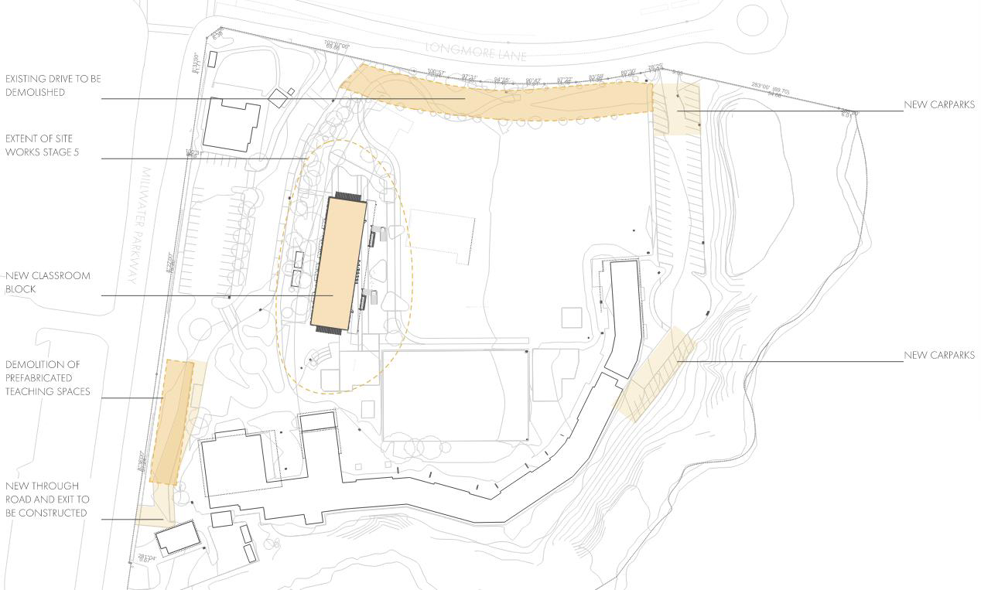
- Daylight Assessment
  - Assessment Methodology
The daylighting provision has been assessed using Climate Based Daylight Modelling (CBDM).
The XXX Stage XX Classroom Block qualifies as a complex building form under the criteria set out in DQLS – Lighting & Visual Comfort, Section 1.1. Although the building is less than 14m deep, the building includes large open-plan learning spaces (Flexible Learning Spaces), and single-sided spaces more than 7m deep (Project Spaces). CBDM is therefore the appropriate daylighting assessment method.
  - b) Complex Building Forms – Daylight Modelling
For complex building forms that do not meet the simple building criteria, Climate Based Daylight Modelling (CBDM) must be used to model Useful Daylight Illuminance (UDI) values for each learning space, in accordance with the daylight modelling requirements and guidelines set out in Sections 1.1.2 and 1.1.3 of DQLS – Lighting & Visual Comfort.
The Useful Daylight Illuminance (UDI) target for learning spaces is 300 lux to 2000 lux for 60% of school hours across more than 50% of the usable floor level.
Excluded spaces are indicated in the results table, below, and excluded areas are also demarcated in the accompanying daylight plots.

Modelling Software
The daylight modelling has been carried out using the Radiance-based Daysim package, via the DesignBuilder front end. Radiance has been validated against CIE 171:2006 Test Cases to Assess the Accuracy of Lighting Computer Programs.

Summary of Key Modelling Inputs
Wall thickness: 110 mm (all external walls)
Window details: the following generic values have been assumed for preliminary design modelling.
- standard single glazing (U-Value COG 5.72, SHGC 0.79, VLT 0.88)
- frame width 40 mm
- frame inside projection 40 mm
- frame outside projection 40 mm
- frame reflectance 0.3
- blinds have not been modelled
Reflectance values: the following generic values have been assumed for preliminary design modelling.
- external ground 0.2
- interior ceilings 0.75 (white acoustic tiles)
- interior walls 0.8 (pale cream paint on plasterboard)
- interior floors 0.2 (DQLS default value)
- external shades 0.3 (aluminium)

External obstructions & shading
All external fins, overhangs and shading features have been modelled as per the architectural Concept Design.
The building orientation was modelled as per the architectural Concept Design, with the long axis aligned a few degrees off north-south.
Weather data: the weather file used was for the Auckland region and was produced by IWEC using historical data from the National Institute of Water & Atmospheric Research (NIWA). The data includes hourly solar intensity and cloud cover for a typical year.
Hours of operation: Occupancy hours of 9:00am to 3:00pm. Full year data has been used, including weekends and holidays. The summer holidays, 20th December to 1st February, have been excluded as per the DQLS requirements.
Time step: Hourly time-steps were applied over a full year; this exceeds the minimum requirement of 15 days per month.
Grid size: A uniform grid of 250 x 250 mm was used across the entire building. This provides for ~190 reference points in the smallest daylighting zones (Breakout Spaces), and considerably more in larger spaces. A margin of 0.5 m was applied to exclude the perimeter zone from the results; this prevents the inclusion of potentially misleading illuminance data close to walls and windows.
Working plane: A working plane height of 0.75 m was used across the building, in anticipation of largely desk-based work.
Excluded Areas: The daylighting plots provided in the appendix show which areas have been included in the analysis, and which areas have been excluded. All ancillary spaces and circulation areas have been excluded. The excluded circulation areas in the large flexible learning spaces are demarcated in the daylighting plots. Where areas adjacent to walls will not be used for learning, a 500 mm perimeter zone has been excluded, as demarcated in the daylighting plots. There are no specialist learning spaces which warrant exclusion from the daylighting analysis.
Shading: All external overhangs and other shading features in the building have been modelled, as per the latest Architectural drawing set.
Buildings adjacent to the proposed new building have been modelled to account for incidental shading; note that future works have also been included to conservatively account for reduced daylighting.

Summary of Modelling Results
The table below summarises the UDI results for each space. Values which meet the DQLS criteria are highlighted in green; spaces and values which fail to meet the DQLS criteria are highlighted in red. Excluded spaces have been highlighted in grey and are excluded from the compliance requirements. Excluded areas are demarcated in the daylighting plots provided in the appendix.
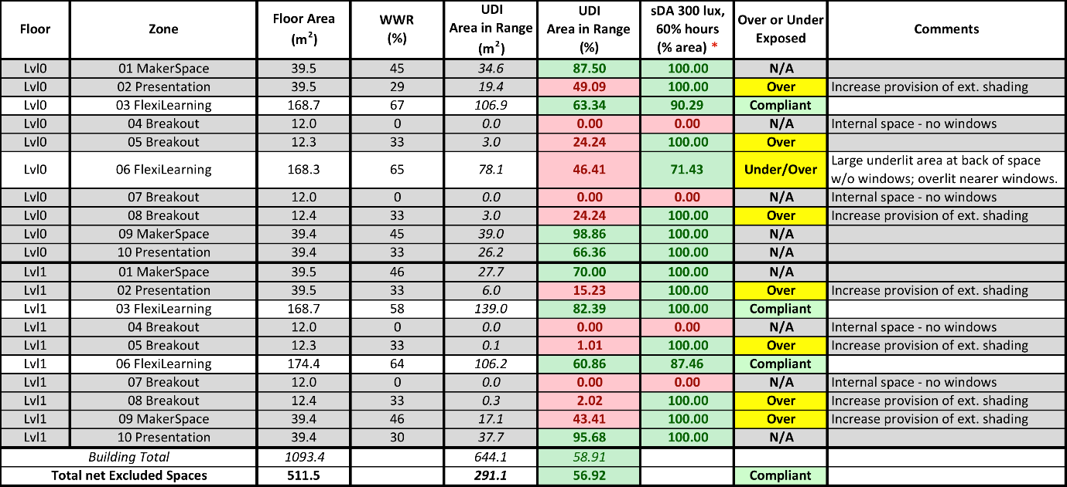
* Reporting of sDA results is optional and is provided here to indicate whether a space is under- or over-exposed.
*Refer to the ‘Rationale for Daylighting Requirements Addendum’ document for example school block results for daylighting performance metrics and compliance requirements.

Recommendations
A number of spaces fail to achieve the minimum UDI criteria. The spaces which fail can be divided into three categories:
Large learning spaces: One large learning space on the ground floor narrowly fails to meet the criteria. This is due to the large internal area of this space with no windows, due to the ancillary spaces on the east side (refer to the daylighting analysis in the Preliminary Design Report for further information). There are no feasible solutions to this; altering the layout of spaces to allow east-facing windows to this area would adversely affect daylighting of other spaces. Consider feature lighting and zoned switching for this area,
Small learning spaces: A number of smaller spaces fail to meet the criteria by a large margin (these are exempt from the compliance requirements). These spaces fail due to excessive hours with >2000 lux (refer to the daylighting analysis in the Preliminary Design Report for further information). These smaller spaces have a higher proportion of floor area along the north and west perimeters, where daylighting regularly exceeds 2000 lux. This may be resolved by providing additional external shading fins to the north and west façades, by reducing the glazing area, or by providing internal shading devices.
- Artificial Lighting Compliance
  - Artificial Lighting
The Electrical Services Preliminary Design Report provides for LED lighting throughout.
The preliminary (indicative) luminaire selections for learning spaces have a CRI R_{A} value of 90, and R₉ value >50. An R₉ value >80 is a DQLS requirement. Where luminaires with R9 <80 are proposed, justification will be provided at Developed Design.
Other artificial lighting criteria (standard maintained illuminance, uniformity ratio, limiting glare index, lamp colour temperature group, etc.) will be addressed at Developed or Detailed Design.
  - Emergency Lighting
Emergency lighting will be provided in compliance with AS/NZS 2293.1, AS/NZS 2293.2, AS/NZS 2293.3, the NZ Building Code, and the specific Fire Engineer’s report for the building.
The Electrical Services Preliminary Design Report provides for LED emergency lighting throughout.
Emergency lighting luminaires will be provided with integral batteries with a life in the order of 5 to 7 years. A minimum battery life of 10 years is a DQLS requirement. Where batteries with a life <10 years are proposed, justification will be provided at Developed Design.
A manual testing system will be provided.
- Security Design Report
  - Security Lighting & Design
The Stage 5 classroom block will be provided with a new XXX security system, which will interface with the existing school security system.
The project floor area is >1000m². A security design report will be provided at Developed or Detailed Design. The report will identify local security issues, and will outline how the design will deal with these issues.

- Acoustic Assessment
  - Assessment Methodology
An acoustic assessment will be provided at Developed Design.
<Provide information on acoustic design criteria, building layout and building envelope construction.>
  - Internal Sound Insulation
< Where applicable, provide results and discussion on internal sound insulation (floors, walls, ceiling and doors), including airborne sound insulation, impact sound insulation and ambient noise environment.>
  - Reverberation and Room Acoustics
< Where applicable, provide results and discussion on internal sound insulation, including airborne sound insulation, impact sound insulation and ambient noise environment.>
  - External Noise
< Where applicable, provide results and discussion on external noise, rain noise, road traffic noise, air noise contour, construction noise mitigation and external noise transmission>
  - Mechanical Service Noise
< Where applicable, provide results and discussion on mechanical services noise.>
- Outdoor Air Supply & CO₂ Compliance
  - Outdoor Air Supply
All spaces (except toilets, ancillary spaces, and internal breakout spaces) will be naturally ventilated.
Larger spaces have openable windows on two or more sides, allowing crossflow ventilation. The Mechanical Services Preliminary Design Drawings provide for openable windows within 7m of any point within each learning space. Architectural compliance will be demonstrated at Developed Design.
Smaller spaces, such as breakout spaces, have openable windows on one side only. These spaces have a depth of ~3.2 m, which is less than twice the ceiling height. Openable windows with an area >10% of the floor area will be provided; compliance will be demonstrated at Developed or Detailed Design as part of NZBC Clause G4 compliance.
A number of breakout spaces are internally located and have no external wall. These spaces will be provided with mechanical supply ventilation at ≥10 l/s/p.
Mechanical extract ventilation will be provided to toilets at ≥35 l/s in compliance with NZSPA’s Toilet Design Guide.
It is a DQLS requirement that all low-level (sill height <1.5 m generally, or 2.0 m adjacent to pedestrian walkways) windows be provided with restrictors. Compliance will be demonstrated at Developed or Detailed Design.
  - CO₂ Concentrations
The building GFA is >600m², therefore climate-based modelling will be used to demonstrate compliance with DQLS CO₂ concentration limits. A modelling report will be provided at Developed & Detailed Design.
The Mechanical Services Preliminary Design Report provides for local temperature and CO₂ monitors in each learning space.
- VOC & Refrigerant Compliance
  - VOC Concentrations
Compliance will be demonstrated at Detailed Design.
<Section 1.1.3 of DQLS – IAQTC requires that for new or upgraded learning spaces, 90% of the carpet, ceiling materials and paints installed must comply with the maximum VOC-content, or the maximum allowable VOC-emission rates, as described by the New Zealand Green Building Council (NZGBC) or Green Building Council of Australia (GBCA) Recognised Eco-Labels list >
<Provide a design statement demonstrating compliance with this requirement. Tabulate the maximum allowable VOC emissions/content, together with values for all materials and components>
  - Refrigerants
The preliminary design allows for either of two heating/cooling system options: a VRF system with hi-wall heat pumps, or an air-source heat pump with hydronic reticulation to fan coil units.
The VRF system would entail refrigerant reticulation within the building envelope. If this option is selected, compliance with AS/NZS 5149.1 will be demonstrated at Developed or Detailed Design. A number of single-split systems are envisaged to serve the breakout spaces, should refrigerant charges otherwise exceed allowable limits for these smaller spaces.
The latter option (heat pumps with hydronic fan coil units) would not entail refrigerant reticulation within the building envelope.
- Thermal Comfort Compliance
  - Minimum Internal Temperature
The winter design temperature for all learning spaces is 18°C – 20°C (19°C +/- 1°C); heating systems will be designed and sized accordingly. Sizing data will be provided at Developed or Detailed Design.
There are no administration, meeting, or staff rooms in this project.
This project is located in Climate Zone 1; there is hence no requirement for heating to toilet facilities.
There are no Universal School Bathrooms requiring heating in this project.
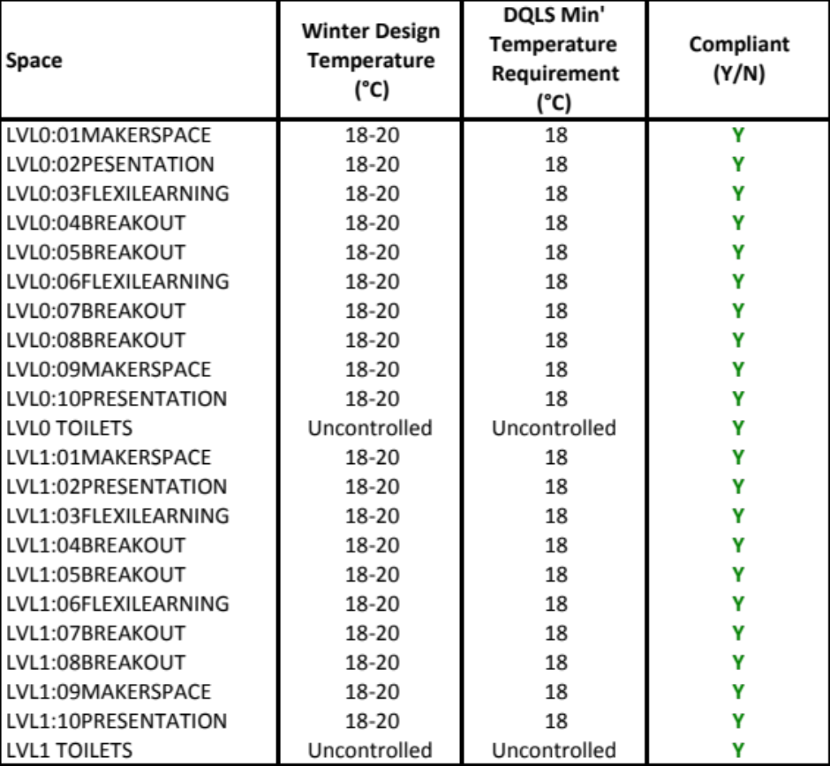
  - Maximum Internal Temperature
Thermal modelling has been carried out to assess maximum internal temperature (overheating) compliance for each learning space. Based on the parameters and assumptions outlined below, all learning spaces comply with the DQLS overheating criteria. The analysis is based on Preliminary Design information; the thermal modelling will be up-dated at Detailed Design.
    - Assessment Methodology
Compliance with the maximum temperature (overheating) requirements has been assessed using thermal modelling.
The XXX Stage XX Classroom Block qualifies as a large building form under the criteria set out in DQLS – IAQTC Section 1.2, as the building GFA is more than 600 m². Thermal modelling is therefore the appropriate assessment method.
    - b) Large Building Forms – Thermal Modelling

Summary of Key Modelling Inputs
Modelling Software: The thermal simulation was modelled using Design Builder (Version 6.1.0.6), and the thermal simulation was carried out using EnergyPlus (Version 9.3). EnergyPlus has been verified using ANSI/ASHRAE Standard 140-2011 and BESTest methods (https://energyplus.net/testing).
Weather files: The weather data used was a Typical Meteorological Year (TMY) dataset for the Auckland region, produced by ASHRAE from historical data. The weather file provides averaged conditions which are suitable for predicting long term energy performance. However, the absence of more extreme temperatures makes TMY datasets less useful for assessing building performance during weather extremes; the results should be read in this context.
Occupancy Schedule: Internal heat gains due to occupants have been modelled based on the data for schools as per Tables G1 and G2 of NZS4218:2009.
Occupancy load was modelled as 90 Watts per student, with 30 students per learning space.
Occupancy | 12am – 8am | 8am – 11am | 11am- 6pm | 6pm – 10pm | 10pm-12am
Week | 0 | 0.95 | 0.95 | 0.1 | 0
Saturday | 0 | 0.1 | 0.1 | 0 | 0
Sunday | 0 | 0 | 0 | 0 | 0
Lighting & Plug Loads: Internal heat gains due to small power have been modelled based on the data for schools as per Tables G1 and G2 of NZS4218:2009. Small power (plug) loads were modelled as 5.4 W/m².
Lighting loads were modelled as 6 W/m².
Lighting & Plug Loads | 12am – 8am | 8am – 11am | 11am- 6pm | 6pm – 10pm | 10pm-12am
Week | 0.05 | 0.95 | 0.95 | 0.3 | 0.05
Saturday | 0.05 | 0.15 | 0.15 | 0.05 | 0.05
Sunday | 0.05 | 0.05 | 0.05 | 0.05 | 0.05
Ventilation & Infiltration Schedules: Natural ventilation was modelled based on the openable area and type (geometry) of the doors and windows in each space, as shown on the latest Architectural drawing set (dated 30/04/2021). Openable windows & doors were modelled to modulate open so as to maintain an interior air temperature between 18-24°C during occupied hours.
Internal doors were modelled to be open 100% of the time during occupied periods.
Infiltration was modelled at a constant rate of 0.5 ACH.
Building Envelope R-Values: Building element R-values were modelled as per the DQLS – IAQTC minimums set out in Section 1.3.1, Table 4. R-values and assumed building element constructions are summarised below.
Building Element | Description | R-Value
Roof | Light-weight insulated roof | 3.5
External Walls | Insulated timber framed wall with plasterboard lining and steel cladding | 2.2
Internal Walls | Uninsulated timber framed walls with plasterboard linings | -
Ground Floor | Uninsulated slab on grade | 2.2
Internal Floor | 100 mm concrete slab floor, with carpet covering | -
Glazing was modelled as standard clear double glazing (4-6-4), in PVC frames.
Glazing Metric | Value
R-ValueWINDOW | 0.33
U-ValueCOG | 3.15
SHGCCOG | 0.74
VLT | 0.85
Shading: All external overhangs and other shading features in the building have been modelled, as per the latest Architectural drawing set.
Buildings adjacent to the proposed new building have been modelled to account for incidental shading; note that future works have also been included (to conservatively account for reduced daylighting).

Summary of Modelling Results:
The table below summarises the thermal modelling results for each space. Based on the parameters and assumptions outlined above, all learning spaces comply with the DQLS overheating criteria.
As required by DQLS - IAQTC Section 1.2, allowable hours above 25°C and 28°C were assessed during the occupied period of 9am to 3:30pm, Monday to Friday from 10th October to 20th December, and 1st February to 15th April.
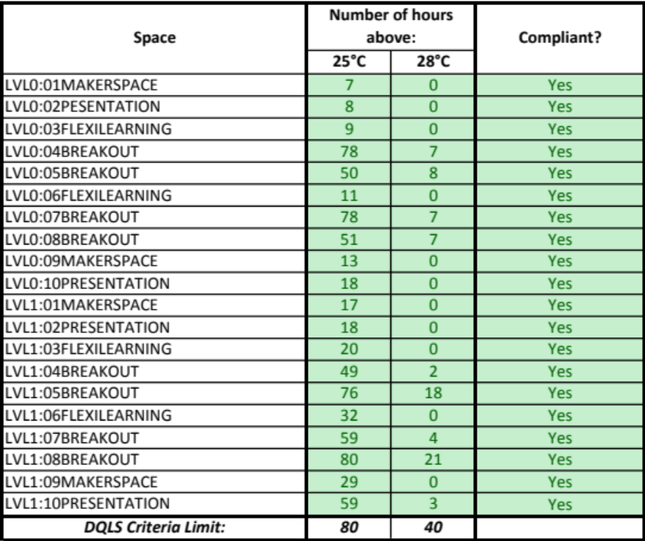

Recommendations
Based on the Preliminary Design, all learning spaces comply with the DQLS overheating criteria.
As this is a simple building form that complies with the DQLS overheating criteria based on effective crossflow ventilation, active cooling is not required. However, some breakout rooms experience only slightly less than 80 hours above 25°C; we recommend that these be fitted with an active cooling system to ensure comfortable conditions.
The thermal modelling will be updated at Developed and Detailed Design to ensure continued compliance. In particular, building element R-values and constructions will be checked, and glazing assumptions (location, type & size of windows) will be updated.
    - Mechanical Cooling
Based on the Preliminary Design assumptions, all learning spaces comply with the DQLS overheating criteria. However, some breakout rooms experience only slightly less than 80 hours above 25°C; we recommend that these be fitted with an active cooling system to ensure comfortable conditions. This will be re-assessed at Developed Design.
Note that a heat-pump system is recommended for heating purposes; provision of mechanical cooling would not incur additional capital expense.
A design statement justifying the need for mechanical cooling and demonstrating that the mechanical cooling system has been sized to achieve compliance with Section 1.2, will be provided at Developed Design.
- Thermal Performance (Insulation) Compliance
  - Building Element R-Values
Compliance with the requirements of DQLS – IAQTC Section 1.3.1 will be demonstrated at Developed or Detailed Design. Insufficient information is available at Preliminary Design to assess compliance.
  - Window to Wall Ratios
Compliance with the requirements of DQLS – IAQTC Section 1.3.2 will be demonstrated at Developed or Detailed Design.
Note that the Preliminary Design has been assessed using thermal modelling and complies with the DQLS – IAQTC overheating criteria. Compliance will be re-assessed at Developed Design.
- Heating & Cooling System Life Cycle Cost Analysis
  - Life Cycle Cost Analysis
As this project has a GFA >600m², a 20-year Life Cycle Cost Analysis was carried out to determine the most appropriate heating system for the project, in line with DQLS requirements.
NZSPA-approved LCCA calculator and default parameter values have been used in this analysis.
Results are summarised in the tables below.
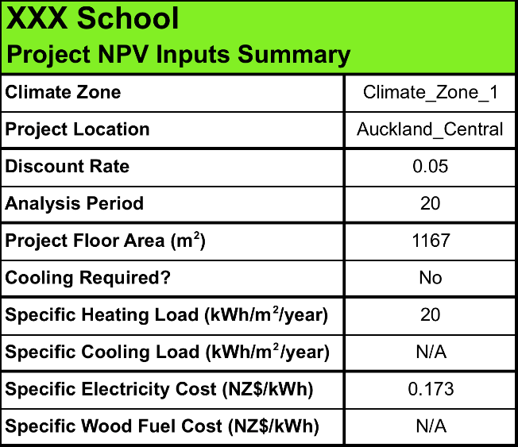
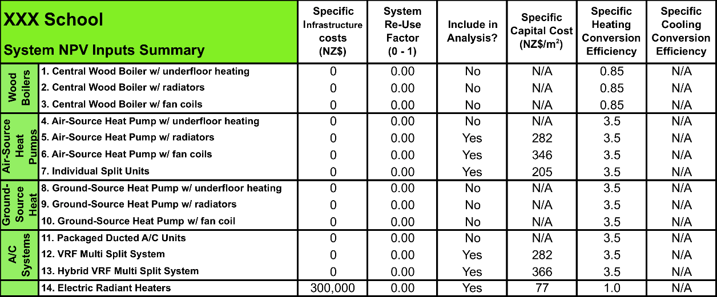
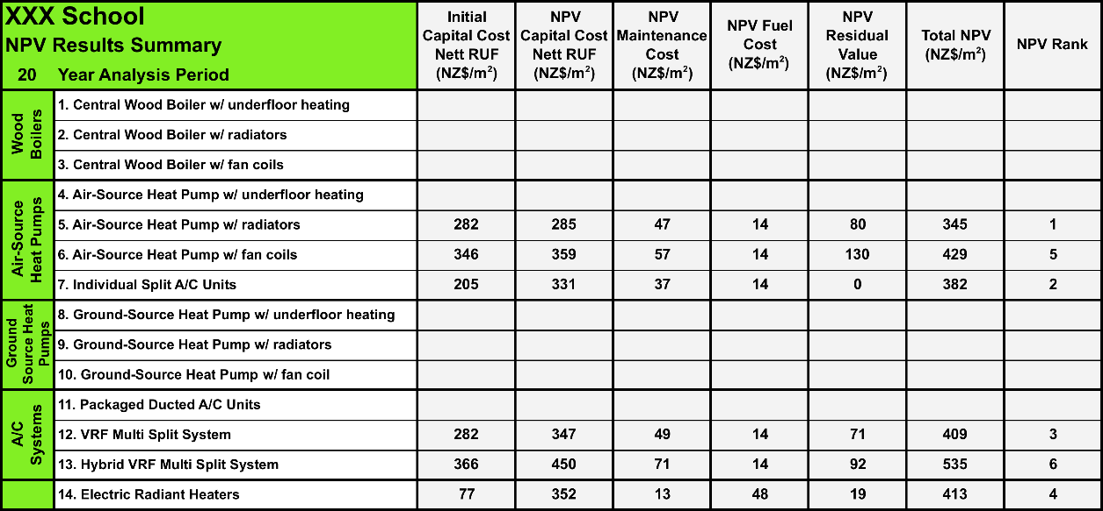
Although the Weighted Attribute Analysis results suggest that Air-Source Heat Pumps and Individual Split A/C units should be preferred over VRF Multi-Split systems, this is due to the lower capital cost attributed to these systems. In practice, relative capital costs vary depending on particulars of the project. VRF systems enable extended pipe runs and a more controlled central plant location, rather than multiple outdoor units with multiple maintenance points distributed about the periphery of the building. Split units will also increase the sizes of the risers required, as individual pipe runs will be required for each unit.
Although suggested in the Master Plan, electric radiant heaters are not a recommended option due to their high power requirements and the limited existing electrical infrastructure. The required increase in electrical infrastructure (in particular, a new transformer) has been included in the LCCA calculations and would make this option significantly more expensive than heat-pump alternatives.
Under the Kigali Amendment, use of R-410 refrigerant based systems are to be progressively phased down. For this reason, two alternative mechanical system options have been proposed.
The first option is a VRF system, which requires refrigerant reticulation within the building envelope, and hence has a relatively high refrigerant charge.
The second option is an air-source heat pump with fan coil units. This uses water as the heat exchange medium within the building envelope, and hence has a lower refrigerant charge. The second option, although more expensive, significantly reduces the volume of R-410 refrigerant used. The second option may also be available with an alternative refrigerant when the project reaches tender stage.
A final system selection will be made in consultation with NZSPA and the School.
- Internal Environmental Monitoring (IEM) Compliance
  - IEM Requirements
As per DQLS – IAQ & TC (p.33 and 34), Internal Environmental Monitoring (IEM) devices are to be installed in teaching spaces.
Below is the plan mark-ups showing the proposed location of the IEMs within the spaces, in line with the IEM requirements in Section 1.6. The IEMs will be sourced from NZSPA.
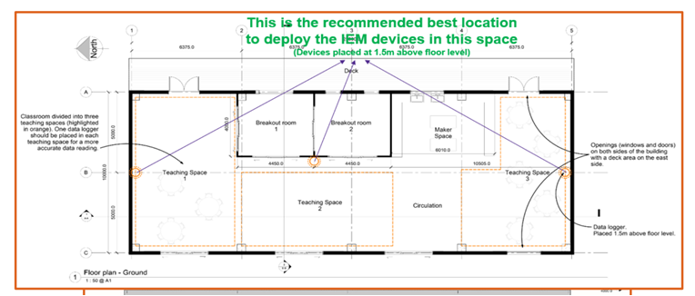
- Specialist & Ancillary Spaces Compliance
  - Specialist & Ancillary Spaces Requirements

Food Technology Spaces
This project includes four ‘Maker Spaces’, which are provided with domestic cooking ranges. These will be fitted with stainless steel domestic range hoods, exhausting through the external walls, and in compliance with as 1668:2 (2012). Required clearances to openable windows are indicated on the Mechanical Services Preliminary Design drawings. Make-up air will be provided via natural ventilation (openable windows).
It is not currently envisaged that the kitchen ranges will use gas. Should this change, compliance with AS/NZS 5261 and/or AS/NZS 5601.1:2013, provision of manual shut off valves, and provision of an automatic gas shut off valve linked to the fire alarm system, will be demonstrated at Developed or Detailed Design.

IT Server Rooms
This project includes a server room/IT cupboard on each floor. These spaces are provided with extract ventilation (in common with the toilet extract system) to maintain an acceptable operating temperature. Make-up air will be provided via door grilles.
The scale of the IT installations is not anticipated to be such as would require active cooling via heat pumps.
A high-limit direct acting thermostat set at 30°C will be provided and interlocked with the toilet extract system, with an audible alarm immediately outside each server room.

Toilet Facilities
This project includes both standard and accessible toilet facilities on both floors. There are no Universal School Bathrooms (HDUs) in this project.
Separate mechanical extract ventilation systems will be provided to each floor. These will provide 35 l/s extract to each cubicle, and 50 l/s to each accessible toilet facility.
The ground floor extract system will exhaust through the external wall. Required clearances to openable windows are indicated on the Mechanical Services Preliminary Design drawings. The first floor systems will exhaust via a roof cowl. Make-up air will be provided via door grilles and under-cuts, as appropriate.
The extract system control strategy will be determined at Developed or Detailed Design.
There are no Workshop Technology or Science Laboratory spaces in this project.
- Conclusions & Recommendations
  - Conclusions
As noted above, compliance with some criteria cannot be demonstrated at Preliminary Design stage. This report will be updated at Developed & Detailed Design.
A number of spaces fail to achieve the minimum UDI criteria due to excessive hours with >2000 lux (refer to Section 3.2, below). This may be resolved by providing additional external shading fins, by reducing the glazing areas, or by providing internal shading devices. Appropriate mitigation measures to be assessed by the Architect.
Four breakout spaces have no external wall, and hence cannot be adequately daylit. As these spaces are used intermittently, we suggest that reliance on artificial lighting is appropriate.
There are no other compliance issues to be addressed at this stage.
  - Recommendations
Lighting: Refer above
Acoustics: TBC by Acoustic Consultant
Indoor Air Quality:
- Climate-based modelling report to be provided at Developed or Detailed Design to demonstrate compliance DQLS CO₂ concentration limits.
- VOC compliance TBC by Architect.
- Compliance with AS/NZS 5149.1 (refrigerant safety) to be demonstrated at Developed or Detailed Design.
Indoor Temperature:
- Heating system sizing data to be provided at Developed or Detailed Design.
- Some breakout rooms experience almost 80 hours above 25°C; these should be provided with an active cooling system to ensure comfortable conditions.
- The thermal modelling should be updated at Detailed Design to ensure continued compliance.
- Explanatory/Limitations Statement
- This report contains the professional opinion of XXXX as to the matters set out herein, in the light of the information available to them during preparation, using their professional judgment and acting in accordance with the standard of care and skill normally exercised by professional building scientist providing similar services in similar circumstances. No other express or implied warranty is made as to the professional advice contained in this report.
- An IEQ assessment has been carried out. We have prepared this report in accordance with the brief as provided and our terms of engagement. The information contained in this report has been prepared by XXXX at the request of its client, the New Zealand School Property Agency (NZSPA) of Education, and is exclusively for its use and reliance. It is not possible to make a proper assessment of this report without a clear understanding of the terms of engagement under which it has been prepared, including the scope of the instructions and directions given to and the assumptions made by XXXX. No responsibility or liability to any third party is accepted for any loss or damage whatsoever arising out of the use of or reliance on this report by any third party.
- The report is also based on information that has been provided to XXXX from other sources or by other parties. The report has been prepared strictly on the basis that the information that has been provided is accurate, complete and adequate. To the extent that any information is inaccurate, incomplete or inadequate, XXXX takes no responsibility and disclaims all liability whatsoever for any loss or damage that resulting from any conclusions based on information that has been provided to XXXX.
- IEQ Assessment Calculations
<Please provide the Daylight & Thermal Modelling calculations>
- Photos of Building and Model Images
<Please provide the building and model images>
- Plans of Building
<Add plans of building here.>



