


Electrical Infrastructure Capacity Report

School Name

Electrical Infrastructure Capacity Report
<Insert a good overview picture of the building/structure here>

<INSTRUCTIONS ON USING THIS TEMPLATE>
<All yellow highlighted text needs to be checked and overwritten as required>
<All text within “< >” is provided as guide to the template use and is to be deleted or overwritten>
<Complete the header on this page and the header & footer on page 2. Then ensure this has flowed through the rest of the document. Note the appendices themselves do not have page numbers. You will need to update the footer on the Appendix A cover page also>

Legend
General instructions
To be completed by School Project Manager or NZSPA Delivery Manager
To be completed by an Energy Engineer, Electrical Engineer or a professional with a similar level of expertise
To be completed by NZSPA Technical Advisory Team

Template V1
<Date>
Prepared By: <Project Manager Name> or <NZSPA Delivery Manager>
For the New Zealand School Property Agency

Document Control Records
Document Prepared by:
<Full Legal Company Name>
<Company Address Physical>
<Company Address Postal>

Telephone: <Company Phone number>
Email: <Company email>
Web: <Company Website>
OR

<Full Name of NZSPA Delivery Manager>

Revision History
Revision No. | Prepared by | Description | Signed | Date
0 | xxx | Draft for review |  | Xx/mm/yyy
1 | xxx | Final |  | Xx/mm/yyy

Document Acceptance
Action | Name | Date
Received by: | xxx
Reviewed by: | xxx

Contents

2
Headings 2
2
2
2
1. 2
1.1 2
1.1.1 2
Bullets and numbering 2
Miscellaneous styles 3
Tables 3
Appendix A - 4

Overview of the Electrical Infrastructure Capacity Report
Projects that upgrade electrical infrastructure to increase electrical capacity to school sites (for example, installing a new/larger transformer) can incur substantial capital costs to NZSPA. Many upgrades can also trigger a change to a higher tariff level or additional line charges, resulting in significant increases in a school's ongoing electricity consumption and costs.
Therefore, for any projects that create additional load to the existing electrical infrastructure, the site-wide electrical supply capacity must be understood first. Designing schools in Aotearoa New Zealand (DSNZ) standards contains this guidance in section 3.9 Electrical and ICT infrastructure.
Before undertaking a project that will increase the load on a school’s existing electrical infrastructure, investigate the below information:
- the capacity of the existing supply,
- how the existing load is balanced,
- the size of the new load,
- how that load needs to be spread to ensure load balance is maintained,
- can the new load or any of the existing load be managed to ensure that the site capacity is not exceeded.

Refer to Australian/New Zealand Wiring Rules AS/NZS 3000 and calculate the maximum demand for the school site.
This report must provide evidence that the upgrade to the existing electrical infrastructure is required, and all other solutions have been considered. The report must be completed by an Energy Engineering, Electrical Engineer, or a professional with a similar level of expertise.
NZSPA’s Technical Advisory Team and the Design Assurance panel will use this report to review:
- the reasons for the upgrade
- the scope of the project
- the ongoing cost impacts.

This information should then be used to inform design requirements and options.

Executive Summary
<This section should cover the following:
- The purpose of this review
  - The scope of the review which should include:
  - the current electrical capacity,
  - connection arrangement and
- indicative costs of increase to capacity
  - a summary of findings including:
  - Whether the current infrastructure is sufficient for the new load for the school site.
  - The considerations required for the site if an increase in infrastructure capacity is the only solution.
- Recommendations>
<This section is to be completed by an Energy Engineer, Electrical Engineer or a professional with a similar level of expertise>

Introduction and Background
<For NZSPA-led projects, an Electrical Infrastructure Capacity Review Report should be submitted at project initiation stage.
For school-led projects, the requirement should be identified in the 10YPP condition assessment or as part of project scoping, and an Electrical Infrastructure Capacity Review Report should be completed to support the finding.>
<provide details here Include details from site inspection: site address, electricity and gas usage for the past two years, peak load of the site, etc >
<provide background of the electrical project that requires additional load and current stage of this project>

Current Connection Arrangements

ICP number of all electrical connections on the school site
<ICP (Installation Control Point) Numbers can be found on the schools Electricity Retailer invoice, it a is a 15-character alpha-numeric code>
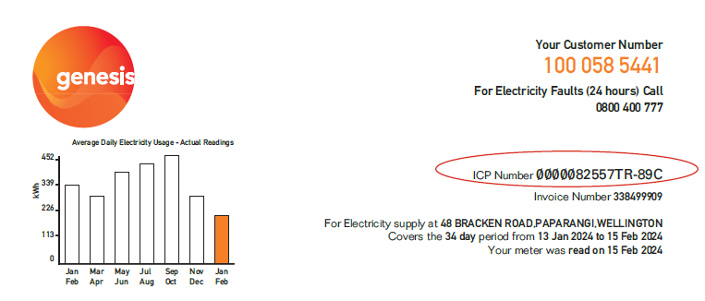
< Provide the ICP number of all the electrical connections on the school site>

What is the school’s current tariff category?
<By inserting the schools ICP(s) into the Electricity Authority (EA) portal, you can determine:
- the ICP’s tariff category (each Electrical Distribution Company has their own tariff categories)
- how each of those tariff categories is applied
- the ICP’s Chargeable Capacity, if it has been recorded in the EA Portal.

See the examples below:
EA Portal showing pricing category code and chargeable capacity for site –
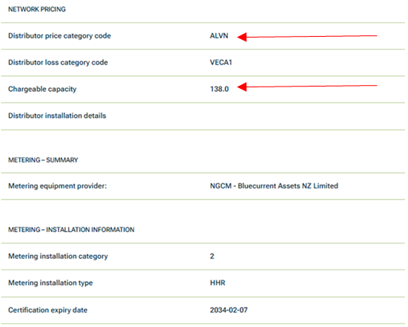
Distribution Company pricing –
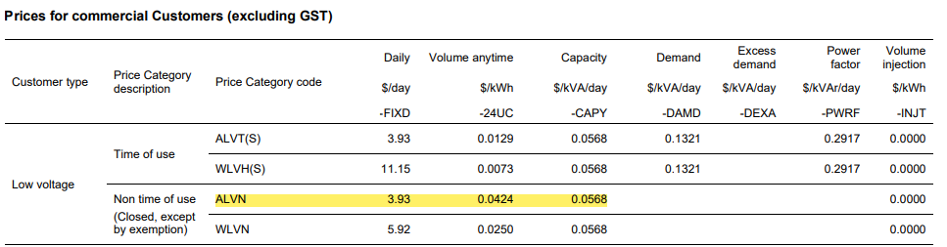
<Provide school’s current tariff category>

What is the existing pole fuse size, e.g., 100amps, 160amps, etc?
<This will need to be requested from the Electrical Distribution Company. They may have it recorded, but most likely it will require the fuses to be pulled and visually checked. This will mean that the school site will need to be powered down and there will be a cost to the project.>
Example:
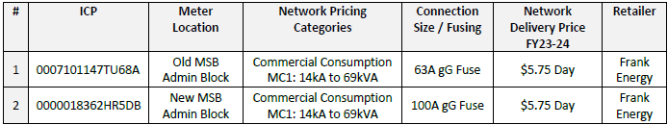
<provide pole fuse size>

Does the transformer supply any ICP’s other than the school ones? Provide details.
<This information can be requested from the Network Distribution Company.>
Example:
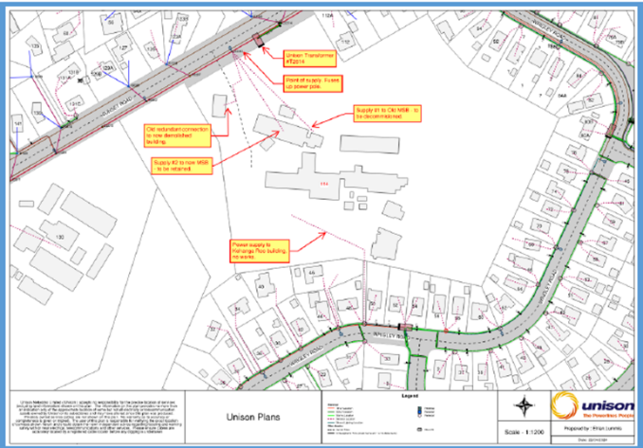
<Provide details of supply from the transformer to other customers>

Collect the ½ hourly consumption data for the last two years for this school site?
<The school need to request from their electricity retailer:
- ½ hourly usage data for the last two years – they should provide this in a CSV file.
- A cost and consumption report for 2 years – showing all costs invoiced for each invoice period including pass through costs such as distribution, transmission and EA charges.
Based on this information produce a chart showing the usage over the period collected.>
Example:
- ½ hourly electricity usage in chronological order
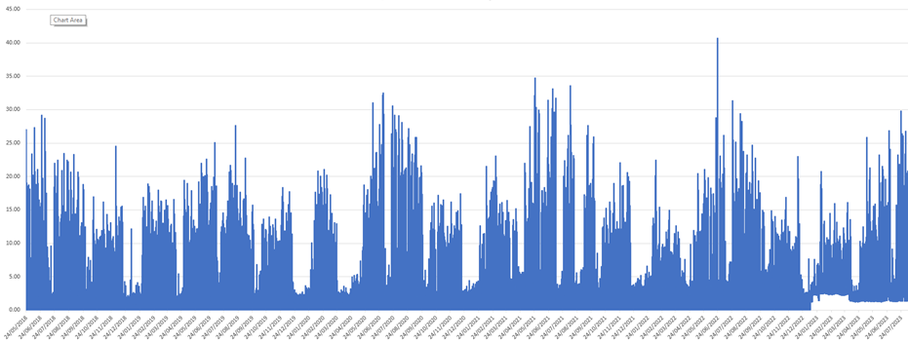
- ½ hourly electricity usage from highest to lowest
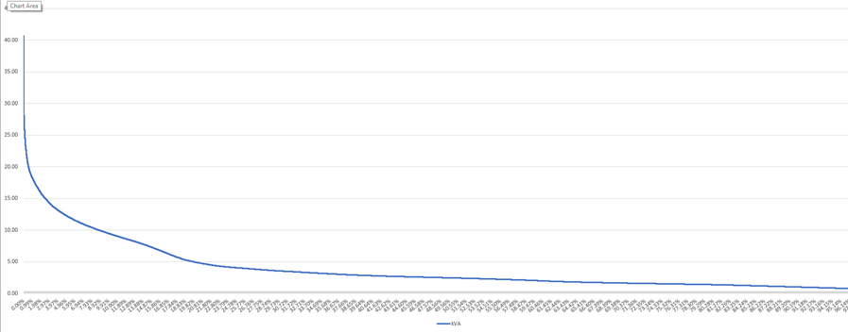
- ½ hourly usage for the first 4 days of the week with the highest peak.
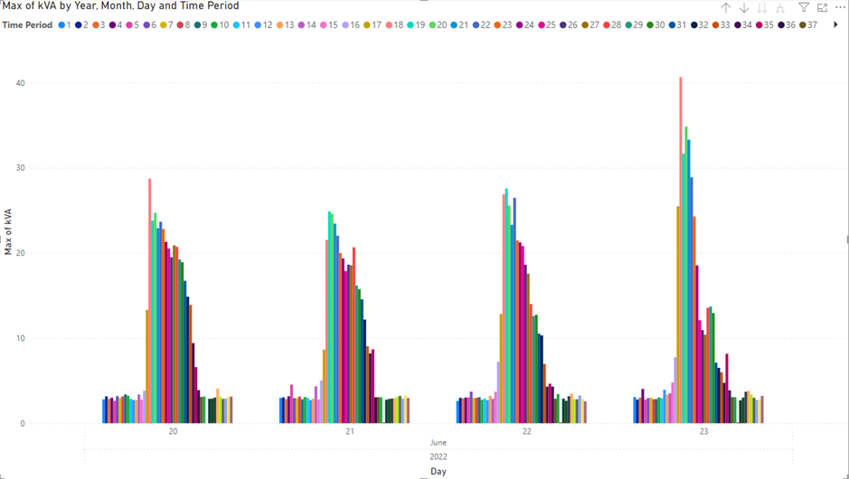
<Provide 1/2 hourly consumption data for the last two years and provide data evidence>

Provide an electrical line diagram to show:
- main switchboard and distribution boards (and their switch capacity)
- size, types and approximate length of mains and submain cabling (and the number of phases)
Example:
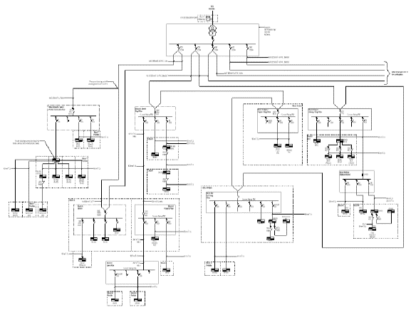
<include the diagram in the Appendix A>

New Electrical Load

What is the ICP number for the connection that the new load will be attached to?
<Provide the ICP number for the connection that the new load will be attached to>

Is the current electrical infrastructure sufficient for the new load? If not, what alternative options have been explored to accommodate this new load without a capacity upgrade?
Before considering an upgrade to the existing electrical infrastructure, all the alternative options should have been explored. These solutions include but are not limited to the following:
- manual load management
  - set timers on heat pumps so they turn on at different times staggered over a 1–2-hour period, starting early in the morning. The heat pumps work together so the temperature in an occupied teaching space gradually reaches 20 – 22 degrees C. After they reach this desired temperature, they will automatically turn off. This will flatten the electrical load curve.
  - set heat pump fans to medium
  - manage hot water cylinder operation through electrical timers. Heat hot water outside peak times and to a higher temperature
- automated load management
  - install a meter for real time load information
  - install heat pump and hot water cylinder controllers centrally run from a digital app
- other technologies, products, or techniques
  - LED lights
  - heat pumps
  - thermal storage
  - electrical storage

<Provide your findings here>
<List all the solutions that have been explored for the school site and provide details of the investigation in Appendix B>

Do the mains, metering and main switchboard have spare capacity? If so, can the supply be increased by upgrading the pole fuse?
<Provide details on the existing mains, metering and main switchboard>
<Provide information on whether the supply be increased by upgrading the pole fuse>

Is there any spare capacity in the network for the new load?
< If not, the local transformer may need to be replaced with a larger one, or a new transformer located on the school site, or an upgrade of low voltage network or high voltage network may be required. Note: any upgrade of the local electricity distribution network will need to be completed by the distributor (e.g. Wellington Electricity) or their approved contractors>
<If there is spare capacity, how much extra capacity is available, and will the Network Distribution Company allow access to that spare capacity? How much capacity is required to accommodate the additional load?>

Future Capacity Upgrades

What size is the transformer required for the new load at the school site?
<Heating/cooling and hot water heating are generally the two largest capacity loads at an all-electric school. Are load monitoring and load management being included to ensure that capacity utilisation is optimised. Has this been modelled?>
Maximum demand calculations will provide indication of peak possible usage but should not be used to set capacity.
Will providing an oversized connection/transformer future proof the school for further capacity increases in the future? Will installing a dedicated transformer on a school site ensure that, that capacity can only be used on that school site? Not at all, spare capacity not being utilised and paid for by the school can be redirected elsewhere in the Network Distribution Companies network – in urban areas this will generally be to infill housing or EV chargers.
Example:
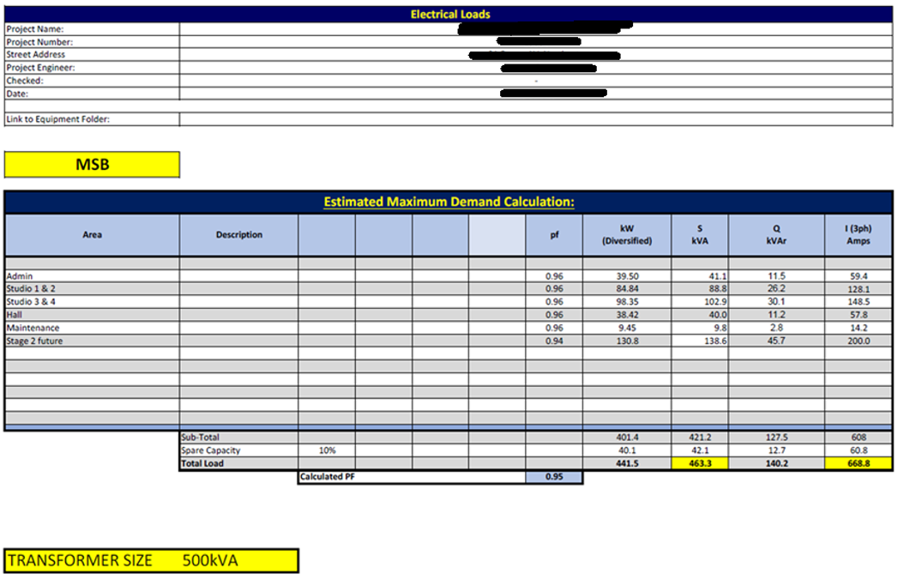
<Provide modelling information and size for the transformer>

Does the capacity upgrade require the school to enter into a new Electricity Supply Agreement?
<Depending on the Electrical Distribution Company, when a certain value of capacity is achieved, there will be a requirement for the ICP to move from a Fixed Price Variable Volume (FPVV) contract to a Time of Use (ToU) contract. If the school’s current supplier cannot provide ToU pricing, then the school will need to change suppliers.>
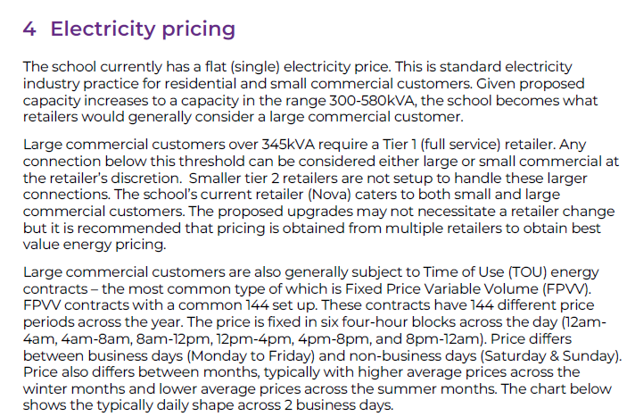
<Provide answer here>

Will the capacity upgrade change the school’s tariff category for the school site? If so, has the school and NZSPA understood the impacts of the upgrade?
<If tariff category is to be changed, new usage and capacity costs must be forecast. Make sure that schools have been provided the information about the potential increase in the electricity costs.
Example:
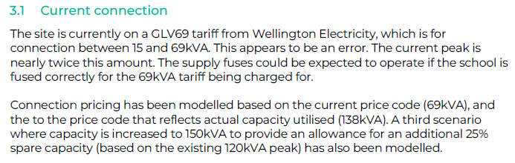
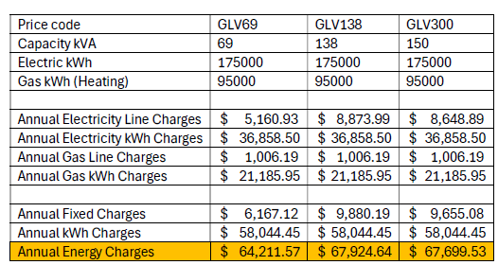
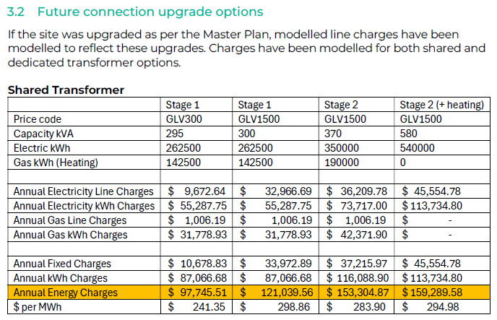
<Note: Schools must be instructed to keep a record of the increase and provide it to the School Resourcing Team for funding increase.>
<Provide information on the change of tariff category if any and provide information on advice the school has received about the impacts>

What is the total cost of the electrical infrastructure upgrade (both capital and ongoing operational cost)
<Understanding the total cost (Capital and ongoing operational cost) for the capacity upgrade will allow projects to assess what other remedies could be incorporated>
<Provide pricing evidence and cost forecast with evidence in Appendix C>

Recommendations
<Based on the information provide recommendation of options>

- Electrical Line Diagram
Provide diagram for
- main switchboard and distribution boards (and their switch capacity)
- size, types and approximate length of mains and submain cabling (and the number of phases
- Alternative Solutions Explored
<List all the alternatives that have been explored and provide rationales as to why they will not suffice>

- Cost forecast of the electrical infrastructure upgrade (both capital and ongoing operational cost)
<Provide evidence of the costs and the forecasts of the ongoing costs>



