


AMP – Asbestos Management Plan

School | [Insert School Name]
School ID | [Insert School ID]
School Address | [Insert School Address]
School Crest / Logo | 
AMP Reference Number | [AMP-[School ID]-1.0]
AMP Issue Date | [Issue Date]
AMP Next Review Date | 8 January 2024

Appointed Asbestos Coordinator
In the event of an emergency or to discuss an asbestos related issue the following nominated people are to be contacted. See Section 11 for procedures.

Primary Contact
Name | [Insert Here]
Current Position Held | [Insert Here]
Mobile Phone | [Insert Here]
Email | [Insert Here]

Secondary Contact
Name | [Insert Here]
Current Position Held | [Insert Here]
Mobile Phone | [Insert Here]
Email | [Insert Here]
The New Zealand School Property Agency provides portfolio-wide support for the management of asbestos within school properties. Schools, Property Advisors, Project Managers, contractors and other stakeholders may contact NZSPA for general enquiries, technical advice, guidance on asbestos management requirements, questions relating to the Accredited Asbestos Services List (AASL), or escalation of significant asbestos-related matters.
Asbestos Management Support
Schoolproperty.Asbestosmanagement@schoolproperty.govt.nz

Document Development
This Asbestos Management Plan template has been produced by the New Zealand School Property Agency to assist in the safe management of asbestos if found to be present within a school structure. The document has been based on WorkSafe issued guidance and developed to better suit educational facilities. This AMP is subject to ongoing development as further consultations take place and as further relevant codes of practice and/or advice on asbestos management become available.
Each new revision of this AMP will be made available as an electronic document to all registered copy holders with an instruction that the superseded copy must be no longer relied upon and archived. Changes to the recent revision will be highlighted. The version number is included within the footer, which is noted on each page. When amendments occur, the entire document will be made available electronically with the version number updated accordingly.
It is the intention that the preparation and use of this AMP assists both the user and PCBU to comply with the Health and Safety at Work (Asbestos) Regulations 2016, the WorkSafe Management and Removal of Asbestos - Approved Code of Practice.
Nothing contained within this document may be considered to alter or modify the above regulations or guidelines, however in order to address the sensitivity of a school environment, NZSPA may suggest controls that exceed the requirements of current regulations. Those responsible for the management of a school property and contractors, are PCBU’s who have a duty of care. Each PCBU is required to comply with all relevant Legislation.
School Principals and School Board should follow NZSPA guidance provided when dealing with asbestos in schools.
Managing asbestos in schools – New Zealand School Property Agency

Document Control
The following provides a record of amendments to this AMP school specific document.
Version | Date | Status | Changes | Author
1.0 | January 2024 | Initial Release | First issue of School AMP Template | Ministry of Education
1.1 | September 2026 | Revision | Updated WorkSafe references to 2026 guidance suite; added AASL requirements; updated contractor responsibilities; revised survey and assessment references; minor formatting corrections. | Ministry of Education - Craig Mansell – Chief Advisor Asbestos Management

School Appointed Asbestos Coordinator
NZSPA highly recommends that [Insert School Name] selects an Asbestos Coordinator as the primary person for the implementation of the AMP and coordination of all asbestos-related work. The school’s Property Advisor could act as the secondary contact if the Asbestos Coordinator is unavailable. There is significant benefit to [Insert School Name] appointing a single coordinator/contact person to maintain one clear line of contact on asbestos matters.
The key responsibilities of the Asbestos Coordinator are to:
- Coordinate the identification of materials containing asbestos, extent and condition.
- Maintain the Asbestos Register.
- Periodically review and monitor the AMP so the plan remains relevant and up to date.
- Coordinate assessment of asbestos risks e.g., exposure.
- Implement the AMP.
- Provide information on the location and condition of ACM to anyone who is liable to work on or disturb them.
- Report to [Insert School Name] Board of Trustees.
In addition, the Asbestos Coordinator will ensure that all contractors engaged to work with asbestos are competent and, where necessary, appropriately licensed to do so. Where applicable, documented procedures will be implemented to select, monitor, and manage contractors who work with asbestos. Generally, this will include:
- Only competent contractors who have the appropriate licenses to work with asbestos will be engaged.
- Monitoring of contractors will be undertaken by the Asbestos Coordinator or an appointed Licensed Asbestos Assessor on behalf.
- Contractor’s training records must be available on request.
- Risk assessments and safe systems of work must be assessed as adequate by the Asbestos Coordinator or an appointed Licensed Asbestos Assessor and in place prior to any works taking place.
- Contractors who analyse air samples or analyse samples of potential asbestos containing ACM must conform to the NZ laboratory requirements - International Accreditation New Zealand (IANZ). [Insert School Name] will ensure all contractors engaged for this purpose are IANZ accredited.
- Licensed Asbestos Assessors who undertake air quality monitoring and employee exposure monitoring must conform to the requirements set out in the Health and Safety at Work (Asbestos) Regulations 2016. [Insert School Name] will ensure all contractors engaged for this purpose are fully accredited and compliant with all NZ legislation.
- The Asbestos Coordinator will ensure that whenever two or more contractors work with ACM or could come into contact with ACM at the same time or are working in the same premises that they co-operate with each other and those they could affect.
Important Note:
Section 1 on the following two pages contains documents that require periodic use and/or updating by the Asbestos Coordinator when required.

Section 1. Document Maintenance – [Insert School Name] Responsibility
The regular maintenance and updating of Section 1 is the responsibility of [Insert School Name] to ensure the appropriate management of any asbestos identified at the school.
The following records will require updating upon the creation of new asbestos documents. All newly created asbestos documents must be appended to this AMP and encompass the entire document.
Document Title and Reference | Issue Date | Building / Area | Issued By

Asbestos Register – See Appendix A
The asbestos register is vital for safely and efficiently managing asbestos within a school environment. This section will feature an up-to-date copy of the asbestos register in Excel format. As changes occur, such as the identification of new asbestos or the removal of existing asbestos, the register will require updates, superseding any previous versions contained within this section.
Asbestos Register Log
Rev | Issue Date | Changes
Asbestos Emergency Event Register – Section 11. Procedures for Incidents and Emergencies and Appendix C
Date of Incident | Contractors Name and Company | Control to Manage the Emergency
Contact with Asbestos Register – Section 11. Procedures for Incidents and Emergencies and Appendix D
Date of Incident | Employee Name | Building / Block Name

Contractor and Visitor Sign In
By signing below, I confirm that I have thoroughly reviewed this Asbestos Management Plan (AMP), paying particular attention to the Asbestos Register, site drawings, and any acknowledged limitations regarding asbestos within this school. Based on this information, I have conducted a risk assessment and understand that the tasks I am assigned to perform are intended to safeguard both myself and the building occupants.
In the event of an asbestos-related incident, I commit to taking all necessary precautions to ensure the safety of myself and others, as outlined Section 11 of this AMP.
Name | Company | Date | Signature

Section 2. Objectives of the Asbestos Management Plan
This AMP details the approach to be taken by School in managing the asbestos hazard on a NZSPA site by documenting procedures designed to minimise the risk of exposure to asbestos of all personnel on School premises, including all NZSPA personnel, teaching staff, maintenance staff, students, maintenance contractors and other visitors. This AMP is to be used in conjunction with the site-specific asbestos register for the school and/or any other records of asbestos containing materials or risk assessments or investigations undertaken for specific school sites.

Duty and Responsibility
New Zealand Health and Safety at Work (Asbestos) Regulations 2016 – Subpart 2 – Management of Asbestos Risks
13 Duty to prepare asbestos management plan.
- This regulation applies if asbestos or ACM is –
  - Identified at a workplace under regulation 10; or
  - Likely to be present at a workplace from time to time.
- A PCBU with management or control of the workplace must ensure that a written plan (an asbestos management plan) for the workplace is prepared.
- A PCBU with management or control of the workplace must ensure that the information in the asbestos management plan is kept up to date.

Regulatory Framework
All work on School / NZSPA buildings and grounds that involve the assessment, management, removal, encapsulation, transport, disposal or otherwise potential disturbance of asbestos containing materials, shall be performed in accordance with all relevant Regulations, Codes of Practice, Advisory Standards and industry standards, including the following as of January 2024:
- Health and Safety at Work Act 2015
- Health and Safety at Work (Asbestos) Regulations 2016
- WorkSafe New Zealand, Interpretive Guidelines for the Health and Safety at Work (Asbestos) Regulations 2016
- WorkSafe New Zealand, Management and Removal of Asbestos Approved Code of Practice (2016) (including subsequent clarifications)
- WorkSafe New Zealand, Managing Asbestos in Your Building or Workplace
- WorkSafe New Zealand, Conducting Asbestos Surveys (April 2026)
- WorkSafe New Zealand, Asbestos Assessments (April 2026)
- BRANZ/ALGA, New Zealand Guidelines for Assessing and Managing Asbestos in Soil (2024 Revision)

Section 3. Responsibility Under the Plan
It is essential that all associated persons of [Insert School Name], including staff, the School Board, NZSPA and engaged contractors understand their responsibilities under this AMP for the safe management of asbestos at this site.

[Insert School Name] Responsibility
The School Board, Principal, and persons responsible for the management and control of the workplace shall:
- Ensure an Asbestos Management Plan (AMP) is maintained where asbestos or asbestos-containing materials are known or likely to be present.
- Ensure the AMP and asbestos register remain current and are reviewed in accordance with legislative requirements.
- Appoint an Asbestos Coordinator responsible for implementing this AMP.
- Ensure asbestos information is communicated to workers, contractors, visitors and other relevant parties.
- Ensure asbestos surveys are undertaken where required.
- Ensure all asbestos-related services are procured through the Accredited Asbestos Services List (AASL), unless an alternative arrangement has been approved by the New Zealand School Property Agency.
- Ensure asbestos incidents, damage and disturbances are reported and managed in accordance with Section 11 of this AMP.
- Ensure sufficient resources are available to effectively manage asbestos risks.
- Cooperate and coordinate with other PCBUs undertaking work at the school.

Accredited Asbestos Services List (AASL)
The New Zealand School Property Agency has established the Accredited Asbestos Services List (AASL) to support the safe and consistent delivery of asbestos-related services across the school property portfolio.
The AASL contains asbestos service providers that have undergone a NZSPA technical review process to demonstrate compliance with relevant legislative, licensing, accreditation, competency and performance requirements.
All parties involved in the planning, procurement, management or delivery of asbestos-related services at the school, including the School Board, Project Managers, Property Advisors and Contractors, shall utilise suppliers from the AASL unless an alternative approach has been approved by the New Zealand School Property Agency.

The use of an AASL supplier does not remove the responsibility of any party to verify that the supplier remains suitably qualified, competent, appropriately licensed, adequately resourced and capable of undertaking the specific scope of work.
Where a specialist asbestos service is required and a suitable supplier is not available through the AASL, engagement of an alternative supplier should only occur following consultation with the New Zealand School Property Agency.

Project Managers
All Project Managers engaged to oversee any projects at the school must ensure the following prior to commencing applicable works;
- They must read this AMP paying particular attention to the Asbestos Register, and associated reports. Appendix A and Appendix B;
- Must not permit any installation / repair outside of normal maintenance activities or refurbishment work that will disturb the fabric of the building or that is in areas of limitations noted in Asbestos Register unless this has been properly risk assessed and if necessary is accompanied by a relevant asbestos refurbishment / demolition survey.
- Must make sure that those working at the school shall be responsible for ensuring that works are conducted in accordance with the AMP.
- Must make sure that contractors adopt and apply proper safety procedures and works are conducted in accordance with all relevant legislative requirements and best industry practice.
- Must ensure that all engaged parties have Asbestos Awareness Training where necessary before working on this school;
- Must notify the Appointed Asbestos Coordinator immediately of any damage to known or presumed ACM or of any accidental disturbance to ACM.

Contractors Working at the Site
All contractors working at the school must ensure the following prior to commencing applicable works;
- They must read this AMP paying particular attention to the Asbestos Register, and associated reports. Appendix A and Appendix B;
- Must not carry out any installation / repair (outside of normal maintenance activities or refurbishment work that will disturb the fabric of the building or that is in areas of limitations noted in Asbestos Register unless this has been properly risk assessed and if necessary is accompanied by a relevant asbestos refurbishment survey.
- Those working at the site shall be responsible for ensuring that works are conducted in accordance with the AMP.
- Contractors must ensure proper safety procedures are followed and works are conducted in accordance with all relevant legislative requirements and best industry practice.
- Must have Asbestos Awareness Training where necessary before working on this site;
- Must notify the Appointed Asbestos Coordinator immediately of any damage to known or presumed ACM or of any accidental disturbance to ACM

Section 4. Principles of Asbestos Management
The purpose of an AMP is to assist the PCBU (School board) to comply with their duties under the Health and Safety at Work (Asbestos) Regulations 2016 and ensure ACM and other non-friable asbestos products are not damaged or deteriorate to such an extent that they become friable and expose the school community and contactors to airborne asbestos fibres.
It is the intention that the preparation and use of this AMP will assist both the PCBU and users occupying the workplace (including contractors) to understand and comply with the Health and Safety at Work (Asbestos) Regulations 2016 and approved documentation published by WorkSafe NZ.
Nothing in this AMP should be considered to alter the above regulations or Approved Code of Practice (ACOP) documentation issued under New Zealand legislation.
The key principle of managing asbestos is summarised below:
- Asbestos removal may not be immediately necessary, but must be completed prior to any remedial works, which will disrupt ACM.
- Asbestos that is identified will be appropriately evaluated against a Manage and Monitor strategy as preference.
- Removal of asbestos should be subject to material and priority risk assessments.
- Asbestos is relatively safe when encapsulated but is dangerous to health when fibres become airborne. This can occur when ACM are damaged and degrading or when disrupted.
- Ideally all asbestos products should be eliminated from the workplace. Accordingly, consideration will be given to the removal of ACM during renovation, refurbishment/demolition and/or maintenance, where practicable, in preference to other control measures such as enclosure, encapsulation or sealing.
- Control measures shall be established to prevent exposure to airborne asbestos fibres.
- No person shall be exposed to the risk of inhalation of asbestos above minimum trace levels in the course of employment without being provided with full information of the work health and safety consequences of exposure and appropriate control strategies.
- Workplace users must be notified of confirmed or presumed ACM within the workplace and be supplied with detailed information on the occupational health and safety consequences of exposure to asbestos and appropriate control measures.
- People working with asbestos, including but not limited to, asbestos removalists and maintenance workers must be suitably protected and trained.
- Products containing asbestos in situ shall be labelled accordingly where deemed necessary.
- The identification and work with ACM should be undertaken by competent persons e.g., Licensed Asbestos Assessors and Licensed Asbestos Contractors respectively.
The general principles of asbestos management (and an AMP) are broadly covered by four phases – identification, assessment, management, communicate. Key phases are set out within the Principals of Asbestos Management Flow Chart below.

Principals of Asbestos Management Flow Chart
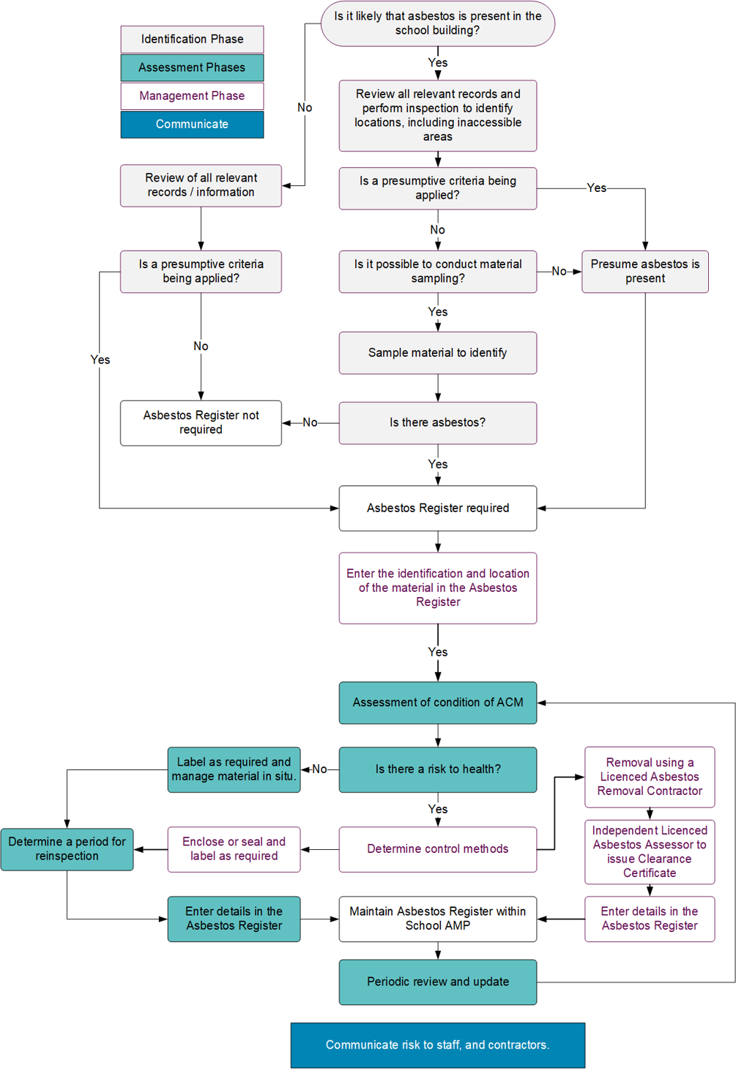

Section 5. Review and Revise
New Zealand Health and Safety at Work (Asbestos) Regulations 2016 (Government, 2016)
14 Duty to review asbestos management plan.
- A PCBU with management or control of a workplace that has an asbestos management plan must ensure that the plan is reviewed and, if necessary, revised if:
- There is a review of control measure(s).
- Asbestos is removed from, disturbed, sealed or enclosed at the workplace.
- The plan is no longer adequate for managing the risk arising from asbestos or ACM at the workplace.
- A representative for workers requests a review.
- 5 years has passed since the plan was last reviewed.
Revisions and amendments to the AMP will include any critical event including but not limited to, any changes made to Asbestos Management Survey(s), the Asbestos Register(s), when works are undertaken and ACM/ACD has been removed and a Clearance Certificate has been issued, or the inclusion of Asbestos Refurbishment and Demolition Surveys where works are not subsequently undertaken.
Revisions and amendments to the AMP may also occur subject to legislative changes, as further relevant codes of practice and/or advice on asbestos management become available from WorkSafe NZ.
Where ongoing air monitoring is being undertaken and is not being undertaken as part of any ‘asbestos work', then only annual amendments will be made to this document, unless action has been taken as a result of fibre levels being above trace levels as defined by the New Zealand Health and Safety (Asbestos) Regulations 2016.
Each new revision of the AMP will be issued to all registered copyholders with an instruction that the superseded copy must be destroyed. A summary of any revisions and amendments will be highlighted for ease of referencing. The revision number can be found on the front cover of this AMP and has been included at the footer on each page. When revisions and amendments occur, the entire document will be reissued with the revision number updated accordingly.

Record Keeping
It is important to retain all copies of asbestos related documents for future reference This can be a physical copy or digital copy which needs to be fully accessible. Where there is a likelihood that documents may continue to be superseded then the most current information must be relied upon.
A complete record of all activities and work permits relating to asbestos works, which have been undertaken at the site is to be maintained. The records that are to be kept include:
- Copies of all asbestos survey reports, including updates and amendments
- Copies of all permit to work documents (if approach is adopted by the school)
- Site induction records pertaining to the information disseminated to contractors prior to conducting work onsite
- Induction records pertaining to the information disseminated to employees regarding the presence of asbestos onsite
- Asbestos Removal Control Plans for asbestos removal works
- Records of any removal or other asbestos related works onsite
- Clearance certificates indicating areas are safe to reoccupy after asbestos removal works
- Asbestos fibre air monitoring results
- All versions of the asbestos register
- Records dealing with regulated and track-able waste and landfill disposal documentation.
Reinspection’s of all ACMs remaining on site are to be conducted by a suitably qualified person only. The reinspection process will involve a visual assessment of the materials to determine if there has been any deterioration since the last inspection and, if so, what course of action should be taken e.g., temporary encapsulation, isolation or immediate removal.
Once the reinspection has been completed, the Asbestos Containing Materials Register is to be updated accordingly. Note that reinspection cycles are defined in Table 3 – Risk Rating and Reinspection Cycles.

Section 6. Identification of Asbestos
New Zealand Health and Safety at Work (Asbestos) Regulations 2016 (Government, 2016) Subpart 2 - Management of asbestos risks
10 Duty to ensure asbestos identified at workplace.
- A PCBU with management or control of a workplace who knows or ought reasonably to know that there is a risk of exposure to respirable asbestos fibres in the workplace must ensure, so far as is reasonably practicable, that all asbestos or ACM giving rise to the risk at the workplace is identified.
In order to locate asbestos-containing materials (ACMs) within a school building a full inspection must be carried out whereby all possible areas that may contain ACMs are inspected. If materials are not recognised on site, they are sampled for analysis to determine their identity. The location of all ACMs (or suspected ACMs) must then be clearly recorded in a report format so that the Appointed Asbestos Coordinator can understand and manage the risk.
There are four types of survey that can be undertaken depending on the aim and purpose for which the survey is to be used:
Management Survey - to locate, as far as reasonably practicable, the presence and extent of any suspect ACMs in the building which could be damaged or disturbed during normal occupancy, including foreseeable maintenance and installation, and to access their condition.
Refurbishment survey – required before any refurbishment work is carried out in order to locate all ACMs within the required area. This will involve destructive surveying in order to access all areas that will be disturbed during the refurbishment works.
Demolition survey – required before any building or part building is demolished in order to locate all ACMs within the required area. This will involve destructive surveying in order to fully access all areas that will be disturbed during the demolition works.
Reinspection Survey – carried out to review ACMs to confirm their current condition and update any management actions to consider any changes.
Different survey types are often combined depending on the requirements of the client. It is possible to carry out a Management with Targeted Refurbishment Survey if the school of New Zealand School Property Agency is planning a localised refurbishment project in one part of the building only. It is also possible to carry out a Refurbishment / Part Demolition Survey or a Reinspection Survey with a Management Survey to areas that were inaccessible during a previous visit.
Prior to attending a site to carry out a survey, the type of survey required, and scope of work must be clearly defined. The survey must then be carefully planned in agreement with the client to include a sampling strategy, a risk assessment and a specification of the type of report required.

Section 7. Assessing Asbestos Risks

Risk Assessment Guidelines
Asbestos that is found to be present does not necessarily create an unacceptable risk. Asbestos is the hazard, but the risk can only be defined when the environment in which it is found is assessed as well.
There are two types of assessment which may have been carried out:
- Material Assessment. See Appendix E
- Priority Assessment. See Appendix F
The scores from each assessment can then be combined to give an overall Hazard Risk Assessment Score.
Material and Priority Assessments have been completed in accordance with New Zealand publications:
Conducting Asbestos Surveys (WorkSafe, April 2026).

Risk Rating Categories
The overall Hazard Risk Assessment Score translates into the following risk rating categories, with the recommended reinspection cycle for each determined risk:
The decisions and the reasons for managing asbestos in the workplace has been quantified by risk assessments for each individual instance or location where asbestos exists.
[Insert School Name] will rely upon qualified and competent Asbestos Surveyors to derive material and priority risk assessments for each ACM, known to date, within the buildings. Priority assessments should be reviewed and confirmed by [Insert School Name].
Combined Priority and Material Score | Potential risk of exposure occurring | Reinspection Cycle
8 or less | Very Low Risk | 5 Years from inspection
9-14 | Low Risk | 3 Years from inspection
15-19 | Medium Risk | 1 Year from inspection
20-24 | High Risk | (1 month – 3 months or 6 months) to be determined by site asbestos surveyor.  Note: High risk items require urgent attention to minimise the risk of exposure events occurring.

Section 8. Management of Asbestos Risks
The remediation priority of ACM has been determined by the combines material and priority risk assessment scores and its associated risk ratings.
Although algorithms / assessments help [Insert School Name] assess the risk from individual ACM, they do not provide a recommended remediation action. As such, risk rating categories have been derived to simplify scores and assist [Insert School Name] to ascertain a removal/remediation hierarchy and asbestos control procedures, which are as follows:
Combined Priority and Material Score | Overall Risk Rating | Remediation Priority
8 or less | Very Low Risk | Very Low remediation priority – ACM may remain in situ under the control of this AMP.
9-14 | Low Risk | Low remediation priority – ACM may remain in situ under the control of this AMP, unless ACM was determined to be in poor condition.
15-19 | Medium Risk | Medium remediation priority – Control measures are required to be implemented within 0-6 months to minimise potential fibre release.
20-24 | High Risk | High remediation priority – ACM requires immediate removal or complete enclosure within 0-3 months.
The above assessment of remediation priority should be considered as a ‘sliding scale’ and updated following the implementation of asbestos control methods for each material (Refer to Controlling Asbestos Risks), or ACM are removed completely. For example, if medium risk unprotected asbestos fibre cement panels are sealed and enclosed, the overall hazard risk rating would decrease as there would be less likelihood of asbestos fibre release. The material would then be in a suitable condition to remain in situ under the control of this AMP, until such time as it is removed.

Controlling Asbestos Risks
There is a hierarchy of asbestos control measures that has been followed to ascertain the most suitable and practicable means of eliminating or minimising the exposure to asbestos, which are summarised as follows:
- DEFERRAL of any control above method if exposure to asbestos is negligible.
- Reduce the risk, so far as is reasonably practicable, by ENCLOSING the asbestos.
- Reduce the risk, so far as is reasonably practicable, by SEALING the asbestos.
- Reduce the risk, so far as is reasonably practicable, by ENCAPSULATING the asbestos.
- Eliminate the risk, so far as reasonably practicable, by REMOVING asbestos.
Deferral of Any Asbestos Control Method - Where the Hazard Risk Assessment Score for ACM are deemed to be Very Low Risk e.g., 0-8, and the risk to airborne asbestos fibres is nil/negligible or asbestos is inaccessible, fully contained or in stable condition control methods can be deferred.
This control method or lack thereof is advantageous as there is no initial cost, however, least effective as the asbestos hazard remains. Ongoing assessments and monitoring are recommended until the ACM is removed or control methods mentioned above are implemented.
Reducing Risk by Enclosing Asbestos - Where removing the asbestos is not reasonably practicable, reducing the risk by enclosing the ACM is the second most preferable and effective control measure, so far as is reasonably practicable.
In general terms, this method is fixing a barrier between the ACM and the surrounding area, so people are not at risk of exposures to airborne asbestos fibres from the material. The task of enclosing asbestos, however, may present its own health risk for the person conducting the work, if asbestos is disturbed and fibres become airborne.
Reducing Risk by Sealing Asbestos - If it is not practicable to remove or enclose asbestos, sealing the ACM is the third most preferable control measure.
Sealing covers the surface of the ACM with a protective coating to prevent the release of asbestos fibres into the air e.g. painting. The task of sealing asbestos, however, may present its own health risk for the person conducting the work, if asbestos is disturbed and fibres become airborne. Sealing or painting should only be carried out on materials that are in good condition.
Sealing ACM is one of the least effective methods for controlling the release of asbestos fibres into the air because the coating used is likely to deteriorate over time and is still vulnerable to impact damage. Sealing ACM should be considered as an interim control measure, while a more robust control method can be implemented.
Reducing Risk by Encapsulating Asbestos - If the original asbestos bond (bonded matrix) is intact and it would create a greater risk to remove the ACM the third most preferable control measure is encapsulation.
Encapsulating asbestos fibres in a resilient matrix e.g., reinforced plastic, bitumen, flexible plaster, cement, etc. provides little opportunity for the release of airborne asbestos fibres. Encapsulation also extends the serviceable life of the material by introducing a resilient surface layer to resist damage (impact, mechanical, or otherwise).
Eliminating Risk by Removing Asbestos - The preferred solution is for buildings to be free of ACM. Therefore, removing ACM that are damaged or deteriorating from the buildings is the first control measure that must be implemented if it is reasonably practicable to do so.
[Insert School Name] has selected to contract out any licensed asbestos removal work (Class A and Class B). Any licensed asbestos removal work will be undertaken in accordance with a site-specific ARSW report by a Licensed Asbestos Assessor and in accordance with the New Zealand Health and Safety at Works (Asbestos) Regulations 2016 and WorkSafe NZ ACOP (November 2016).

Section 9. Asbestos Removal and Remediation

Work Involving Asbestos
Working with asbestos requires an appropriate level of training and experience. It is also a requirement for certain types of asbestos removal to be undertaken by an appropriately licensed asbestos removal contractor. A list of current license holders can be found on the Asbestos License Holder Register on the WorkSafe website: License holder register | WorkSafe.
In addition to licensing requirements, NZSPA recommends the use of suppliers listed on the Approved Asbestos Specialist List (AASL). The AASL was established to assist schools and project teams in identifying suppliers that have undergone a technical review against NZSPA requirements relating to asbestos services.
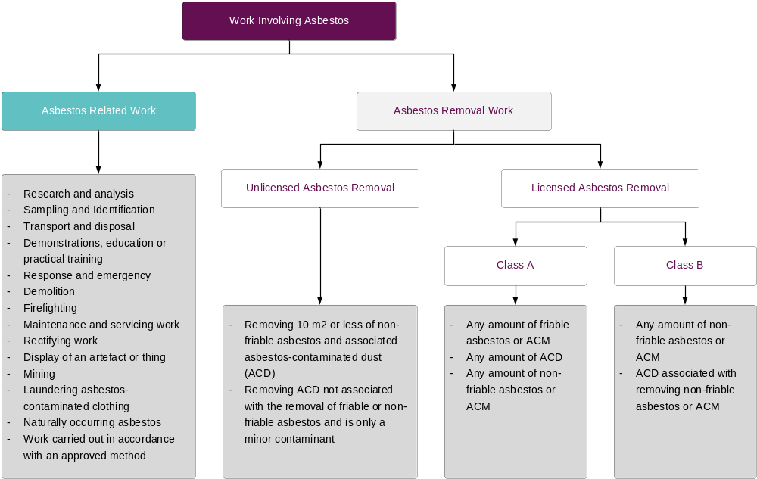
Figure 4 – Work Involving Asbestos, WorkSafe New Zealand, ACOP - Management and Removal of Asbestos
Where work involving asbestos is being undertaken at a school, NZSPA issued guidelines are to be followed and contracted parties should consider controls that exceed the current regulations due to the sensitive nature of the working environment and its occupants.
NZSPA-Asbestos-Removal-Requirements
Licensed Asbestos Removal Class A – The removal of any amount of FRIABLE asbestos containing materials. This work must be carried out by an asbestos removal contractor with:
Licensed Asbestos Removal Class B – The removal of more than 10m2 non-friable asbestos containing materials. This work must be carried out by an asbestos removal contractor with:
Unlicensed: This category covers the removal of 10m2 or less of non-friable asbestos-containing materials throughout the entirety of a project. While we acknowledge that current legislation does not mandate notification to WorkSafe for such work, it's frequently observed that when non-notifiable work is performed at a school, asbestos removal doesn't always adhere to the current approved code of practice. This can result in the school managing a heightened level of risk.
We have taken the position that all unlicensed work should be notified as Class B and adhere to the Class B requirements listed above.
Things to consider when this type of asbestos removal work is carried out.
- No more than 10m2 of non-friable materials can be removed during the project
- Safe removal techniques and control measures are required
- Persons undertaking the task need to be trained for this type of work
- Persons undertaking the task must use appropriate PPE and RPE
- All waste and PPE needs to be double wrapped, sealed in polythene and disposed of in accordance with the Disposal Resource Management Act 1991
- All other risks need to be assessed.
- Health monitoring for the workers is required.

Independent Licensed Asbestos Assessor
Prior to the removal of any high risk ACM a Licensed Asbestos Assessor shall be engaged to work independently of the asbestos removal contractor. The assessor will be responsible for ensuring the asbestos materials removal contractor achieves a satisfactory level of workmanship and complies fully with statutory requirements and the requirements of the Asbestos Removal Scope of Work.

Independence
Where any type of asbestos removal or remediation work takes place at a school, the LAA must be financially independent from the asbestos removalist. Accepted recommendations by the removalist would not be considered best practice and brings in to question the independence of the Licensed Asbestos Assessor to the Licensed Asbestos Removalist.

Asbestos Remediation Risks
All schools are required to prioritise conducting asbestos removal works outside of regular school hours. Exceptions to this mandate must receive approval from the School Property Health and Safety team and will only be granted if they can demonstrate the highest level of safety for individuals on-site.
This requirement primarily aims to safeguard students and other community members from potential exposure to airborne asbestos fibres. Whilst risk controls will always be in place during asbestos removal works (for example, isolation), the dynamic nature of school environments means that additional measures are considered appropriate to ensure the safety of students and the broader community.
The school must also consider the use of its facilities by community groups. As removal works must occur exclusively outside of regular school hours, the school must ensure that no individuals, including external community groups, are present on-site. Asbestos removal works should be scheduled during school holidays or weekends, depending on the volume being removed.
The New Zealand School Property Agency recommends the use of the ‘school letter’ template when informing schools communities about the removal.
Notice-of-Asbestos-Removal-Work.docx

Asbestos Process When Planning a Project Flow Chart
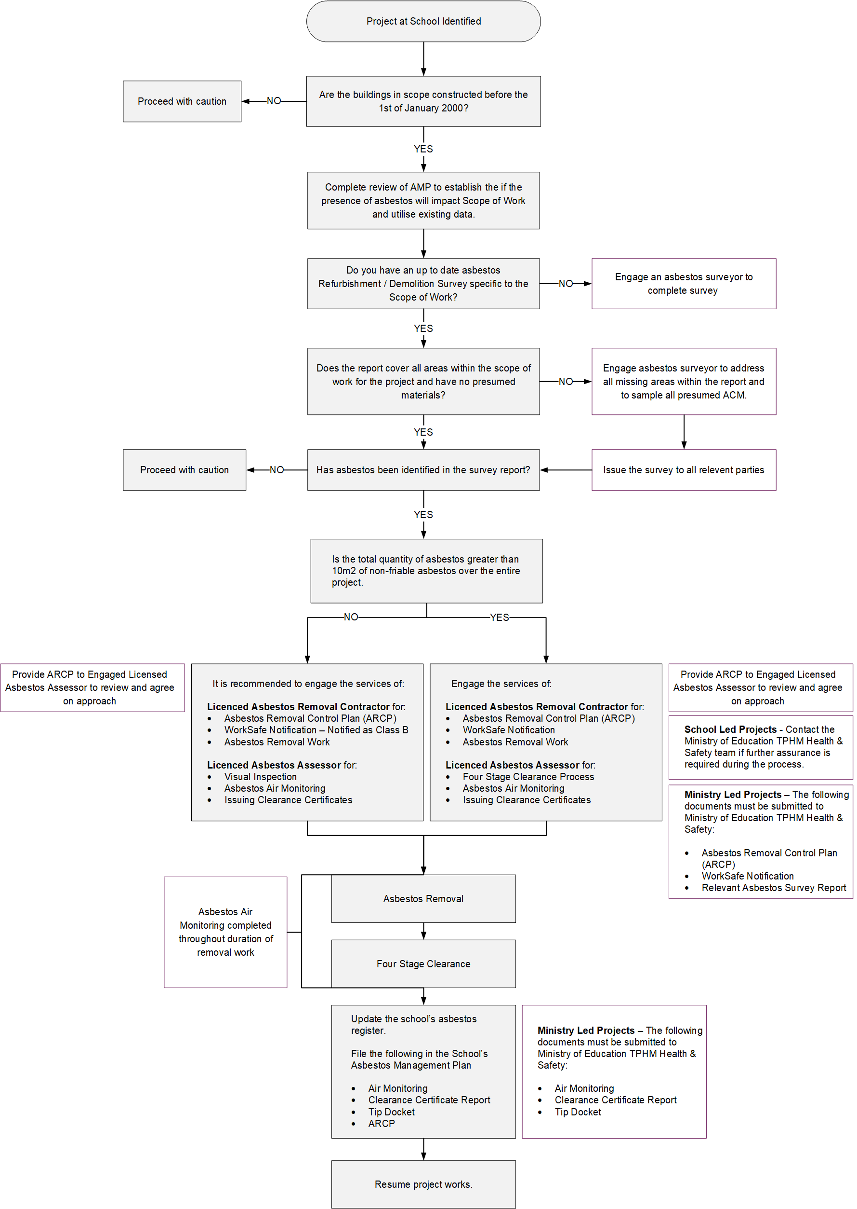

Section 10. Communicating the Presence of Asbestos
New Zealand Health and Safety at Work (Asbestos) Regulations 2016 (Government, 2016) Subpart 2 – Management of asbestos risks
12 Duty to ensure presence and location of asbestos indicated.
- A PCBU with management of control of a workplace must ensure that the presence and location of asbestos or ACM identified at the workplace under regulation 10 are clearly indicated (in a way that complies with the requirements of any applicable safe work instrument).

Asbestos Register
An Asbestos Register is a table that sets out the details of where asbestos is located throughout the buildings and is derived from on-site investigation and sampling and reporting carried out to date.
Where asbestos removal works are undertaken, the Asbestos Register will need to be updated to include the relevant information specific to these works.
The Asbestos Register should form part of the [Insert School Name] Hazard Register.
On arrival to site contractors/workers will be provided the most recent version of the sites asbestos register. The asbestos register should be read in conjunction with the most recent Asbestos Management Survey and all other survey types appended to this AMP. These documents will contain all the associated detailed site plans and photos of all known locations of presumed and confirmed asbestos containing materials present on site.
The contractors/workers will be required to sign and date the contractor register on page 9 confirming that they have read and understood the contents of the register and contents of this AMP.

Labelling and Signage
Labelling increases awareness of the presence of ACM and its location and is deemed the most direct method of warning to users.
The key principles of labelling asbestos are summarised below:
- Labels should be sufficiently durable.
- Labels should be clear and easy to read.
- Labels should be maintained and remain in good condition.
- Labels should be consistent with the location of any asbestos recorded in the Asbestos Register.
- Direct labelling of ACM (if safe to do so) is the most effective means, however, where direct labelling is not possible, labels should be situated as close as possible to the ACM.
- Labels should not be concealed (painted) or covered.
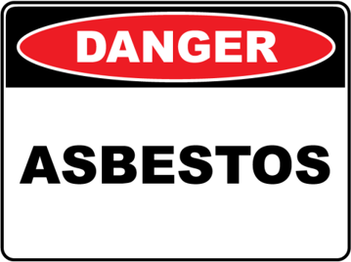 | 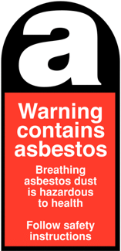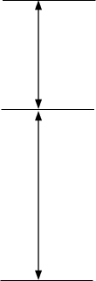 | White ‘a’ on a black background.  40% of total height.  Standard wording in white or black on a red background  60% of total height.
Figure 6 – Examples of asbestos warning signs and stickers / labels.
Initially, individuals should consult the Asbestos Register to ascertain the locations of asbestos-containing materials (ACMs). It is the responsibility of those accessing the workplace to familiarize themselves with the contents of the Asbestos Register, as well as other documents referenced within the Asbestos Management Plan (AMP). They should also conduct their own risk assessment and develop a Site-Specific Safety Plan (SSSP), ensuring that all work is carried out in accordance with relevant guidance material, regulations, and Approved Codes of Practice (ACOP). It's important to note that the information provided in the Asbestos Register takes precedence over labelling.
[Insert School Name] acknowledges the benefits of labelling while exercising caution regarding the potential anxiety labels may provoke. Labels can sometimes create a false sense of security. Moreover, it may not be feasible to label all areas where asbestos has been confirmed or presumed to be present.
To mitigate the risk of inadvertent disturbance, whether mechanical or otherwise, [Insert School Name] will consider the installation of self-adhesive labels or other prominent signage on or near asbestos-containing materials where feasible. The locations of these labels will be documented in a table and optionally marked on site plans within the AMP.

Section 11. Procedures for Incidents and Emergencies
An incident or emergency situation is likely to entail inadvertent disruption to ACM present through the actions of workplace staff, visitors, maintenance personnel, contractors, after-hours vandalism/criminal entry or damage due to inclement weather. Where such events have occurred, this will be considered a health and safety incident and be reported in accordance with [Insert School Name]’s policy for accidents at the workplace.
If for any reason a material is encountered that is suspected of containing asbestos during any works that occur, work must stop immediately. Please notify the Appointed Asbestos Coordinator for the school, and if asbestos/ACM has been disturbed: The process in Figure 7 should be followed.
Where it has been established that asbestos has been disturbed, immediate steps are required to control the risk to people within the local vicinity. Figure 8 below describes the initial actions following identification of potential friable asbestos.

Recording Asbestos Incidents and Emergencies
In the event of an asbestos related incident or emergency the Asbestos Emergency form included at Appendix C should be completed as well as the Contact with Asbestos form included at Appendix D (if an employee of school is inadvertently exposed to asbestos).
All forms will be kept as official records until the AMP is officially updated and these can be filed within the relevant appendix and the asbestos register can be updated.

Recommended Equipment for Dealing with Asbestos Emergencies
It is advisable for the school to acquire a list of the following items and keep stock levels sufficient to assist in the event of an asbestos emergency.
- Asbestos Waste Bags
- P3 disposable masks
- Category 3 type 5/6 suits
- Duct tape
- Low pressure spray bottle
- Disposable rags
- Barrier tape / warning tape

Emergency Procedure for Potential Asbestos Disturbance Flow Chart
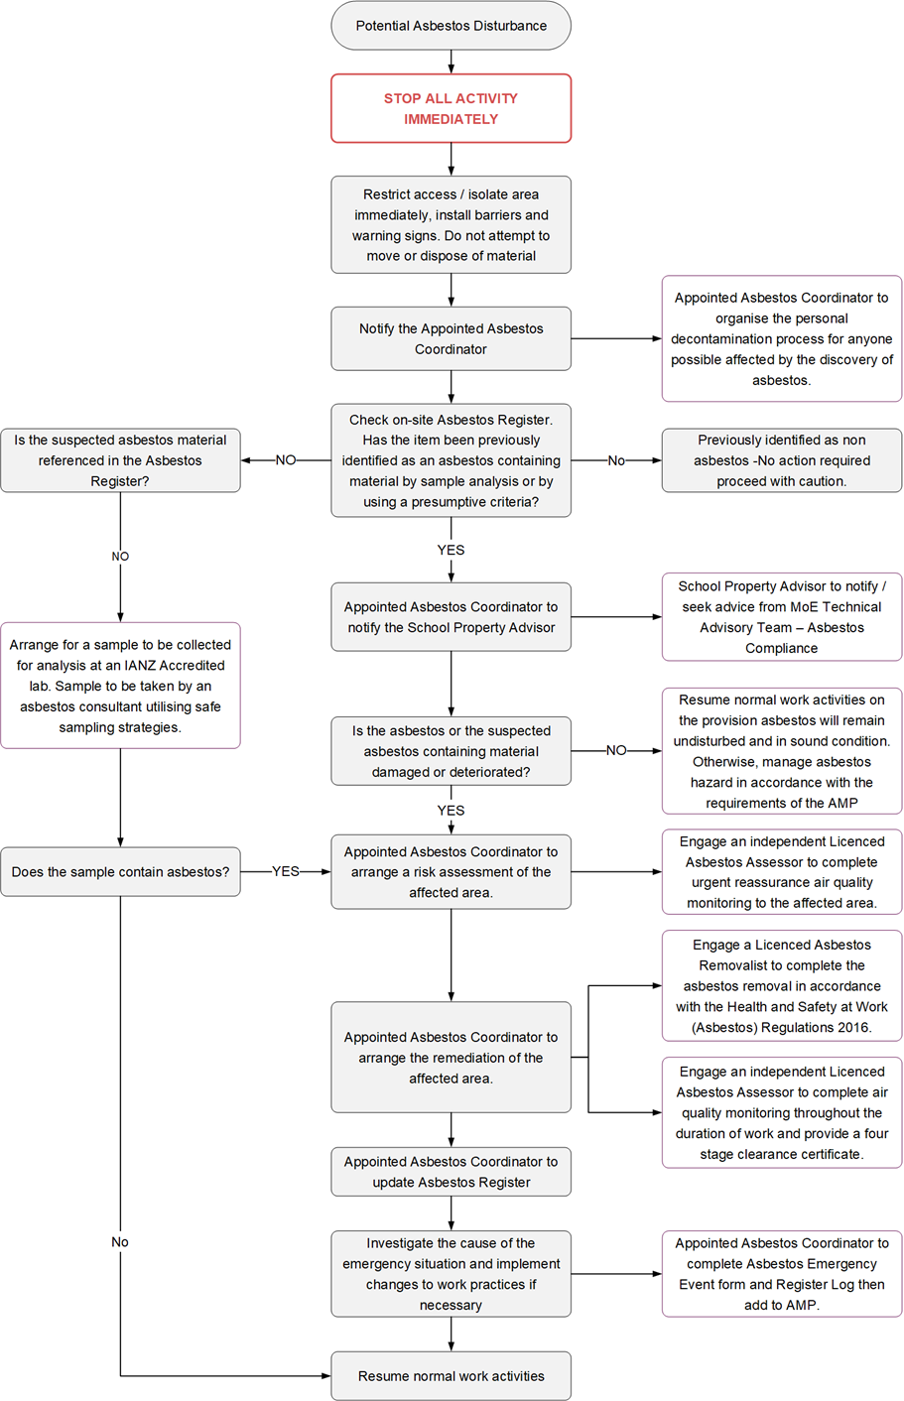

Emergency Procedure Requiring Personal Decontamination Flow Chart
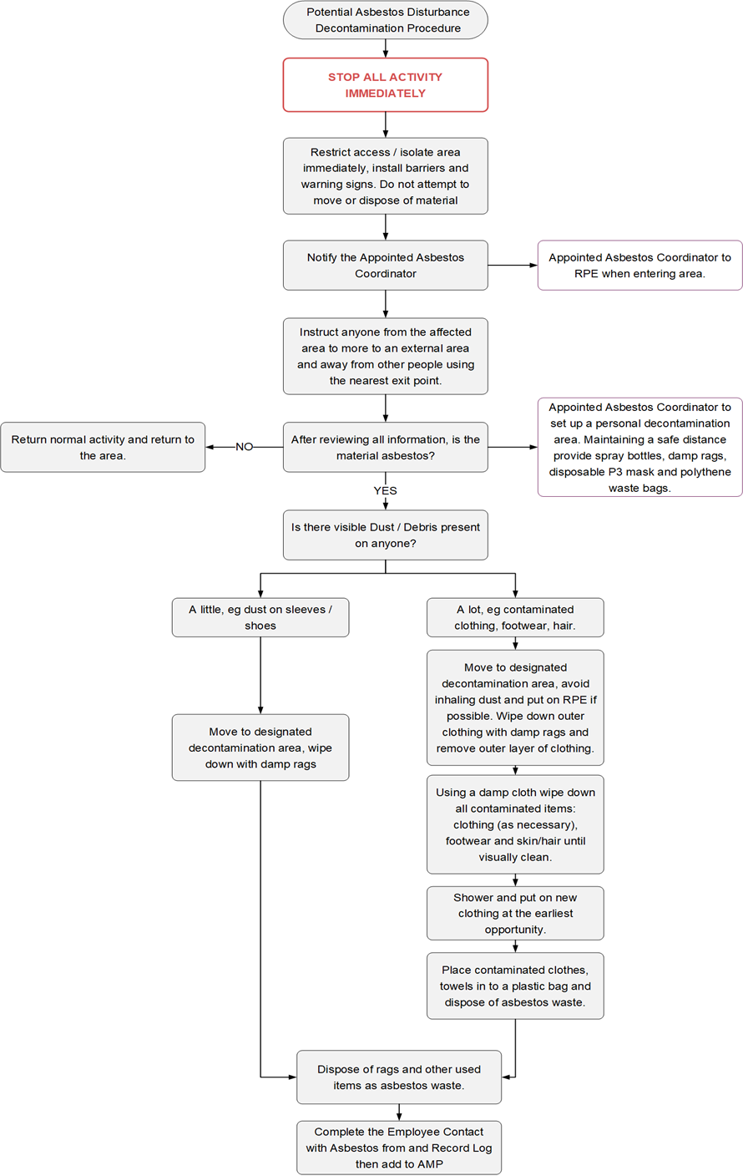

Section 12. Health Monitoring
New Zealand Health and Safety at Work (Asbestos) Regulations 2016 (Government, 2016) Subpart 3 - Health monitoring, training, and use of equipment
15 Duty to provide health monitoring.
- A PCBU must ensure that health monitoring is provided in accordance with regulation 16, and with Part 3 of the Health and Safety at Work (General Risk and Workplace Management) Regulations 2016, to a worker carrying out work for the business or undertaking if the worker is
  - Carrying out licensed asbestos removal work at a workplace and is at risk of exposure to asbestos when carrying out the work; or
  - Carrying out other ongoing asbestos removal work or asbestos-related work and is at risk of exposure to asbestos when carrying out the work.
- For the purposes of subclause (1)(a), the PCBU must ensure that the health monitoring of the worker commences within 4 weeks of the worker starting to carry out licensed asbestos removal work.
[Insert School Name]acknowledges health monitoring guidelines set out by the New Zealand Health and Safety at Works (Asbestos) Regulations 2016 and ACOP.
[Insert School Name] has selected to contract out any licensed asbestos removal work (Class A and Class B) and the risk of [Insert School Name] staff being exposed to airborne asbestos when doing work is considered low, there is no duty for [Insert School Name] to provide health monitoring.

Section 13. Training
New Zealand Health and Safety at Work (Asbestos) Regulations 2016 (Government, 2016) Subpart 3 - Health monitoring, training, and use of equipment
17 Duty to train workers about asbestos.
- In addition to the training required by regulation 9 of the Health and Safety at Work (General Risk and Workplace Management) Regulations 2016, a PCBU must ensure that workers who are engaged by the PCBU and who the PCBU reasonably believes may be involved in asbestos removal work or in the carrying out of asbestos-related work are trained in the identification and safe handling of, and suitable control measures for, asbestos and ACM.
[Insert School Name] acknowledges training guidelines set out by the New Zealand Health and Safety at Works (Asbestos) Regulations 2016 and ACOP.
[Insert School Name] has selected to contract out any licensed asbestos removal work (Class A and Class B) and the risk of [Insert School Name] staff being exposed to asbestos when doing work is considered low. There is no duty for [Insert School Name] to provide training to staff or visitors except for the considered parties below.
Appointed Asbestos Coordinator - Or those undertaking tasks on their behalf should have adequate training for the task carried out. The training required for the Appointed Asbestos Coordinator is:
- Asbestos Awareness Training
External Contractors - If a person’s work may involve them coming into contact with asbestos at the school site, then they should have adequate training. The school may request anyone whose work may involve coming into contact with asbestos to have the following:
- Asbestos Awareness Training
It’s recommended that the school requests evidence of such training and retain a copy of any certificates for future reference.
The type of information requested should be:
- Contractors Name.
- Date of Training
- Description / Type of Training
- Training Provider
- Evidence of Training (any certificates of attainment)

- Asbestos Register
Include the most current version of the Excel Register in this section if printing out

- Asbestos Reports
The following documents will be included within this appendix as or when they are produced.
Asbestos Management Survey.
Asbestos Reinspection Reports.
Asbestos Refurbishment Reports
Asbestos Demolition Reports.
Asbestos Removal Scope of Work Reports.
Asbestos Removal Control Plans.
Asbestos Clearance / Re-Occupation Certificates.
Asbestos Air Quality Monitoring Reports.
Asbestos Sample Reports.
Escalation Reports.

- Asbestos Emergency Event Form

Part A: Personal Details
Name
Address
Email
Mobile
Date of Birth
Position

Part B: Asbestos Exposure if you believe you have been
Where were you exposed to asbestos (School)?
Date/time of exposure
Location (Building name)
Area e.g., roof void:
Was the asbestos containing material friable? | ☐ Yes | ☐ No
Was the Asbestos Management Plan examined prior to commencing work? | ☐ Yes | ☐ No

Part C: Controls to Manage the Emergency
Emergency event | Controls to manage emergency
I hereby declare that the details furnished above are true and correct to the best of my knowledge and belief and I undertake to inform you of any changes therein, immediately. In case any of the above information is found to be false or untrue or misleading or misrepresenting, I am aware that I may be held liable for it.
Contractor name |  | Signature
School representative name |  | Signature

Comments
- Contact with Asbestos Form

Part A: Personal Details
Name
Address
Email
Mobile
Date of Birth
Position

Part B: Asbestos Exposure if you believe you have been
Where were you exposed to asbestos (School)?
Date/time of exposure
Location (Building name)
Area e.g., roof void:
Was the asbestos containing material friable? | ☐ Yes | ☐ No
Was the Asbestos Management Plan examined prior to commencing work? | ☐ Yes | ☐ No

Part C: Controls to Manage the Emergency
Emergency event | Controls to manage emergency
I hereby declare that the details furnished above are true and correct to the best of my knowledge and belief and I undertake to inform you of any changes therein, immediately. In case any of the above information is found to be false or untrue or misleading or misrepresenting, I am aware that I may be held liable for it.
Contractor name |  | Signature
School representative name |  | Signature

Comments
- Material Assessment
This assesses the likelihood of asbestos material to release fibres into the air should it be disturbed. The main parameters that determine the likelihood of the material to release airborne fibres and the relative hazard of the types of fibre released are:
- Product type (e.g., product that contains asbestos).
- Extent of damage or deterioration.
- Surface treatment.
- Asbestos type.
Materials with assessment scores of 10 or more are regarded as having a high potential to release fibres, if disturbed. Scores of between 7-9 are regarded as having a medium potential and between 5-6 a low potential. Scores of 4 or less have a very low potential to release fibres.

Material Assessment Descriptors
Sample Variable | Score | Examples of Scores
Product Type (or Debris from Product) | 1 | Asbestos reinforced composites (plastics, resins, mastics, roofing felts, vinyl floor tiles, semi-rigid paints or decorative finishes, asbestos cement etc)
Product Type (or Debris from Product) | 2 | Asbestos insulating board, mill boards, other low density insulation boards, asbestos textiles, gaskets, ropes and woven textiles, asbestos paper and felt
Product Type (or Debris from Product) | 3 | Thermal insulation (eg pipe and boiler lagging), sprayed asbestos, loose asbestos, asbestos mattresses and packing
Extent of Damage / Deterioration | 0 | Good condition: no visible damage
Extent of Damage / Deterioration | 1 | Low damage: a few scratches or surface marks; broken edges on board, tiles etc.
Extent of Damage / Deterioration | 2 | Medium damage: significant breakage of materials or several small areas where material has been damaged revealing loose asbestos fibres
Extent of Damage / Deterioration | 3 | High damage or delamination of materials, sprays and thermal insulation. Visible asbestos debris.
Surface Treatment | 0 | Composite materials containing asbestos: reinforced plastics, resins, vinyl tiles
Surface Treatment | 1 | Enclosed sprays and lagging, asbestos insulating board (with exposed face painted or encapsulated), asbestos cement sheets etc.
Surface Treatment | 2 | Unsealed asbestos insulating board, or encapsulated lagging and sprays
Surface Treatment | 3 | Unsealed laggings and sprays
Asbestos Type | 1 | Chrysotile only
Asbestos Type | 2 | Amphibole asbestos excluding crocidolite
Asbestos Type | 3 | Crocidolite or mixture of Crocidolite with any other asbestos type
Total |  | Maximum Score of 12
- Priority Assessment
The priority assessment considers various human factors in order to modify the priority assigned by the material assessment. Parameters, which are considered include:
- The location of the material.
- Its extent.
- The use to which the location is put.
- The level of occupancy of the area.
- The activities carried on in the area.
- The likelihood/frequency with which maintenance activities are likely to take place.
Assessment Parameter | Score | Examples of Score
Normal Occupant Activity
Main Type of Activity in Area | 0 | Rare disturbance activity (eg little used store room)
Main Type of Activity in Area | 1 | Low disturbance activities (eg office type activity)
Main Type of Activity in Area | 2 | Periodic disturbance (eg industrial or vehicular activity which may cause contact with ACMs)
Main Type of Activity in Area | 3 | High levels of disturbance, (eg fire door with asbestos insulating board sheet in constant use)
Likelihood of Disturbance
Location | 0 | Outdoors
Location | 1 | Large Rooms or well-ventilated areas
Location | 2 | Rooms up to 100 sq metres in area
Location | 3 | Restricted or confined areas
Accessibility | 0 | Usually inaccessible or unlikely to be disturbed
Accessibility | 1 | Occasionally likely to be disturbed
Accessibility | 2 | Easily disturbed
Accessibility | 3 | Routinely disturbed
Extent / Amount | 0 | Small amounts or single items (eg strings, gaskets)
Extent / Amount | 1 | Less than 10 sq metres area, or 10 metre pipe run
Extent / Amount | 2 | 10 to 50 sq metres area or 10 to 50 metres pipe run
Extent / Amount | 3 | More than 50 sq metres, or 50 metres pipe run
Average Score |  | Average of scores for Location, Accessibility and Extent / Amount, Maximum score of 3
Human Exposure Potential
Number of Occupants | 0 | None
Number of Occupants | 1 | 1 to 3
Number of Occupants | 2 | 4 to 10
Number of Occupants | 3 | More than 10
Frequency of Use of Area | 0 | Infrequent
Frequency of Use of Area | 1 | Monthly
Frequency of Use of Area | 2 | Weekly
Frequency of Use of Area | 3 | Daily
Average Time Area is in Use | 0 | Less than 1 hour
Average Time Area is in Use | 1 | 1 to less than 3 hours
Average Time Area is in Use | 2 | 3 to less than 6 hours
Average Time Area is in Use | 3 | More than 6 hours
Average Score |  | Average of scores for Number of Occupants, Frequency of Use of Area, and Average Time Area is in Use - Maximum score of 3
Maintenance Activity
Type of Maintenance Activity | 0 | Minor disturbance (e.g. possibility of contact when gaining access)
Type of Maintenance Activity | 1 | Low disturbance (e.g. changing light bulbs in asbestos insulating board ceiling)
Type of Maintenance Activity | 2 | Medium disturbance (e.g. lifting one or two asbestos insulating board ceiling tiles to access a valve)
Type of Maintenance Activity | 3 | High levels of disturbance (e.g. removing a number of asbestos insulating board ceiling tiles to replace a valve or for recabling)
Frequency of Maintenance Activity | 0 | Unlikely - almost never
Frequency of Maintenance Activity | 1 | Less than once a year
Frequency of Maintenance Activity | 2 | Less than once a month
Frequency of Maintenance Activity | 3 | More often than once a month
Average Score |  | Average of scores for Type of Maintenance Activity and Frequency of Maintenance Activity - Maximum score of 3
Total Score

- Definitions
AASL – Accredited Asbestos Services List | A New Zealand School Property Agency supplier list established to support the procurement of asbestos-related services across the school property portfolio. The AASL contains suppliers that have undergone a technical review against NZSPA-defined requirements. Inclusion on the AASL does not replace legislative obligations, licensing requirements, competency assessments, or contractor due diligence.
ACD | Asbestos containing dust or debris that has settled within a workplace and is (or is assumed to be) contaminated with asbestos.
ACM | Asbestos containing material(s).
Air Monitoring | Air monitoring involves sampling airborne asbestos fibres to assist in assessing exposure to asbestos and the effectiveness of implemented control measures.
Airborne Asbestos Fibres | Fibres of asbestos small enough to become airborne.
AMP | Asbestos Management Plan.
Amosite | Also called brown asbestos. Amosite asbestos offered good tensile strength and heat resistance.
Approved Code of Practice (ACOP) | The Code of Practice for the Management and Removal of Asbestos sets out WorkSafe NZ’s expectations in relation to identifying and controlling the work health and safety risks arising from asbestos, in order to help PCBU’s and workers achieve compliance with the Health and Safety at Work (Asbestos) Regulations 2016.
ARSW | Asbestos Remediation Scope of Work
AER | Asbestos Escalation Report
Asbestos Removalist | A company whose business or undertaking includes asbestos removal work and holds a current Asbestos Removal License issued by WorkSafe NZ.
Asbestos Removal Control Plan | A plan that is typically prepared by the licensed asbestos removalist to comply with Section 32 of the New Zealand Health and Safety at Work (Asbestos) Regulations 2016 and includes details of how asbestos removal will be managed and carried out.
Asbestos Work Area | The immediate area where work on ACM is occurring.
Bonded Asbestos | Material where the asbestos fibres are bound by cement, vinyl, resin or other similar material matrix.
Chrysotile | Also called white asbestos. This is the most commonly used form of asbestos. Chrysotile asbestos is the type usually present in ACM in New Zealand buildings.
Clearance Inspection | An inspection done by an independent Licensed Asbestos Assessor to verify that an asbestos area is safe to reoccupy after asbestos work is completed. Clearance inspection must include visual inspection and may include clearance monitoring and/or dust sampling.
Clearance Air Monitoring | Air monitoring using static or positional samples to measure the level of airborne asbestos fibres in an area following work on ACM. An area is considered clear when the fibre count is measured as below 0.01 fibres/ml.
Control Monitoring | Air monitoring using static or positional samples to measure the level of airborne asbestos fibres in an area during work on ACM. Control monitoring is used to assess the effectiveness of control measures, not personal exposure, and to give added assurance to the school community.
Crocidolite | Also called blue asbestos. Crocidolite is considered to be the most dangerous type of asbestos due to the fact that fibres are sharp and needle-like.
CSI | Contaminated Site Investigation
DSI | Detailed Site Investigation – an intrusive ground investigation to identify potential land contamination.
Exposure Monitoring | Air monitoring within the breathing zone of a person to measure the level of respirable airborne asbestos fibres in an area (usually a work zone) – also referred to as personal monitoring. Exposure monitoring results are directly comparable to the airborne contamination standard.
Friable | In relation to asbestos or ACM, in a powder form or able to be crumbled or pulverised or reduced to a powder by hand pressure when dry.
Non-Friable | In relation to asbestos or ACM, when dry may not be crumbled, pulverised or reduced to powder by hand pressure.
Health Monitoring | In relation to an individual, means monitoring of the individual to identify any changes in his or her health status because of exposure to certain health hazards.
HEPA Filter | High Efficiency Particulate Air filter is at least 99.97% efficient at collecting an aerosol particulate 0.3 micrometre in size, meeting requirements of the ACOP for vacuum filtration performance.
HSG264  UK Publication | Asbestos: The Survey Guide
HSG227  UK Publication | A comprehensive guide to Managing Asbestos in premises.
HSG248  UK Publication | Asbestos: The Analysts’ Guide (second edition)
High Risk | Asbestos materials that pose a high health risk to personnel or the public in the area of the material – there is a high potential for the material to release asbestos fibres, if disturbed.
LAA - Licensed Asbestos Assessor | Person licensed under WorkSafe NZ to provide asbestos assessment services including but not limited to, asbestos surveys/reports, air monitoring during Class A asbestos removal work, clearance inspections for Class A asbestos removal work and issue clearance certificates for Class A asbestos removal work.
LAR - Licensed Asbestos Removalist | A company whose business or undertaking includes asbestos removal work and holds a current Asbestos Removal License issued by WorkSafe, appropriate for the Class of work being performed.
New Zealand Health and Safety at Work (Asbestos) Regulations 2016 | Mandatory regulations governing all work involving asbestos in New Zealand
HSWA 2015 | Health and Safety at Work Act, WorkSafe New Zealand 2015
PCBU | Person Conducting a Business or Undertaking.
PPE/RPE | Personal Protective Equipment / Respiratory Protective Equipment, which refers to anything used or worn by a person (including clothing) to minimise risks to the person’s health and safety and includes air-supplied respiratory equipment.
Suitably Qualified Asbestos Surveyor | Individuals that can demonstrate that they have sufficient competency to conduct specified surveys through a combination of qualifications and experience. The most widely-held training qualification is BOHS Proficiency Module P402: Surveying and Sampling Strategies for Asbestos in Buildings. The P402 is a basic minimum qualification for individuals carrying out asbestos surveys and on its own it does not demonstrate competency. Therefore, in addition, individuals should also have a minimum of six months practical experience of carrying out asbestos surveys under the supervision of experienced and suitably qualified personnel.
Trace Level | In air, an average concentration over any 8-hour period of less than 0.01 respirable asbestos fibres per millilitre of air.
Asbestos-related Work | Work that would normally be prohibited under the Asbestos Regulations 2016 without controls under a safe work practice by workers who hold asbestos awareness training. It relates to work that is minor or low risk.



