


Drinking Water Safety Plan
  - <School Name>



Revision Number | Date | Description

 | Name | Date
Prepared by
Approved by | <School Name> Board
Version number

Contents
1. School Details 6
1.1 Background and Population 6
1.2 Key Contacts 6
2. Description of Water Supply 8
2.1 Source 8
2.2 Treatment 8
2.3 Storage 11
2.3.1 Untreated water storage 11
2.3.2 Treated water storage 12
2.4 Distribution System 13
2.4.1 Backflow Prevention 13
2.5 Aerial View and Schematic of Water Supply 14
2.6 Daily Water Demand and Storage Requirements 15
2.6.1 Untreated Water Storage 16
2.6.2 Treated Water Storage 17
2.7 Resource Consent 17
2.8 Te Mana O Te Wai 18
3. Source Water Risk Management Plan 19
3.1 Catchment Description 19
3.2 Impact of Catchment Activities on Water Quality 19
3.3 Water Quantity Available From Source 20
3.4 Climate Change Impacts 20
3.5 Cyanobacteria 21
4. Risks and Improvement Actions 22
4.1 Risk Assessment 22
4.2 Improvement Actions 0
5. Compliance, Maintenance and Reporting 1
5.1 Compliance 1
5.2 Operations and Maintenance Activities 1
5.3 Previous Water Quality Issues 1
5.4 Monitoring and Reporting 1
6. Contingency Plans 3
7. Review 6
8. Useful Links 7
Taumata Arowai 7
Legislation and Regulations 7
New Zealand School Property Agency 7
Appendix A - Maintenance and Servicing 0
Appendix B - Operations and Maintenance 0
Appendix C - 1
List of Tables
Table 1-1: School background, population and building information 2
Table 1-2: Key contact information 2
Table 2-1: Details of the surface water supply 4
Table 2-2: Details of pretreatment process 5
Table 2-3: Details of the cartridge filtration system 5
Table 2-4: Details of the UV disinfection system 6
Table 2-5: Details of chlorine residual disinfection 6
Table 2-6: Water treatment plant housing details 6
Table 2-7: Untreated water storage tank details 7
Table 2-8: Treated water storage tank details 8
Table 2-9: Medium or high hazard backflow activities connected to the school's treated water supply 9
Table 2-10: Daily water demand 12
Table 2-11: Untreated water storage requirements 12
Table 2-12: Untreated water storage installed at the school. 12
Table 2-13: Treated water storage requirements 13
Table 2-14: Treated water storage installed at the school. 13
Table 3-1: Previous water quantity issues 16
Table 4-1 Risks and improvement actions 0
Table 4-2: Summary of improvement measures the school will take to minimise risks 0
Table 5-1: Previous water quality issues 1
Table 6-1: Contingency plans for the school water supply 3
List of Figures
Figure 2-1: Water supply intake, treatment and storage locations 11
Figure 2-2: School water supply and treatment schematic 11
Figure 3-1: Aerial image showing the location of the surface water take and its catchment area 15

- School Details
  - Background and Population
Table 1-1: School background, population and building information
School name | Provide details.
Number of people served by the water supply | - Students and Staff (current) –  - Students and Staff (future – 2033) –  - Houses –  - Other –  - Total (P) –
Peak population (e.g. during events) | Provide details.
Number of buildings supplied with drinking water | Insert number of buildings
Supply category | Choose an item.  Supply Category:  If ≤100 people: Select Rules – Small  If 101 - 500 people: Select Rules – Medium  If >500 people: Select Rules - Large
Other components supplied with drinking water | insert other supplied components e.g., swimming pool, irrigation system.
Address | Provide details.
Hinekōrako Code | Provide details.

  - Key Contacts
Table 1-2: Key contact information
Role and organisation | Name | Contact details
Caretaker | Provide details. | Email: Provide details.  Phone: Provide details.  Mobile: Provide details.
Plumber | Provide details. | Email: Provide details.  Phone: Provide details.  Mobile: Provide details.
Maintenance Contractor | Provide details. | Email: Provide details.  Phone: Provide details.  Mobile: Provide details.
Registered Water Carrier | Provide details. | Email: Provide details.  Phone: Provide details.  Mobile: Provide details.
New Zealand School Property Agency | Water Services Team | Email: water.services@schoolproperty.govt.nz
School to add more rows and details as applicable, otherwise delete this row. | Provide details. | Email: Provide details.  Phone: Provide details.  Mobile: Provide details.

- Description of Water Supply
  - Source
The school sources its water from a surface water supply. The details of the supply are summarised in Table 2-1.
Table 2-1: Details of the surface water supply
Water source | Surface water
Source name | Insert the source name (e.g. river, stream or lake).
Property owner of land on which the water abstraction point is located | Provide details.
Intake type | Choose an item.
Intake details | Provide details.
Intake protection | ☐ The intake type reduces the likelihood of weed and debris clogging the water supply pump.  ☐ The intake type prevents fish and other aquatic organisms being sucked from the water.
Supply pump details | Provide details.  EXAMPLE
Photo of surface water take | 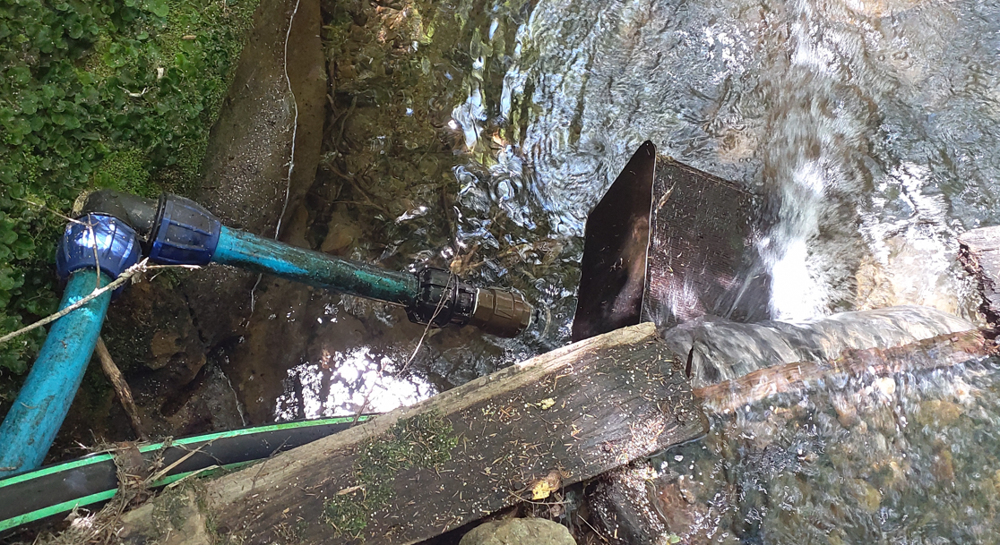

  - Treatment
The school water treatment plant consists of the following components:
Check the box if installed at school:
☐ Pretreatment
☐ Cartridge filtration
☐ UV disinfection
☐ Residual chlorination
Details about each of the main treatment components and the treatment plant housing can be found in the tables below.
Table 2-2: Details of pretreatment process
Copy this table until each pretreatment process has its own table.
Pretreatment type | Choose an item.
Pretreatment process details | Provide details.
Photo of pretreatment process | 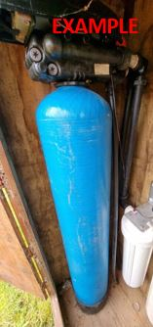
Table 2-3: Details of the cartridge filtration system
Number of cartridge filters | Provide details.
Cartridge filter pore size:  (check boxes that apply) | ☐ 20 micron  ☐ 5 micron  ☐ 1 micron  ☐ Other - Provide details.
Is differential pressure measured across each filter? | Choose an item.
Photo of cartridge filters | 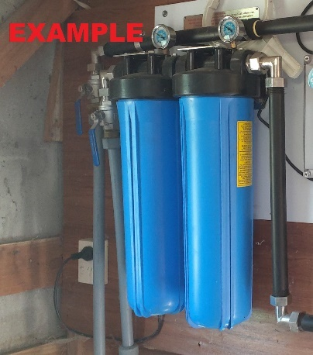
Table 2-4: Details of the UV disinfection system
UV unit make and model | Provide details.
Validation Standard | Choose an item.
Does flow through the UV unit stop automatically on low UV intensity (UVI) or low dose (e.g., via a solenoid valve)? | Choose an item.
Is there a lamp status indication? | Choose an item.
Is there an alarm? | Choose an item.
How often is the UV unit serviced? | Choose an item.
Photo of UV system | 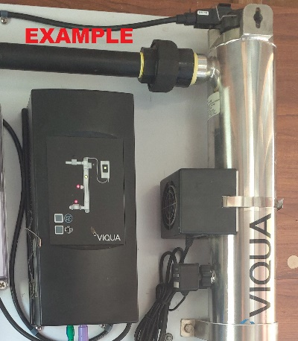
Table 2-5: Details of chlorine residual disinfection
Remove this table if there is no chlorine residual dosing.
Chlorine type | Choose an item.
Target chlorine residual concentration for water leaving the treatment plant | Choose an item.
Target chlorine residual concentration for water in the distribution system | Choose an item.
Photo of residual disinfection system | 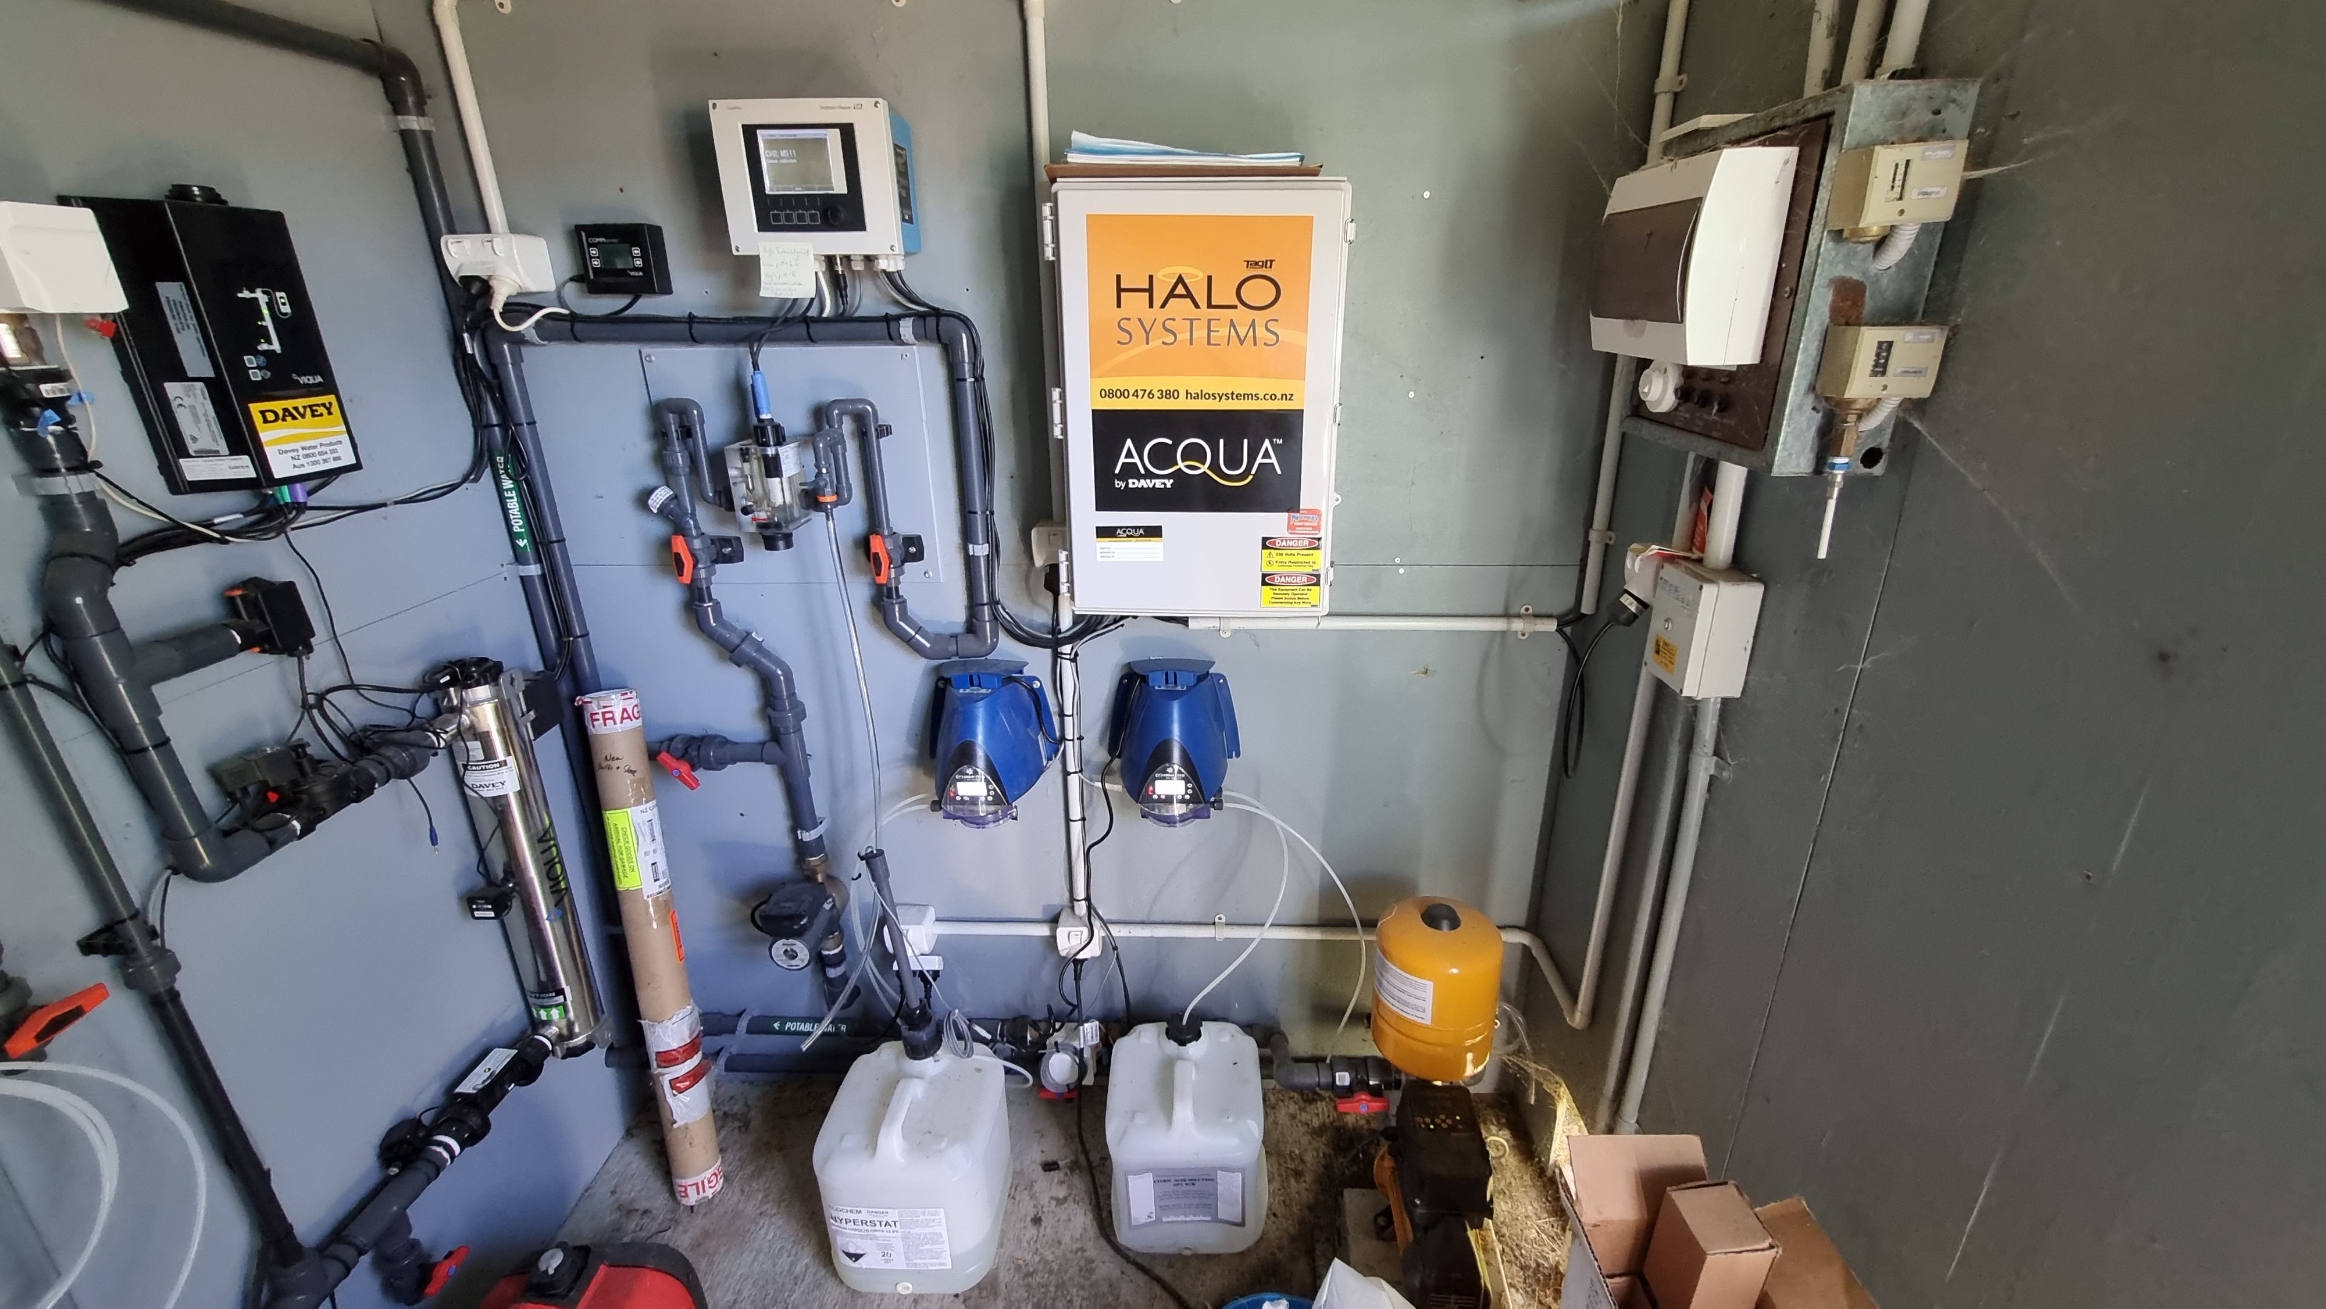  EXAMPLE
Table 2-6: Water treatment plant housing details
Treatment plant housing (e.g., locked shed) | Provide details.
Photo of treatment plant housing
  - Storage
    - Untreated water storage
The school has a total of insert volume L untreated water storage. To prevent contamination of the untreated water, it is important that the tanks are in average or good condition, have vermin protection in place and have secure lids. Details of the untreated storage tank(s) are provided in the table(s) below.
Table 2-7: Untreated water storage tank details
Copy this table until each untreated water tank has its own table.
Tank number | Provide details.
Volume (L) | Choose an item.
Material | Choose an item.
Condition | Choose an item.
Year installed | Provide details.
Vermin protection | Check boxes that apply:  ☐ All lids secured  ☐ All vents, overflows and gaps screened with mesh with a maximum mesh size of 1.5 mm (or a flap valve is installed on the overflow)  ☐ Other - Provide details.
Photo of tank
    - Treated water storage
The school has a total of insert volume L treated water storage. To prevent contamination of the treated water, it is important that the tanks are in average or good condition, have vermin protection in place and have secure lids. Details of the treated storage tank(s) are provided in the table(s) below.
Table 2-8: Treated water storage tank details
Copy this table until each treated water tank has its own table. If none, delete the table and amend the text above to say that there are no treated water storage tanks
Tank number | Provide details.
Volume (L) | Choose an item.
Material | Choose an item.
Condition | Choose an item.
Year installed | Provide details.
Vermin protection | Check boxes that apply:  ☐ All lids secured  ☐ All vents, overflows and gaps screened with mesh with a maximum mesh size of 1.5 mm (or a flap valve installed on the overflow)
Photo of tank
  - Distribution System
    - Backflow Prevention
Backflow into the drinking water supply can present a risk if contaminated water enters the treated water distribution system. This can affect both the quality and safety of the water supply.
All hose taps in the school Choose an item. have a permanently attached hose connection vacuum breaker.
If there are no high or medium risk activities at the school, delete the rest of this section and replace with the following sentence:
The water supply has no medium or high hazard activities occurring that require a backflow prevention device.
The water supply medium or high hazard backflow activities that require a backflow prevention device are captured in the table below.
Refer to NZ Building Code Acceptable Solutions and Verification Methods – Clause G12 Water Supplies for more information about backflow prevention hazards and backflow prevention devices.
As a minimum, every hose tap needs a permanently attached hose connection vacuum breaker (unless the tap is associated with a medium or high hazard, in which case a backflow prevention device is needed as per Clause G12 and the following table).
Delete the rows in the following table that aren’t applicable.
Table 2-9: Medium or high hazard backflow activities connected to the school's treated water supply
Activity | Hazard | Type of backflow prevention device required | Type of backflow prevention device installed | Listed on Argest register | Meets require-ments?
Swimming pool | Medium | Testable double check valve, reduced pressure zone (RPZ) device or air gap | Choose an item. | Choose an item. | Choose an item.
Dental clinic | High | Reduced Pressure Zone device or air gap | Choose an item. | Choose an item. | Choose an item.
Farm trough | Medium | Testable double check valve, reduced pressure zone (RPZ) device or air gap | Choose an item. | Choose an item. | Choose an item.
Laboratory | Medium | Testable double check valve, reduced pressure zone (RPZ) device or air gap | Choose an item. | Choose an item. | Choose an item.
Untreated water storage tanks connected to treated water distribution (i.e., not source water storage tanks) | Medium | Testable double check valve, reduced pressure zone (RPZ) device or air gap | Choose an item. | Choose an item. | Choose an item.
Irrigation | Medium | Testable double check valve, reduced pressure zone (RPZ) device or air gap | Choose an item. | Choose an item. | Choose an item.
Fire sprinkler system | Medium | Testable double check valve, reduced pressure zone (RPZ) device or air gap | Choose an item. | Choose an item. | Choose an item.
Boiler feed water | High | Reduced Pressure Zone device or air gap | Choose an item. | Choose an item. | Choose an item.
Hose taps used for mixing pesticides | High | Reduced Pressure Zone device or air gap | Choose an item. | Choose an item. | Choose an item.
If there is a backflow hazard and the backflow prevention does not meet requirements, capture this in the risk table and improvements table in Section 4.
  - Aerial View and Schematic of Water Supply
An aerial image of the school showing key features of the water supply, and a schematic showing the details of the water supply, are shown in the figures below.
Figure 2-1: Water supply intake, treatment and storage locations
Replace this figure with the school’s top view annotated to show surface water take location, tanks and water treatment plant (and water pipes if their location is known). This can also be done by hand and included as an Appendix. If this is the case, reference the appendix number here.
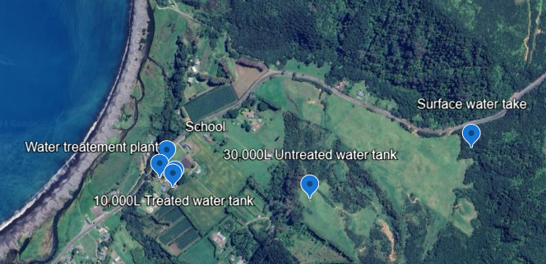
Figure 2-2: School water supply and treatment schematic
Replace this schematic with one of the examples provided. Use the one which is closest and adjust it to be a true representation of the school’s water supply and treatment.
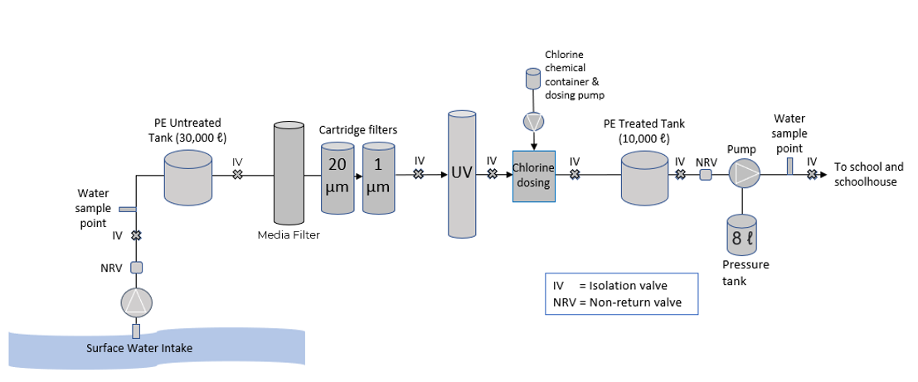
  - Daily Water Demand and Storage Requirements
The estimated daily demand for the water supply is calculated by using the School Water Upgrades Design Guidance (WSP, 2023). An average use of 20 L/person/day is assumed based on average condition of the network / standard fittings and fixtures. The estimated daily water demand (Q) is the total population (P) multiplied by average use (A). This is captured in the table below.
Table 2-10: Daily water demand
Number of people served by the supply (P) | Provide details.
Average use (A) | 20 L/person/day
Estimated daily demand (Q = P x A) | Provide details. L/day.
    - Untreated Water Storage
The New Zealand School Property Agency recommends that self-supplying schools relying on surface water store enough untreated water to meet the school’s demand for a minimum of 7 days.
The volume of untreated drinking water storage required (VU) is the estimated daily demand (Q) multiplied by the number of days untreated water storage is required for (RU). This is captured in the table below.
Table 2-11: Untreated water storage requirements
Requirement for untreated water storage (RU) for surface water supplied schools | 7 days
Minimum volume untreated drinking water required (VU = Q x RU) | Provide details. L
The untreated water storage installed at the school is summarised in the table below.
Table 2-12: Untreated water storage installed at the school.
Untreated water storage installed at the school (U) | Provide details. L
This provides untreated water storage for (DU = U/Q) | Provide details. days
<Check the box that currently applies to the school:>
☐ There is enough untreated water to meet the New Zealand School Property Agency’s requirements.
☐ To meet the requirements an additional insert volume L of untreated water storage is to be installed.
Ensure upgrade requirements are reflected in the risk register and improvement actions in Section 4.
    - Treated Water Storage
NZSPA recommends that self-supplying schools store enough treated drinking water for three days, both to minimise disruption if there is a treatment plant outage and to provide enough during an emergency. The volume of treated drinking water storage required (VT) is the estimated daily demand (Q) multiplied by the number of days treated water storage is required for (RT). This is captured in the table below.
Table 2-13: Treated water storage requirements
Requirement for treated water storage (RT) | 3 days
Minimum treated drinking water required (VT = Q x RT) | Provide details. L
Treated water tank size required | Choose an item.
The treated water storage installed at the school is summarised in Table 2-14.
Table 2-14: Treated water storage installed at the school.
Treated water storage installed (T) | Provide details. L
This provides treated water storage for (DT= T/Q) | Provide details. days
<Check the box that currently applies to the school:>
☐ There is enough treated water to meet NZSPA’s requirements.
☐ To meet the requirements an additional insert volume L of treated water storage is to be installed.
Ensure upgrade requirements are reflected in the risk register and improvement actions in Section 4.
  - Resource Consent
Given that the school water source is surface water, a resource consent might be required for the source water. <Check the box that applies to the school:>
Check with the regional council whether a consent is required or not.
☐The surface water take does not require a resource consent.
☐The school has a resource consent for the surface water take and the consent number is Provide details.
☐The surface water take requires a resource consent, but the school does not have a consent. Applying for a consent has been added to the improvement plan in section 4.2.
  - Te Mana O Te Wai
The National Policy Statement for Freshwater Management is that freshwater is managed in a way that gives effect to Te Mana o te Wai. Te Mana o te Wai recognises that protecting the health of freshwater protects the health and well-being of the wider environment. It sets the following hierarchy of obligations:
- ‘First, the health and well-being of water bodies and freshwater ecosystems; and
- Second, the health needs of people (such as drinking water); and
- Third, the ability of people and communities to provide for their social, economic, and cultural well-being, now and in the future.’
The school gives effect to Te Mana o Te Wai in the following ways:
Check the boxes that demonstrate the school is taking care of water and the environment. Where improvements are planned, check those boxes and copy the improvements into the improvements table in Section 4.
☐ Wastewater is treated and disposed of appropriately to avoid contaminating surface water and groundwater and to minimise other adverse effects.
☐ Water is used carefully and efficiently.
☐ There is no obvious leakage and leaks are fixed promptly.
☐ Having water-efficient devices (e.g. no old-style urinals or single flush toilets).
☐ Dangerous chemicals are handled with care.
The school plans to improve the way it gives effect to Te Mana o Te Wai in the following ways:
☐ Taking care with water use and only using what is needed.
☐ Fixing all leaks promptly.
☐ Installing water-efficient devices (e.g. push button taps, dual flush toilets).
☐ Handling dangerous chemicals with care.
☐ Upgrading the wastewater system to achieve compliance.

- Source Water Risk Management Plan
  - Catchment Description
The school is in the insert region region. The catchment for the drinking water supply includes the catchment of the streams upstream of the intake. This Source Water Risk Management Plan (SWRMP) considers the entire catchment of the surface water intake.
Figure 3-1 shows the location of the surface water take and its catchment in relation to the surrounding area.
Figure 3-1: Aerial image showing the location of the surface water take and its catchment area
Replace this aerial image with an aerial image which shows the surface
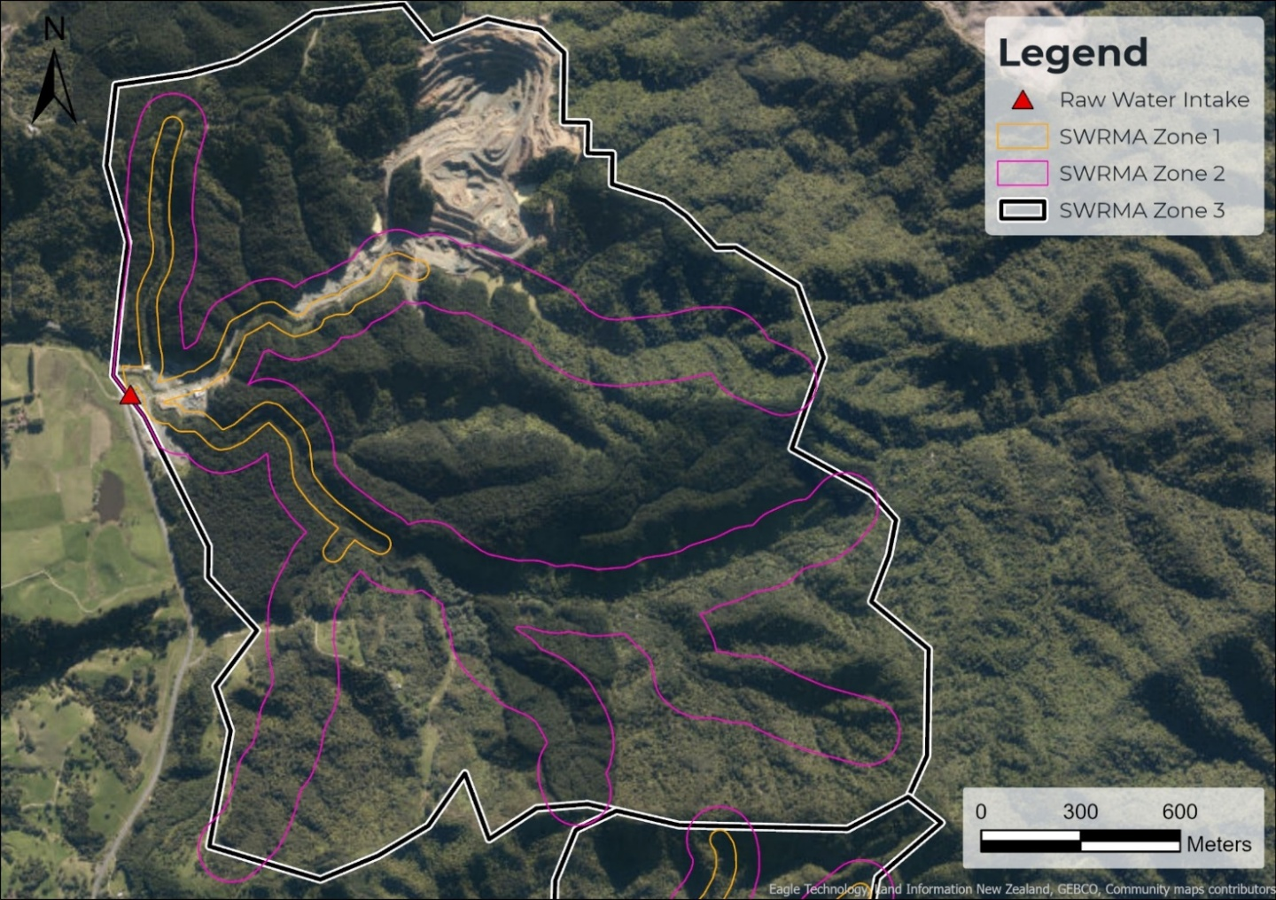
  - Impact of Catchment Activities on Water Quality
Given that the school’s drinking water is supplied by surface water, the following activities within the catchment area may impact the water quality: <check all boxes that apply>
☐ Livestock
☐ Wastewater effluent disposal
☐ Intensive agricultural land use or areas where animal effluent is irrigated to land
☐ Forestry
☐ Contaminated sites
☐ Landfill
☐ Cemetery / urupā
☐ Areas where pesticides are applied
☐ Geothermal water
☐ Saline water (i.e. sea or estuary)
The school plans to reduce the contamination risk in the area around the surface water take as follows: <check all boxes that apply>
☐ Monitor source water in line with the Drinking Water Quality Assurance Rules
☐ Perform regular inspections of the surface water intake to identify maintenance requirements and potential contamination risks
☐ Investigate an alternative water source
☐ Add any additional activities as required
Ensure upgrade requirements are reflected in the risk register and improvement actions in Section 4.
  - Water Quantity Available From Source
Table 3-1: Previous water quantity issues
Has there been a problem with lack of water over the past ten years? | Choose an item.
If yes, provide details: | Provide details or N/A
If yes, have there been any improvements to address these or are there any planned? | Provide details or N/A
  - Climate Change Impacts
Climate related factors influencing catchment conditions and water demand include rainfall and temperature. With climate change, rainfall patterns are expected to become more variable and total annual rainfall will drop in some areas (particularly the east coast and the north of the North Island), which will mean that surface water sources may be impacted. More intense storms may increase turbidity and make the water more difficult to treat. In addition, increasing temperatures may lead to an increased demand on the water supply, particularly if it is used for outdoor uses such as irrigation and/or a swimming pool. In the future, the school may need to increase the amount of water abstracted from the surface water source and/or find an alternative source, to continue to provide a reliable water supply.
  - Cyanobacteria
Given that the school is supplied by a surface water source exposed to sunlight, there is a moderate to high risk of cyanobacteria blooms forming in the source. <check whichever box that applies>
☐ As this a small water supply, the water within 50 m of the intake must be visually inspected for the presence of benthic cyanobacteria mats and planktonic cyanobacterial growth, every month from October to May. If there is evidence of cyanobacterial growth, steps must be taken to evaluate the cyanotoxin risk to consumers. If there is a risk of supplying water with cyanotoxins that exceed the Maximum Acceptable Value (MAV) in the Drinking Water Standards, abstraction of the water must cease until the risk is no longer present. The school will need to provide an alternative water supply (e.g. tankered water from a registered water carrier) in the meantime.
☐ As this is a medium/large supply, a cyanobacteria/cyanotoxin response plan must be prepared which includes vigilance levels for assessing the presence of cyanobacteria and alert levels related to the presence of cyanotoxins, monitoring for cyanobacteria/cyanotoxins and the action that will be taken to protect consumers. This is included as an improvement action in section 4.2.

- Risks and Improvement Actions
  - Risk Assessment
Table 4-1 summarises the key risks for the drinking water supply, both in terms of safety and having enough water. It describes:
- What could cause these risks to happen.
- The ways these events could be identified.
- The existing preventive measures in place to reduce the likelihood of the event happening or the consequence if it did occur.
- The residual risk rating once the existing preventive measures are considered. The following risk definitions have been used:
  - Low: Insignificant or minor consequence, with little disruption to normal operation; not likely to happen.
  - Medium: Significant manageable disruption to safe water supply, with requirement for increased monitoring. Potential aesthetic issues; likelihood possible.
  - High: Major disruption to safe water supply, e.g., complete failure of systems, acute harm to people or widespread illness; high level of monitoring and incident management required; likely to happen.
- The additional improvements that are needed to reduce the risk to an acceptable level.
If a preventive measure is already in place, check the applicable box in the Existing Preventive Measures Column. Add additional text if needed.
Review and amend the Residual Risk rating for each risk using the guidance document for reference.
If any of the listed preventive measures aren’t already in place, check the applicable box in the Improvements column. Add additional improvements as required.
If there is no residual chlorination, delete the row for the risk Treatment – Residual Chlorination.
Table 4-1 Risks and improvement actions
Supply Component | Event Description | Possible Causes | Existing Measures to Identify the Hazard | Existing Preventive Measures | Residual Risk | Improvement
Source Water | Increased sediment load in surface water source | - Forestry practices  - Fire in the catchment  - Temporary increases in turbidity due to heavy rainfall | - Visual observations  - Weather forecast | ☐ The intake screen reduces the likelihood of weed and debris clogging the water supply pump  ☐ Appropriate water treatment (e.g. pretreatment, cartridge filtration, and UV) | High | ☐ Install an intake screen that reduces the likelihood of weed and debris clogging the water supply pump  ☐ Install appropriate water treatment (e.g. pretreatment, cartridge filtration, and UV)  ☐ Investigate alternative water source
Source Water | Contamination of source water by faecal material | - Source water receives faecal matter from animals in the catchment area  - Wastewater disposal field located close to the surface water source | - E. coli or total coliforms measured in raw water samples  - Visual evidence of animals in the catchment area | ☐ Livestock fencing to prevent access to the catchment area  ☐ There is no wastewater effluent discharge to water in the catchment area  ☐ Cartridge filtration  ☐ UV disinfection | High | ☐ Install cartridge filtration  ☐ Install UV disinfection
Source Water | Contamination of source water by chemicals | - Contaminated site  - Landfill  - Pesticides applied to land | - Observed use of agricultural or horticultural spraying in the catchment area.  - Taste or odour complaints  - Source water chemical testing | ☐ No known potentially contaminating activities within the catchment area  ☐ Appropriate pretreatment (e.g. oxidation) | Medium | ☐ Monitor chemicals in line with the Quality Assurance Rules  ☐ Install appropriate pretreatment (e.g. oxidation)  ☐ Investigate alternative water source
Source Water | Contamination of source water by cyanobacteria | - Cyanobacteria, algae growth affecting the water quality through the release of toxins into the water | - Bloom / algal growth observed during visual inspection  - Taste or odour complaints  - Reports of illness | ☐ Cease taking water if there is a cyanobacteria bloom and use a tanker supply from a registered water carrier instead  ☐ Appropriate treatment (e.g. activated carbon filter) | Medium | ☐ Prepare a cyanobacteria/cyanotoxin response plan  ☐ Install appropriate water treatment (e.g. activated carbon filter)  ☐ Investigate alternative water source
Source Water | Insufficient source water | - Low flows in source water  - Insufficient storage volume  - Leakage from untreated water storage tanks  - Leakage or rupture in supply pipeline  - Supply pump failure | - Visual observations  - Local reports of drought  - Low levels in untreated water tank | ☐ No historical issues with running out of source water  ☐ The school has 7 days of untreated water storage  ☐ Tanker supply from a registered water carrier | Medium | ☐ Investigate alternative water source  ☐ Install tanks to provide 7 days of untreated water storage
Treatment – Pre-treatment | Chemical or physical contaminants are not controlled to acceptable level | - Inadequate filter maintenance  - Failure to replenish reagents | - Caretaker check of local display of reagent levels and unit operation  - Taste or odour issues in treated water | ☐ Weekly checks of pre-treatment system and reagent levels  ☐ The pre-treatment system is serviced every 6 months | Medium | ☐ Schedule weekly checks of pre-treatment system and reagent levels  ☐ Schedule servicing of the pre-treatment system every 6 months
Treatment – Cartridge Filtration | Particles and/or natural organic matter not removed | - Inadequate filter maintenance  - Using incorrect filters or missing filters | - Elevated turbidity in filtered water  - E. coli or total coliforms detected in treated water | ☐ The filters are replaced every 6 months or earlier as required | Medium | ☐ Schedule cartridge filter replacement as per manufacturer’s recommendations
Treatment – UV Disinfection | Inadequate disinfection | - Inadequate UV intensity or dose  - Power outage leading to no UV disinfection  - Using incorrect UV lamps | - E. coli or total coliforms detected in treated water  - Alarm active on UV control unit indicating power failure, lamp failure and/or low UV dose  - Low UV transmissivity due to no or inadequate pre-treatment  - Scale formation on the UV sleeve(s) (e.g. from high levels of calcium in the water)  - Absence of maintenance records  - Repeated power failures of a duration that threatens the ability to supply treated water to consumers | ☐ Annual UV servicing, including cleaning sleeves and replacing lamps  ☐ Person responsible for maintaining the drinking water supply is trained in the maintenance schedule of the UV units and undertakes maintenance in accordance with the schedule | Medium | ☐ Schedule UV servicing as per manufacturer’s recommendations  ☐ Ensure the person responsible for maintaining the drinking water supply is trained in the maintenance schedule of the UV units and undertakes maintenance in accordance with the schedule
Treatment – Residual Chlorination | Low chlorine residual in the treated water | - High chlorine demand (e.g. from high organic load)  - Chlorine chemical supply is exhausted  - Problems with the chlorine dosing pump.  - Hypochlorite is past its expiry date  - Contaminants entering the water supply network via backflow or leaks | - E. coli or total coliforms measured in the treated water at the tap  - Reports of illness within the community that may be linked to water quality  - Supply of hypochlorite found to be exhausted during routine site visits  - Low level chlorine alarm  - Free available chlorine (FAC) is less than 0.5 mg/L as it leaves the treatment plant or less than 0.2 mg/L in the distribution system (i.e., at a drinking water tap) | ☐ FAC is monitored regularly with a handheld meter or continuous analyser  ☐ Annual maintenance of the chlorination system  ☐ Hypochlorite is replaced at least every 3 months | Medium | ☐ Purchase a handheld FAC meter and monitor FAC concentration in accordance with the Drinking Water Quality Assurance Rules  ☐ Schedule regular maintenance of the chlorine dosing system  ☐ Schedule regular replacement of hypochlorite (3 monthly)
Treatment - General | Loss of supply  Inadequate treated water | - Not enough water in treated water tanks to meet demand due to poor performance or failure of the water treatment plant  - Pump failure  - Leakage from treated water tanks | - Low pressure or no water  - Visual sign of leakage from tanks upon inspection  - Reduction in water storage levels | ☐ Weekly inspection of treatment plant and tank levels  ☐ All tanks are in excellent, good, or average condition | Low | ☐ Replace tanks that are in poor condition  ☐ Install smart flow meter and monitor water usage  ☐ Install remote monitoring of alarms and storage volume
Storage | Contamination of supply | - Animals, birds, or insects entering treated water tanks.  - Water from the roof of the tank drains into the tank  - Contaminants  - Vandalism of treated water tanks  - Contamination though any penetrations | - E. coli or total coliforms measured in the distribution system  - Visual sign of entry point for animals, birds, or insects during routine inspection  - Visual signs of cracking or damage to the roof during routine inspection  - Complaints about taste or odour  - Visual signs of vandalism during routine inspection | ☐ Treated water tank is secure to prevent access by animals, birds and insects, with all penetrations sealed and all openings covered by insect mesh or a flap valve  ☐ Measures are in place to prevent vandalism  ☐ Provide frequency e.g., weekly visual checks carried out to identify any locations where water from the roof may enter or any vandalism | Low | ☐ Repair tanks so that there are no ingress points for vermin or insects  ☐ Schedule regular inspections of the tank for new holes or cracks  ☐ Install measures to prevent vandalism  ☐ Install an additional insert volume L of treated water storage
Distribution | Loss of supply  Extraordinary water use | - Leakage  - Excessive usage  - Demand exceeds supply from the water treatment plant | - Loss of pressure in areas of the network  - Observation of water leaks or wastage in the distribution network  - Pressure complaints from consumers  - Water quality complaints | ☐ No problems with a lack of treated water  ☐ No problems with low pressure  ☐ No obvious leaks and all leaks are fixed promptly  ☐ Water efficient devices are installed | Medium | ☐ Install an additional insert volume L of treated water storage  ☐ Fix leaks  ☐ Install water efficient devices  ☐ Install a smart water meter and monitor water usage
Distribution | Contamination of supply | - Backflow of water from the hazardous activity back into the distribution system | - Illness or injury (e.g. to skin  - Water quality complaints  - E. coli or total coliforms detected in the distribution system | ☐ There are no activities which are a high or medium backflow hazard connected to the water supply  ☐ Backflow prevention device is installed at insert location of device and associated hazardous activity.  ☐ Permanently attached vacuum breakers are installed on all hose taps | Medium | ☐ Install the required backflow prevention devices on all high and medium risk activities  ☐ Install permanently attached vacuum breakers on all hose taps

  - Improvement Actions
The improvement actions identified in the previous sections of the report and the risks and improvement actions table are summarised in Table 4-2. The improvements have been prioritised as follows:
- Urgent improvements are those which address drinking water safety concerns or address a lack of water (i.e. high risk).
- Non-urgent improvements are those which improve the resilience and reliability of the supply, or enable full compliance with the Drinking Water Quality Assurance Rules.
School to copy improvements from Table 4-1 to Table 4-2 and confirm they are actioned.
Insert additional lines in the table so that there is one line per improvement action.
Table 4-2: Summary of improvement measures the school will take to minimise risks
Supply Component | Improvement | Priority
Source Water |  | Choose an item.
Treatment |  | Choose an item.
Storage |  | Choose an item.
Distribution |  | Choose an item.

- Compliance, Maintenance and Reporting
  - Compliance
The basis for assessing the drinking water quality at Provide details. is compliance with the Drinking Water Quality Assurance Rules.
  - Operations and Maintenance Activities
The maintenance and servicing requirements of the school, as per the “Maintenance and Servicing Guideline and Checklist” tool have been compiled in Appendix A.
Example provided in Appendix A, please update.
The operation and maintenance manual that covers the day-to-day operations of the water supply system Choose an item.
Confirm where the operation and maintenance manual is kept. If there is no manual, add it as an improvement item in Section 4.
  - Previous Water Quality Issues
Table 5-1: Previous water quality issues
Has E. coli been detected in the treated water over the past five years? | Choose an item.
If yes, provide details: | Provide details or N/A
If yes, have there been any improvements to address these or are there any planned? | Provide details or N/A
  - Monitoring and Reporting
The water quality monitoring requirements for the water supply can be found in the “Maintenance and Servicing Guideline and Checklist” tool. The New Zealand School Property Agency is in discussion with Taumata Arowai to develop a practical approach to monitoring. In the meantime, the school should sample and test for the presence of E. coli and total coliforms in treated water at the tap monthly, as well as undertake periodic source water testing as recommended by NZSPA. Additional monitoring will be required for any other parameters which exceed 50% of the MAV in the source water.
Drinking water suppliers using surface water are required to report water quality monitoring information to Taumata Arowai via Hinekōrako. Choose an item.
The New Zealand School Property Agency is in discussion with Taumata Arowai to develop a practical approach to reporting. In the meantime, the school should capture its monitoring results in the monitoring spreadsheet in the “Maintenance and Servicing Guideline and Checklist” tool, so that they can provide this information at a future date.

- Contingency Plans
The contingency plans in Table 6-1 have been developed to guide the school about the action required following a serious event. If there is uncertainty around how serious an event is, contact Taumata Arowai.
The school must notify Taumata Arowai and the New Zealand School Property Agency (water services/property advisor) of any event where:
- The drinking water is or may be unsafe.
- The drinking water does not comply with the drinking water standards.
- Enough drinking water can’t be provided.
- There is a ‘notifiable risk or hazard’ (declared by Taumata Arowai).
Table 6-1: Contingency plans for the school water supply
Event | Indicators | Required Action
Water Contamination  Examples:  1. Severe microbiological contamination of the abstracted source water (such that treatment is ineffective).  2. Source water contaminated by chemicals | - A contamination event in the catchment area may be observed by or reported to the school.  - E. coli (greater than 0 per 100mL) or total coliforms (greater than 10 cfu/mL) detected in water that has been treated, indicating bacterial contamination.  - Complaints of discoloured, strange tasting or smelling water coming from taps, indicating chemical contamination.  - Treatment plant failure (e.g., UV dose too low)  - Reports of illness within the community that may be linked to water quality. | - Notify NZSPA (water services and property advisor) and determine if Taumata Arowai and/or the Medical Officer of Health needs to be notified.  - Investigate the cause and inspect source and treatment plant to rectify the problem as quickly as possible.  - Provide another source of drinking water until water of acceptable quality can be supplied again (e.g., bottled water, tanker water)  - Record incident and actions taken.  In a case of bacterial contamination:  - Implement ‘boil water’ notice (see Appendix C).  - Commence daily E. coli sampling at the post-treatment and distribution zone sampling points, until three consecutive samples are <1 per 100 mL.  - Consider increased disinfection using chlorine and flushing the network.  In a case of chemical contamination:  - Implement ‘do not drink’ notice.  - Flush distribution system (or isolated area of distribution system if the problem is isolated to that area).  - Monitor appropriate determinands in the affected area to assess the effectiveness of the contingency measures.  - Notify customers, when the supply is safe to use, that they need to flush their taps before use.  Update the Drinking Water Safety Plan if necessary.
Water Shortage | - Reduced or no flow reaching the treatment plant.  - Unexpectedly high water usage  - Leaks in the system | - Notify the principal and determine if Taumata Arowai needs to be notified.  - Organise alternative water source (e.g., tanker water)  - Determine if the alternative water supply is sufficiently different in water quality to impact on effective treatment e.g. disinfection.  - Consider restricting water use.  - Implementation of permanent alternative water source may need to be considered if water shortages occur frequently because of low water availability.  - Record incident and actions taken.  Update the Drinking Water Safety Plan if necessary
Natural Disaster | - Personal experience of the event and/or local reports from the area or region.  - Media coverage of activity. | In the event of a significant natural disaster, the immediate response to the event and potential school closure will be managed by the principal in conjunction with Civil Defence.  Once access to the water treatment plant has been obtained:  - Full checks of all the plant and equipment required to establish it can be operated.  - Visual checks of all water storage tanks to check for damage and verify water tightness.  - Check the turbidity of the source and filtered water to determine if the turbidity has increased.  - If the effectiveness of the treatment process (due to potential damage) has been impacted, put measures in place to assure the supply of safe drinking water.  - Monitor leaks in the network and repair them.  - Record incident and actions taken.  Update the Drinking Water Safety Plan if necessary.

- Review
Each year on its anniversary date and any time there are material changes in the water supply or contact information, this plan is to be reviewed, updated, and approved by the Board of Trustees to check that it is meeting its purpose. This is done by:
- Checking compliance with the Drinking Water Quality Assurance Rules in the annual monitoring report to Taumata Arowai.
- Checking to see if any issues have been identified as part of the routine maintenance checks.
If there has been a non-compliance or issue identified, the drinking water safety plan is to be updated to include:
- Any new risks or causes identified (e.g., change to the monitoring events/equipment failure, changes in operating staff, changes in the source.
- Any new preventative measures (for both existing and new causes)
The improvement schedule should be updated to include the most up-to-date information. Such updates could include:
- Additional improvements planned for the school.
- Improvements that have been completed.

- Useful Links

Taumata Arowai
Drinking Water Standards, Drinking Water Quality Assurance Rules and Drinking Water Aesthetic Values: https://www.taumataarowai.govt.nz/for-water-suppliers/new-compliance-rules-and-standards/
Taumata Arowai homepage: https://www.taumataarowai.govt.nz/
Taumata Arowai’s Guidance on Te Mana o te Wai: https://www.taumataarowai.govt.nz/te-mana-o-te-wai/
Notify Taumata Arowai: https://www.taumataarowai.govt.nz/for-water-suppliers/incident-notifications/
Notifiable risks and hazards discussion document: https://te-puna-korero.taumataarowai.govt.nz/regulatory/notifiable-risks-or-hazards/user_uploads/notifiable-risks-or-hazards-discussion-document.pdf

Legislation and Regulations
Water Services Act 2021: https://www.legislation.govt.nz/act/public/2021/0036/latest/LMS374564.html
Water Services (Drinking Water Standards for New Zealand) Regulations 2022: https://www.legislation.govt.nz/regulation/public/2022/0168/latest/whole.html
NZ Building Code Acceptable Solutions and Verification Methods – Clause G12 Water Supplies: https://www.building.govt.nz/building-code-compliance/g-services-and-facilities/g12-water-supplies/
National Policy Statement for Freshwater Management: https://environment.govt.nz/acts-and-regulations/national-policy-statements/national-policy-statement-freshwater-management/

New Zealand School Property Agency
Drinking water in schools: https://www.schoolproperty.govt.nz/day-to-day-management/water-supply-in-schools/guidance-for-schools-that-supply-their-own-drinking-water

- Maintenance and Servicing
School to copy and paste in maintenance and servicing schedule.
Example for school with water supply serving 101 – 500 people provided.

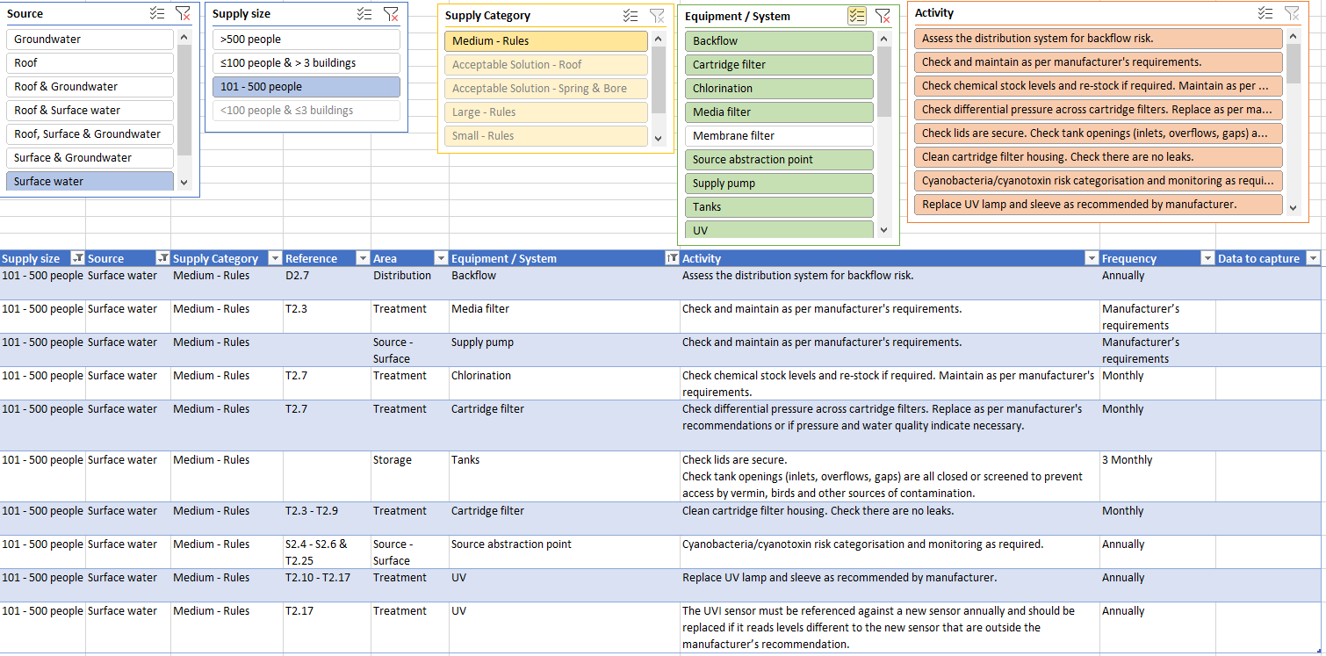
- Operations and Maintenance
School to add in operations and maintenance plan if applicable

BOIL WATER NOTICE
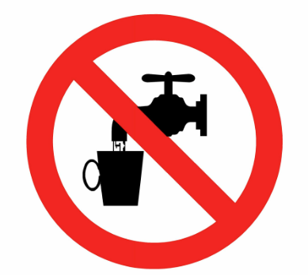
All water to be used for drinking and food preparation is to be boiled.
For advice visit Manatū Hauora – Ministry of Health website:
https://www.health.govt.nz/your-health/healthy-living/drinking-water/water-contamination-events



NZ Building Code Acceptable Solutions and Verification Methods – Clause G12 Water Supplies
Argest undertakes annual testing of all testable backflow prevention devices on its register.

