


Drinking Water Safety Plan
  - <School Name>



Revision Number | Date | Description

 | Name | Date
Prepared by
Approved by | <School Name> Board
Version number

Contents
1. School Details 2
1.1 Background and Population 2
1.2 Key Contacts 3
2. Description of Water Supply 4
2.1 Source 4
2.2 Treatment 5
2.3 Storage 8
2.3.1. Untreated Water Storage 8
2.3.2. Treated Water Storage 9
2.4 Distribution System 10
2.4.1. Backflow Prevention 10
2.5 Aerial View and Schematic of Water Supply 11
2.6 Daily Water Demand and Storage Requirements 12
2.6.1. Untreated Water Storage 12
2.6.2. Treated Water Storage 13
2.7 Resource Consent 13
2.8 Te Mana O Te Wai 14
3. Source Water Risk Management Plan 15
3.1 Catchment Description 15
3.2 Impact of Catchment Activities on Water Quality 16
3.2.1. Impact of Catchment Activities on Roof Water Quality 16
3.2.2. Impact of Catchment Activities on Groundwater Quality 16
3.3 Water Quantity Available From Source 16
3.4 Climate Change Impacts 16
3.5 Cyanobacteria 17
4. Risks and Improvement Actions 18
4.1 Risk Assessment 18
4.2 Improvement Actions 0
5. Operations, Maintenance, Monitoring and Reporting 1
5.1 Operations and Maintenance Activities 1
5.2 Previous Water Quality Issues 1
5.3 Monitoring and Reporting 1
6. Contingency Plans 3
7. Review 6
8. Useful Links 7
Taumata Arowai 7
Legislation and Regulations 7
New Zealand School Property Agency 7
Appendix A 0
Maintenance and Servicing 0
Appendix B 0
Operations and Maintenance 0
Appendix C 1
List of Tables
Table 1-1: School background, population and building information 2
Table 2-1: Details of the rainwater supply 4
Table 2-2: Details of the groundwater supply 4
Table 2-3: Details of the cartridge filtration system 6
Table 2-4: Details of the UV disinfection system 6
Table 2-5: Details of pretreatment process 7
Table 2-6: Details of pH correction 7
Table 2-7: Details of the chlorination system for residual disinfection 7
Table 2-8: Water treatment plant housing details 8
Table 2-9: Untreated water storage tank details 8
Table 2-10: Treated water storage tank details 9
Table 2-11: Medium or high hazard backflow activities connected to the school's treated water supply 10
Table 2-12: Daily water demand 12
Table 2-13: Untreated water storage requirements 13
Table 3-1: Previous water quantity issues 16
Table 4-1: Risks and improvement actions 0
Table 4-2: Summary of improvement measures the school will take to minimise risks 0
Table 5-1: Previous water quality issues 1
Table 6-1: Contingency plans for the school water supply 3
List of Figures
Figure 2-1: Water supply roof catchments, bore, treatment and storage locations 11
Figure 2-2: School water supply and treatment schematic 12

School Details

Background and Population
Table 1-1: School background, population and building information
School name
Number of people served by the water supply | - Students and Staff (current) –  - Students and Staff (future – 2033) –  - Houses –  - Other –  - Total (P) –
Peak population (e.g. during events)
Number of buildings supplied with drinking water
Other components supplied with drinking water (e.g. pool, irrigation)
Address
Hinekōrako Code
Compliance pathway

Key Contacts
Role and organisation | Name | Contact details
Caretaker |  | Email:  Phone:  Mobile:
Plumber |  | Email:  Phone:  Mobile:
Maintenance Contractor |  | Email:  Phone:  Mobile:
Consumables supplier (e.g. cartridge filter, UV lamp) |  | Email:  Phone:  Mobile:
Registered Water Carrier |  | Email:  Phone:  Mobile:
New Zealand School Property Agency | Water Services Team | Email: water.services@schoolproperty.govt.nz

Description of Water Supply

Source
The school sources its water from a rainwater supply and from a groundwater supply. A groundwater supply can be either a bore or a spring supply. The details of the supply are summarised in Table 2-1 and Table 2-2.
Table 2-1: Details of the rainwater supply
Water source | Roof
What is the total roof area used to collect drinking water (in m²)?
Is the roof material suitable for drinking water?
What is the condition of each of the roofs used to collect drinking water?
What measures does the school already have in place to reduce contaminants from the roof entering the water supply?
Table 2-2: Details of the groundwater supply
Water source | Bore
Well number
Property owner of land on which the bore is located
Bore depth (m)
Casing diameter (m)
Drilling date
Screen present?
Is the bore pump located down the bore or above ground?
Groundwater source and headworks protection | Copy the applicable protection measures the school already has in place from the guidance document.
Photo of bore headworks | 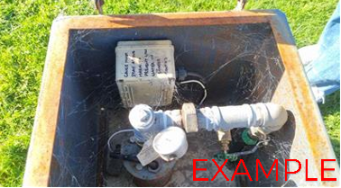

Water source | Spring
Property owner of land on which the spring is located
Groundwater source and headworks protection | Copy the applicable protection measures the school already has in place from the guidance document.
Photo of spring headworks | 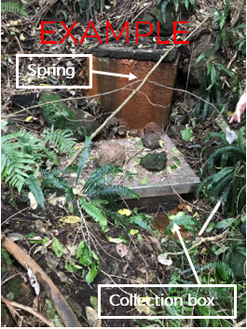

Treatment
The school water treatment plant consists of the following components:
- Pretreatment
- Cartridge filtration
- UV disinfection
- Residual chlorination
Details about each of the main treatment components and the treatment plant housing can be found in the tables below.
Table 2-3: Details of the cartridge filtration system
Number of cartridge filters
What is the pore size on each cartridge filter?
How often are the cartridge filters replaced?
Is differential pressure measured across each filter?
Photo of cartridge filters | 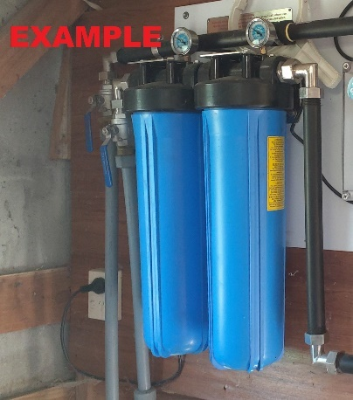
Table 2-4: Details of the UV disinfection system
UV unit make and model
Is the UV unit validated for NSF/ANSI 55 for class A systems?
Does flow through the UV unit stop automatically on low UV intensity (UVI) or low dose (e.g., via a solenoid valve)?
Is there a lamp status indication?
Is there an alarm? If yes, is it an audible or visual alarm?
How often is the UV unit serviced?
Photo of UV system | 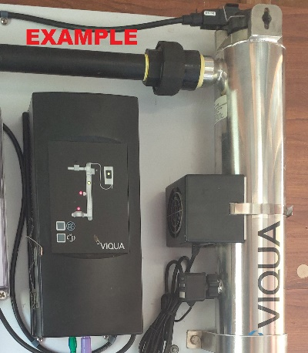
Table 2-5: Details of pretreatment process
Pretreatment type
Pretreatment process details
Photo of pretreatment process | 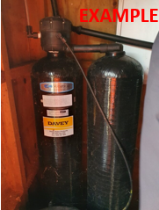
Table 2-6: Details of pH correction
Method of pH correction (e.g. acid dosing, calcium carbonate)
Photo of pH correction system
Table 2-7: Details of the chlorination system for residual disinfection
Chlorine type | Hypochlorite
What is the target chlorine concentration for water leaving the treatment plant (mg/L)?
What is the target chlorine concentration for water in the distribution system (mg/L)?
Photo of chlorination system | 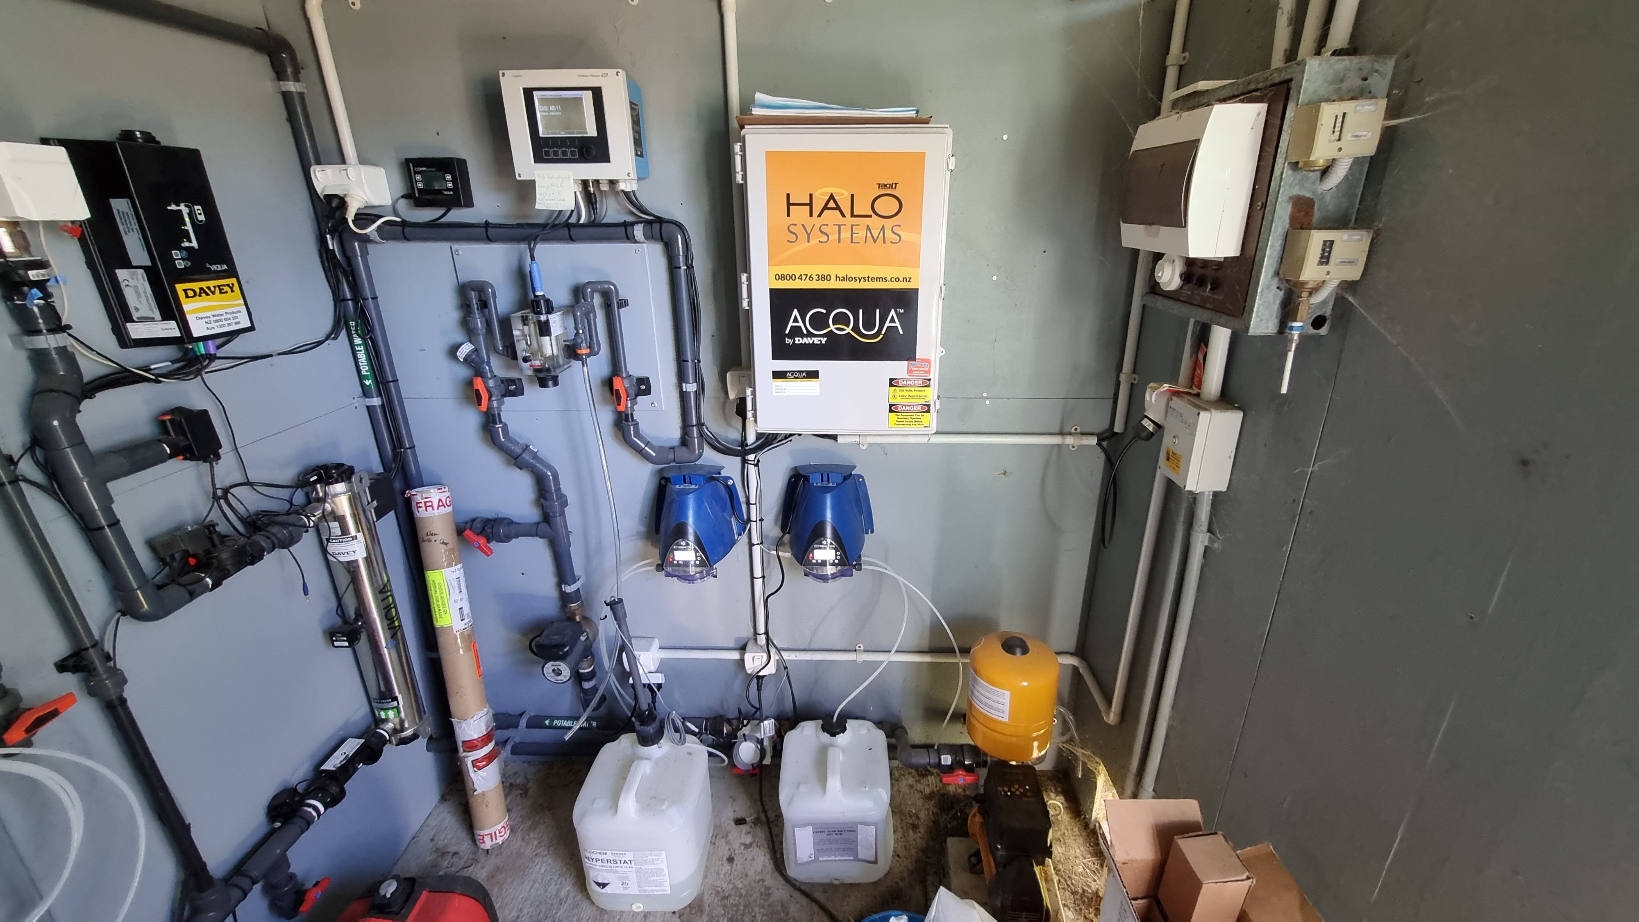  EXAMPLE
Table 2-8: Water treatment plant housing details
Treatment plant housing (e.g., locked shed)
Photo of treatment plant housing exterior | 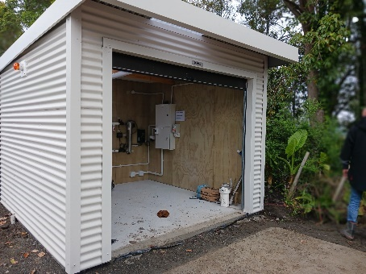  EXAMPLE
Photo of treatment plant housing | 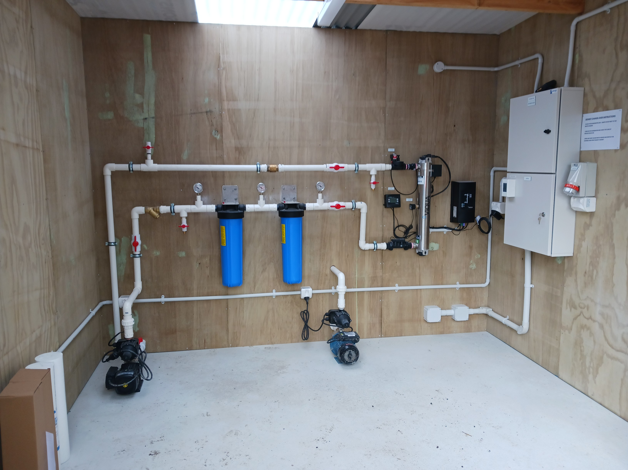  EXAMPLE

Storage

2.3.1. Untreated Water Storage
The school has a total of XX L untreated water storage. To prevent contamination of the untreated water, it is important that the tanks are in average or good condition, have vermin protection in place and have secure lids. Details of the untreated storage tank(s) are provided in the table(s) below.
Table 2-9: Untreated water storage tank details
Tank number
Volume (L)
Material
Condition
Year installed
Vermin protection
Photo of tank

2.3.2. Treated Water Storage
The school has a total of XX L treated water storage. To prevent contamination of the treated water, it is important that the tanks are in average or good condition, have vermin protection in place and have secure lids. Details of the treated storage tank(s) are provided in the table(s) below.
Table 2-10: Treated water storage tank details
Tank number
Volume (L)
Material
Condition
Year installed
Vermin protection
Photo of tank

Distribution System

2.4.1. Backflow Prevention
Backflow into the drinking water supply can present a risk if contaminated water enters the treated water distribution system. This can affect both the quality and safety of the water supply.
All hose taps in the school do / do not have a permanently attached hose connection vacuum breaker.
The medium or high hazard backflow activities connected to the drinking water supply that require a backflow prevention device are captured in the table below.
Table 2-11: Medium or high hazard backflow activities connected to the school's treated water supply
Activity | Hazard | Type of backflow prevention device required | Type of backflow prevention device installed | Listed on Argest register | Meets requirements?

Aerial View and Schematic of Water Supply
An aerial image of the school showing key features of the water supply, and a schematic showing the details of the water supply, are shown in the figures below.
Replace this aerial image with an aerial image which is labelled to show the school and its key supply components
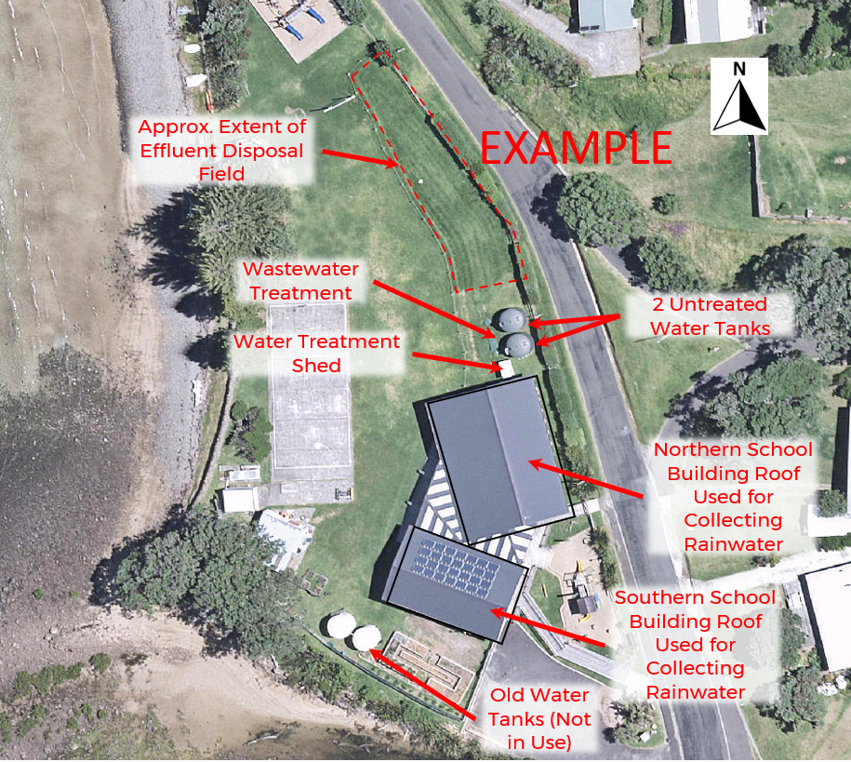
Figure 2-1: Water supply roof catchments, bore, treatment and storage locations
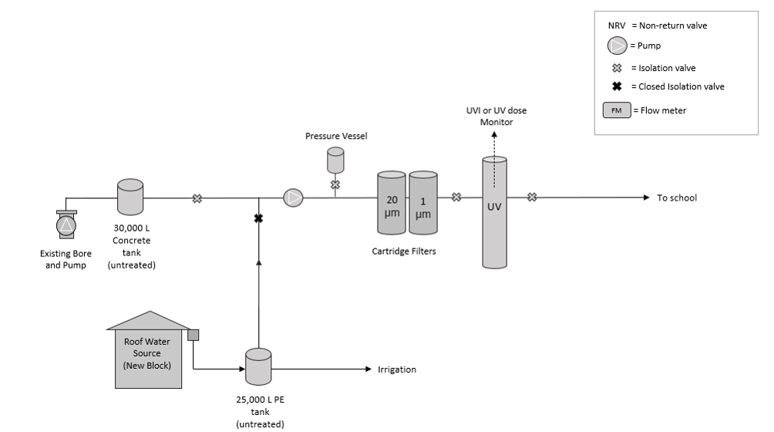
Figure 2-2: School water supply and treatment schematic

Daily Water Demand and Storage Requirements
The estimated average daily water demand is captured in the table below.
Table 2-12: Daily water demand
Water users | Average daily water use (litres per day)
Staff and students
Pool
Houses
Community hall
Early childhood centres
Other (describe)
Total estimated daily demand (Q)

2.6.1. Untreated Water Storage
The New Zealand School Property Agency recommends that self-supplying schools relying on groundwater store enough untreated water to meet the school’s demand of at least 7 days. More storage volume will be required for schools if there has been a problem in the past with the school running out of water. If this is the case, please contact the Water Services team at NZSPA for a roof water storage assessment.
The volume of untreated drinking water storage required (VU) is the estimated daily demand (Q) multiplied by the number of days untreated water storage is required for (RU). This is captured in the table below.
Table 2-13: Untreated water storage requirements
Requirement for untreated water storage for rainwater supplied schools (RU) | 7 days
Minimum volume untreated drinking water required (VU) | XX litres
Volume of untreated water storage capacity currently available | XX litres
There is enough untreated water to meet the New Zealand School Property Agency’s requirements / To meet the New Zealand School Property Agency’s requirements, an additional XXX L of untreated water storage needs to be installed.

2.6.2. Treated Water Storage
NZSPA recommends that self-supplying schools store enough treated drinking water for three days, both to minimise disruption if there is a treatment plant outage and to provide enough during an emergency. The volume of treated drinking water storage required (VT) is the estimated daily demand (Q) multiplied by the number of days treated water storage is required for (RT). This is captured in the table below.
Requirement for treated water storage (RT) | 3 days
Minimum treated drinking water required (VT = Q x RT) | XX litres
Treated water tank size required (VT) | XX litres
Volume of treated water storage capacity currently available | XX litres
There is enough treated water to meet the New Zealand School Property Agency’s requirements / To meet the New Zealand School Property Agency’s requirements, an additional XXX L of treated water storage needs to be installed.

Resource Consent
The groundwater take does not require a resource consent.
The school has a resource consent for the groundwater take and the consent number is XX.
The groundwater take requires a resource consent, but the school does not have a consent. Applying for a consent has been added to the improvement plan in section 4.2.

Te Mana O Te Wai
The National Policy Statement for Freshwater Management is that freshwater is managed in a way that gives effect to Te Mana o te Wai. Te Mana o te Wai recognises that protecting the health of freshwater protects the health and well-being of the wider environment. It sets the following hierarchy of obligations:
- ‘First, the health and well-being of water bodies and freshwater ecosystems; and
- Second, the health needs of people (such as drinking water); and
- Third, the ability of people and communities to provide for their social, economic, and cultural well-being, now and in the future.’
The school gives effect to Te Mana o Te Wai in the following ways:
- Copy applicable ways in which the school gives effect to Te Mana o Te Wai from the guidance document
The school plans to improve the way it gives effect to Te Mana o Te Wai in the following ways:
- Copy applicable improvements from the guidance document

Source Water Risk Management Plan

Catchment Description
The school is in the XX region. The catchment for the drinking water supply includes the roofs on the following buildings:
- List buildings used for collecting roof water
Although the catchment for the drinking water supply includes the catchment of the aquifer that may feed the spring and/or bore, this Source Water Risk Management Plan (SWRMP) only considers the area around the groundwater take up to 2.5 km from the bore/spring.
Figure 3-1 shows the location of the groundwater take in relation to the surrounding area.
Replace this aerial image with an aerial image which shows the groundwater take in relation to the surrounding area
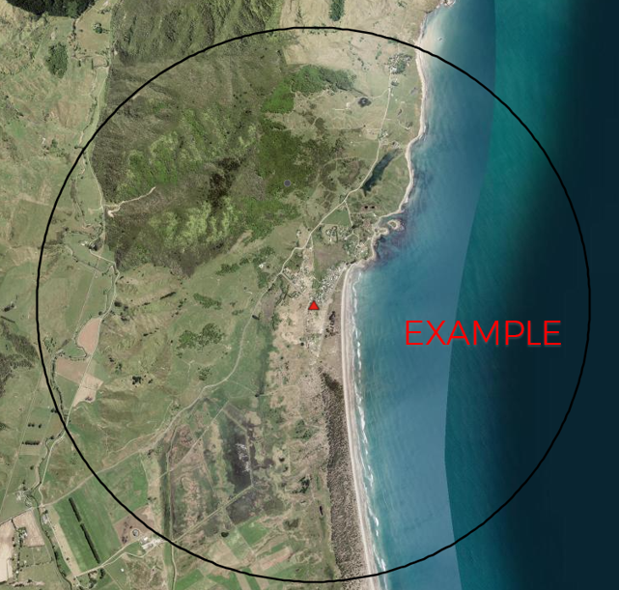
Figure 3-1: Aerial image showing the location of the groundwater take

Impact of Catchment Activities on Water Quality

3.2.1. Impact of Catchment Activities on Roof Water Quality
Given that the school’s drinking water is partly supplied by rainwater, the following activities may impact the roof water quality:
- Faecal matter from birds and other animals on the roof
- Copy applicable contaminant sources from the guidance document
The school plans to improve the quality of the roof water collected as follows:
- Copy applicable improvements from the guidance document

3.2.2. Impact of Catchment Activities on Groundwater Quality
Given that the school’s drinking water is partly supplied by groundwater, the following activities may impact the groundwater quality:
- Copy applicable contaminant sources from the guidance document
The school plans to reduce the contamination risk in the area around the groundwater take as follows:
- Copy applicable improvements from the guidance document

Water Quantity Available From Source
Table 3-1: Previous water quantity issues
Has there been a problem with lack of water over the past ten years?
If yes, provide details:
If yes, have there been any improvements to address these or are there any planned?

Climate Change Impacts
Climate related factors influencing catchment conditions and water demand include rainfall and temperature. With climate change, rainfall patterns are expected to become more variable and total annual rainfall will drop in some areas (particularly the east coast and the north of the North Island), which will mean that roof water will become a less reliable source. Groundwater sources may also be impacted. In addition, increasing temperatures may lead to an increased demand on the water supply, particularly if it is used for outdoor uses such as irrigation and/or a swimming pool. In the future, the school may need to increase the roof area used for collecting roof water, increase the storage volume and/or find an alternative source, to continue to provide a reliable water supply.

Cyanobacteria
Given that the school is supplied by roof water and groundwater, it is categorised as a low risk for the presence of cyanobacteria.

Risks and Improvement Actions

Risk Assessment
Table 4-1 summarises the key risks for the drinking water supply, both in terms of safety and having enough water. It describes:
- What could cause these risks to happen.
- The ways these events could be identified.
- The existing preventive measures in place to reduce the likelihood of the event happening or the consequence if it did occur.
- The residual risk rating once the existing preventive measures are considered. The following risk definitions have been used:
  - Low: Insignificant or minor consequence, with little disruption to normal operation; not likely to happen.
  - Medium: Significant manageable disruption to safe water supply, with requirement for increased monitoring. Potential aesthetic issues; likelihood possible.
  - High: Major disruption to safe water supply, e.g., complete failure of systems, acute harm to people or widespread illness; high level of monitoring and incident management required; likely to happen.
- The additional improvements that are needed to reduce the risk to an acceptable level.

Table 4-1: Risks and improvement actions
Supply Component | Event Description | Possible Causes | Existing Measures to Identify the Hazard | Existing Preventive Measures | Residual Risk | Improvement
Source Water | Contamination of source water by faecal material. | - Source water receives faecal matter from animals on the catchment area.  - Wastewater disposal field located close to the groundwater source. | - E. coli or total coliforms measured in raw water samples.  - Visual evidence of animals on the catchment area. | - Leaf screens on all supply downpipes  - Leaf screens on some supply downpipes  - First flush diverter(s) for some of the roof water entering the untreated water storage tanks  - First flush diverter(s) for all of the roof water entering the untreated water storage tanks  - Bore has sanitary borehead above ground level  - Livestock cannot get within 5 metres of the bore  - Wastewater effluent disposal field is at least 20 metres from the bore  - Cartridge filtration  - UV disinfection | - Low  - Medium  - High | - Install leaf screens on all supply downpipes  - Install first flush diverter(s) for all roof water entering the untreated water storage tanks  - Install sanitary borehead  - Fencing an area at least 5 metres around the bore headworks  - Consider relocating bore or effluent disposal field to increase separation  - Install cartridge filtration  - Install UV disinfection
Source Water | Contamination of source water by chemicals | - Nearby spraying  - Unsuitable roof materials  - Solid fuel heaters and/or boilers on site.  - Contaminated site  - Landfill  - Pesticides applied to land  - Geothermal or geological influences  - Metal pipe and fittings | - Observed use of agricultural or horticultural spraying near the school.  - Taste or odour complaints  - Source water chemical testing. | - First flush diverter(s) for some of the roof water entering the untreated water storage tanks  - First flush diverter(s) for all of the roof water entering the untreated water storage tanks  - Roof materials are suitable for contact with drinking water  - Solid fuel heaters and boilers aren’t used on site  - Bore has sanitary borehead above ground level  - Abstraction depths over 30 metres below ground level with confining layers  - No known potentially contaminating activities within 2.5 km of the bore/spring | - Low  - Medium  - High | - Install first flush diverter(s) for all roof water entering the untreated water storage tanks  - Monitor chemicals in line with the Quality Assurance Rules / Acceptable Solution  - Perform regular inspections of the roof source to identify maintenance requirements and deterioration  - Ask neighbouring farmers to notify the school before they spray. Before spraying starts, disconnect the roof water collection system and reconnect once it has been washed clean (e.g. by the rain)  - Replace roof materials with materials that are suitable for contact with drinking water  - Decommission solid fuel heaters/boilers  - Install sanitary borehead above ground level  - Monitor chemicals in line with the Quality Assurance Rules  - Perform regular inspections of the headworks to identify maintenance requirements and potential contamination  - Investigate alternative water source
Source Water | Insufficient source water | - Periods of little to no rainfall  - Insufficient storage volume  - Leakage from untreated water storage tanks  - Pump failure  - Water abstraction /pumping exceeds recharge rates  - Insufficient storage volume | - Local reports of drought.  - Low levels in untreated water tank.  - Bore runs dry. | - No historical issues with running out of source water  - The school has 7 days of untreated water storage  - Tanker supply from a registered water carrier | - Low  - Medium  - High | - Install tanks to provide 7 days of untreated water storage  - Investigate alternative water source  - Residual risk may increase in future due to climate variability. Consider proactive measures such as increasing storage or alternative sources.
Storage | Contamination of supply | - Animals, birds, or insects entering water storage tanks.  - Vandalism  - Contamination enters though unsealed / unmeshed gaps  - Rainwater enters through gaps or cracks in the tank | - E. coli or total coliforms measured in the distribution system.  - Visual sign of entry point for animals, birds, or insects during routine inspection.  - Visual signs of cracking or damage to the roof during routine inspection.  - Complaints about taste or odour.  - Visual signs of vandalism during routine inspection. | - All tanks are in average, good or very good condition  - All tanks are secure from access by animals, birds and insects, with all penetrations sealed and all openings covered by insect mesh or a flap valve.  - Measures are in place to prevent vandalism  - Regular visual checks carried out to identify any locations where water from the roof may enter or any vandalism. | - Low  - Medium  - High | - Replace all poor and very poor condition tanks  - Repair tanks so that there are no ingress points for vermin or insects  - Schedule regular inspections of the tanks  - Install measures to prevent vandalism
Treatment – Pre-treatment | Chemical or physical contaminants are not controlled to acceptable level | - Inadequate treatment process  - Inadequate filter maintenance  - Failure to replenish reagents | - Caretaker check of local display of reagent levels and unit operation  - Taste or odour issues in treated water  - Treated water chemical testing | - Weekly checks of pre-treatment system and reagent levels  - The pre-treatment system is serviced every 6 months | - Low  - Medium  - High | - Schedule weekly checks of pre-treatment system and reagent levels  - Schedule servicing of the pre-treatment system every 6 months  - Quarterly testing of chemical constituents exceeding 50% of MAV
Treatment – Cartridge Filtration | Particles and/or natural organic matter (e.g. from leaves) not removed | - Inadequate filter maintenance.  - Using incorrect filters or missing filters | - Elevated turbidity in filtered water.  - E. coli or total coliforms detected in treated water. | - There is cartridge filtration, including a filter with a pore size of 5 microns or smaller  - The filters are replaced every 6 months or earlier as required  - Cartridge filters cannot be bypassed | - Low  - Medium  - High | - Install cartridge filtration  - Schedule cartridge filter replacement as per manufacturer’s recommendations  - Remove bypass
Treatment – UV Disinfection | Inadequate disinfection | - Inadequate UV intensity or dose.  - Power outage leading to no UV disinfection.  - Using incorrect UV lamps. | - E. coli or total coliforms detected in treated water.  - Alarm active on UV control unit indicating power failure, lamp failure and/or low UV dose.  - Low UV transmissivity due to no or inadequate pre-treatment  - Scale formation on the UV sleeve(s) (e.g. from high levels of calcium in the water).  - Absence of maintenance records.  - Repeated power failures of a duration that threatens the ability to supply treated water to consumers. | - Annual UV servicing, including cleaning sleeves and replacing lamps  - Person responsible for maintaining the drinking water supply is trained in the maintenance schedule of the UV units and undertakes maintenance in accordance with the schedule  - Solenoid valve automatically stops flow through the UV unit if there is a UV fault  - UV unit cannot be bypassed | - Low  - Medium  - High | - Schedule UV servicing as per manufacturer’s recommendations.  - Ensure the person responsible for maintaining the drinking water supply is trained in the maintenance schedule of the UV units and undertakes maintenance in accordance with the schedule  - Install a solenoid valve to automatically stop flow through the UV unit if there is a UV fault  - Remove bypass
Treatment – Residual Chlorination | Low chlorine residual in the treated water | - High chlorine demand (e.g. from high organic load).  - Chlorine chemical supply is exhausted.  - Problems with the chlorine dosing pump.  - Hypochlorite is past its expiry date.  - Contaminants entering the water supply network via backflow or leaks. | - E. coli or total coliforms measured in the treated water at the tap.  - Reports of illness within the community that may be linked to water quality.  - Supply of hypochlorite found to be exhausted during routine site visits.  - Low level chlorine alarm.  - Free available chlorine (FAC) is less than 0.5 mg/L as it leaves the treatment plant or less than 0.2 mg/L in the distribution system (i.e., at a drinking water tap). | - FAC is monitored regularly with a handheld meter or continuous analyser  - Annual maintenance of the chlorination system  - Hypochlorite is replaced at least every 3 months  - Person responsible for maintaining the drinking water supply is trained in the maintenance schedule of the chlorination plant and undertakes maintenance in accordance with this | - Low  - Medium  - High | - Purchase a handheld FAC meter and monitor FAC concentration in accordance with the Drinking Water Quality Assurance Rules  - Schedule regular maintenance of the chlorine dosing system  - Schedule regular replacement of hypochlorite (every 3 months)
Treated Water | Loss of supply  Inadequate treated water | - Not enough water in treated water tanks to meet demand due to poor performance or failure of the water treatment plant.  - Pump failure.  - Leakage from treated water tanks. | - Low pressure or no water.  - Visual sign of leakage from tanks upon inspection.  - Reduction in water storage levels. | - Weekly inspection of treatment plant and tank levels.  - All tanks are in excellent, good or average condition.  - Treated water storage tank which holds 3 days of treated water | - Low  - Medium  - High | - Replace tanks that are in poor condition.  - Install smart flow meter and monitor water usage.  - Install remote monitoring of alarms and storage volume.  - Install a treated water storage tank which holds 3 days of treated water
Distribution | Loss of supply  Extraordinary water use | - Leakage.  - Excessive usage.  - Demand exceeds supply from the water treatment plant. | - Loss of pressure in areas of the network.  - Observation of water leaks or wastage in the distribution network.  - Pressure complaints from consumers.  - Water quality complaints. | - No problems with a lack of treated water  - No problems with low pressure  - No obvious leaks and all leaks are fixed promptly  - Water efficient devices are installed  - Treated water storage tank which holds 3 days of treated water | - Low  - Medium  - High | - Install a treated water storage tank which holds 3 days of treated water  - Fix leaks  - Install water efficient devices  - Install a smart water meter and monitor water usage.
Distribution | Loss of power means the treatment plant and pumps cannot operate | - Power outage | - Power outage  - Water supply stops | - Power outages are rare  - Portable generator | - Low  - Medium | - Purchase a portable generator to power the distribution pump
Distribution | Contamination of supply | - Backflow of water from the hazardous activity back into the distribution system  - Cross-connection between potable and non-potable supply  - Poor condition pipes allow contaminants to enter the distribution network | - Illness or injury (e.g. to skin).  - Water quality complaints.  - E. coli or total coliforms detected in the distribution system. | - There are no activities which are a high or medium backflow hazard connected to the treated water supply  - Backflow prevention device is installed  - Permanently attached vacuum breakers are installed on all hose taps  - There are no cross-connections between the potable and non-potable supplies (or there is no non-potable supply)  - Distribution pipework is in good condition | - Low  - Medium  - High | - Install a backflow prevention device on the supply to all high and medium risk activities  - Install permanently attached vacuum breakers on all hose taps  - Remove all cross-connections between the potable and non-potable supplies  - Replace distribution pipework

Improvement Actions
The improvement actions identified in the previous sections of the report and the risks and improvement actions table are summarised in Table 4-2. The improvements have been prioritised as follows:
- Urgent improvements are those which address drinking water safety concerns or address a lack of water (i.e. high risk).
- Non-urgent improvements are those which improve the resilience and reliability of the supply, or enable full compliance with the Drinking Water Quality Assurance Rules/Acceptable Solution.
Table 4-2: Summary of improvement measures the school will take to minimise risks
Supply Component | Improvement | Priority
Source Water |  | Urgent  Non-urgent
Treatment |  | Urgent  Non-urgent
Storage |  | Urgent  Non-urgent
Distribution |  | Urgent  Non-urgent

Operations, Maintenance, Monitoring and Reporting

Operations and Maintenance Activities
The maintenance and servicing requirements of the school, as per the “Maintenance and Servicing Guideline and Checklist” tool have been compiled in Appendix A.
The operation and maintenance manual that covers the day-to-day operations of the water supply system is stored in XXX.

Previous Water Quality Issues
Table 5-1: Previous water quality issues
Has E. coli been detected in the treated water over the past five years?
If yes, provide details:
If yes, have there been any improvements to address these or are there any planned?

Monitoring and Reporting
The water quality monitoring requirements for the water supply can be found in the “Maintenance and Servicing Guideline and Checklist” tool. The New Zealand School Property Agency is in discussion with the Water Services Authority Taumata Arowai to develop a practical approach to monitoring. In the meantime, the school should sample and test for E. coli and total coliforms in the treated water at the tap monthly, as well as periodic source water testing as recommended by NZSPA. Additional monitoring will be required for any other parameters which exceed 50% of the MAV in the source water.
Since the school is using an Acceptable Solution, no reporting is required to the Water Services Authority Taumata Arowai.
Since the school is a small supply under the Drinking Water Quality Assurance Rules, 6-monthly reporting to the Water Services Authority Taumata Arowai is required.
Since the school is a medium supply under the Drinking Water Quality Assurance Rules, 3-monthly reporting to the Water Services Authority Taumata Arowai is required.
Since the school is a large supply under the Drinking Water Quality Assurance Rules, monthly reporting to the Water Services Authority Taumata Arowai is required.
The New Zealand School Property Agency is in discussion with the Water Services Authority Taumata Arowai to develop a practical approach to reporting. In the meantime, the school should capture its monitoring results in the monitoring spreadsheet in the “Maintenance and Servicing Guideline and Checklist” tool, so that they can provide this information at a future date.

Contingency Plans
The contingency plans in Table 6-1 have been developed to guide the school about the action required following a serious event. If there is uncertainty around how serious an event is, contact the Water Services Authority Taumata Arowai.
The school must notify Taumata Arowai and NZSPA (water services/property advisor) of any event where:
- The drinking water is or may be unsafe.
- The drinking water does not comply with the drinking water standards.
- Enough drinking water can’t be provided.
- There is a ‘notifiable risk or hazard’ (declared by Taumata Arowai).
Table 6-1: Contingency plans for the school water supply
Event | Indicators | Required Action
Water Contamination  Examples:  - Severe microbiological contamination of the abstracted source water (such that treatment is ineffective).  - Roof contaminated by spray drift or over spraying (chemical contamination) | - A contamination event in the catchment area may be observed by or reported to the school.  - E. coli (greater than 0 per 100mL) or total coliforms (greater than 10 cfu/mL) detected in water that has been treated, indicating bacterial contamination.  - Complaints of discoloured, strange tasting or smelling water coming from taps, indicating chemical contamination.  - Treatment plant failure (e.g., UV dose too low)  - Roof water source: Spray drift or over spraying reported indicating possible chemical contamination.  - Reports of illness within the community that may be linked to water quality. | - Notify NZSPA (water services and property advisor) and determine if the Water Services Authority Taumata Arowai and/or the Medical Officer of Health needs to be notified.  - Investigate the cause and inspect source and treatment plant to rectify the problem as quickly as possible.  - Provide another source of drinking water until water of acceptable quality can be supplied again (e.g., bottled water, tanker water)  - Record incident and actions taken.  - In a case of bacterial contamination:  - Implement ‘boil water’ notice (see Appendix C).  - Commence daily E. coli sampling at the post-treatment and distribution zone sampling points, until three consecutive samples are <1 per 100 mL.  - Consider increased disinfection using chlorine and flushing the network.  - Disable drinking water fountains.  - In a case of chemical contamination:  - Implement ‘do not drink’ notice.  - Flush distribution system (or isolated area of distribution system if the problem is isolated to that area).  - For roof spray contamination: Identify the person or organisation doing the spraying, and if possible, the product used. Drain the contents of the tank(s) connected to the roof. Disconnect the downpipe from the tank. Clean roof and tank. Reconnect the downpipe to the tank.  - Monitor appropriate determinands in the affected area to assess the effectiveness of the contingency measures.  - Notify customers, when the supply is safe to use, that they need to flush their taps before use.  - Update the Drinking Water Safety Plan if necessary.
Water Shortage | - Reduced or no flow reaching the treatment plant.  - Unexpectedly high water usage  - Leaks in the system | - Notify the principal and determine if the Water Services Authority Taumata Arowai needs to be notified.  - Organise alternative water source (e.g., tanker water)  - Determine if the alternative water supply is sufficiently different in water quality to impact on effective treatment e.g. disinfection.  - Consider restricting water use.  - Implementation of a permanent alternative water source may need to be considered if water shortages occur frequently because result of low water availability.  - Record incident and actions taken.  - Determine cause of shortage (drought/leakage)  - Check for supply leakage and make necessary repairs before reinstatement  - Update the Drinking Water Safety Plan if necessary
Natural Disaster | - Personal experience of the event and/or local reports from the area or region.  - Media coverage of activity. | - In the event of a significant natural disaster, the immediate response to the event and potential school closure will be managed by the principal in conjunction with Civil Defence.  - Once access to the water treatment plant has been obtained:  - Full checks of all the plant and equipment to establish it can be operated.  - Visual checks of all water storage tanks to check for damage and verify water tightness.  - Check the turbidity of the source and filtered water to determine if the turbidity has increased.  - If the effectiveness of the treatment process (due to potential damage) has been impacted, put measures in place to assure the supply of safe drinking water.  - Monitor leaks in the network and repair them.  - Record incident and actions taken.  - Update the Drinking Water Safety Plan if necessary.

Review
Each year on its anniversary date and any time there are material changes in the water supply or contact information, this plan is to be reviewed, updated, and approved by the Board of Trustees to check that it is meeting its purpose. This is done by:
- Checking compliance with the Drinking Water Quality Assurance Rules in the monitoring report to the Water Services Authority Taumata Arowai.
- Checking compliance with the Acceptable Solution
- Checking to see if any issues have been identified as part of the routine maintenance checks.
- Reviewing the response to adverse events (e.g. E. coli contamination or loss of water supply).
If there has been a non-compliance or issue identified, the drinking water safety plan is to be updated to include:
- Any new risks or causes identified (e.g., change to the monitoring events/equipment failure, changes in operating staff, changes in the source.
- Any new preventative measures (for both existing and new causes)
The improvement schedule should be updated to include the most up-to-date information. Such updates could include:
- Additional improvements planned for the school.
- Improvements that have been completed.

Useful Links

Taumata Arowai
Drinking Water Standards, Drinking Water Quality Assurance Rules and Drinking Water Aesthetic Values: https://www.taumataarowai.govt.nz/drinking-water-suppliers-and-operators/for-drinking-water-suppliers/ways-to-comply/drinking-water-quality-assurance-rules
Drinking Water Acceptable Solutions: https://www.taumataarowai.govt.nz/drinking-water-suppliers-and-operators/for-drinking-water-suppliers/ways-to-comply/acceptable-solutions
Taumata Arowai homepage: https://www.taumataarowai.govt.nz/
Notify Taumata Arowai: https://www.taumataarowai.govt.nz/drinking-water-suppliers-and-operators/notify-us
Registered water carriers: https://www.taumataarowai.govt.nz/for-the-public/public-registers#e697

Legislation and Regulations
Water Services Act 2021: https://www.legislation.govt.nz/act/public/2021/0036/latest/LMS374564.html
Water Services (Drinking Water Standards for New Zealand) Regulations 2022: https://www.legislation.govt.nz/regulation/public/2022/0168/latest/whole.html
NZ Building Code Acceptable Solutions and Verification Methods – Clause G12 Water Supplies: https://www.building.govt.nz/building-code-compliance/g-services-and-facilities/g12-water-supplies/
National Policy Statement for Freshwater Management: https://environment.govt.nz/acts-and-regulations/national-policy-statements/national-policy-statement-freshwater-management/

New Zealand School Property Agency
Drinking water in schools: https://www.schoolproperty.govt.nz/day-to-day-management/water-supply-in-schools/guidance-for-schools-that-supply-their-own-drinking-water

Appendix A

Maintenance and Servicing
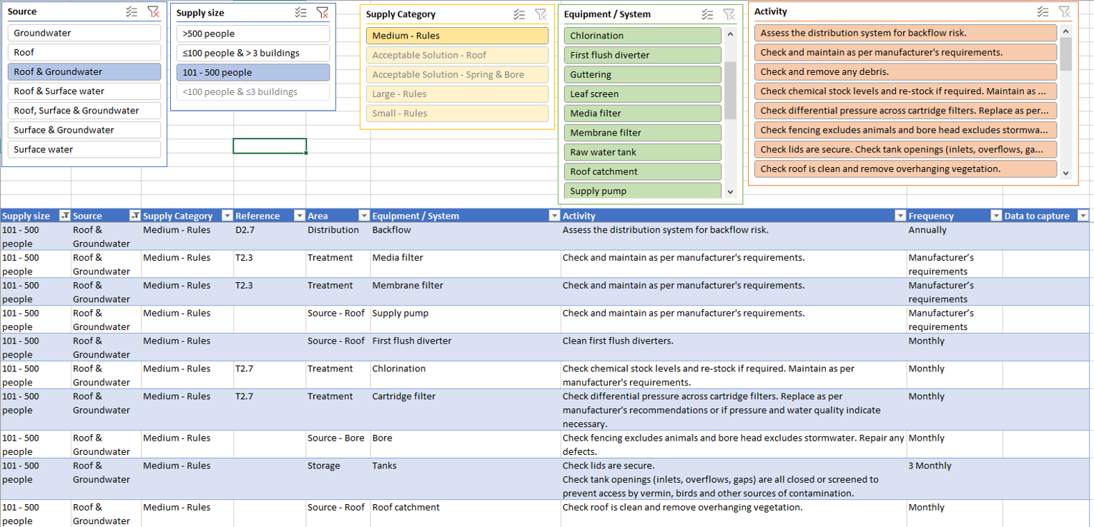
EXAMPLE
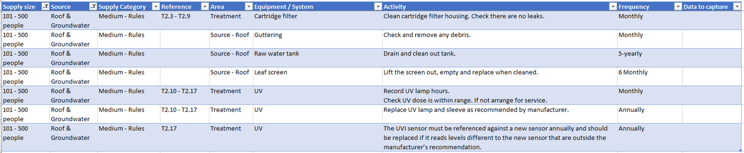

Appendix B

Operations and Maintenance

Appendix C

BOIL WATER NOTICE
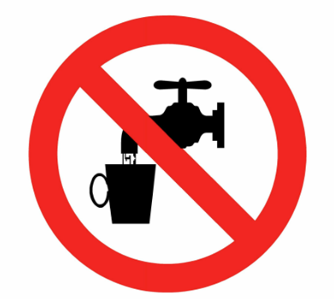

All water to be used for drinking and food preparation is to be boiled.
For advice visit Manatū Hauora – Ministry of Health website:
https://www.health.govt.nz/your-health/healthy-living/drinking-water/water-contamination-events



NZ Building Code Acceptable Solutions and Verification Methods – Clause G12 Water Supplies
Argest undertakes annual testing of all testable backflow prevention devices on its register.

