


Drinking Water
Safety Plan Guidance – Surface Water

Contents
1. Introduction 3
2. Glossary of terms 4
3. Section 1 – School Details 15
4. Section 2 – Description of Water Supply 16
5. Section 3 – Source Water Risk Management Plan 18
6. Section 4 – Risks and Improvement Actions 19
6.1 Risk Assessment 19
6.2 Improvement Actions 23

- Introduction
Preparing a drinking water safety plan (DWSP) is a risk management process that aims to ensure a safe, reliable, and resilient supply of drinking water to the staff, students and other people who drink your water. Your drinking water safety plan records key features and elements of your water supply system and their condition and location, key hazards and risks to your drinking water supply and how you will manage them to ensure that drinking water is sufficient and safe.
Guidance notes are provided in text boxes like this one throughout the drinking water safety plan template. Once the guidance is actioned the text box may be deleted.
<Guidance in angle brackets like these can also be deleted once the guidance is actioned.>
We have started completing the drinking water safety plan template for your school, based on information that you’ve provided to the New Zealand School Property Agency (NZSPA). Please check the details that we have entered and correct where necessary.

- Glossary of terms
The following terms are used in the drinking water safety plan and definitions are provided here:
Table 1: Glossary of terms
Air gap | A physical gap between the level of water inlet and the highest water level (flood rim level in the figure below), so that the water cannot flow backwards into the water supply. This is one of the approved methods to prevent backflow.  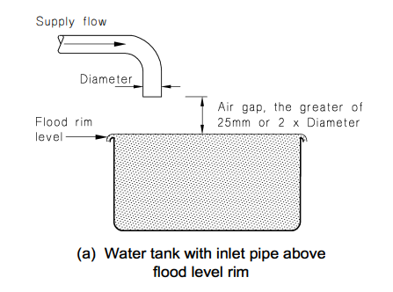  Figure 1: Air gap separation (from the Acceptable Solutions and Verification Methods For New Zealand Building Code Clause G12 Water Supplies)
Backflow | When water flows backwards from a hazardous activity connected to the drinking water supply, this can contaminate the water and make it unsafe to drink or use (e.g. water from a swimming pool, farm trough, laboratory).  There are three backflow hazard categories: high (potential to cause death), medium (potential to cause illness or injury) and low (potential to affect the taste, odour, or appearance of the water).  Refer to section 3 of the Acceptable Solutions and Verification Methods For New Zealand Building Code Clause G12 Water Supplies for more information about backflow hazards and the acceptable methods for preventing these.
Backflow prevention device | A device which allows water to flow in one direction only, and which is used to prevent contaminated water from a hazardous activity entering the drinking water system. The most common types of devices are a testable double check valve and a reduced pressure zone (RPZ) valve.  NZSPA contracts Argest to test all testable backflow prevention devices on its register annually, to meet the requirements of the Building Act.
Cartridge filtration | A cartridge filter is a type of filtration equipment, used to remove unwanted particles from the drinking water. Cartridge filters are used to improve the quality of the water and to make sure that the UV disinfection is effective (as otherwise the bugs can hide behind the particles and not be inactivated). This is the most commonly used type of filtration system for drinking water supplies. The cartridge filters are encased within individual housings and the filters need replacing on a regular basis. There are normally two (and sometimes three) cartridge filters in series.  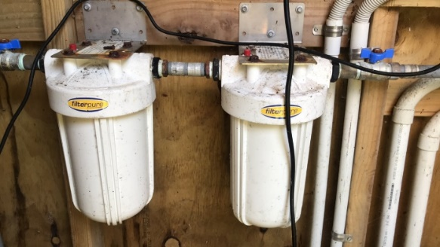  Figure 2: Example cartridge filter housing  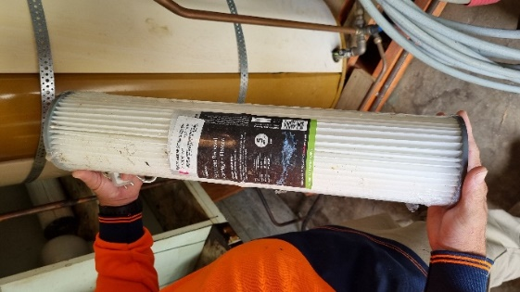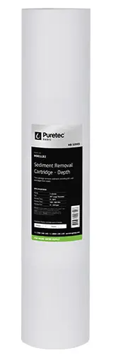  Figure 3: Example filters
Cartridge filter pore size | The cartridge filter has tiny pores (holes) and only things smaller than the pore size can pass through to the next treatment step (normally UV disinfection). Larger particles are captured in the filter. The most common pore sizes for cartridge filters are 20 micron and 5 micron. Water flows through the filter with the larger pore size first to remove larger particles, then through the filter with the smaller pore size to remove smaller particles not removed by the first cartridge.
Chlorine residual | Residual chlorination refers to the dosing of water with chlorine after filtration and UV disinfection, so that a level of chlorine is present in the water in the distribution system. The purpose of this is to treat for any microbial contamination that may enter the distribution system (e.g. due to leaks) prior to the point of use. The level of residual chlorine is measured as free available chlorine (FAC).
Compliance | As registered water suppliers, self-supplying schools are required to comply with the Water Services Act. This includes providing water which meets the limits in the Drinking Water Standards, preparing a drinking water safety plan and complying with the Drinking Water Quality Assurance Rules or an applicable Acceptable Solution.
Contingency plans | These set out the action required (e.g. sampling, ordering tanker delivery of safe water from another compliant supply) if there is an event like water contamination, water shortage or a natural disaster.
Cyanobacteria | Cyanobacteria live in water and can manufacture their own food by photosynthesis. While they are quite small, being unicellular, they often grow in colonies large enough to see. Cyanobacteria are more likely to occur in water that is exposed to sunlight (e.g. surface water sources). Some cyanobacteria produce toxins that have health effects. Their presence will also block filters. Special treatment processes are needed to remove cyanobacteria and cyanotoxins, if they are present.  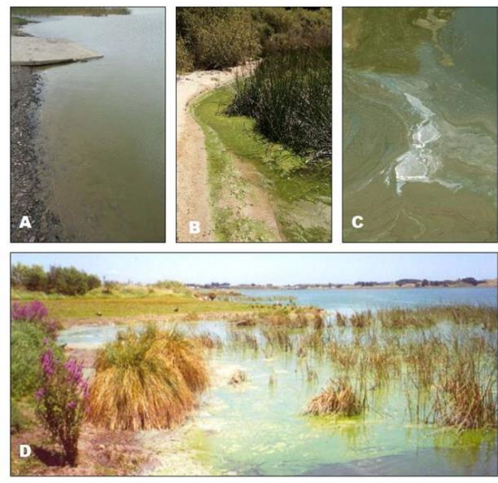  Figure 4: Stock Photos of Planktonic Cyanobacteria Blooms  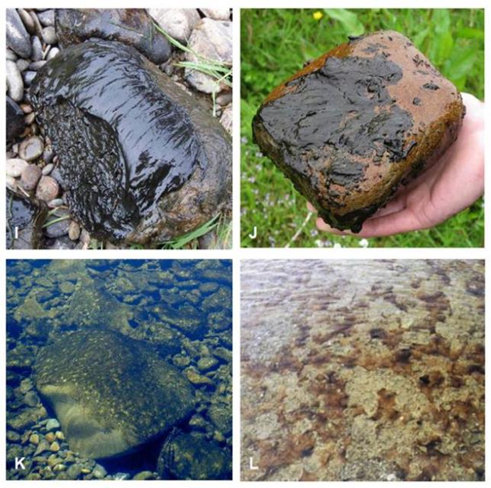  Figure 5: Stock Photos of Benthic Cyanobacteria Blooms
Differential pressure | The difference between the pressure measured before and after a filter, gives an indication of how clogged a filter is, and indicates when the filter should be replaced.  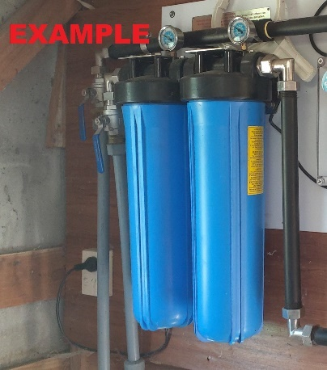  Differential pressure gauges  Figure 6: Example cartridge filters with differential pressure gauges
E. coli | Escherichia coli (E. coli) bacteria normally live in the intestines of healthy people and animals. Most types of E. coli are harmless or cause relatively low level diarrhoea. Several strains, such as E. coli O157:H7, can cause severe stomach cramps, bloody diarrhoea and vomiting. If E. coli is detected in drinking water, this indicates it has been contaminated with faeces and may contain organisms which can cause illness.
Testable Double check valve | A testable backflow prevention device which is used to protect against backflow from a medium or low hazard activity.  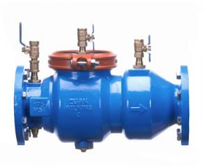  Figure 7: Example testable double check valve
DWSP | Drinking water safety plan
Free available chlorine | See chlorine residual
Hinekōrako Code | The unique code (comprising three letters and three numbers) assigned to the drinking water supply by Taumata Arowai. Hinekōrako is Taumata Arowai’s online system for water suppliers to report results and notify Taumata Arowai of incidents that may result in either disruption to the water supply or unsafe water being provided to consumers.
Hose connection vacuum breaker | A device on an outdoor tap which prevents water from the hose moving back into the water supply.  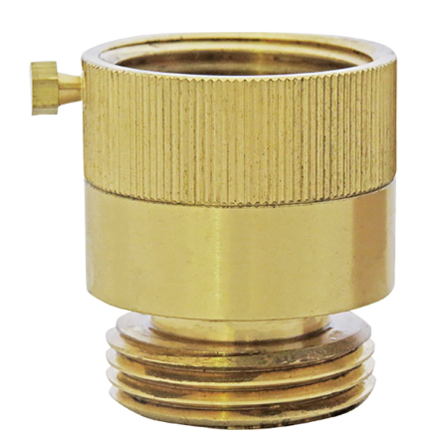  Figure 8: Example hose connection vacuum breaker
Maintenance Contractor | A contractor which the school has a contractual arrangement with, to undertake regular maintenance on the drinking water system (e.g. replacing cartridge filters and UV lamps). Alternatively, this may be the plumber that the school calls when maintenance is needed on the water supply. If a staff member or community member normally undertakes the maintenance on the water supply, note this in Table 1-2 (Key contact information).
Pretreatment | A treatment process to remove contaminants that are not removed by cartridge filtration and UV disinfection, or could reduce the effectiveness of cartridge filtration and UV disinfection. Common examples are pretreatment to remove iron and manganese, or to reduce the hardness of the water.
Preventative Measures | The things that will reduce the likelihood of a hazard occurring, or the consequences if it did occur. For example, preventing vermin getting into water storage tanks reduces the likelihood of contamination, and a water treatment plant reduces the consequence if the source water is contaminated with faecal material.
Quartz sleeve | The UV quartz sleeve is the glass tube in which the ultraviolet lamp is installed in order to separate the lamp from the water flow and exclude dirt and moisture. It must be kept clean to enable the UV light to penetrate and disinfect the water, and if obscured by scratches or deposits of any kind, it must be cleaned or replaced.
Registered Water Carrier | A water supplier who provides drinking water via a tanker to consumers, and who is registered with Taumata Arowai. Schools must use a registered water carrier when they need to top up their water supply or source an alternative supply of water during an incident.
Reduced pressure zone (RPZ) device | A testable backflow prevention device which is used to protect against backflow from a high hazard activity. While it can also be used for preventing backflow from low or medium hazard activities, it is significantly more expensive than other devices approved for those activities.  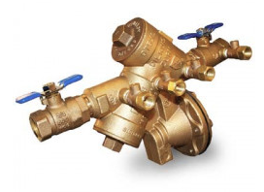  Figure 9: Example reduced pressure zone (RPZ) device
Residual chlorination | See chlorine residual.
Solenoid valve | An electronic valve which prevents water flowing through the UV unit when the UV intensity (or UV dose) is too low. The purpose of this is to prevent unsafe water being delivered to the distribution system.  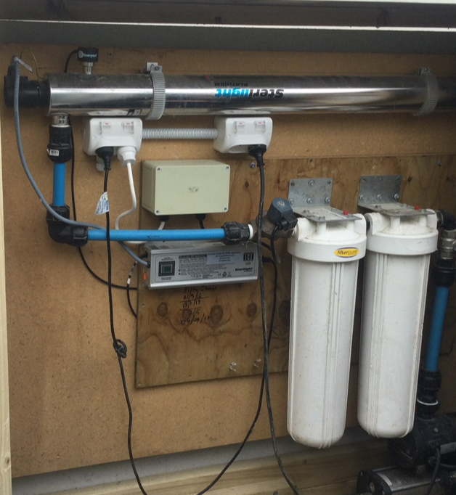  UV unit  Solenoid valve  Figure 10: Example solenoid valve being used to control a UV unit
Surface water | Water sourced from any body of water above ground, including rivers, streams, lakes, wetlands, creeks and reservoirs.
Surface water take | The infrastructure located at the extraction point of a surface water source. The surface water take include the intake screen, pipes and infrastructure required to extract the water.  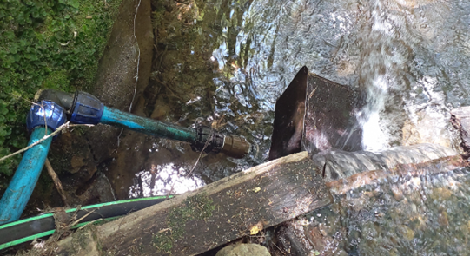  EXAMPLE  Figure 11: Example of surface water take
Taumata Arowai | The drinking water, wastewater and stormwater regulator for Aotearoa New Zealand.
Total coliforms | Total coliforms include bacteria that are found in the soil, in water that has been influenced by surface water, and in human or animal waste. Their presence in drinking water shows that the water has been contaminated with bacteria.
Turbidity | A measure of how clear (or dirty) the water is. The lower the turbidity, the clearer the water. It’s important that water has low turbidity before entering the UV disinfection unit, as otherwise germs can hide behind the particles and not be inactivated.
UV disinfection | UV light is shone through the water to inactivate germs (bacteria, viruses and protozoa) so that they cannot reproduce to cause illness in anyone drinking the water. The UV lamp is housed in a casing or sleeve and needs replacing on a regular basis.  It is important that the UV unit is validated against one of four approved standards listed in the Drinking Water Quality Assurance Rules or Acceptable Solution. Validation is required to achieve compliance and to provide confidence that the UV system is a high quality and reliable unit.  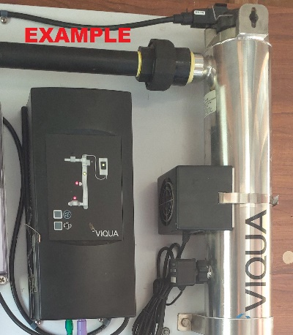  Figure 12: Example UV unit
UV auto shutdown | Flow through the UV unit automatically stops if the UV intensity (or UV dose) is too low e.g. during a power cut or if the UV lamp hasn’t warmed up yet
UV dose and UV intensity (UVI) | The amount of UV light that passes through the water. An average dose (reduction equivalent dose) of 40 mW/cm² is required. Validated units will achieve this.
UV lamp status indication | A display that indicates whether the UV lamp needs replacing (e.g. light turns from green to red when the lamp needs replacing).  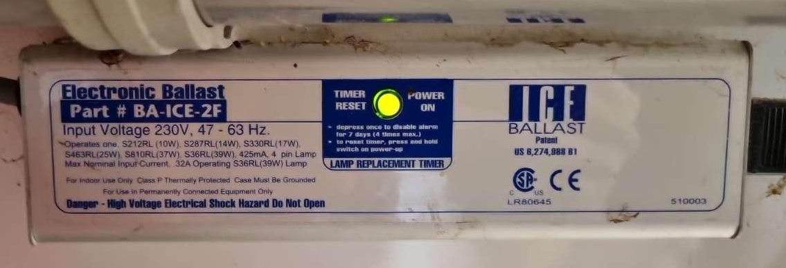  Figure 13: Example UV lamp status indication
UV validation certificate | A validation certificate for UV water treatment serves as documented proof that the ultraviolet (UV) system has been tested as effective at deactivating microorganisms in compliance with a specific internationally recognised standard. It confirms that the UV treatment consistently meets required disinfection levels, ensuring the safety and quality of the treated water. A copy of the validation certificate can be obtained from the supplier.
Water supply category | The school’s water supply will fall into one of the following categories:  - Drinking Water Quality Assurance Rules - Small  - Drinking Water Quality Assurance Rules - Medium  - Drinking Water Quality Assurance Rules - Large

- Section 1 – School Details
Table 1-1 (School background, population and building information) has been partially pre-populated using information that the New Zealand School Property Agency holds about the school.
Please review and complete the table.
If the school’s drinking water supply supplies other properties (e.g. school house, community hall), please enter the average number of people in the boxes for Houses and Other in Table 1-1. If there are occasions where there is a much larger population (e.g. an event at the hall), please enter the maximum number of people in the Peak population box.

- Section 2 – Description of Water Supply
This section provides a summary description of the school’s water supply. Complete the tables and check the boxes that apply (click in a box to make it checked).
Take photos of key parts of your water supply and insert them into the relevant tables.
Details of your surface water source is captured in Table 2-1.
Details of your school’s water treatment system is captured in Section 2.2.
If you do not have a pretreatment system (e.g. pH correction or media filter), remove Table 2-2. If you have multiple pretreatment processes, copy Table 2-2 until each pretreatment process has its own table.
If you do not have a chlorine dosing system to maintain a chlorine residual in your school water supply network, delete Table 2-5 (Details of chlorine residual disinfection).
For Table 2-7 (Untreated water storage tank details) and Table 2-8 (Treated water storage tank details), if the tank volume is unknown, it can be calculated as follows:
- For a rectangular tank, multiply the length (L) times the width (W) times the height (H) (i.e. L x W x H).
- For a cylindrical tank, measure the diameter and the height of the tank (to the bottom of the overflow if there is one). Multiply the diameter (D) by the diameter (D), then multiply by 3.14, divide by 4 and multiply by the height (H) (i.e. πD²H/4)
If you do not have any treated water storage, delete Table 2-8 (Treated water storage tank details) and amend the text above to say that the school has no treated water storage.
Check whether any of the activities listed in Table 2-9 (Medium or high hazard backflow activities connected to the school's drinking water supply) are connected to the surface water supply. Delete the rows that aren’t applicable and complete the rows that do apply. If none of the activities listed in Table 2-9 are connected to the school’s drinking water supply, delete all of the section after the first two paragraphs and say “The water supply has no medium or high hazard activities occurring that require a backflow prevention device.”
Replace the example figures in Figure 2-1 (Water supply intake, treatment and storage locations) and Figure 2-2 (School water supply and treatment schematic) with an annotated aerial image and a schematic that accurately reflect the school’s water supply.
NZSPA has typical schematics in PowerPoint that you can edit for Figure 2-2:
- Choose one of the PowerPoint slides provided that has a schematic which most closely resembles the school’s water supply.
- Modify it to be a true representation of your school’s water supply.
- Use the snipping tool to select the schematic once completed.
- ‘Save as’ the picture file and import into the DWSP, or copy and paste it into the DWSP.

- Section 3 – Source Water Risk Management Plan
Protection of source water is of paramount importance, and this is the first barrier against drinking water contamination and illness. Protecting source water starts with understanding your source water and how it could become contaminated or run out.
Replace the aerial image in Figure 3-1 (Aerial image showing the location of the surface water take and its catchment area) with one showing the location of the school’s surface water take and its catchment area.
Consider what things could cause the surface water to become contaminated and check the boxes that apply. Then check the boxes with the relevant improvements and make sure these are captured in Table 4-2 (Summary of improvement measures the school will take to minimise risks).

- Section 4 – Risks and Improvement Actions
  - Risk Assessment
Complete the risk assessment table (Table 4-1) once you have completed the previous sections of the DWSP.
The next step is to review the risk rating, considering the preventative measures that you already have in place. The following risk definitions have been used:
- Low: Insignificant or minor consequence, with little disruption to normal operation; not likely to happen.
- Medium: Significant manageable disruption to safe water supply, with requirement for increased monitoring. Potential aesthetic issues; likelihood possible.
- High: Major disruption to safe water supply, e.g., complete failure of systems, acute harm to people or widespread illness; high level of monitoring and incident management required; likely to happen.
We make the following recommendations about how to score each risk.
Risk (Event Description) | Low | Medium | High
Increased sediment load in surface water source. | If all the following are present:  - The intake screen reduces the likelihood of weed and debris clogging the water supply pump  - Appropriate water treatment (e.g. pretreatment, cartridge filtration, and UV) | If the following are present:  - Appropriate water treatment (e.g. pretreatment, cartridge filtration, and UV)  - BUT the following is missing:  - The intake screen reduces the likelihood of weed and debris clogging the water supply pump | If this is missing:  - Appropriate water treatment (e.g. pretreatment, cartridge filtration, and UV)
Contamination of source water by faecal material. | If all the following are present:  - No livestock grazing within the catchment area  - There is no wastewater effluent disposal in the catchment area  - Cartridge filtration  - UV disinfection | If the following are present:  - Cartridge filtration  - UV disinfection  - BUT some of the following are present:  - Livestock grazing within the catchment area  - There is wastewater effluent disposal in the catchment area | If one or both of these are missing:  - Cartridge filtration  - UV disinfection
Contamination of source water by chemicals | If the following applies:  - No known potentially contaminating activities within the catchment area | If both of the following apply:  - Potentially contaminating activities within the catchment area  - Appropriate pretreatment (e.g. oxidation) | If both of the following apply:  - Chemical contaminant(s) are present at levels above 50% of the Maximum Acceptable Value (MAV) in the Drinking Water Standards  - No appropriate pretreatment (e.g. oxidation)
Insufficient Source Water | The school has never had a problem with a lack of drinking water due to insufficient source water.  AND  There is at least 7 days’ untreated water storage | The school has a problem with a lack of drinking water due to insufficient source water less often than once a year.  OR  There is less than 7 days’ untreated water storage | The school has problems with a lack of drinking water at least once a year due to insufficient source water  AND  There is less than 7 days’ untreated water storage
Chemical or physical contaminants are not controlled to acceptable level | If all the following apply:  - Weekly checks of pre-treatment system and reagent levels  - The pre-treatment system is serviced every 6 months | If either of the following apply:  - Weekly checks of pre-treatment system and reagent levels  - The pre-treatment system is serviced every 6 months | If none of the following apply:  - Weekly checks of pre-treatment system and reagent levels  - The pre-treatment system is serviced every 6 months
Particles and/or natural organic matter not removed | There is cartridge filtration, including a filter with a pore size of 5 microns or smaller  AND  The cartridge filters are replaced at least every 6 months (or more often if required) | There is cartridge filtration, including a filter with a pore size of 5 microns or smaller  AND  The cartridge filters are replaced less often than every 6 months | There is no cartridge filtration
Inadequate disinfection | All of the following are in place:  - There is a validated UV unit which treats all the drinking water  - The UV unit is serviced at least annually, including replacing UV lamps and cleaning sleeves.  - There is an automatic control system in place which prevents water flowing through the UV unit if the UV dose/intensity is insufficient (e.g. via a solenoid valve) | All of the following are in place:  - There is a UV unit which treats all the drinking water  - The UV unit is serviced at least annually, including replacing UV lamps and cleaning sleeves. | There is no UV unit  OR  There is a UV unit which treats only some of the drinking water
Low chlorine residual in the treated water  (Note: this risk only applies if there is a chlorine dosing system to maintain a chlorine residual in the pipe network, which is uncommon in schools) | All of the following are in place:  - The chlorine dosing system is serviced at least annually  - Hypochlorite is replaced on a regular basis (at least 3 monthly) and before its expiry date  AND  - Free available chlorine (FAC) is measured on a regular basis at the tap and is always between 0.2 mg/L and 5 mg/L | Some but not all of the following are in place:  - The chlorine dosing system is serviced at least annually  - Hypochlorite is replaced on a regular basis (at least 3 monthly) and before its expiry date  AND  - Free available chlorine is measured on a regular basis at the tap and is normally above 0.2 mg/L | There is no regular servicing of the chlorine dosing system  The hypochlorite is not replaced on a regular basis  There is no monitoring of FAC at the tap or FAC is often below 0.2 mg/L
Loss of supply  Inadequate treated water due to failure of the water treatment plant or its pump  (Note: this risk only applies to a lack of treated water, as a lack of source water is covered in a separate risk above) | The school has not had a problem with a lack of treated drinking water in the last 5 years.  AND  There is at least 3 days’ treated water storage (as per section 2.6.2) | The school has had a problem with a lack of treated drinking water less often than once a year.  OR  There is less than 3 days’ treated water storage (as per section 2.6.2) | The school has had a problem with a lack of treated drinking water more often than once a year.  AND  There is less than 3 days’ treated water storage (as per section 2.6.2)
Storage - Contamination of supply | Any gaps or holes are covered in mesh with a gap size of no more than 1.5 mm (or in the case of an overflow, a flap valve is installed on it)  AND  All lids are secure | There are fine cracks (<1.5 mm) in the roof of the tank  AND  All lids are secure | There are gaps or holes in the tank that are greater than 1.5 mm  OR  Lids are missing or are not secure
Loss of supply due to excessive water usage  Extraordinary water use | There has not been a problem with low pressure or low flow in the last 5 years.  AND  Any leaks in the distribution network are fixed promptly | There are problems with low pressure or low flow in the distribution system less often than once a year  OR  Any leaks in the distribution network are fixed promptly | There are problems with low pressure or low flow in the distribution system more often than once a year  OR  There are known leaks or problems with excessive water use
Distribution - Contamination of supply from backflow | There are no medium or high hazard activities connected to the distribution system  OR  There are medium or high hazard activities connected to the distribution system, and backflow prevention devices which meet the requirements of the Building Code are in place in every case | There is a medium hazard activity connected to the distribution system and there is no associated backflow prevention device  OR  There is a medium hazard activity connected to the distribution system and the associated backflow prevention device does not meet the requirements of the Building Code | There is a high hazard activity connected to the distribution system and there is no associated backflow prevention device  OR  There is a high hazard activity connected to the distribution system and the associated backflow prevention device does not meet the requirements of the Building Code
Enter improvement items into the improvements column for any risk which is rated as medium or high.
  - Improvement Actions
The improvement actions the school plans to take to improve the safety and reliability of its water supply is one of the most important sections of the drinking water safety plan. It is also useful when reporting progress (e.g. to the Board of Trustees).
Copy the improvement items from the previous sections into Table 4-2 (Summary of improvement measures the school will take to minimise risks) from:
- Section 2.4.1 Backflow Prevention
- Section 2.6 Daily Water Demand and Storage Requirements
- Section 2.8 Te Mana o Te Wai
- Section 3.2 Impact of Catchment Activities on Water Quality
- Section 3.3 Water Quantity Available From Source
- Table 4-1 Risk Assessment.
For each improvement, choose whether it is an urgent or non-urgent priority:
- Urgent improvements are those which address drinking water safety concerns or address a lack of water (i.e. those which address a high risk).
- Non-urgent improvements are those which improve the resilience and reliability of the supply, or enable full compliance with the Drinking Water Quality Assurance Rules (i.e. those which address a medium risk, or which are needed to meet NZSPA’s storage requirements, or improve Te Mana o Te Wai or achieve full regulatory compliance).
Urgent and non-urgent improvements are summarised in the table below.

 | Urgent |  | Non-urgent
 | Problem | Potential Solutions | Problem | Potential Solutions
Source | Problems with running out of water | - Consider alternative sources  - Increase storage  - Stop supplying other properties  - Install water efficient devices  - Install a pool cover  - Consider using non-potable water for irrigation and the pool
Source | Contamination of source water by faecal material | - Install cartridge filtration and UV disinfection  - Consider alternative sources | Iron/manganese exceed aesthetic values and no or inadequate treatment to remove it | - Install chlorine oxidation and Greensand filter
Source | Poor condition or insecure surface water intake | - Upgrade or replace intake structure  - Consider alternative source (e.g. roof water) | Potentially contaminating activities within the catchment area | - Measure parameters of concern in the source water to determine whether further action is required (e.g. additional treatment or alternative source)
Treatment | No treatment plant | - A new compliant treatment plant and smart flow meter in a dedicated shed | UV unit isn’t validated | - Replace UV unit with a validated unit
Treatment | Treatment processes needed for microbiologically safe water are missing | - Install cartridge filtration  - Install a validated UV unit | UV unit doesn’t shut down automatically on low UVI/UV dose | - Install solenoid valve to automatically stop flow through UV unit on low UV intensity/dose (needs to be done in conjunction with treated water storage tanks otherwise there will be no water for the school if there is a UV fault)
Treatment | Maximum Acceptable Value (MAV) in the Drinking Water Standards is exceeded in source water and no or inadequate process in place to remove it | - Install treatment process to address MAV exceedance | No flow control on UV unit (to prevent flow exceeding validated flow rate) | - Install flow restrictor  - Use flow meter to control flow through UV
Treatment |  | - Install treatment process to address MAV exceedance | No residual chlorination system and population > 100 people | - Install a residual chlorination system
Treatment |  | - Install treatment process to address MAV exceedance | Multiple treatment plants and/or overly complex pipework | - Modify supply so that there is a single treatment plant, if possible
Storage | Poor condition storage tanks (e.g. leaking excessively) | - Replace storage tanks | Storage tanks vulnerable to contamination by insects (i.e. small holes or gaps) | - Seal all holes and penetrations or cover with insect mesh so that gap size is no more than 1.5 mm
Storage | Storage tank vulnerable to contamination by vermin (i.e. large holes) | - Install vermin protection (i.e. install a flap valve if it’s an overflow, repair holes) | Storage tank doesn’t have an air vent | - Install air vent with light trap and insect mesh
Storage |  |  | Storage tank air vent doesn’t have a light trap and/or insect mesh | - Replace air vent with one that has a light trap and insect mesh
Storage |  |  | Storage tank doesn’t have an overflow | - Install an overflow with a flap valve to prevent access by vermin
Storage |  |  | Storage doesn’t meet NZSPA requirements | - Install additional storage so that there is at least 7 days of untreated water storage and 3 days of treated water storage
Distribution | High or medium backflow hazard (or cross-connection risk) and no/inadequate backflow prevention device | - Install backflow prevention device that complies with section 3.3 of the Acceptable Solution for Clause G12 Water Supplies of the Building Code | No permanently attached vacuum breakers on hose taps | - Install permanently attached vacuum breakers on hose taps
Distribution |  |  | School supplies other properties | - Move towards ceasing supply to other properties  - If water source is plentiful, consider continuing supply of non-potable water to other properties if an agreement can be reached between the school and property owner that they will install a compliant treatment plant
Monitoring |  |  | Sample taps missing | - Install sample taps to allow sampling in the positions described in the relevant section of DWQAR or the Acceptable Solution
Monitoring |  |  | No flow measurement | Install smart flow meter downstream of the water treatment plant to record the school’s water demand and provide for remote monitoring and data acquisition via a network connection
Monitoring |  |  | No remote monitoring of continuously monitored parameters, treatment plant faults and tank levels | Establish remote monitoring of continuously monitored parameters, treatment plant faults and tank levels



Drinking water safety planning | Taumata Arowai
https://www.building.govt.nz/building-code-compliance/g-services-and-facilities/g12-water-supplies/
https://www.building.govt.nz/building-code-compliance/g-services-and-facilities/g12-water-supplies/
Water Services Act: https://www.legislation.govt.nz/act/public/2021/0036/latest/LMS374564.html
Taumata Arowai: Drinking Water Standards, Drinking Water Quality Assurance Rules and Acceptable Solutions https://www.taumataarowai.govt.nz/for-water-suppliers/new-compliance-rules-and-standards/
Register of drinking water supplies, including registered water carriers https://hinekorako.taumataarowai.govt.nz/publicregister/supplies/
https://www.taumataarowai.govt.nz/
https://www.legislation.govt.nz/regulation/public/2022/0168/latest/whole.html
Acceptable Solution for Clause G12 Water Supplies of the Building Code: https://www.building.govt.nz/building-code-compliance/g-services-and-facilities/g12-water-supplies/#:~:text=Requires%20the%20safe%20supply%2C%20storage,where%20hot%20water%20is%20necessary).

