


Drinking Water Safety Plan Guidance
  - Roof Water Supplies

Contents
Introduction 2
Glossary of Terms 3
1. Section 1 – School Details 12
2. Section 2 – Description of Water Supply 14
Section 2.1 Source 14
Section 2.2 Treatment 14
Section 2.3 Storage 15
Section 2.4 Distribution 16
Section 2.5 Aerial View and Schematic of Water Supply 17
Section 2.6 Daily Water Demand and Storage Requirements 18
Section 2.7 Te Mana o Te Wai 19
3. Section 3 – Source Water Risk Management Plan 20
Section 3.1 Catchment Description 20
4. Section 4 – Risks and Improvement Actions 22
Table 4-1 Risks and Improvement Actions 22
Table 4-2: Summary of Improvement Actions 27
5. Section 5 – Operations, Maintenance, Monitoring and Reporting 32
Section 5.1 Operations and Maintenance 32
Section 5.2 Monitoring and Reporting 32

Introduction
Preparing a drinking water safety plan (DWSP) is a risk management process that aims to ensure a safe, reliable, and resilient supply of drinking water to the staff, students and other people who drink your water. Your drinking water safety plan records key features and elements of your water supply system and their condition and location, key hazards and risks to your drinking water supply and how you will manage them to ensure that drinking water is sufficient and safe.
We have started completing the drinking water safety plan template for your school, based on information that you’ve provided to the New Zealand School Property Agency (NZSPA). Please check the details that we have entered and correct where necessary.
Where text is highlighted, please review and complete, and remove the highlight.

Glossary of Terms
The following terms are used in the drinking water safety plan and definitions are provided here:
Table 1: Glossary of terms
Air gap | A physical gap between the level of water inlet and the highest water level (flood rim level in the figure below), so that the water cannot flow backwards into the water supply. This is one of the approved methods to prevent backflow.  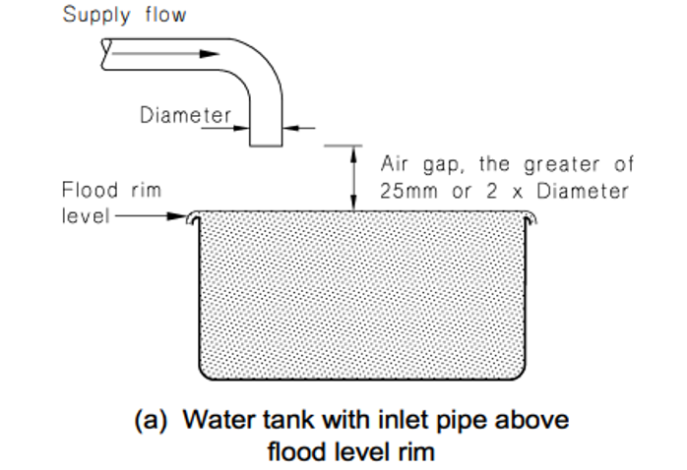  Figure 1: Air gap separation (from the Acceptable Solutions and Verification Methods For New Zealand Building Code Clause G12 Water Supplies)
Backflow | When water flows backwards from a hazardous activity connected to the drinking water supply, this can contaminate the water and make it unsafe to drink or use (e.g. water from a swimming pool, farm trough, laboratory).  There are three backflow hazard categories: high (potential to cause death), medium (potential to cause illness or injury) and low (potential to affect the taste, odour, or appearance of the water).  Refer to section 3 of the Acceptable Solutions and Verification Methods For New Zealand Building Code Clause G12 Water Supplies for more information about backflow hazards and the acceptable methods for preventing these.
Backflow prevention device | A device which allows water to flow in one direction only, and which is used to prevent contaminated water from a hazardous activity entering the drinking water system. The most common types of devices are a testable double check valve and a reduced pressure zone (RPZ) valve.  NZSPA contracts Argest to test all testable backflow prevention devices on its register annually, to meet the requirements of the Building Act.
Cartridge filtration | A cartridge filter is a type of filtration equipment, used to remove unwanted particles from the drinking water. Cartridge filters are used to improve the quality of the water and to make sure that the UV disinfection is effective (as otherwise the bugs can hide behind the particles and not be inactivated). This is the most commonly used type of filtration system for drinking water supplies. The cartridge filters are encased within individual housings and the filters need replacing on a regular basis. There are normally two (and sometimes three) cartridge filters in series.  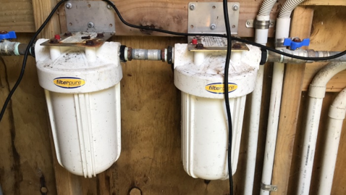  Figure 3: Example cartridge filter housing  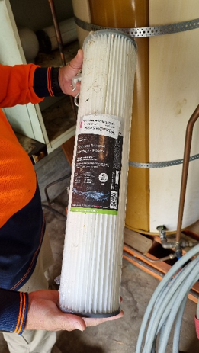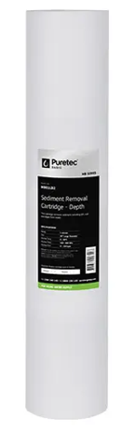  Figure 4: Example filters
Cartridge filter pore size | The cartridge filter has tiny pores (holes) and only things smaller than the pore size can pass through to the next treatment step (normally UV disinfection). Larger particles are captured in the filter. The most common pore sizes for cartridge filters are 20 micron and 5 micron. Water flows through the filter with the larger pore size first to remove larger particles, then through the filter with the smaller pore size to remove smaller particles not removed by the first cartridge.
Chlorine residual | Residual chlorination refers to the dosing of water with chlorine after filtration and UV disinfection, so that a level of chlorine is present in the water in the distribution system. The purpose of this is to treat for any microbial contamination that may enter the distribution system (e.g. due to leaks) prior to the point of use. The level of residual chlorine is measured as free available chlorine (FAC).
Compliance | As registered water suppliers, self-supplying schools must comply with the Water Services Act. This includes providing water which meets the limits in the Drinking Water Standards, preparing a drinking water safety plan and complying with the Drinking Water Quality Assurance Rules or an applicable Acceptable Solution.
Contingency plans | These set out the action required (e.g. sampling, ordering tanker delivery of safe water from another compliant supply) if there is an event like water contamination, water shortage or a natural disaster.
Cyanobacteria | Cyanobacteria live in water and can manufacture their own food by photosynthesis. While they are quite small, being unicellular, they often grow in colonies large enough to see. Cyanobacteria are more likely to occur in water that is exposed to sunlight (e.g. surface water sources). Some cyanobacteria produce toxins that have health effects. Cyanobacteria will also block filters. Special treatment processes are needed to remove cyanobacteria and cyanotoxins, if they are present.
Differential pressure | The difference between the pressure measured before and after a filter, gives an indication of how clogged a filter is, and indicates when the filter should be replaced.  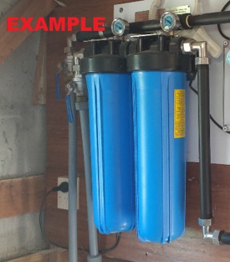  Figure 5: Example cartridge filters with differential pressure gauges
E. coli | Escherichia coli (E. coli) bacteria normally live in the intestines of healthy people and animals. Most types of E. coli are harmless or cause relatively low level diarrhoea. Several strains, such as E. coli O157:H7, can cause severe stomach cramps, bloody diarrhoea and vomiting. If E. coli is detected in drinking water, this indicates it has been contaminated with faeces and may contain organisms which can cause illness.
Testable Double check valve | A testable backflow prevention device which is used to protect against backflow from a medium or low hazard activity.  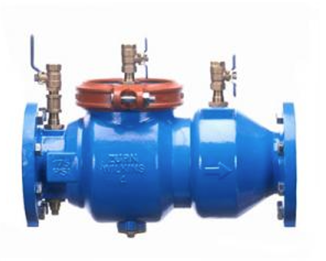  Figure 6: Example testable double check valve
DWSP | A drinking water safety plan is a simple risk-based guide that explains how a water supply will be kept safe and reliable by identifying possible hazards and setting out actions to prevent contamination and protect consumers.
First flush diverter(s) | Captures the first flow of water from the roof, along with sediment and other contaminants that are washed off the roof when it first starts to rain. Most contaminants are washed off in the initial rain, so this device results in cleaner water being collected in the untreated water storage tanks.  The first flush diverter needs to be emptied of the accumulated contaminants on a regular basis.  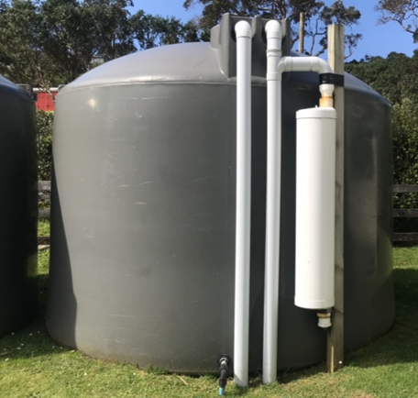  Figure 7: Example first flush diverter
Free available chlorine | See chlorine residual
Hinekōrako Code | The unique code (comprising three letters and three numbers) assigned to the drinking water supply by Taumata Arowai. Hinekōrako is Taumata Arowai’s online system for water suppliers to report results and notify Taumata Arowai of incidents that may result in either disruption to the water supply or unsafe water being provided to consumers.
Hose connection vacuum breaker | A device on an outdoor tap which prevents water from the hose moving back into the water supply.  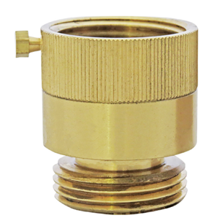  Figure 8: Example hose connection vacuum breaker
Leaf screens | An angled device with mesh located on the downpipe to prevent leaves etc. entering the water supply. Alternatively, gutter guards may be installed to achieve the same purpose.  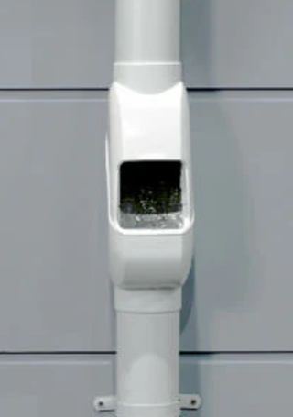  Figure 9: Example leaf screen
Maintenance Contractor | A contractor which the school has a contractual arrangement with, to undertake regular maintenance on the drinking water system (e.g. replacing cartridge filters and UV lamps). Alternatively, this may be the plumber that the school calls when maintenance is needed on the water supply. If a staff member or community member normally undertakes the maintenance on the water supply, note this in Table 1-2 (Key contact information).
pH correction | pH correction is a treatment process used to adjust the acidity or alkalinity of water to improve water quality and protect distribution infrastructure. In New Zealand School Property Agency school treatment systems, pH correction is normally installed after UV disinfection. This placement prevents the risk of calcium carbonate scaling on UV sleeves when pH is increased (e.g., via CaCO₃ media) and still allows pH to be stabilised before the water enters the school’s plumbing. pH may be increased using calcium carbonate or other alkaline materials, or decreased through controlled acid dosing, depending on the source water characteristics.
Preventative Measures | The things that will reduce the likelihood of a hazard occurring, or the consequences if it did occur. For example, preventing vermin getting into water storage tanks reduces the likelihood of contamination, and a water treatment plant reduces the consequence if the source water is contaminated with faecal material.
Quartz sleeve | The UV quartz sleeve is the glass tube in which the ultraviolet lamp is installed in order to separate the lamp from the water flow and exclude dirt and moisture. It must be kept clean to enable the UV light to penetrate and disinfect the water, and if obscured by scratches or deposits of any kind, it must be cleaned or replaced.
Registered Water Carrier | A water supplier who provides drinking water via a tanker to consumers, and who is registered with Taumata Arowai. Schools must use a registered water carrier when they need to top up their water supply or source an alternative supply of water during an incident.
Reduced pressure zone (RPZ) device | A testable backflow prevention device which is used to protect against backflow from a high hazard activity. While it can also be used for preventing backflow from low or medium hazard activities, it is significantly more expensive than other devices approved for those activities.  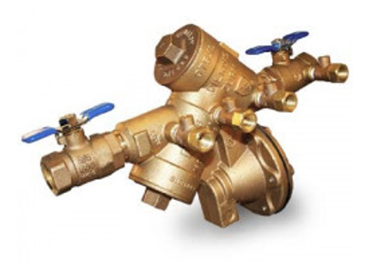  Figure 10: Example reduced pressure zone (RPZ) device
Residual chlorination | See chlorine residual.
Roof catchment area | All the roof areas used for harvesting rainwater for the roof water supply, measured in square metres (m²).
Solenoid valve | An electronic valve which prevents water flowing through the UV unit when the UV intensity (or UV dose) is too low. The purpose of this is to prevent unsafe water being delivered to the distribution system.  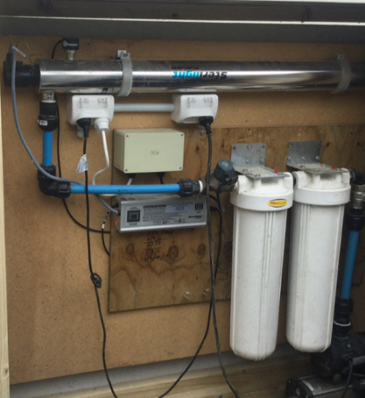  Figure 11: Example solenoid valve being used to control a UV unit
Taumata Arowai | The drinking water, wastewater and stormwater regulator for Aotearoa New Zealand.
Total coliforms | Total coliforms include bacteria that are found in the soil, in water that has been influenced by surface water, and in human or animal waste. Their presence in drinking water shows that the water has been contaminated with bacteria.
Turbidity | Turbidity measures how clear or cloudy the water is—lower turbidity means clearer water. Cartridge filters can reduce turbidity by removing suspended particles, but they do not remove colour, which comes from dissolved substances; low turbidity is essential before UV disinfection so germs aren’t shielded by particles.
UV disinfection | UV light is shone through the water to inactivate germs (bacteria, viruses and protozoa) so that they cannot reproduce to cause illness in anyone drinking the water. The UV lamp is housed in a casing or sleeve and needs replacing on a regular basis.  It is important that the UV unit is validated against one of four approved standards listed in the Drinking Water Quality Assurance Rules or Acceptable Solution. Validation is required to achieve compliance and to provide confidence that the UV system is a high quality and reliable unit.  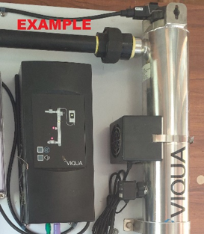  Figure 13: Example UV unit
UV auto shutdown | Flow through the UV unit automatically stops if the UV intensity (or UV dose) is too low e.g. during a power cut or if the UV lamp hasn’t warmed up yet
UV dose and UV intensity (UVI) | The amount of UV light that passes through the water. An average dose (reduction equivalent dose) of 40 mW/cm² is required. Validated units will achieve this.
UV lamp status indication | A display that indicates whether the UV lamp needs replacing (e.g. light turns from green to red when the lamp needs replacing).  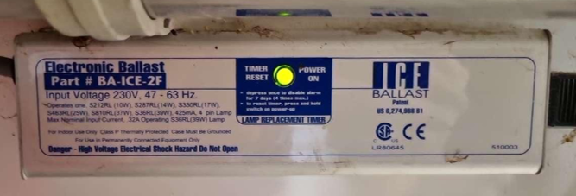  Figure 14: Example UV lamp status indication
UV validation certificate | A validation certificate for UV water treatment serves as documented proof that the ultraviolet (UV) system has been tested as effective at deactivating microorganisms in compliance with a specific internationally recognised standard. It confirms that the UV treatment consistently meets required disinfection levels, ensuring the safety and quality of the treated water. A copy of the validation certificate can be obtained from the supplier.
Compliance pathway | The school’s water supply will need to comply with one of the following categories:  - Drinking Water Acceptable Solution for Self-supplied Buildings  - Drinking Water Quality Assurance Rules - Small  - Drinking Water Quality Assurance Rules - Medium  - Drinking Water Quality Assurance Rules - Large

- Section 1 – School Details
Table 1-1 (School background, population and building information) has been partially pre-populated using information that the New Zealand School Property Agency holds about the school. Please review and complete the table.
If the school’s drinking water supply supplies other properties (e.g. school house, community hall), please enter the average number of people in the boxes for Houses and Other in Table 1-1.
If there are occasions where there is a much larger population (e.g. an event at the hall), please enter the maximum number of people in the Peak population box.
For compliance pathway, choose one option from the following table. NZSPA’s preference is that the Acceptable Solution is used if the eligibility criteria are met.
Please refer to the Acceptable Solution for the full list of eligibility criteria.
Compliance Pathway Option | Eligibility Criteria
Self-Supplied Buildings Drinking Water Acceptable Solution | - Population up to 500 people  - 10 or fewer buildings supplied with drinking water on one property (or adjoining properties in common ownership)  - Water must be suitable for treatment by cartridge filtration and UV disinfection (pre-treatment may be required)  - If the supply is to more than three buildings or for more than 100 people, the pipes carrying drinking water must not be near a septic tank, wastewater treatment plant or effluent disposal field.
Drinking Water Quality Assurance Rules – Small Self-Supplied Buildings Supply | - Population up to 100 people  - 10 or fewer buildings supplied with drinking water on one property (or adjoining properties in common ownership)
Drinking Water Quality Assurance Rules – Small Networked Supply | - Population up to 100 people  - 11 or more buildings supplied with drinking water, or water is supplied to another property owned by someone else
Drinking Water Quality Assurance Rules – Medium Self-Supplied Buildings Supply | - Population 101 – 500 people  - 10 or fewer buildings supplied with drinking water on one property (or adjoining properties in common ownership)
Drinking Water Quality Assurance Rules – Medium Networked Supply | - Population 101 – 500 people  - 11 or more buildings supplied with drinking water, or water is supplied to another property owned by someone else
Drinking Water Quality Assurance Rules – Large Self-Supplied Buildings Supply | - Population more than 500 people  - 10 or fewer buildings supplied with drinking water on one property (or adjoining properties in common ownership)
Drinking Water Quality Assurance Rules –Large Networked Supply | - Population more than 500 people  - 11 or more buildings supplied with drinking water, or water is supplied to another property owned by someone else

- Section 2 – Description of Water Supply
  - Source
To calculate the roof area, measure the length and width of the roof that is used for collecting rain water. Multiply the two figures to calculate the area in square metres (m²) of the roof (e.g. 4 metres (length) multiplied by 3 metres (width) = 12 m² in total).
Check whether your roof material is suitable for collecting drinking water. Uncoated lead flashings, lead-head nails, treated timber, asbestos roofs, bitumen, lead-based paints, and other coatings containing chemicals not suited for contact with drinking water are examples of unsuitable materials.
Use the following criteria when assessing the roof condition:
- Good: As new condition / minor wear and tear / minor deterioration of surfaces.
- Average: Minor cracking / minor damage to coatings
- Poor: Roof damaged, weakened or displaced / roof is badly damaged or weakened. Coatings in need of heavy maintenance or renewal / coatings are badly damaged or non-existent.
Possible measures the school may already have in place to reduce contaminants from the roof entering the water supply are:
- Leaf screens on all supply downpipes
- Leaf screens on some supply downpipes
- First flush diverter(s) for some of the roof water entering the untreated water storage tanks
- First flush diverter(s) for all of the roof water entering the untreated water storage tanks
  - Treatment
Check that the treatment steps listed (cartridge filtration and UV) are present. Delete any that are missing and add any other treatment steps that are present (e.g. chlorination, pretreatment).
Take photos of key parts of your water supply and insert them into the relevant tables.
For Table 2-2 (Details of the cartridge filter system), the pore size for the filter can be found on the packaging or supply note that comes with the filters. This will be shown as in µm (microns) (e.g. 20 and 5 µm). If the packaging is not available, please contact the filter supplier for details.
To answer the question about whether differential pressure is measured across the cartridge filters, check whether there are pressure gauges on either side of each cartridge filter.
Check the name plate on the UV unit for the UV make and model, and to see whether it is validated for NSF/ANSI 55 Class A. The validation certificate for the UV system is available from the supplier, and a copy should be held on file at the school.
Ask your UV installer or plumber if flow through the UV unit stops automatically if there is a UV fault.
The school may have pretreatment (e.g. activated carbon filters to remove lead or media filters for softening). If so, add the details to Table 2-5 (Details of the pretreatment system), otherwise delete the table.
The school may have pH correction to adjust the acidity or alkalinity of water. If so, add the details to the table describing pH correction. If you do not have a pH correction system, delete the table.
Chlorination is only required for supplies serving over 500 people. If the school has a chlorine dosing system to maintain a chlorine residual in the water supply network, complete Table 2-5 (Details of chlorine residual disinfection), otherwise delete the table. If the school uses chlorine, training in the safe handling, storage and dosing of chlorine is required for staff involved in chlorine dosing.
  - Storage
Copy Table 2-7 (Untreated water storage tank details) and Table 2-7 (Treated water storage tank details) to match the number of tanks at the school so that there is one table per tank.
If the tank volume is unknown, calculated it as follows:
- For a rectangular tank, multiply the length (L) times the width (W) times the height (H) (i.e. L x W x H).
- For a cylindrical tank, measure the diameter and the height of the tank (to the bottom of the overflow if there is one). Multiply the diameter (D) by the diameter (D), then multiply by 3.14, divide by 4 and multiply by the height (H) (i.e. πD²H/4)
For the tank material, most tanks are either polyethylene (PE) or concrete.
For the condition of the tank, choose from one of the following:
- Very good: as new
- Good: no structural issues, some minor deterioration
- Average: minor cracks and/or moderate deterioration
- Poor: cracks, signs of leaking, structural issues, significant deterioration and/or bulging
- Very Poor: significant cracks or holes, obvious leaks, significant structural issues and/or significant deterioration
To prevent vermin and other contaminants entering the tank, state which of the following measures are in place:
- Secure lid
- No gaps greater than 1.5 mm
- Flap valve on the overflow
If you do not have any treated water storage, delete Table 2-8 (Treated water storage tank details) and amend the text above to say that the school has no treated water storage.
If the condition of the tank is poor or very poor, or if vermin or other contaminants could enter the tank, capture this in the risk table and improvements table in Section 4.
  - Distribution
Check whether there are any activities which pose a backflow hazard connected to the school’s drinking water supply (see the table below for the most common backflow hazards at schools). If there are any backflow hazards, check whether an appropriate backflow prevention device is in place. If there is a backflow prevention device, make sure it is on Argest’s backflow prevention register (Argest will then test it each year to make sure it is still working). Enter the details in Table 2-9 (Medium or high hazard backflow activities connected to the school's water treated water supply).
If there is a backflow hazard and the backflow prevention does not meet requirements, capture this in the risk table and improvements table in Section 4.
Refer to NZ Building Code Acceptable Solutions and Verification Methods – Clause G12 Water Supplies for more information about backflow prevention hazards and backflow prevention devices.
If there are no backflow hazards connected to the school’s drinking water supply, delete all of the section after the first two paragraphs and replace with a sentence that says, “The water supply has no medium or high hazard activities that require a backflow prevention device.”
Activity | Hazard level | Type of backflow prevention device required
Swimming pool | Medium | Testable double check valve, reduced pressure zone (RPZ) device or air gap
Dental clinic | High | Reduced Pressure Zone device or air gap
Farm trough | Medium | Testable double check valve, reduced pressure zone (RPZ) device or air gap
Laboratory | Medium | Testable double check valve, reduced pressure zone (RPZ) device or air gap
Untreated water storage tanks connected to treated water distribution (i.e., not source water storage tanks) | Medium | Testable double check valve, reduced pressure zone (RPZ) device or air gap
Irrigation | Medium | Testable double check valve, reduced pressure zone (RPZ) device or air gap
Fire sprinkler system | Medium | Testable double check valve, reduced pressure zone (RPZ) device or air gap
Boiler feed water | High | Reduced Pressure Zone device or air gap
Hose taps used for mixing pesticides | High | Reduced Pressure Zone device or air gap
As a minimum, every hose tap needs a permanently attached hose connection vacuum breaker (unless the tap is associated with a medium or high hazard, in which case a backflow prevention device is needed as per Clause G12 and the above table).
Copy the information about the risks and planned improvements in the risk table and improvements table in Section 4.
  - Aerial View and Schematic of Water Supply
Replace the example figures in Figure 2-1 (Water supply roof catchments and sampling locations) and Figure 2-2 (School water supply and treatment schematic) with an annotated aerial image and a schematic that accurately reflect the school’s water supply.
NZSPA has typical schematics in PowerPoint that you can edit for Figure 2-2:
- Choose one of the PowerPoint slides provided that has a schematic which most closely resembles the school’s water supply.
- Modify it to be a true representation of your school’s water supply.
- Use the snipping tool to select the schematic once completed.
- ‘Save as’ the picture file and import into the drinking water safety plan, or copy and paste it into the drinking water safety plan.
  - Daily Water Demand and Storage Requirements
To estimate the average daily water demand:
Step 1. Determine the maximum population:
- Confirm with NZSPA the maximum projected school roll in 10 years’ time and beyond
- Add 10% for staff
- Select current or future population, whichever is greater.
Step 2. Calculate the water use for students and staff:
- If water meter data is available, use this to calculate the average day demand
- If not, calculate the average daily demand assuming:
  - 10 litres per person per day (for newer systems with low leakage)
  - 15 litres per person per day (typical median value)
  - 20 litres per person per day (for older systems with high leakage).
Step 3. Add an allowance for any other uses connected to the drinking water supply, for example:
- Pool: daily volume lost by evaporation and used for backwash and as advised by the company that provided your pool filter or the person that maintains your pool
- Houses: 227 litres per person per day
- Community Hall: 15 litres per person per day
- Early childhood centre: 20 litres per person per day
Enter the details in the table describing average daily water use. Delete any rows that don’t apply.
The New Zealand School Property Agency recommends that self-supplying schools relying on roof water store enough untreated water to meet the school’s demand for at least 20 days. To calculate the untreated water storage requirements, multiply the average daily use calculated above by 20 days.
More storage volume will be required for schools if there has been a problem in the past with the school running out of water. If this is the case, please contact the Water Services team at NZSPA for a roof water storage assessment.
NZSPA recommends that self-supplying schools store enough treated drinking water for three days, both to minimise disruption if there is a treatment plant outage and to provide enough during an emergency. To calculate the treated water storage requirements in the table of treated water storage requirements), multiply the average daily use calculated above by 3 days.
Compare the total volume of untreated and treated water storage that the school already has with the required amount and state whether this is sufficient, or if more storage needs to be installed. If more storage is needed, capture this in the risk table and improvements table in Section 4.
  - Te Mana o Te Wai
Te Mana o te Wai recognises that protecting the health of freshwater protects the health and well-being of the wider environment. Examples of ways the school can give effect to Te Mana o Te Wai are:
- Taking care with water use and only using what is needed
- There is no obvious leakage and leaks are fixed promptly
- Having water-efficient devices (e.g. no old-style urinals or single flush toilets)
- Dangerous chemicals are handled with care
- Wastewater is treated and disposed of appropriately to minimise adverse effects.
List the ways in which the school already gives effect to Te Mana o Te Wai and list the ways in which the school plans to improve in this area. Where improvements are planned, copy these into the improvements table in Section 4.

- Section 3 – Source Water Risk Management Plan
Protection of source water is of paramount importance, and this is the first barrier against drinking water contamination and illness. Protecting source water starts with understanding your source water and how it could become contaminated or run out.
  - Catchment Description
Replace the highlighted text with the name of the region and list the buildings that are used to collect roof water.
Replace the aerial image in Figure 3-1 (Aerial image showing the location of the school) with one showing the location of the school.
Consider what things could cause the rain water to become contaminated add applicable ones to the list.
Potential sources of contaminants for roof water include:
- Faecal matter from birds and other animals on the roof
- Leaves and organic matter from overhanging vegetation or nearby trees
- Chemicals from roof cleaning
- Deposits from chimneys
- Poor quality/degrading roof materials or chemicals leaching from the roof
- Spraying on nearby properties
List improvement actions the school could take to reduce contaminants entering the water supply. Potential improvements include:
- Trimming back vegetation overhanging roofs used for the water supply
- Installing leaf screens on downpipes used for collecting roof water
- Installing a first flush diverter to reduce contaminants entering the tank
- Installing downpipe diverters and using these when cleaning the roof or when chemical spraying is scheduled to occur on neighbouring properties, to prevent chemicals entering the water supply
- Replacing/upgrading roof materials
- Removing/decommissioning nearby chimneys and replacing with a clean heat source (e.g. heat pumps)
Copy the information about the risks and planned improvements in the risk table and improvements table in Section 4.

- Section 4 – Risks and Improvement Actions

Table 4-1 Risks and Improvement Actions
Complete the risk assessment table (Table 4-1: Risks and improvement actions) once you have completed the previous sections of the drinking water safety plan.
Review the existing preventative measures that the school could have in place to reduce each risk and delete those that don’t apply.
Review the risk rating, considering the preventative measures that you already have in place. The following risk definitions have been used:
- Low: Insignificant or minor consequence, with little disruption to normal operation; not likely to happen.
- Medium: Significant manageable disruption to safe water supply, with requirement for increased monitoring. Potential aesthetic issues; likelihood possible.
- High: Major disruption to safe water supply, e.g., complete failure of systems, acute harm to people or widespread illness; high level of monitoring and incident management required; likely to happen.
Choose whichever risk rating is appropriate and delete the others. We make the following recommendations about how to score each risk.
If there is no residual chlorination, delete the row for the risk Treatment – Residual Chlorination.
Table 4-1: Risk evaluation guidance
Risk (Event Description) | Low | Medium | High
Contamination of source water by faecal material. | If all the following are present:  - Cartridge filtration  - UV disinfection  - Leaf screens on all supply downpipes  - First flush diverter(s) for all of the roof water entering the untreated water storage tanks | If the following are present:  - Cartridge filtration  - UV disinfection  BUT some of the following are missing:  - Leaf screens on all supply downpipes  - First flush diverter(s) for all of the roof water entering the untreated water storage tanks | If one or both of these are missing:  - Cartridge filtration  - UV disinfection
Contamination of source water by chemicals | If all roof materials are suitable for contact with drinking water  AND  There is no nearby agricultural or horticultural spraying (within 200 m) | If either or both of the following apply:  - The roof contains materials unsuitable for contact with drinking water (uncoated lead flashings, lead-head nails, treated timber, asbestos roofs, bitumen, lead-based paints, and other coatings containing chemicals not suited for contact with drinking water)  - There is no nearby agricultural or horticultural spraying  AND  There are flush diverter(s) on all of the roof water entering the untreated water storage tanks | If either or both of the following apply:  - The roof contains materials unsuitable for contact with drinking water (uncoated lead flashings, lead-head nails, treated timber, asbestos roofs, bitumen, lead-based paints, and other coatings containing chemicals not suited for contact with drinking water)  - There is no nearby agricultural or horticultural spraying  AND  There are not flush diverter(s) on all of the roof water entering the untreated water storage tanks
Insufficient source Water | The school has never had a problem with a lack of drinking water due to insufficient source water  AND  There is at least 20 days’ untreated water storage (as per section 2.6.1) | The school has a problem with a lack of drinking water due to insufficient source water less often than once a year  OR  There is less than 20 days’ untreated water storage (as per section 2.6.1) | The school has problems with a lack of drinking water more than once a year due to insufficient source water
Contamination of water in storage tanks | All tanks are in average, good or very good condition  AND  Any gaps or holes are covered in mesh with a gap size of no more than 1.5 mm (or in the case of an overflow, a flap valve is installed on it)  AND  All lids are secure | All tanks are in average, good or very good condition  AND  There are fine cracks (<1.5 mm) in the roof of the tank  AND  All lids are secure | One or more tanks are in poor or very poor condition  OR  There are gaps or holes in the tank that are greater than 1.5 mm  OR  Lids are missing or are not secure
Particles and/or natural organic matter not removed | There is cartridge filtration, including a filter with a pore size of 5 microns or smaller  AND  The cartridge filters are replaced at least every 6 months (or more often if required)  AND  There is no bypass around the cartridge filters | There is cartridge filtration, including a filter with a pore size of 5 microns or smaller  AND  The cartridge filters are replaced less often than every 6 months  OR  There is a bypass around the cartridge filters | There is no cartridge filtration
Inadequate disinfection | All of the following are in place:  - There is a validated UV unit which treats all the drinking water  - The UV unit is serviced at least annually by a trained operator, including replacing UV lamps and cleaning sleeves.  - There is an automatic control system in place which prevents water flowing through the UV unit if the UV dose/intensity is insufficient (e.g. via a solenoid valve)  - There is no bypass around the UV unit | All of the following are in place:  - There is a UV unit which treats all the drinking water  - The UV unit is serviced at least annually by a trained operator, including replacing UV lamps and cleaning sleeves.  AND  There is no automatic control system in place which prevents water flowing through the UV unit if the UV dose/intensity is insufficient (e.g. via a solenoid valve)  OR  There is a bypass around the UV unit | There is no UV unit  OR  There is a UV unit which treats only some of the drinking water
Low chlorine residual in the treated water  (Note: this risk only applies if there is a chlorine dosing system to maintain a chlorine residual in the pipe network, which is uncommon in schools) | All of the following are in place:  - The chlorine dosing system is serviced at least annually  - Hypochlorite is replaced on a regular basis and before its expiry date  - Person responsible for maintaining the drinking water supply is trained in the maintenance of the chlorine plant and undertakes maintenance in accordance with this  AND  - Free available chlorine (FAC) is measured on a regular basis at the tap and is always between 0.2 mg/L and 5 mg/L | Some but not all of the following are in place:  - The chlorine dosing system is serviced at least annually  - Hypochlorite is replaced on a regular basis and before its expiry date  - Person responsible for maintaining the drinking water supply is trained in the maintenance of the chlorine plant and undertakes maintenance in accordance with this  AND  - Free available chlorine is measured on a regular basis at the tap and is normally above 0.2 mg/L | There is no regular servicing of the chlorine dosing system  OR  The hypochlorite is not replaced on a regular basis  OR  There is no monitoring of FAC at the tap or FAC is often below 0.2 mg/L
Loss of supply  Inadequate treated water due to failure of the water treatment plant or its pump  (Note: this risk only applies to a lack of treated water, as a lack of source water is covered in a separate risk above) | The school has not had a problem with a lack of treated drinking water in the last 5 years.  AND  There is at least 3 days treated water storage (as per section 2.6.2) | The school has had a problem with a lack of treated drinking water less often than once a year.  OR  There is less than 3 days treated water storage (as per section 2.6.2) | The school has had a problem with a lack of treated drinking water more often than once a year.  AND  There is less than 3 days treated water storage (as per section 2.6.2)
Loss of supply due to excessive water usage  Extraordinary water use | There has not been a problem with low pressure or low flow in the last 5 years.  AND  Any leaks in the distribution network are fixed promptly | There are problems with low pressure or low flow in the distribution system less often than once a month  OR  Any leaks in the distribution network are fixed promptly | There are problems with low pressure or low flow in the distribution system more often than once a month  OR  There are known leaks or problems with excessive water use
Loss of power means the treatment plant and pumps cannot operate | Power outages are rare (less than once a year)  OR  The school has a portable generator which can power the treatment plant and pumps | N/A | N/A
Distribution - contamination of supply from backflow, cross-connections with a non-potable supply or poor condition pipes | There are no medium or high hazard activities connected to the distribution system  OR  There are medium or high hazard activities connected to the distribution system, and backflow prevention devices which meet the requirements of the Building Code are in place in every case  AND  There are no cross-connections between the potable and non-potable supplies (or there is no non-potable supply)  AND  Distribution pipework is in good condition | There is a medium hazard activity connected to the distribution system and there is no associated backflow prevention device  OR  There is a medium hazard activity connected to the distribution system and the associated backflow prevention device does not meet the requirements of the Building Code  OR  Distribution pipework is in poor condition | There is a high hazard activity connected to the distribution system and there is no associated backflow prevention device  OR  There is a high hazard activity connected to the distribution system and the associated backflow prevention device does not meet the requirements of the Building Code  OR  There are cross-connections between the potable and non-potable supplies  OR  Distribution pipework is in very poor condition
Review the improvement items and delete any that the school already has in place. There should be improvement items for any risk which is rated as medium or high.

Table 4-2: Summary of Improvement Actions
The improvement actions the school plans to take to improve the safety and reliability of its water supply is one of the most important sections of the drinking water safety plan. It is also useful when reporting progress (e.g. to the Board of Trustees).
Copy the improvement items from the previous sections into Table 4-2 (Summary of improvement measures the school will take to minimise risks) from:
- Section 2.4.1 Backflow Prevention
- Section 2.6 Daily Water Demand and Storage Requirements
- Section 2.7 Te Mana o Te Wai
- Section 3.2 Impact of Catchment Activities on Water Quality
- Section 3.3 Water Quantity Available from Source
- Table 4-1 Risk Assessment.
Insert additional lines in the table so that there is one line per improvement action.
For each improvement, choose whether it is an urgent or non-urgent priority:
- Urgent improvements are those which address drinking water safety concerns or address a lack of water (i.e. those which address a high risk).
- Non-urgent improvements are those which improve the resilience and reliability of the supply or enable full compliance with the Drinking Water Quality Assurance Rules/Acceptable Solution (i.e. those which address a medium risk, or which are needed to meet NZSPA’s storage requirements or improve Te Mana o Te Wai or achieve full regulatory compliance).
Urgent problems and potential improvement actions are summarised in Table 4-2, and non-urgent problems and potential improvement actions are summarised in Table 4-3.
Table 4-2: Urgent problems and potential improvements
 | Urgent Problem | Potential Improvements
Source | Obvious problems with roof water collection network (e.g. broken pipes) | - Fix broken collection pipes
Source | Roof materials not suitable for contact with drinking water | - Replace roof and/or lead-head nails with materials suitable for contact with drinking water
Source | Problems with running out of water | - Fix any broken collection pipes  - Consider alternative sources  - Increase storage  - Stop supplying other properties  - Install water efficient devices  - Install a pool cover  - Consider using non-potable water for irrigation and the pool
Source | Agricultural/horticultural spraying nearby | - Install downpipe diverters and use these to disconnect the roof source from the tanks when there is spraying nearby (and during roof maintenance)  - Ask nearby farmers to provide advance warning of spraying
Source | Maximum acceptable value (MAV) in the Drinking Water Standards is exceeded in source water and no/inadequate process to remove it | - Remove source of contamination  - Install treatment process to address MAV exceedance
Treatment | No treatment plant | - Install a new compliant treatment plant and smart flow meter in a dedicated shed
Treatment | Treatment processes needed for microbiologically safe water are missing | - Maintain the water treatment plant (e.g. replace cartridge filters, UV lamp etc.)  - Install cartridge filtration  - Install a validated UV unit (if maintenance doesn’t fix problem)  - Install a solenoid valve to stop water flowing through the UV unit if there is a UV fault
Treatment | Bypass around water treatment plant (or part of treatment process) | - Remove bypass
Storage | Very poor or poor condition storage tanks (e.g. leaking excessively) | - Replace storage tanks
Storage | Storage tank vulnerable to contamination by vermin (i.e. large holes) | - Install vermin protection (i.e. install a flap valve if it’s an overflow, repair holes)
Distribution | High or medium backflow hazard (or cross-connection risk) and no/inadequate backflow prevention device | - Install backflow prevention device that complies with section 3.3 of the Acceptable Solution for Clause G12 Water Supplies of the Building Code  - Remove high or medium risk activity from the water supply
Distribution | Significant leakage from network | - Fix leaks
Table 4-3: Non-urgent problems and potential improvements
 | Non-urgent Problems | Potential Improvements
Source | Leaf screens and downpipe diverters not installed on every pipe used for roof water collection. | - Install leaf screens  - Install downpipe diverters
Source | No first flush diverters | - Install a first flush diverter on the first tank in each group of untreated water storage tanks
Treatment | UV unit isn’t validated | - Replace UV unit with a validated unit
Treatment | UV unit doesn’t shut down automatically on low UVI/UV dose | - Install solenoid valve to automatically stop flow through UV unit on low UVI/UV dose (needs to be done in conjunction with treated water storage tanks otherwise there will be no water for the school if there is a UV fault)
Treatment | No flow control on UV unit (to prevent flow exceeding validated flow rate) | - Install flow restrictor  - Use flow meter to control flow through UV
Treatment | No residual chlorination system and population > 500 people | - Install a residual chlorination system
Treatment | Multiple treatment plants and/or overly complex pipework | - Modify supply so that there is a single treatment plant if possible
Storage | Storage tanks vulnerable to contamination by insects (i.e. small holes or gaps) | - Seal all holes and penetrations or cover with insect mesh so that gap size is no more than 1.5 mm
Storage | Storage tank doesn’t have an air vent | - Install air vent with light trap and insect mesh
Storage | Storage tank air vent doesn’t have a light trap and/or insect mesh | - Replace air vent with one that has a light trap and insect mesh
Storage | Storage tank doesn’t have an overflow | - Install an overflow with a flap valve to prevent access by vermin
Storage | Storage doesn’t meet NZSPA requirements | - Install additional storage so that there is at least 7 days of untreated water storage and 3 days of treated water storage
Distribution | No permanently attached vacuum breakers on hose taps | - Install permanently attached vacuum breakers on hose taps
Distribution | School supplies other properties | - Move towards ceasing supply to other properties  - If water source is plentiful, consider continuing supply of non-potable water to other properties if an agreement can be reached between the school and property owner that they will install a compliant treatment plant
Monitoring | Sample taps missing | - Install sample taps to allow sampling in the positions described in the relevant section of the Acceptable Solution or the Drinking Water Quality Assurance Rules
Monitoring | No flow measurement | - Install smart flow meter downstream of the water treatment plant to record the school’s water demand and provide for remote monitoring and data acquisition via a network connection
Monitoring | No remote monitoring of continuously monitored parameters, treatment plant faults and tank levels | - Establish remote monitoring of continuously monitored parameters, treatment plant faults and tank levels

- Section 5 – Operations, Maintenance, Monitoring and Reporting
  - Operations and Maintenance
Apply the applicable filters in NZSPA’s “Maintenance and Servicing Guideline and Checklist” tool and take a screen shot or snip and paste into Appendix A.
If there is an operations and maintenance manual for the water supply, state where this is stored. If not, delete and add preparing an operations and maintenance manual to the improvements table in section 4.2.
  - Monitoring and Reporting
Choose the highlighted sentence that corresponds to the school’s compliance pathway (from Table 1-1) and delete the other highlighted sentences.



Drinking water safety planning | Taumata Arowai
https://www.building.govt.nz/building-code-compliance/g-services-and-facilities/g12-water-supplies/
https://www.building.govt.nz/building-code-compliance/g-services-and-facilities/g12-water-supplies/
Water Services Act: www.legislation.govt.nz/act/public/2021/0036/latest/LMS374564.html
Taumata Arowai: Drinking Water Standards, Drinking Water Quality Assurance Rules and Acceptable Solutions www.taumataarowai.govt.nz/for-water-suppliers/new-compliance-rules-and-standards/
Register of drinking water supplies, including registered water carriers https://hinekorako.taumataarowai.govt.nz/publicregister/supplies/
www.taumataarowai.govt.nz/

