


Drinking Water Safety Plan Guidance
  - Groundwater

Contents
Introduction 2
Glossary of Terms 3
1. Section 1 – School Details 13
2. Section 2 – Description of Water Supply 15
Section 2.1 Source 15
Section 2.2 Treatment 15
Section 2.3 Storage 16
Section 2.4 Distribution 17
Section 2.5 Aerial View and Schematic of Water Supply 18
Section 2.6 Daily Water Demand and Storage Requirements 19
Section 2.7 Resource Consent 20
Section 2.8 Te Mana o Te Wai 20
3. Section 3 – Source Water Risk Management Plan 21
Section 3.1 Catchment Description 21
4. Section 4 – Risks and Improvement Actions 23
Table 4-1 Risks and Improvement Actions 23
Table 4-2: Summary of Improvement Actions 29
5. Section 5 – Operations, Maintenance, Monitoring and Reporting 34
Section 5.1 Operations and Maintenance 34
Section 5.2 Monitoring and Reporting 34

Introduction
Preparing a drinking water safety plan (DWSP) is a risk management process that aims to ensure a safe, reliable, and resilient supply of drinking water to the staff, students and other people who drink your water. Your drinking water safety plan records key features and elements of your water supply system and their condition and location, key hazards, and risks to your drinking water supply and how you will manage them to ensure that drinking water is sufficient and safe.
We have started completing the drinking water safety plan template for your school, based on information that you’ve provided to the New Zealand School Property Agency (NZSPA). Please check the details that we have entered and correct where necessary.
All highlighted text in the template requires completing or choosing between two or more options. Any incorrect options should be deleted and the highlighting removed.

Glossary of Terms
The following terms are used in the drinking water safety plan and definitions are provided here:
Table 1: Glossary of terms
Air gap | A physical gap between the level of water inlet and the highest water level (flood rim level in the figure below), so that the water cannot flow backwards into the water supply. This is one of the approved methods to prevent backflow.  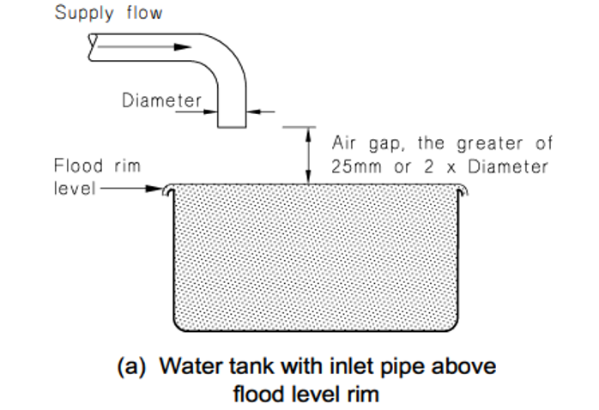  Figure 1: Air gap separation (from the Acceptable Solutions and Verification Methods For New Zealand Building Code Clause G12 Water Supplies)
Backflow | When water flows backwards from a hazardous activity connected to the drinking water supply, this can contaminate the water and make it unsafe to drink or use (e.g. water from a swimming pool, farm trough, laboratory).  There are three backflow hazard categories: high (potential to cause death), medium (potential to cause illness or injury) and low (potential to affect the taste, odour, or appearance of the water).  Refer to section 3 of the Acceptable Solutions and Verification Methods For New Zealand Building Code Clause G12 Water Supplies for more information about backflow hazards and the acceptable methods for preventing these.
Backflow prevention device | A device which allows water to flow in one direction only, and which is used to prevent contaminated water from a hazardous activity entering the drinking water system. The most common types of devices are a testable double check valve and a reduced pressure zone (RPZ) valve.  NZSPA contracts Argest to test all testable backflow prevention devices on its register annually, to meet the requirements of the Building Act.
Bore headworks | The infrastructure located at the extraction point of a bore groundwater source. The headworks include the bore, the bore head and the pump infrastructure required to extract the water.  A sanitary bore head is one that meets the sanitary bore head requirements in the Drinking Water Quality Assurance Rules (Taumata Arowai, 2022, section 4.9.2 S3 Sanitary Bore Head Requirements). Among other things, this includes an above ground bore head installed in an area not prone to ponding, with a concrete apron surrounding the bore head and extending at least 1 metre in all directions.  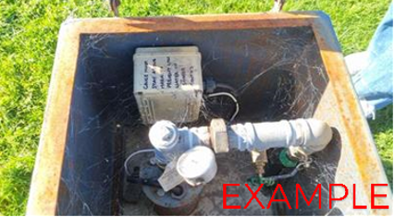  Figure 2: Example bore headworks
Cartridge filtration | A cartridge filter is a type of filtration equipment, used to remove unwanted particles from the drinking water. Cartridge filters are used to improve the quality of the water and to make sure that the UV disinfection is effective (as otherwise the bugs can hide behind the particles and not be inactivated). This is the most commonly used type of filtration system for drinking water supplies. The cartridge filters are encased within individual housings and the filters need replacing on a regular basis. There are normally two (and sometimes three) cartridge filters in series.  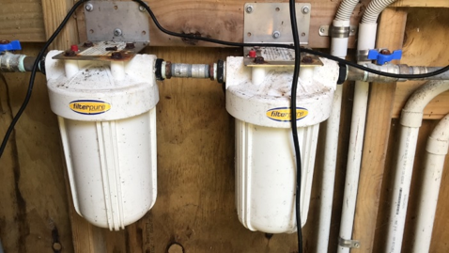  Figure 3: Example cartridge filter housing  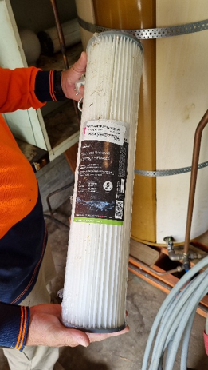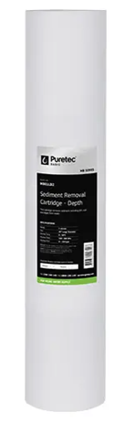  Figure 4: Example filters
Cartridge filter pore size | The cartridge filter has tiny pores (holes) and only things smaller than the pore size can pass through to the next treatment step (normally UV disinfection). Larger particles are captured in the filter. The most common pore sizes for cartridge filters are 20 micron and 5 micron. Water flows through the filter with the larger pore size first to remove larger particles, then through the filter with the smaller pore size to remove smaller particles not removed by the first cartridge.
Chlorine residual | Residual chlorination refers to the dosing of water with chlorine after filtration and UV disinfection, so that a level of chlorine is present in the water in the distribution system. The purpose of this is to treat for any microbial contamination that may enter the distribution system (e.g. due to leaks) prior to the point of use. The level of residual chlorine is measured as free available chlorine (FAC).
Compliance | As registered water suppliers, self-supplying schools must comply with the Water Services Act. This includes providing water which meets the limits in the Drinking Water Standards, preparing a drinking water safety plan and complying with the Drinking Water Quality Assurance Rules or an applicable Acceptable Solution.
Contingency plans | These set out the action required (e.g. sampling, ordering tanker delivery of safe water from another compliant supply) if there is an event like water contamination, water shortage or a natural disaster.
Cyanobacteria | Cyanobacteria live in water and can manufacture their own food by photosynthesis. While they are quite small, being unicellular, they often grow in colonies large enough to see. Cyanobacteria are more likely to occur in water that is exposed to sunlight (e.g. surface water sources). Some cyanobacteria produce toxins that have health effects. Cyanobacteria will also block filters. Special treatment processes are needed to remove cyanobacteria and cyanotoxins, if they are present.
Differential pressure | The difference between the pressure measured before and after a filter, gives an indication of how clogged a filter is, and indicates when the filter should be replaced.  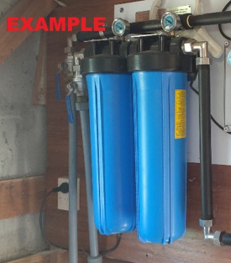  Figure 5: Example cartridge filters with differential pressure gauges
E. coli | Escherichia coli (E. coli) bacteria normally live in the intestines of healthy people and animals. Most types of E. coli are harmless or cause relatively low level diarrhoea. Several strains, such as E. coli O157:H7, can cause severe stomach cramps, bloody diarrhoea and vomiting. If E. coli is detected in drinking water, this indicates it has been contaminated with faeces and may contain organisms which can cause illness.
Testable Double check valve | A testable backflow prevention device which is used to protect against backflow from a medium or low hazard activity.  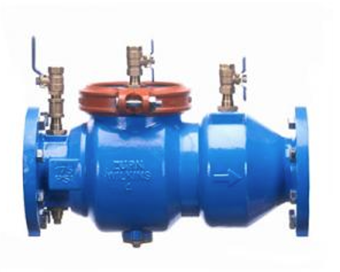  Figure 6: Example testable double check valve
DWSP | A drinking water safety plan is a simple risk-based guide that explains how a water supply will be kept safe and reliable by identifying possible hazards and setting out actions to prevent contamination and protect consumers.
Free available chlorine | See chlorine residual
Groundwater | Water sourced from underground, abstracted from a bore (see bore headworks) or a spring (see spring headworks).
Hinekōrako Code | The unique code (comprising three letters and three numbers) assigned to the drinking water supply by Taumata Arowai. Hinekōrako is Taumata Arowai’s online system for water suppliers to report results and notify Taumata Arowai of incidents that may result in either disruption to the water supply or unsafe water being provided to consumers.
Hose connection vacuum breaker | A device on an outdoor tap which prevents water from the hose moving back into the water supply.  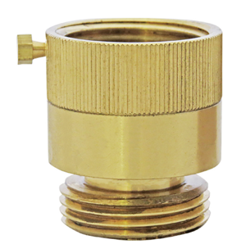  Figure 8: Example hose connection vacuum breaker
Maintenance Contractor | A contractor which the school has a contractual arrangement with, to undertake regular maintenance on the drinking water system (e.g. replacing cartridge filters and UV lamps). Alternatively, this may be the plumber that the school calls when maintenance is needed on the water supply. If a staff member or community member normally undertakes the maintenance on the water supply, note this in Table 1-2 (Key contact information).
pH correction | pH correction is a treatment process used to adjust the acidity or alkalinity of water to improve water quality and protect distribution infrastructure. In New Zealand School Property Agency school treatment systems, pH correction is normally installed after UV disinfection. This placement prevents the risk of calcium carbonate scaling on UV sleeves when pH is increased (e.g., via CaCO₃ media) and still allows pH to be stabilised before the water enters the school’s plumbing. pH may be increased using calcium carbonate or other alkaline materials, or decreased through controlled acid dosing, depending on the source water characteristics.
Pretreatment | A treatment process to remove contaminants that are not removed by cartridge filtration and UV disinfection, or could reduce the effectiveness of cartridge filtration and UV disinfection. Common examples are pretreatment to remove iron and manganese, or to reduce the hardness of the water.
Preventative Measures | The things that will reduce the likelihood of a hazard occurring, or the consequences if it did occur. For example, preventing vermin getting into water storage tanks reduces the likelihood of contamination, and a water treatment plant reduces the consequence if the source water is contaminated with faecal material.
Quartz sleeve | The UV quartz sleeve is the glass tube in which the ultraviolet lamp is installed to separate the lamp from the water flow and exclude dirt and moisture. It must be kept clean to enable the UV light to penetrate and disinfect the water, and if obscured by scratches or deposits of any kind, it must be cleaned or replaced.
Registered Water Carrier | A water supplier who provides drinking water via a tanker to consumers, and who is registered with Taumata Arowai. Schools must use a registered water carrier when they need to top up their water supply or source an alternative supply of water during an incident.
Reduced pressure zone (RPZ) device | A testable backflow prevention device which is used to protect against backflow from a high hazard activity. While it can also be used for preventing backflow from low or medium hazard activities, it is significantly more expensive than other devices approved for those activities.  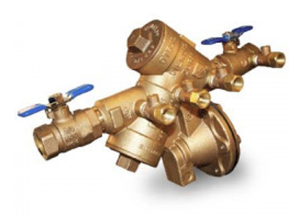  Figure 10: Example reduced pressure zone (RPZ) device
Residual chlorination | See chlorine residual.
Sanitary bore head | See bore headworks
Solenoid valve | An electronic valve which prevents water flowing through the UV unit when the UV intensity (or UV dose) is too low. The purpose of this is to prevent unsafe water being delivered to the distribution system.  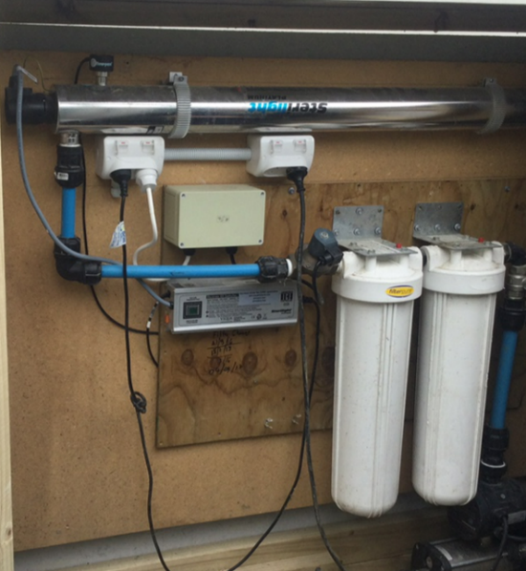  Figure 11: Example solenoid valve being used to control a UV unit
Spring headworks | The infrastructure located at the extraction point of a spring groundwater source. The headworks include the spring, the collection box and any other infrastructure required to extract the water.  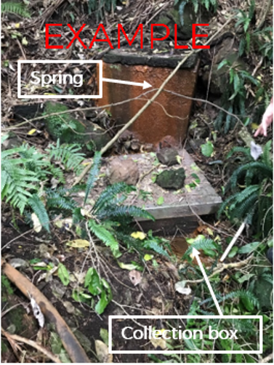  Figure 12: Example spring headworks
Taumata Arowai | The drinking water, wastewater, and stormwater regulator for Aotearoa New Zealand.
Total coliforms | Total coliforms include bacteria that are found in the soil, in water that has been influenced by surface water, and in human or animal waste. Their presence in drinking water shows that the water has been contaminated with bacteria.
Turbidity | Turbidity measures how clear or cloudy the water is—lower turbidity means clearer water. Cartridge filters can reduce turbidity by removing suspended particles, but they do not remove colour, which comes from dissolved substances; low turbidity is essential before UV disinfection so germs aren’t shielded by particles.
UV disinfection | UV light is shone through the water to inactivate micro-organisms (bacteria, viruses and protozoa) so that they cannot reproduce to cause illness in anyone drinking the water. The UV lamp is housed in a casing or sleeve and needs replacing on a regular basis.  It is important that the UV unit is validated against one of four approved standards listed in the Drinking Water Quality Assurance Rules or Acceptable Solution. Validation is required to achieve compliance and to provide confidence that the UV system is a high quality and reliable unit.  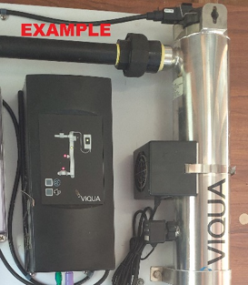  Figure 13: Example UV unit
UV auto shutdown | Flow through the UV unit automatically stops if the UV intensity (or UV dose) is too low e.g. during a power cut or if the UV lamp hasn’t warmed up yet
UV dose and UV intensity (UVI) | The amount of UV light that passes through the water. An average dose (reduction equivalent dose) of 40 mJ/cm² is required. Validated units will achieve this.
UV lamp status indication | A display that indicates whether the UV lamp needs replacing (e.g. light turns from green to red when the lamp needs replacing).  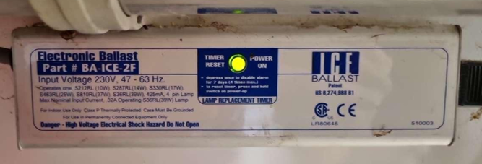  Figure 14: Example UV lamp status indication
UV validation certificate | A validation certificate for UV water treatment serves as documented proof that the ultraviolet (UV) system has been tested as effective at deactivating microorganisms in compliance with a specific internationally recognised standard. It confirms that the UV treatment consistently meets required disinfection levels, ensuring the safety and quality of the treated water. A copy of the validation certificate can be obtained from the supplier.
Compliance pathway | The school’s water supply will need to comply with one of the following categories:  - Drinking Water Acceptable Solution for Self-supplied Buildings  - Drinking Water Quality Assurance Rules - Small  - Drinking Water Quality Assurance Rules - Medium  - Drinking Water Quality Assurance Rules - Large

- Section 1 – School Details
Table 1-1 (School background, population and building information) has been partially pre-populated using information that the New Zealand School Property Agency holds about the school. Please review and complete the table.
If the school’s drinking water supply supplies other properties (e.g. school house, community hall), please enter the average number of people in the boxes for Houses and Other in Table 1-1.
If there are occasions where there is a much larger population (e.g. an event at the hall), please enter the maximum number of people in the Peak population box.
For compliance pathway, choose one option from the following table. NZSPA’s preference is that the Acceptable Solution is used if the eligibility criteria are met. Please refer to the Acceptable Solution for the full list of eligibility criteria.
Compliance Pathway Option | Eligibility Criteria
Self-Supplied Buildings Drinking Water Acceptable Solution | - Population up to 500 people  - 10 or fewer buildings supplied with drinking water on one property (or adjoining properties in common ownership)  - Water must be suitable for treatment by cartridge filtration and UV disinfection (pre-treatment may be required)  - If the supply is to more than three buildings or for more than 100 people, the pipes carrying drinking water must not be near a septic tank, wastewater treatment plant or effluent disposal field.  - Springs and bores must be protected by headworks which minimise the risk of surface water contamination, and be fenced to exclude farm animals within 5 metres  - Springs and bores must not be affected by contaminating activities e.g. septic tank, effluent disposal field.
Drinking Water Quality Assurance Rules – Small Self-Supplied Buildings Supply | - Population up to 100 people  - 10 or fewer buildings supplied with drinking water on one property (or adjoining properties in common ownership)
Drinking Water Quality Assurance Rules – Small Networked Supply | - Population up to 100 people  - 11 or more buildings supplied with drinking water, or water is supplied to another property owned by someone else
Drinking Water Quality Assurance Rules – Medium Self-Supplied Buildings Supply | - Population 101 – 500 people  - 10 or fewer buildings supplied with drinking water on one property (or adjoining properties in common ownership)
Drinking Water Quality Assurance Rules – Medium Networked Supply | - Population 101 – 500 people  - 11 or more buildings supplied with drinking water, or water is supplied to another property owned by someone else
Drinking Water Quality Assurance Rules – Large Self-Supplied Buildings Supply | - Population more than 500 people  - 10 or fewer buildings supplied with drinking water on one property (or adjoining properties in common ownership)
Drinking Water Quality Assurance Rules –Large Networked Supply | - Population more than 500 people  - 11 or more buildings supplied with drinking water, or water is supplied to another property owned by someone else

- Section 2 – Description of Water Supply
This section provides a summary description of the school’s water supply. Take photos of key parts of your water supply and insert them into the relevant tables.
  - Source
Details of your groundwater source are captured in Table 2-1. If the water source is a bore, keep the first part of the table and delete rows from “Water source – Spring” onwards. Include all known information about the bore. The well number is the bore identifying number captured in the council’s well database. Note the property owner of the land on which the bore is located, the bore depth (metres), casing diameter (mm) and drilling date. Note if there is a screen present in the bore and if the bore pump is located in the bore or is above ground. Include a photo of the bore headworks.
If the water source is a spring, delete the rows of the table from “Water source – Bore” to “Photo of bore headworks”. Include all known information about the spring, including who is the owner of the land on which the spring is located. Include a photo of the spring headworks.
If there is no spring, delete the rows of the table from “Water source – Spring” to “Photo of spring headworks”.
Examples of groundwater source and headworks protection measures the school may already have in place to prevent contaminants entering the supply are as follows. Copy the applicable ones into Table 2-1:
- Protected by headworks which minimise the risk of contamination from nearby surface water
- Farm animals are excluded (e.g., with a fence) from an area extending at least 5 metres from the bore
- Groundwater source is not impacted by contamination from a sewage disposal field or effluent discharge (e.g., a septic tank) through separation of at least 20 metres
- Groundwater source is not impacted by other sources of contamination (refer to section 3.2)
- Groundwater source is not geothermal water
  - Treatment
Check that the treatment steps listed (e.g., cartridge filtration and UV) are present. Delete any that are not installed (e.g. chlorination, pretreatment) and add any other treatment steps that are present.
For the table of details of the cartridge filter system, the pore size for the filter can be found on the packaging or supply note that comes with the filters. This will be shown as in µm (microns) (e.g. 20 and 5 µm). If the packaging is not available, please contact the filter supplier for details.
The school may have pretreatment (e.g. ion exchange or softener). If so, add the details to the table describing the pretreatment process. If you do not have a pretreatment system, delete the table. If you have multiple pretreatment processes, copy this table until each pretreatment process has its own table.
To answer the question about whether differential pressure is measured across the cartridge filters, check whether there are pressure gauges on either side of each cartridge filter.
Provide information about the UV disinfection system. Check the name plate on the UV unit for the UV make and model, and to see whether it is validated for NSF/ANSI 55 Class A. The validation certificate for the UV system is available from the supplier, and a copy should be held on file at the school. Ask your UV installer or plumber if flow through the UV unit stops automatically if there is a UV fault.
The school may have pH correction to adjust the acidity or alkalinity of water. If so, add the details to the table describing pH correction. If you do not have a pH correction system, delete the table.
Chlorination is only required for supplies serving over 500 people. If the school has a chlorine dosing system to maintain a chlorine residual in the water supply network, complete the table of details of chlorine residual disinfection, otherwise delete the table. Specify what is the target chlorine concentration for water leaving the treatment plant (e.g. 0.6 mg/L) and what is the target chlorine concentration in the distribution system (e.g. 0.3 mg/L). Training in the safe handling, storage and dosing of chlorine is required for staff involved in chlorine dosing.
Provide details of the water treatment plant housing.
  - Storage
Copy the tables for water storage tank details to match the number of tanks at the school so that there is one table per tank.
If the tank volume is unknown, it can be calculated as follows:
- For a rectangular tank, multiply the length (L) times the width (W) times the height (H) (i.e. L x W x H).
- For a cylindrical tank, measure the diameter and the height of the tank (to the bottom of the overflow if there is one). Multiply the diameter (D) by the diameter (D), then multiply by 3.14, divide by 4 and multiply by the height (H) (i.e. πD²H/4)
For the tank material, most tanks are either polyethylene (PE) or concrete.
For the condition of the tank, choose from one of the following:
- Very good: as new
- Good: no structural issues, some minor deterioration
- Average: minor cracks and/or moderate deterioration
- Poor: cracks, signs of leaking, structural issues, significant deterioration and/or bulging
- Very Poor: significant cracks or holes, obvious leaks, significant structural issues and/or significant deterioration
To prevent vermin and other contaminants entering the tank, state which of the following measures are in place:
- Secure lid
- No gaps greater than 1.5 mm
- Flap valve on the overflow

If you do not have any treated water storage, delete the Treated water storage tank details table and amend the text above to say that the school has no treated water storage.
If the condition of the tank is poor or very poor, or if vermin or other contaminants could enter the tank, capture this in the risk table and improvements table in Section 4.
  - Distribution
Check whether there are any activities which pose a backflow hazard connected to the school’s drinking water supply (see the table below for the most common backflow hazards at schools). If there are any backflow hazards, check whether an appropriate backflow prevention device is in place. If there is a backflow prevention device, make sure it is on Argest’s backflow prevention register (Argest will then test it each year to make sure it is still working). Enter the details in the table of medium or high hazard backflow activities connected to the school's water treated water supply).
If there is a backflow hazard and the backflow prevention does not meet requirements, capture this in the risk table and improvements table in Section 4.
Refer to NZ Building Code Acceptable Solutions and Verification Methods – Clause G12 Water Supplies for more information about backflow prevention hazards and backflow prevention devices.
If there are no backflow hazards connected to the school’s drinking water supply, delete all of the section after the first two paragraphs and replace with a sentence that says, “The water supply has no medium or high hazard activities that require a backflow prevention device.”
Activity | Hazard level | Type of backflow prevention device required
Swimming pool | Medium | Testable double check valve, reduced pressure zone (RPZ) device or air gap
Dental clinic | High | Reduced Pressure Zone device or air gap
Farm trough | Medium | Testable double check valve, reduced pressure zone (RPZ) device or air gap
Laboratory | Medium | Testable double check valve, reduced pressure zone (RPZ) device or air gap
Untreated water storage tanks connected to treated water distribution (i.e., not source water storage tanks) | Medium | Testable double check valve, reduced pressure zone (RPZ) device or air gap
Irrigation | Medium | Testable double check valve, reduced pressure zone (RPZ) device or air gap
Fire sprinkler system | Medium | Testable double check valve, reduced pressure zone (RPZ) device or air gap
Boiler feed water | High | Reduced Pressure Zone device or air gap
Hose taps used for mixing pesticides | High | Reduced Pressure Zone device or air gap
As a minimum, every hose tap needs a permanently attached hose connection vacuum breaker (unless the tap is associated with a medium or high hazard, in which case a backflow prevention device is needed as per Clause G12 and the above table).
Copy the information about the risks and planned improvements in the risk table and improvements table in Section 4.
  - Aerial View and Schematic of Water Supply
Replace the example figures in Figure 2-1 (Water supply bore, treatment storage locations) and Figure 2-2 (School water supply and treatment schematic) with an annotated aerial image and a schematic that accurately reflect the school’s water supply.
NZSPA has typical schematics in PowerPoint that you can edit for Figure 2-2:
- Choose one of the PowerPoint slides provided that has a schematic which most closely resembles the school’s water supply.
- Modify it to be a true representation of your school’s water supply.
- Use the snipping tool to select the schematic once completed.
- ‘Save as’ the picture file and import into the drinking water safety plan or copy and paste it into the drinking water safety plan.
  - Daily Water Demand and Storage Requirements
To estimate the average daily water demand:
Step 1. Determine the maximum population:
- Confirm with NZSPA the maximum projected school roll in 10 years’ time and beyond
- Add 10% for staff
- Select current or future population, whichever is greater.
Step 2. Calculate the water use for students and staff:
- If water meter data is available, use this to calculate the average day demand
- If not, calculate the average daily demand assuming:
  - 10 litres per person per day (for newer systems with low leakage)
  - 15 litres per person per day (typical median value)
  - 20 litres per person per day (for older systems with high leakage).
Step 3. Add an allowance for any other uses connected to the drinking water supply, for example:
- Pool: daily volume lost by evaporation and used for backwash and as advised by the company that provided your pool filter or the person that maintains your pool
- Houses: 227 litres per person per day
- Community Hall: 15 litres per person per day
- Early childhood centre: 20 litres per person per day
Enter the details in the table describing average daily water use. Delete any rows that don’t apply.
The New Zealand School Property Agency recommends that self-supplying schools relying on groundwater store enough untreated water to meet the school’s demand for at least 7 days. To calculate the untreated water storage requirements, multiply the average daily use calculated above by 7 days.
NZSPA recommends that self-supplying schools store enough treated drinking water for three days, both to minimise disruption if there is a treatment plant outage and to provide enough during an emergency. To calculate the treated water storage requirements in the table of treated water storage requirements), multiply the average daily use calculated above by 3 days.
Compare the total volume of untreated and treated water storage that the school already has with the required amount and state whether this is sufficient, or if more storage needs to be installed. If more storage is needed, capture this in the risk table and improvements table in Section 4.
  - Resource Consent
Given that the school uses groundwater as a drinking water source, a resource consent might be required to take this water. Choose the highlighted sentence that corresponds to the school’s consent requirements and delete the other highlighted sentences.
  - Te Mana o Te Wai
Te Mana o te Wai recognises that protecting the health of freshwater protects the health and well-being of the wider environment. Examples of ways the school can give effect to Te Mana o Te Wai are:
- Taking care with water use and only using what is needed
- There is no obvious leakage and leaks are fixed promptly
- Having water-efficient devices (e.g. no old-style urinals or single flush toilets)
- Dangerous chemicals are handled with care
- Wastewater is treated and disposed of appropriately to minimise adverse effects.
List the ways in which the school already gives effect to Te Mana o Te Wai and list the ways in which the school plans to improve in this area. Where improvements are planned, copy these into the improvements table in Section 4.

- Section 3 – Source Water Risk Management Plan
Protection of source water is of paramount importance, and this is the first barrier against drinking water contamination and illness. Protecting source water starts with understanding your source water, how it could become contaminated or insufficient for your needs.
  - Catchment Description
Replace the highlighted text with the name of the region. Replace the aerial image in Figure 3-1 (Aerial image showing the location of the groundwater take) with one showing the location of the school’s groundwater take, including the area extending 2.5 km from the source. Mark the location of the bore or spring on the aerial image.
Consider what things could cause the groundwater to become contaminated and add applicable ones to the list. The closer a hazard is to the bore/spring, the greater the risk that it could have a negative effect on the quality and safety of the water. Potential sources of contaminants for groundwater include:
Within 5 m of the bore/spring:
- Livestock can get within 5 m of the bore/spring
Within 20 m of the bore/spring:
- Wastewater effluent disposal field
- Offal pit
Within 2.5 km of the bore/spring:
- Intensive agricultural land use or areas where animal effluent is irrigated to land
- Contaminated sites
- Underground storage tank (such as at a petrol station)
- Waste pond
- Landfill
- Areas where pesticides are applied
- Geothermal water
- Saline water (i.e. sea or estuary)
List improvement actions the school could take to reduce contaminants entering the water supply. Potential improvements include:
- Fence an area extending at least 5 metres around the headworks of the bore
- Upgrade bore head to meet the sanitary bore head requirements in the Drinking Water Quality Assurance Rules
- Monitor source water in line with the Drinking Water Quality Assurance Rules
- Perform regular inspections of the bore/spring headworks to identify maintenance requirements and potential contamination risks
- Investigate an alternative water source
Copy the information about the risks and planned improvements in the risk table and improvements table in Section 4.

- Section 4 – Risks and Improvement Actions

Table 4-1 Risks and Improvement Actions
Complete the risk assessment table (Table 4-1: Risks and improvement actions) once you have completed the previous sections of the drinking water safety plan.
Review the existing preventative measures that the school could have in place to reduce each risk and delete those that don’t apply.
Review the risk rating, considering the preventative measures that you already have in place. The following risk definitions have been used:
- Low: Insignificant or minor consequence, with little disruption to normal operation; not likely to happen.
- Medium: Significant manageable disruption to safe water supply, with requirement for increased monitoring. Potential aesthetic issues; likelihood possible.
- High: Major disruption to safe water supply, e.g., complete failure of systems, acute harm to people or widespread illness; high level of monitoring and incident management required; likely to happen.
Choose whichever risk rating is appropriate and delete the others. We make the following recommendations about how to score each risk.
If there is no residual chlorination, delete the row for the risk Treatment – Residual Chlorination.
Table 4-1: Risk evaluation guidance
Risk (Event Description) | Low | Medium | High
Contamination of source water by faecal material | If all the following are present:  - Bore has sanitary borehead above ground level  - Livestock cannot get within 5 metres of the bore/spring  - Wastewater effluent disposal field is at least 20 metres from the bore/spring  - Cartridge filtration  - UV disinfection | If the following are present:  - Cartridge filtration  - UV disinfection  BUT some of the following are present:  - Bore does not have a sanitary borehead above ground level  - Livestock can get within 5 metres of the bore/spring  - Wastewater effluent disposal field is within 20 metres of the bore/spring | If one or both of these are missing:  - Cartridge filtration  - UV disinfection
Contamination of source water by chemicals | If all the following apply:  - Bore has sanitary borehead above ground level  - Abstraction depth is over 30 metres below ground level with confining layers  - No known potentially contaminating activities within 2.5 km of the bore/spring | If either of the following apply:  - Abstraction depth is over 30 metres below ground level with confining layers  - No known potentially contaminating activities within 2.5 km of the bore/spring  AND  - Bore has sanitary borehead above ground level  OR  - Chemical contaminant(s) are present at levels above 50% of the Maximum Acceptable Value (MAV) in the Drinking Water Standards | If both of the following apply:  - Potentially contaminating activities within 2.5 km of the bore/spring  - Bore does not have a sanitary borehead above ground level  OR  - Chemical contaminant(s) are present at levels above the Maximum Acceptable Value (MAV) in the Drinking Water Standards
Insufficient source Water | The school has never had a problem with a lack of drinking water due to insufficient source water  AND  There is at least 7 days untreated water storage (as per section 2.6.1) | The school has a problem with a lack of drinking water due to insufficient source water less than once a year  OR  There is less than 7 days untreated water storage (as per section 2.6.1) | The school has problems with a lack of drinking water at least once a year due to insufficient source water  AND  There is less than 7 days untreated water storage
Chemical or physical contaminants are not controlled to acceptable level | If all the following apply:  - Weekly checks of pretreatment system and reagent levels  - The pre-treatment system is serviced every 6 months  OR  - The source water quality is of a sufficiently good quality to not require pretreatment | If either of the following apply:  - Weekly checks of pretreatment system and reagent levels  - The pre-treatment system is serviced every 6 months | If none of the following apply:  - Weekly checks of pretreatment system and reagent levels  - The pre-treatment system is serviced every 6 months
Contamination of water in storage tanks | All tanks are in average, good or very good condition  AND  Any gaps or holes are covered in mesh with a gap size of no more than 1.5 mm (or in the case of an overflow, a flap valve is installed on it)  AND  All lids are secure | All tanks are in average, good or very good condition  AND  There are fine cracks (<1.5 mm) in the roof of the tank  AND  All lids are secure | One or more tanks are in poor or very poor condition  OR  There are gaps or holes in the tank that are greater than 1.5 mm  OR  Lids are missing or are not secure
Particles and/or natural organic matter not removed | There is cartridge filtration, including a filter with a pore size of 5 microns or smaller  AND  The cartridge filters are replaced at least every 6 months (or more often if required)  AND  There is no bypass around the cartridge filters | There is cartridge filtration, including a filter with a pore size of 5 microns or smaller  AND  The cartridge filters are replaced less often than every 6 months  OR  There is a bypass around the cartridge filters | There is no cartridge filtration
Inadequate disinfection | All of the following are in place:  - There is a validated UV unit which treats all the drinking water  - The UV unit is serviced at least annually by a trained operator, including replacing UV lamps and cleaning sleeves  - There is an automatic control system in place which prevents water flowing through the UV unit if the UV dose/intensity is insufficient (e.g. via a solenoid valve)  - There is no bypass around the UV unit | All of the following are in place:  - There is a UV unit which treats all the drinking water  - The UV unit is serviced at least annually by a trained operator, including replacing UV lamps and cleaning sleeves  AND  There is no automatic control system in place which prevents water flowing through the UV unit if the UV dose/intensity is insufficient (e.g. via a solenoid valve)  OR  There is a bypass around the UV unit | There is no UV unit  OR  There is a UV unit which treats only some of the drinking water
Low chlorine residual in the treated water  (Note: this risk only applies if there is a chlorine dosing system to maintain a chlorine residual in the pipe network, which is uncommon in schools) | All of the following are in place:  - The chlorine dosing system is serviced at least annually  - Hypochlorite is replaced on a regular basis and before its expiry date  - Person responsible for maintaining the drinking water supply is trained in the maintenance of the chlorine plant and undertakes maintenance in accordance with this  AND  - Free available chlorine (FAC) is measured on a regular basis at the tap and is always between 0.2 mg/L and 5 mg/L | Some but not all of the following are in place:  - The chlorine dosing system is serviced at least annually  - Hypochlorite is replaced on a regular basis and before its expiry date  - Person responsible for maintaining the drinking water supply is trained in the maintenance of the chlorine plant and undertakes maintenance in accordance with this  AND  - Free available chlorine is measured on a regular basis at the tap and is normally above 0.2 mg/L | There is no regular servicing of the chlorine dosing system  OR  The hypochlorite is not replaced on a regular basis  OR  There is no monitoring of FAC at the tap or FAC is often below 0.2 mg/L
Loss of supply  Inadequate treated water due to failure of the water treatment plant or its pump  (Note: this risk only applies to a lack of treated water, as a lack of source water is covered in a separate risk above) | The school has not had a problem with a lack of treated drinking water in the last 5 years.  AND  There is at least 3 days treated water storage (as per section 2.6.2) | The school has had a problem with a lack of treated drinking water less often than once a year.  OR  There is less than 3 days treated water storage (as per section 2.6.2) | The school has had a problem with a lack of treated drinking water once or more often than once a year.  AND  There is less than 3 days treated water storage (as per section 2.6.2)
Loss of supply due to excessive water usage  Extraordinary water use | There has not been a problem with low pressure or low flow in the last 5 years.  AND  Any leaks in the distribution network are fixed promptly | There are problems with low pressure or low flow in the distribution system less often than once a year  OR  Any leaks in the distribution network are fixed promptly | There are problems with low pressure or low flow in the distribution system either annually or more often than once a year  OR  There are known leaks or problems with excessive water use
Loss of power means the treatment plant and pumps cannot operate | Power outages are rare (less than once a year)  OR  The school has a portable generator which can power the treatment plant and pumps | Power outages occur more than once a year  AND  The school does not have a portable generator which can power the treatment plant and pumps | N/A
Distribution - contamination of supply from backflow | There are no medium or high hazard activities connected to the distribution system  OR  There are medium or high hazard activities connected to the distribution system, and backflow prevention devices which meet the requirements of the Building Code are in place in every case  AND  There are no cross-connections between the potable and non-potable supplies (or there is no non-potable supply)  AND  Distribution pipework is in good condition | There is a medium hazard activity connected to the distribution system and there is no associated backflow prevention device  OR  There is a medium hazard activity connected to the distribution system and the associated backflow prevention device does not meet the requirements of the Building Code  OR  Distribution pipework is in poor condition | There is a high hazard activity connected to the distribution system and there is no associated backflow prevention device  OR  There is a high hazard activity connected to the distribution system and the associated backflow prevention device does not meet the requirements of the Building Code  OR  There are cross-connections between the potable and non-potable supplies  OR  Distribution pipework is in very poor condition
Review the improvement items and delete any that the school already has in place. There should be improvement items for any risk which is rated as medium or high.

Table 4-2: Summary of Improvement Actions
The improvement actions the school plans to take to improve the safety and reliability of its water supply is one of the most important sections of the drinking water safety plan. It is also useful when reporting progress (e.g. to the Board of Trustees).
Copy the improvement items from the previous sections into Table 4-2 (Summary of improvement measures the school will take to minimise risks) from:
- Section 2.4.1 Backflow Prevention
- Section 2.6 Daily Water Demand and Storage Requirements
- Section 2.8 Te Mana o Te Wai
- Section 3.2 Impact of Catchment Activities on Water Quality
- Section 3.3 Water Quantity Available from Source
- Table 4-1 Risk Assessment.
Insert additional lines in the table so that there is one line per improvement action.
For each improvement, choose whether it is an urgent or non-urgent priority:
- Urgent improvements are those which address drinking water safety concerns or address a lack of water (i.e. those which address a high risk).
- Non-urgent improvements are those which improve the resilience and reliability of the supply or enable full compliance with the Drinking Water Quality Assurance Rules/Acceptable Solution (i.e. those which address a medium risk, or which are needed to meet NZSPA’s storage requirements or improve Te Mana o Te Wai or achieve full regulatory compliance).
Urgent problems and potential improvement actions are summarised in Table 4-2, and non-urgent problems and potential improvement actions are summarised in Table 4-3.
Table 4-2: Urgent problems and potential improvements
 | Urgent Problem | Potential Improvements
Source | Contamination of source water by faecal material | - Install cartridge filtration and UV disinfection  - Install a stock fence at least 5 m around the bore/spring  - Move the bore or source of contamination (e.g. effluent disposal field) so that there is a separation distance of at least 20 m
Source | Poor condition or insecure bore | - Seal penetrations and repair other obvious defects  - Assess bore condition and upgrade is feasible (bore replacement or alternative water source options to be completed under non-urgent solutions)  - Consider alternative source (e.g. roof water)
Source | Maximum acceptable value (MAV) in the Drinking Water Standards is exceeded in source water and no/inadequate process to remove it | - Remove source of contamination  - Install treatment process to address MAV exceedance  - Consider alternative source
Source | No way to sample source  water | - Add source water sampling tap for each bore and spring
Treatment | No treatment plant | - Install a new compliant treatment plant and smart flow meter in a dedicated shed
Treatment | Treatment processes needed for microbiologically safe water are missing | - Maintain the water treatment plant (e.g. replace cartridge filters, UV lamp etc.)  - Install cartridge filtration  - Install a validated UV unit (if maintenance doesn’t fix problem)  - Install a solenoid valve to stop water flowing through the UV unit if there is a UV fault (if existing UV unit cannot be repaired or upgraded to address the issue)
Treatment | Bypass around water treatment plant (or part of treatment process) | - Remove bypass
Storage | Very poor or poor condition storage tanks (e.g. leaking excessively) | - Replace storage tanks
Storage | Storage tank vulnerable to contamination by vermin (i.e. large holes) | - Install vermin protection (i.e. install a flap valve if it’s an overflow, repair holes)
Storage | No storage tank (bore water supplies) | - Install an untreated water storage tank (sufficient to meet 7 days’ demand)
Distribution | High or medium backflow hazard (or cross-connection risk) and no/inadequate backflow prevention device | - Install backflow prevention device that complies with section 3.3 of the Acceptable Solution for Clause G12 Water Supplies of the Building Code  - Remove high or medium risk activity from the water supply
Distribution | Significant leakage from network | - Fix leaks
Table 4-3: Non-urgent problems and potential improvements
 | Non-urgent Problem | Potential Solutions
Whole System | Overly complex supply (e.g. multiple sources, multiple treatment plants, complex pipework) | - Simplify supply, reduce number of sources and treatment plants
Whole System | Source inadequate to reliably meet school water requirements for majority of the time | - Increase storage  - Stop supplying other properties  - Install water efficient devices  - Install a pool cover  - Consider using non-potable water for irrigation and the pool  - Develop / improve bore source to improve yield  - Consider alternative source (e.g. roof water)
Source | Bore doesn’t meet all requirements for sanitary bore head in S3 rules of the Drinking Water Quality Assurance Rules | - Upgrade bore head to meet sanitary bore head requirements in S3 rules of the Drinking Water Quality Assurance Rules
Source | Chemical contaminant(s) present in source water at levels between 50% and 100% of MAV and no/inadequate process to remove it | - Sample and test source and treated water quarterly for contaminants to check levels do not exceed MAV.  - Consider installing a treatment process to remove the contaminant(s)
Source | Iron/manganese exceed aesthetic values and no/inadequate treatment to remove it | - Install chlorine oxidation and Greensand filter or ion exchange
Source | Other aesthetic issues in source water | - Additional treatment process to address aesthetic issues
Source | Potentially contaminating activities within 2.5 km of the bore | - Measure parameters of concern in the source water to determine whether further action is required (e.g. additional treatment or alternative source)
Treatment | UV unit isn’t validated | - Replace UV unit with a validated unit
Treatment | UV unit doesn’t shut down automatically on low UVI/UV dose | - Install solenoid valve to automatically stop flow through UV unit on low UVI/UV dose (needs to be done in conjunction with treated water storage tanks otherwise there will be no water for the school if there is a UV fault)
Treatment | No flow control on UV unit (to prevent flow exceeding validated flow rate) | - Install flow restrictor  - Use flow meter to control flow through UV
Treatment | No residual chlorination system and population > 500 people | - Install a residual chlorination system
Treatment | Multiple treatment plants and/or overly complex pipework | - Modify supply so that there is a single treatment plant if possible
Storage | Storage tanks vulnerable to contamination by insects (i.e. small holes or gaps) | - Seal all holes and penetrations or cover with insect mesh so that gap size is no more than 1.5 mm
Storage | Storage tank doesn’t have an air vent | - Install air vent with light trap and insect mesh
Storage | Storage tank air vent doesn’t have a light trap and/or insect mesh | - Replace air vent with one that has a light trap and insect mesh
Storage | Storage tank doesn’t have an overflow | - Install an overflow with a flap valve to prevent access by vermin
Storage | Storage volume doesn’t meet NZSPA requirements | - Install additional storage so that there is at least 7 days of untreated water storage and 3 days of treated water storage
Distribution | No permanently attached vacuum breakers on hose taps | - Install permanently attached vacuum breakers on hose taps
Distribution | School supplies other properties not in common ownership | - Move towards ceasing supply to other properties  - If water source is plentiful, consider continuing supply of non-potable water to other properties if an agreement can be reached between the school and property owner that they will install a compliant treatment plant
Monitoring | Sample taps missing | - Install sample taps to allow sampling in the positions described in the relevant section of the Acceptable Solution or the Drinking Water Quality Assurance Rules
Monitoring | No flow measurement | - Install smart flow meter downstream of the water treatment plant to record the school’s water demand and provide for remote monitoring and data acquisition via a network connection
Monitoring | No remote monitoring of continuously monitored parameters, treatment plant faults and tank levels | - Establish remote monitoring of continuously monitored parameters, treatment plant faults and tank levels
- Section 5 – Operations, Maintenance, Monitoring and Reporting
  - Operations and Maintenance
Apply the applicable filters in NZSPA’s “Maintenance and Servicing Guideline and Checklist” tool and take a screen shot or snip and paste into Appendix A.
If there is an operations and maintenance manual for the water supply, state where this is stored. If not, delete and add preparing an operations and maintenance manual to the improvements table in section 4.2.
  - Monitoring and Reporting
Choose the highlighted sentence that corresponds to the school’s compliance pathway (from Table 1-1) and delete the other highlighted sentences.



Drinking water safety planning | Taumata Arowai
https://www.building.govt.nz/building-code-compliance/g-services-and-facilities/g12-water-supplies/
https://www.building.govt.nz/building-code-compliance/g-services-and-facilities/g12-water-supplies/
https://www.taumataarowai.govt.nz/assets/Uploads/Rules-and-standards/Drinking-Water-Quality-Assurance-Rules-2022-Released-25-July-2022.pdf
Water Services Act: www.legislation.govt.nz/act/public/2021/0036/latest/LMS374564.html
Taumata Arowai: Drinking Water Standards, Drinking Water Quality Assurance Rules and Acceptable Solutions www.taumataarowai.govt.nz/for-water-suppliers/new-compliance-rules-and-standards/
Register of drinking water supplies, including registered water carriers https://hinekorako.taumataarowai.govt.nz/publicregister/supplies/
www.taumataarowai.govt.nz/

